**Exercise: Circuits**

1. Given the following logic functions, please write down the corresponding truth tables, and construct the logic circuits in Logisim to implement the all the following logic functions (i.e., the share the same set of inputs A and B). The circuits should be simplified as much as possible.



Reference Solution:

After simplification:



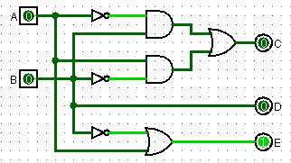

Note: it is also ok to write as C = A XOR B

1. Please build circuits in Logisim according to the following truth table. The circuits should be simplified as much as possible.

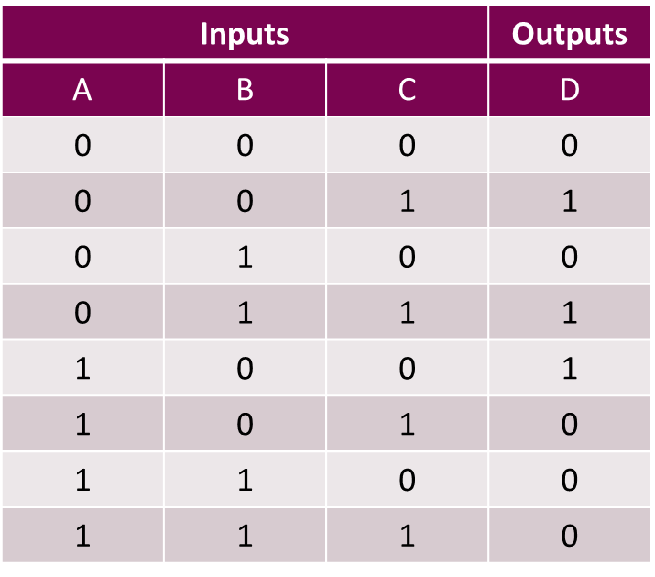

Reference Solution:

1. Sum-of-produce and simplified by binary logic rules



1. Using K-map

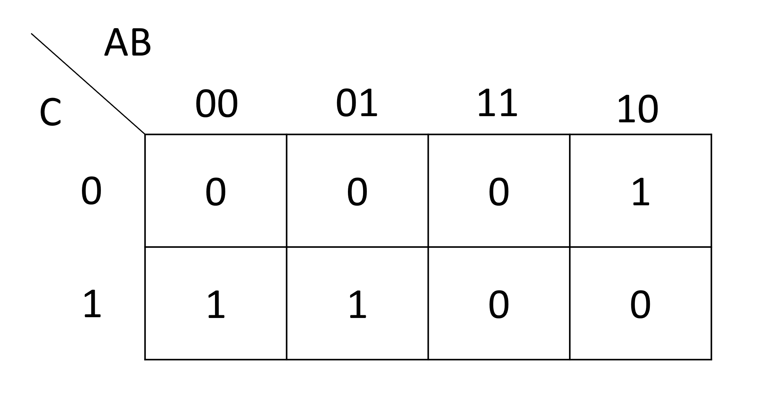

So the derived expression is the same as above

The circuit in Logisim:

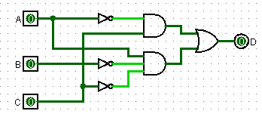

1. Suppose the timing diagram of the input D and clock C of a clocked D flip-flop by raising edges is as follows, please draw the timing diagram of its output Q.

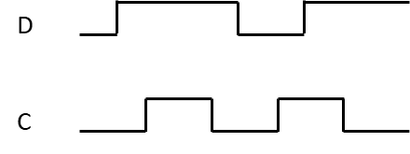

Reference solution:

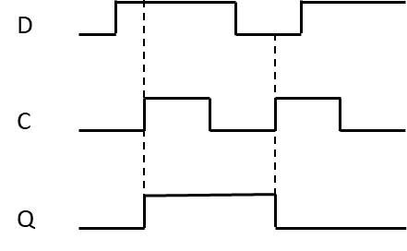

1. Suppose the timing diagram of the input D and clock C of a D flip-flop triggered by falling edges is as follows, please draw the timing diagram of its output Q.

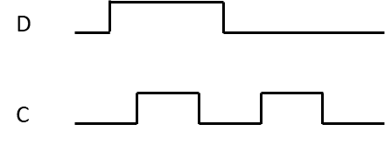

Reference solution:

