**Exercise - Circuit**

1. Given the following logic functions, please write down the corresponding truth tables, and construct the logic circuits in Logisim to implement the all the following logic functions (i.e., the share the same set of inputs A and B). The circuits should be simplified as much as possible.



1. Please build circuits in Logisim according to the following truth table. The circuits should be simplified as much as possible.

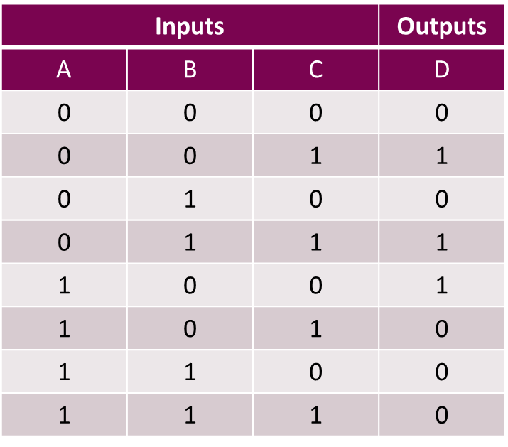

1. Suppose the timing diagram of the input D and clock C of a D flip-flop triggered by raising edges is as follows, please draw the timing diagram of its output Q.

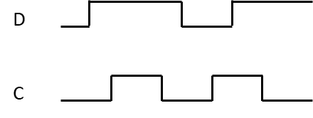

1. Suppose the timing diagram of the input D and clock C of a D flip-flop triggered by falling edges is as follows, please draw the timing diagram of its output Q.

