

**Software Project Management Plan**

AAU - Gold Team

Version: 2.0

Date: 4/25/2017

Revision History

Document Owner: Philip Parker

|  |  |  |  |
| --- | --- | --- | --- |
| **Date** | **Revision** | **Description** | **Author** |
| 02/25/2017 | 1.0 | Document creation | Philip Parker, Casey Boatman |
| 04/25/2017 | 2.0 | Final Document Update | Philip Parker |

1 Overview 3

1.1 Project Summary 3

1.1.1 Purpose, scope and objective 3

1.1.2 Assumptions and constraints 3

1.1.2.1 Assumptions 3

1.1.2.2 Constraints 3

1.1.3 Project deliverables 4

1.1.3.1 Software deliverables 4

1.1.3.2 Document deliverables 4

1.1.3.2.1 Team documents 4

1.1.3.2.2 Client documents 4

1.1.4 Schedule 4

1.2 Evolution of the SPMP 5

2 References 6

3 Definitions 7

4 Project organization 8

4.1 External structure 8

4.2 Internal structure 8

4.3 Roles and responsibilities 8

5 Managerial process plan 10

5.1 Project start-up plan 10

5.1.1 Estimation plan 10

5.1.2 Staffing plan 10

5.1.3 Resource acquisition plan 10

5.1.3.1 Hardware resources 10

5.1.3.2 Software resources 10

5.1.3.3 Other resources 10

5.2 Work plan 10

5.2.1 Work activities 10

5.2.2 Schedule and resource allocation 11

5.3 Control plan 11

5.3.1 Requirements control plan 11

5.3.2 Schedule control plan 11

5.3.3 Quality control plan 11

5.3.4 Reporting plan 11

5.4 Risk management plan 11

5.5 Project closeout plan 11

6 Technical process plans 13

6.1 Process model 13

6.2 Methods, tools and techniques 13

6.3 Infrastructure plan 13

6.4 Product acceptance plan 13

7 Supporting process plans 14

7.1 Configuration management plan 14

7.2 Verification and validation plan 14

7.3 Documentation plan 14

7.4 Quality assurance plan 14

7.5 Reviews and audit plan 14

7.6 Problem resolution plan 14

7.7 Subcontractor management plans 14

7.8 Process improvement plan 14

# Overview

This is the Software Project Management Plan (SPMP) for the Above Average University (AAU) Gold Team. This team will be in charge of creating the University Portal. This document defines the goals of the project, and includes a description of the deliverables and deadlines.

Every university needs a proper website, with tools to allow students and faculty complete necessary tasks for their work within the university. The goal of the team is to design the website and tool with the core functionality required, and hopefully provide additional functionality per customer request if time permits.

The Gold Team will consist of: Philip Parker, Casey Boatman, Justin Andras, Ryan Peters, Jonathon Nowak, Joshua Potrawski, Aaron Tonkovich, and Jacob Hertl

## Project Summary

Under the Project Summary section, the overview of purpose, scope, and objectives will be given and discussed. This section will also contain the constraints, project deliverables, summary of the schedule, and the plan for change in the SPMP.

### Purpose, scope and objective

The purpose of this document is to serve as a guide for the development of the project, making sure that all requirements are met. It will guide us to making sure the final product falls within the actual needs of the customer.

The objective of the project is the development of the university portal, as well as, the creation of a solid platform that will allow for future functionality and upgrades.

* **Faculty needs:**

Faculty needs to be able to review courses offered at the university, and to add additional information regarding offered courses. They also need to be able to view students enrolled in their courses. Additional needs for faculty include being able to post and review announcements through the department, and posting/updating events for the university.

* **Student needs:**   
  Student needs to be able to look up courses offered, and register for available courses. They also need to be able to view details of their accounts, such as- balances, transcript, etc. They will also be able to search through a directory to easily find faculty contact information.

### Assumptions and constraints

#### Assumptions

* The Gold Team has enough experience personally and as a whole to complete the project.
* The team will work together to complete the project.
* The client will respond in timely manner to all questions from the team.
* Additional human resources might be available to the project.

#### Constraints

* Due to the nature of the project and its dependability on already existing solutions and technologies, third party software and already available solutions will be used in the project as needed.
* Team meetings will be required at least once every week.
* Additional financial resources are not available for the project.

### Project deliverables

The Gold Team will produce a working tool to serve as the AAU university portal, and this tool will serve both students and faculty with necessary university actions.

#### Software deliverables

The Gold Team will deliver a working University Portal tool.

#### Document deliverables

The Gold Team will provide multiple documents during this whole project. Most documents will be for team use, as well as, requirements to provide IEEE standard documentation on the project. Other documents will be for deliverables for the client.

##### Team documents

The following documents are for the team use and are required by IEEE standard:

* Software Project Management Plan.
* Software Requirements Specification.
* Software Testing Plan.
* Software Design Document.
* Software Quality Assurance Plan.
* Software Configuration Management Plan.
* Software Verification and Validation Plan.

##### Client documents

The following documents will be delivered to the client:

* User manual.
* Code Base.

### Schedule

The schedule of the project phases, milestones and corresponding documents is given in Table 1:

|  |  |  |
| --- | --- | --- |
| **Project milestone** | **Project artifact** | **Due date** |
| Project start |  | February 2017 |
| Finish Initial Documentation | SPMP, SVVP, SQAP, SCMP | February 2017 |
| Initial Product Release | Phase 1 product | March 2017 |
| Client / Team presentations | PM presentation, RE presentation, TE presentation | March 2017 |
| Client / Team presentations Continued | IE presentation, SA presentation | April 2017 |
| Phase 2 product release | Phase 2 product | April 2017 |
| Final documentation | All 9 team documents completed | April/May 2017 |
| Final product release | Phase 3 final product | May 2017 |

**Table 1. Gold Team milestones and due dates**

## Evolution of the SPMP

As the project progresses and is updated, so will the documentation for the project be updated. We have a version control for the tool, and we will sync updates to the documentation per release of the versions of the tool.

# References

* IEEE Std 1058-1998, *IEEE Standard for Software Project Management Plans*, IEEE 1998
* Eric Braude, Michael Bernstein *Software Engineering: Modern Approaches*, John Wiley & Sons,  
   2011

# Definitions

• UP = University Portal

• CI = Configuration Item

• QA = Quality Assurance

• SPMP = Software Project Management Plan (this document)

• SCMP = Software Configuration Management Plan

• SRS = Software Requirements Specification

• SDD = Software Design Document

• SQAP = Software Quality Assurance Plan

• SVVP = Software Verification Validation Plan

• STP = Software Test Plan

• UM = User manual

• PM = Project Manager

• SA = Software Architect

• RE = Requirements Engineer

• TE = Test Engineer

• IE = Integration Engineer

• CD = Code Developer

• WFTC = Workflow Test Cases

# Project organization

The SPMP will identify the organizational entities external to the project and their interaction with the project team, as well as internal project structure and roles and responsibilities for the project.

Section 4.1 describes the external interfaces to the Synergy project team, section 4.2 describes the internal structure of the team, while section 4.3 describes the roles performed by the team members.

## External structure

The client for this project is Above Average University (AAU); however, Professor Ruijian Zhang will serve directly as the customer contact. All formal communication between the client and the team is facilitated through Professor Zhang. The communication to the client will be done through emails.

## Internal structure

Below you will find a graph of the basic hierarchy for this project. The project will be organized as a team of peers with a project manager over-seeing them and a customer over-seeing as well. The roles for the team are project manager, requirement engineer, software architect, integration engineer, and testing engineer. Everyone on the team will also be playing the role of code developer on top of their given job, (this includes the project manager as well).

## Roles and responsibilities

The responsibilities of each team member are shown below. Being responsible for a document includes:

* Making sure the document is created and turned in on time
* Having the project manager identify the writers of each document
* Keeping the document current throughout the development process

In addition to the roles defined by TSP the team used a meeting driver role, with the intention of improving the efficiency of the team’s meetings. The meeting driver acts as a time keeper and meeting facilitator. The role is assigned to different team member before each meeting.

|  |  |  |  |  |  |  |
| --- | --- | --- | --- | --- | --- | --- |
| **Role** | **PM** | **SA** | **RE** | **TE** | **IE** | **CD** |
| **Member** | **Phil Parker** | **Casey Boatman, Justin Andras** | **Ryan Peters** | **Josh Potrawski, Jon Nowak** | **Jacob Hertl, Aaron Tonkovich** | **All Team Members** |
| **Document Responsibility** | **SPMP** | **SDD, UM** | **SRS** | **SQAP, SVVP, STP** | **SCMP** | **Code Base** |

**Table 2. List of roles with their responsible documentation**

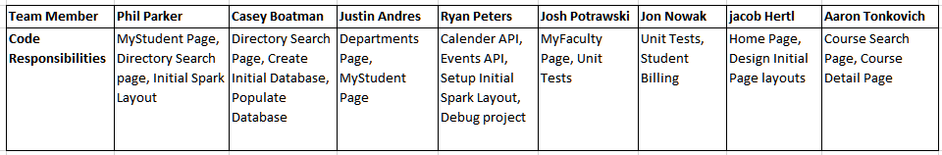

**Table 2.1 List of Coding Responsibilities**

# Managerial process plan

Continued in this section, will be the start-up plan, risk management plan, and the project work plan. These will all specify the managerial process plan.

## Project start-up plan

The SPMP outlines the resources and materials needed to start the project and will include: estimation plan, staffing plan, resource acquisition plan and training plan.

### Estimation plan

This project will have a finished working product around the end of March; however, this will not be the final version of that product. The team has estimated that about every month we will be able to release a new version of the product that contains upgrades, additional functionality and bug fixes. The final version will be released and presented by May.

### Staffing plan

The Gold Team is a fixed team, and is completely and fully staffed. The members are listed in the overview section of this document.

### Resource acquisition plan

All resources will be available at the beginning of the project, until the end of the project.

These are the following categories for resources to be used in this project:

* Hardware resources.
* Software resources.
* Other resources.

#### Hardware resources

Each team member has their own PC to use. Any additional hardware resources, such as- printers, copiers, etc., will be available through the university.

#### Software resources

Each team member is responsible for obtaining whichever Java IDE they would like to use, and same goes for using MySQL databases. They must also create accounts and use Trello and GitHUB.

We additionally added a few more resources to help finish our project on time, and to help get all requirements covered within the project. The resources were- SparkJava framework, Freemarker Templates, and MySQL workbench. These were all free resources and did not have to cost any money, but they were new to the team so new risks were opened up. The team was successful in using these new technologies to finish the project.

#### Other resources

Additional resources may be needed as we move through the project. The project manager will make sure that these resources are provided for the team.

### 

## Work plan

The SPMP will specify the work activities, schedule and resources for the University Portal.

### Work activities

The team will plan major work activities within team meetings. Any changes or new priorities that should occur before the next corresponding team meeting, will be handled by the project manager.

### Schedule and resource allocation

The team has already gone over personal schedules, and will schedule meetings and important project discussions during appropriate times. Most work will be required by each member to complete on their own time, so resources are up to each member to obtain to allow them to work efficiently and effectively.

## Control plan

The SPMP will specify the metrics, reporting mechanisms, and control procedures necessary to measure, report and control the product requirements, the project schedule, resources and quality of work processes and work products.

### Requirements control plan

The requirements for the University Portal project will be documented in the SRS. There are two aspects of the requirements control plan:

* Traceability. Every artifact produced in this project should be able to be traced back to the requirements documents. Traceability will be discussed and decided in meetings.
* Version control. We will be expecting changes as we re-release new versions of the product; therefore, we will also need to keep the requirements updated and under version control.

### Schedule control plan

Scheduling for the Gold Team will be maintained by the Project Manager. It is his responsibility to gather information about project tasks, and create the necessary scheduling for each phase of the project. Trello is the tool that will keep track of the tasks worked on.

Minutes (meeting notes) will be kept by a member of the team during each meeting, and then uploaded to the GitHUB repository so everyone may view them. There is no specific member in charge of taking the minutes every week, so the responsibility will be split among the members for each week. The PM will handle any discrepancies with taking the minutes.

### Quality control plan

The Software Quality Assurance Plan (SQAP) will handle the specifications for the quality control plan.

### Reporting plan

The team will communicate with itself when reporting tasks and bugs, although all tasks and reported bugs will go through the PM as well. All client interaction will be held through email communication, primarily between the PM and Professor Zhang.

## Risk management plan

The Risk Management Plan will be handled by the PM, but implemented through all team members. Primarily the PM will cover:

* Risk management plan for identifying, analyzing, and prioritizing risk factors.
* Contingency planning and methods that will be used to track risk factors, changes, and responses to those changes.

## Project closeout plan

The Gold Team will come to an end in May 2017. At that time the team must have finished:

* A working and completely functional version of the University Portal.
* Archive all the project’s artifacts (documents, source code, project plans, user documentation, etc.).

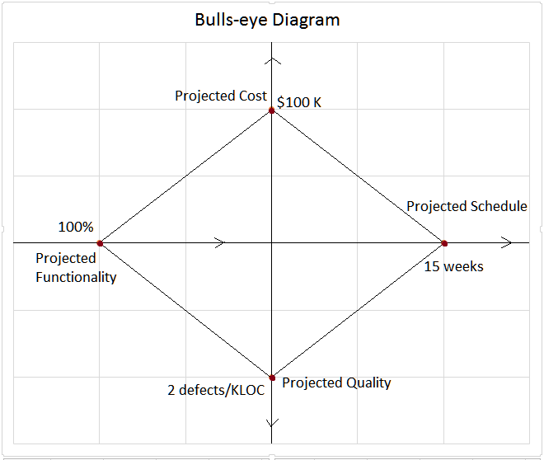

**Picture 5.1 Projected Bulls-eye Diagram for Project Estimation**

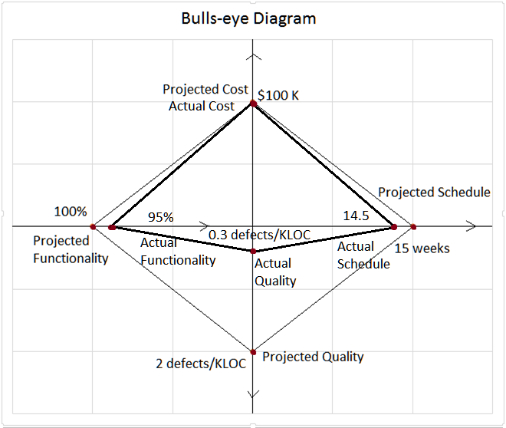

**Picture 5.2 Actual Bulls-eye Diagram of Project**

|  |  |  |  |
| --- | --- | --- | --- |
| **Factor** | **Weight** | **C# Benefits** | **Java Benefits** |
| **Internet Friendly** | 8 | 7 | 8 |
| **Team Familiarity** | 10 | 3 | 10 |
| **Compilation Speed** | 1 | 5 | 5 |
| **Runtime on Processor** | 3 | 6 | 4 |
| **Core Functionality** | 6 | 7 | 4 |
| **Ease of Use** | 8 | 6 | 5 |
| **TOTAL** |  | 199 | 235 |

**Table 5.1 Language Decision Plan**

|  |  |  |  |  |  |  |  |  |
| --- | --- | --- | --- | --- | --- | --- | --- | --- |
| **No** | **Title** | **Likelihood of occurrence** | **Estimated Impact** | **Estimated Cost to Manage** | **Priority Rating** | **Retirement Plan** | **Responsible Persons** | **Completion Date** |
| **1** | Team member drops class | 1 | 9 | 5 | 100 | Conquest | PM | 7-Apr |
| **2** | Requirements Change | 3 | 8 | 7 | 168 | Conquest | SA | 24-Mar |
| **3** | SPARK creates challenges | 7 | 7 | 2 | 32 | Conquest | RE / IE | 25-Apr |
| **4** | Member unable to use new software | 5 | 9 | 6 | 72 | Conquest | PM | 25-Apr |
| **5** | Member overwrites Version Control | 3 | 7 | 6 | 192 | Avoidance | RE / IE | 20-Apr |
| **6** | Bugs prevent work from being completed | 4 | 6 | 5 | 175 | Conquest | TE | 20-Apr |

**Table 5.2 Risk Management Plan**

# Technical process plans

The SPMP will specify the development process model, technical models, tools and techniques that will be used to develop the work products, project infrastructure and product acceptance plan.

## Process model

We are using Waterfall at the start of this project. We agreed this would be the best course of action, as we can get the base functionality that we would like implemented finished before taking on additional features. Upon proper completion of the base project, we will be implementing an Agile style development process. This will make it easier for our team to split up specific features that we would like to enhance, or any additional features added.

## Methods, tools and techniques

For this project, we will be using MySql for our database, GitHub for version control, and Trello for project Management. We are also making use of Google Docs to be able to work on documentation together simultaneously.

## Infrastructure plan

Each team member will have their own working PCs, Internet Access, and accounts for needed tools, such as- GitHUB, Trello, etc. Additional items, like- printers, copiers, etc., are available in the university, and available for use by the team.

## Product acceptance plan

Project Manager Phil Parker will need to completely look over the project three weeks prior to the due date. If any other features are needed to be added to the project, we will do one more sprint (2-week development cycle) to implement any final new features. Our last week before the final due date will be used to tighten up the project and do any last-minute bug fixing. We will run through all of the manual WFTC and ensure they are working properly. Professor Zhang will complete the final inspection of this project.

# Supporting process plans

The SPMP will include the plans for the supporting processes that are part of the software project. These are the other documents listed in section 1.1.3.2.1 of the SPMP. These documents will have responsibility shared among all members of the team; however, the documents will have certain members in charge according to the document specifications.

## Configuration management plan

The SCMP will be handled by the integration engineers- Aaron and Jacob. This document will be completed early in the project, and then revised as the project continues.

## Verification and validation plan

The SVVP will be handled by the testing engineers- Jonathon and Joshua. This document will be completed early in the project, and then revised as the project continues.

## Documentation plan

A lot of documents will be produced and worked on throughout the project’s lifetime. The documents share responsibility among the team members, but each document will be lead and finalized their corresponding team members.

## Quality assurance plan

The SQAP will be handled by the testing engineers- Jonathon and Joshua. This document will be completed early in the project, and then revised as the project continues.

## Reviews and audit plan

Our project will not be receiving an actual audit, instead it will be more like customer inspection before release. Gold Team will use GitHUB as a version control, and review each members’ code before anything is finalized and checked into production code. Code reviews will not need to be reviewed by every member, just the PM and at least 2 other team members.

## Problem resolution plan

The PM will take charge to resolve any conflicts among the team members. Problems in code will handled among the team, and should be caught and rid of during code reviews.

## Subcontractor management plans

No parts or tasks of the project will be sent out to subcontractors. This project will only be worked on and completed by members of the Gold Team.

## Process improvement plan

Process improvement will be done as a part of the final project evaluation, this will be between Phase 2 and the Final product phase. At that time the process improvement plan will be created.