Part 4:
Task 1:
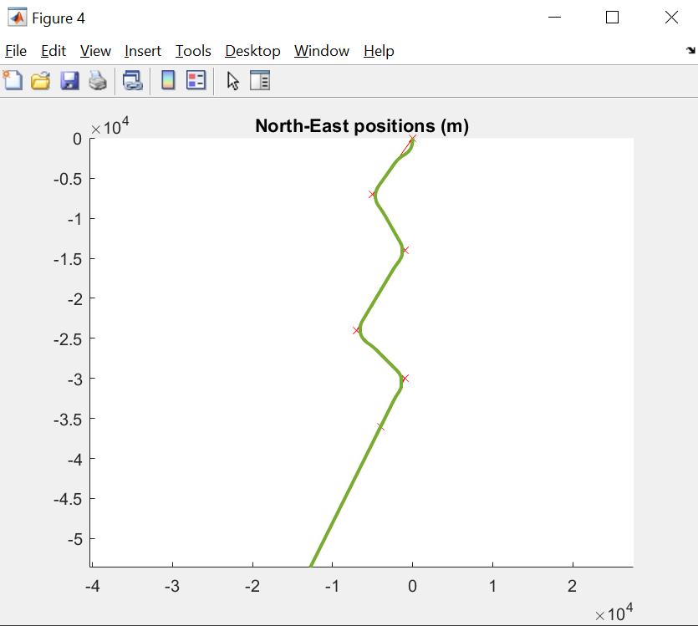
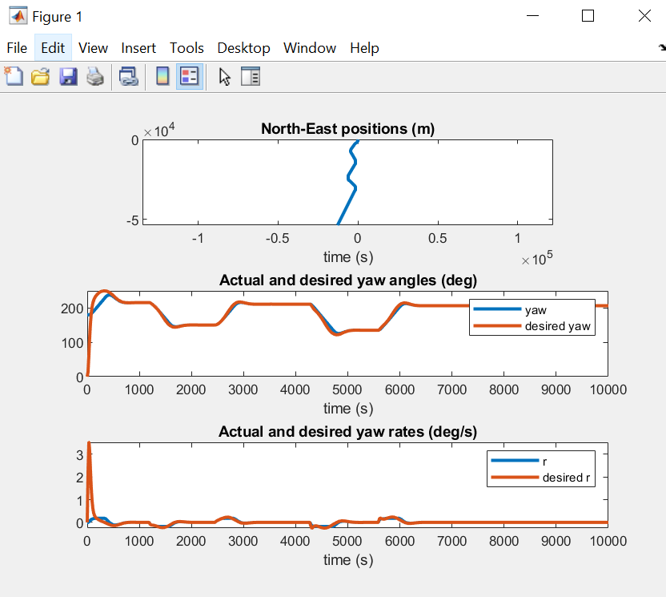
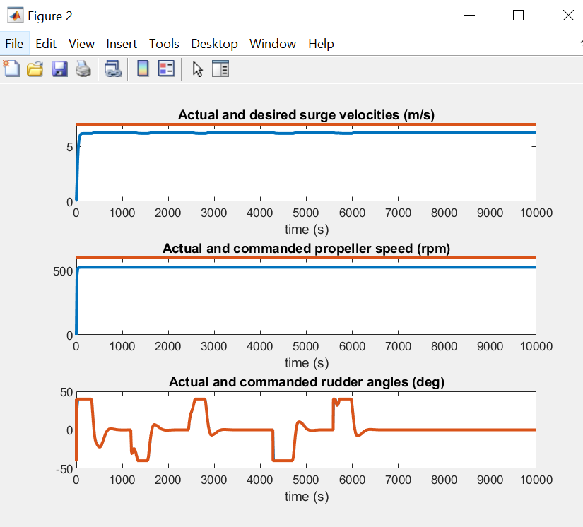
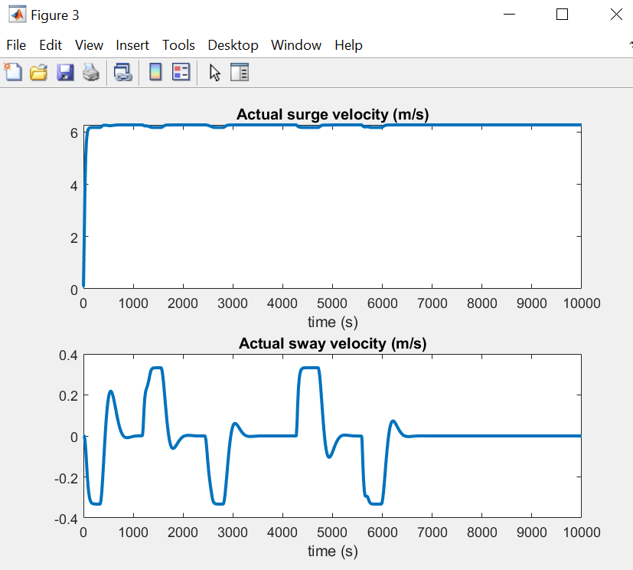
Task 2a):
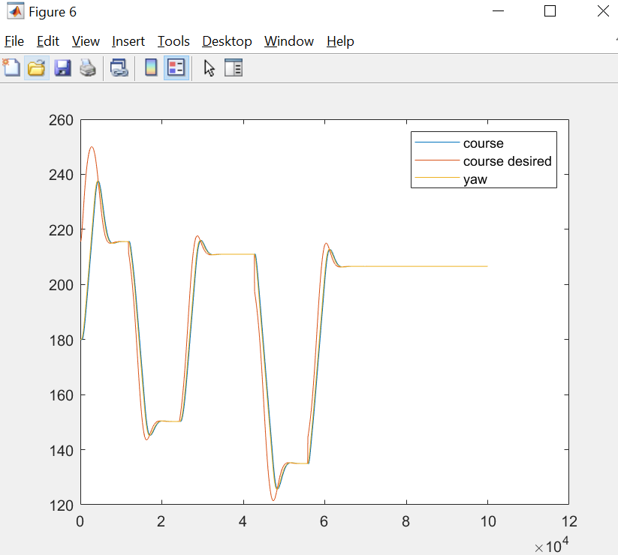

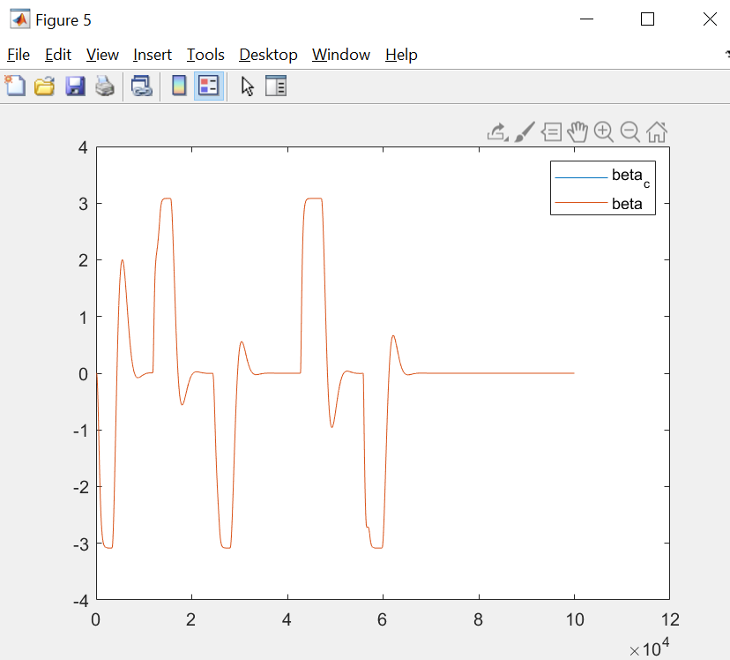
With no current or wind, beta and beta_c are identical.

With no current or wind I would say theres no point in crab-angle compensation. Looking at the plot over desired course and actual course we can see they are more or less identical so the boat tracks well enough.

Task 2b)
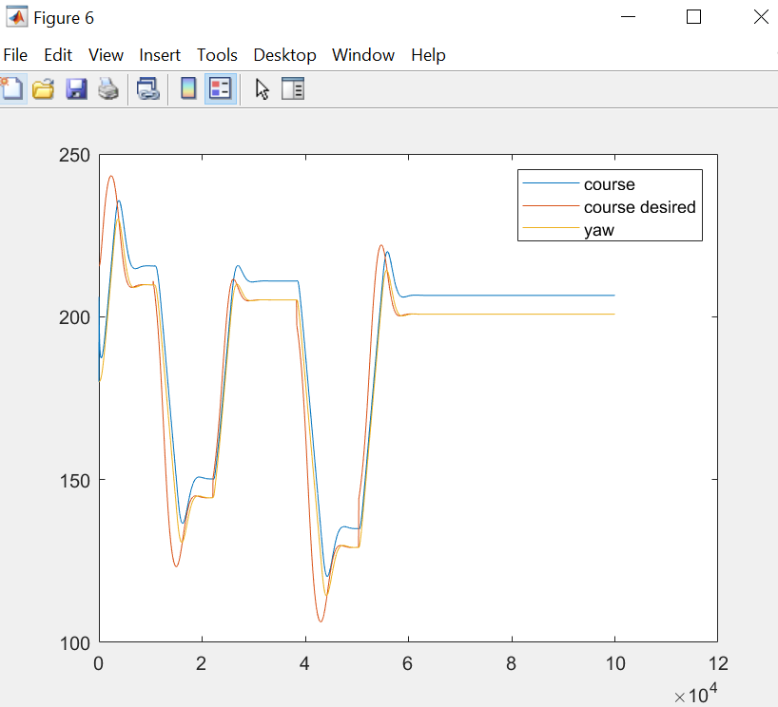
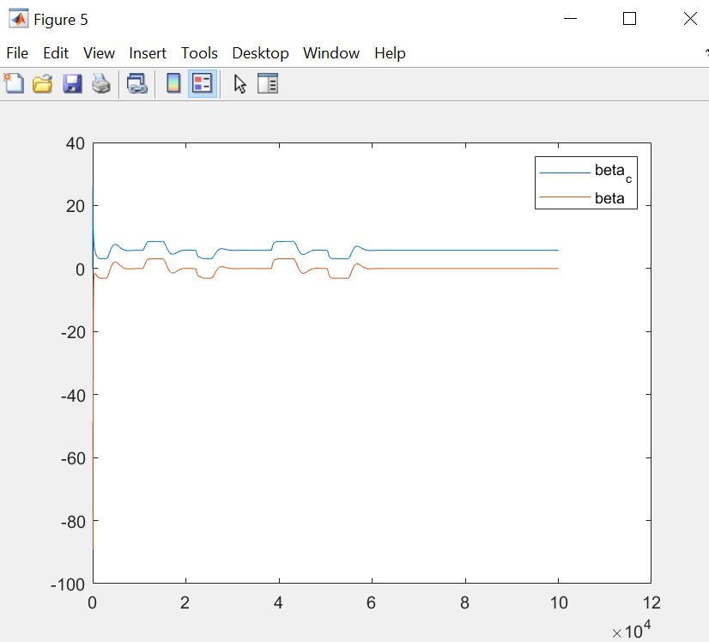

Here we see a larger deviation from the desired course and actual course. Some compensation in the form of crab angle compensation or error-integration would be beneficial here.

Task2c)
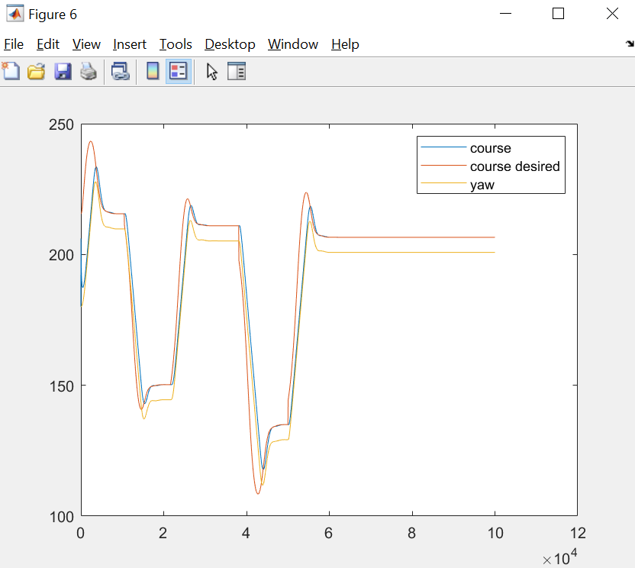
With crab-angle compensation. Its nice again 😊

Task2d)
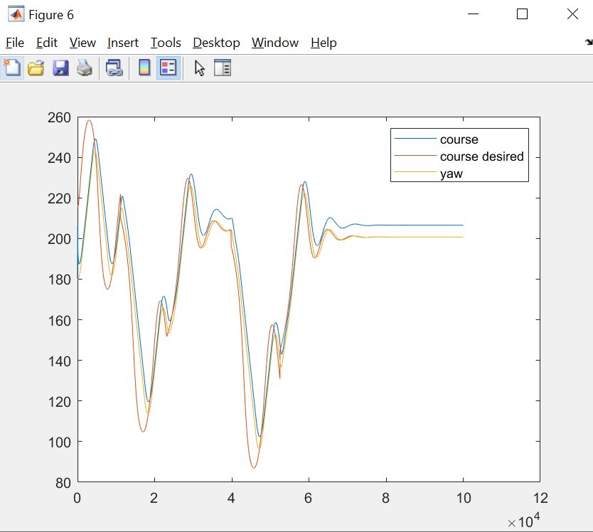
With ILOS. Looks nice, k = 5. Looks better than crab-angle compensation with some better tuning, but it is more dynamics and integral action gives -90 degree phase shift which is normally unwanted. I’d say crab-angle compensation with out small current at least is better. If you add wind and more disturbances, then integral action is generally better.

