Task 1.3:
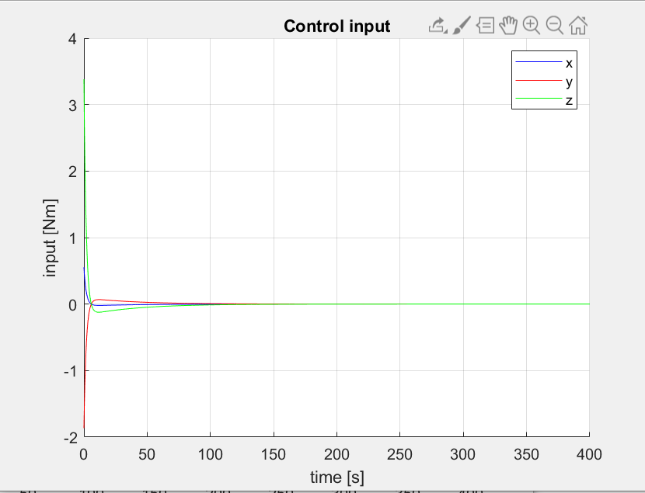
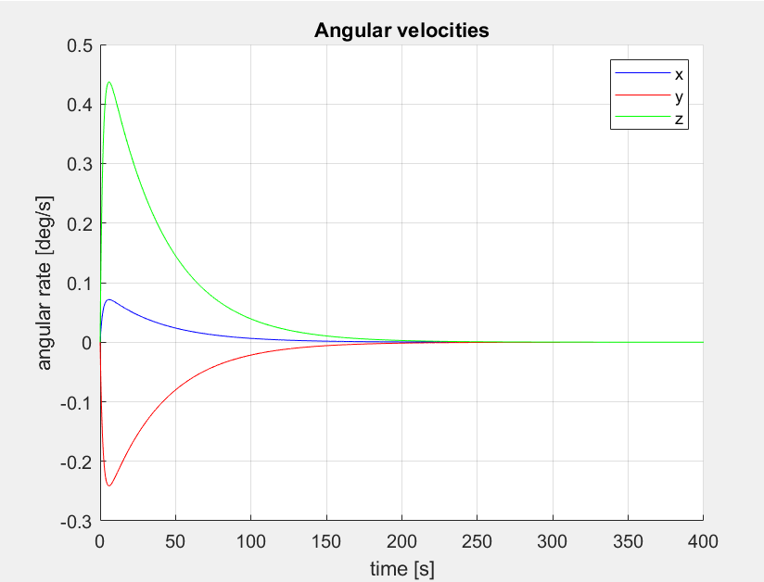
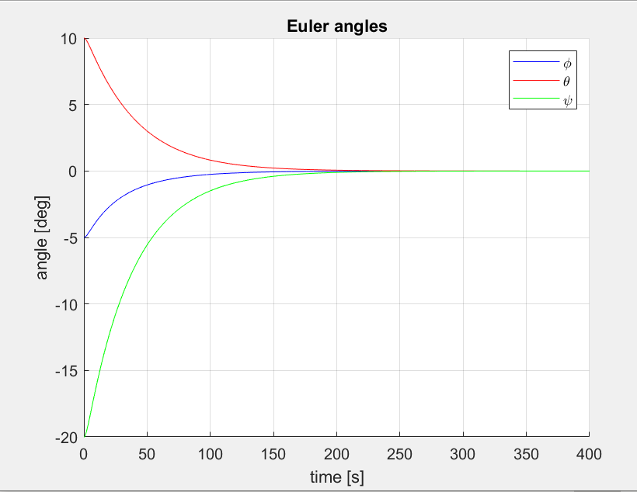

Code:
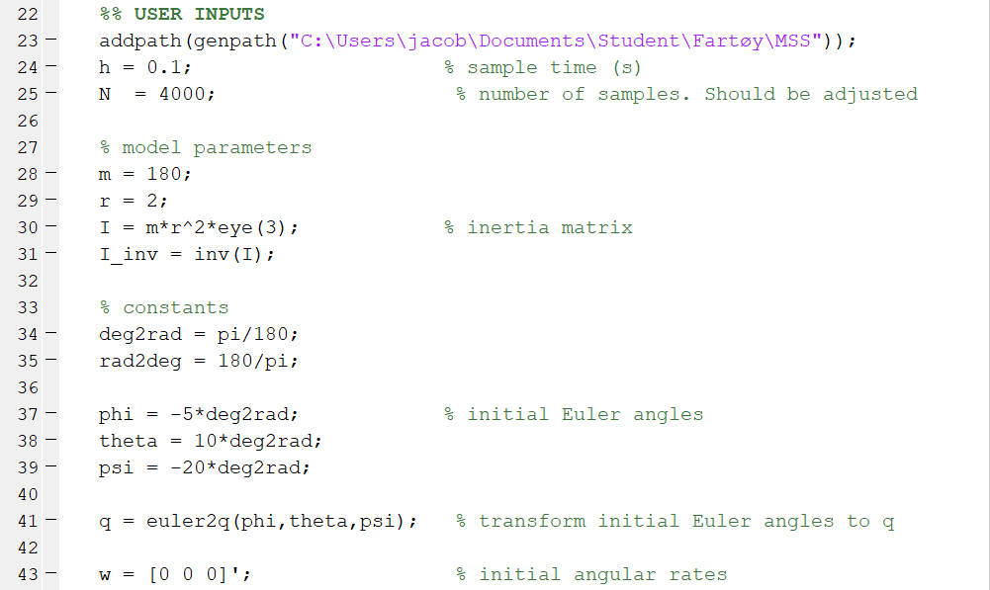
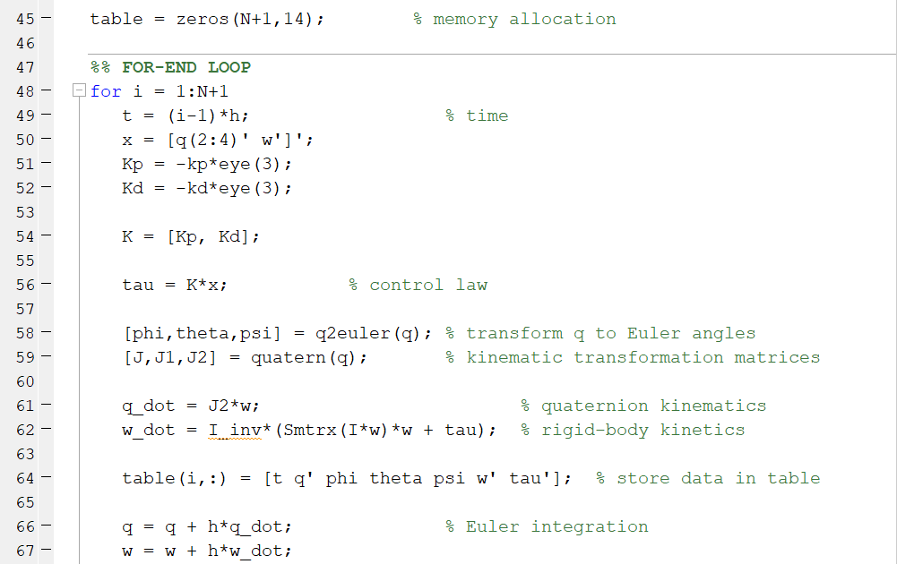
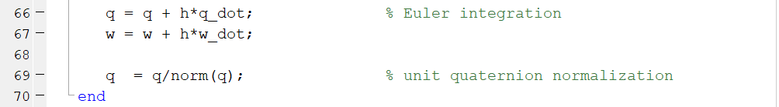

The system-response matches our expectations of such a system with a 0-reference. For a non-zero constant referance we would change the feedback-terms in the control-law to be the difference between the reference-state and the current state.

Task 1.5:

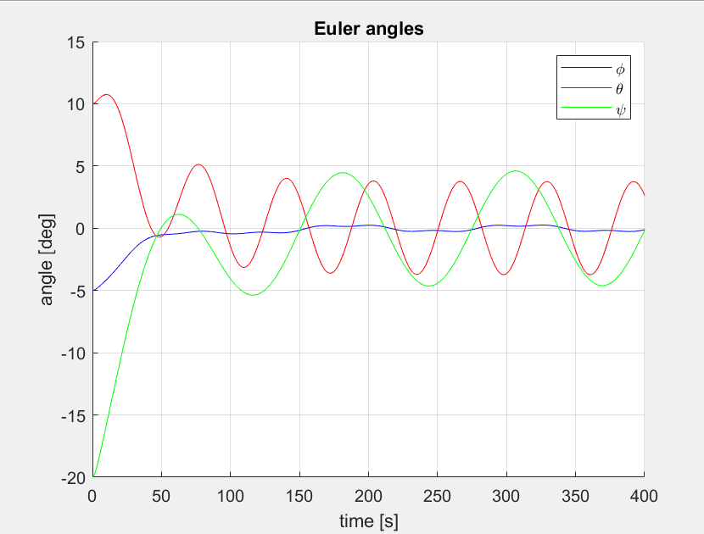
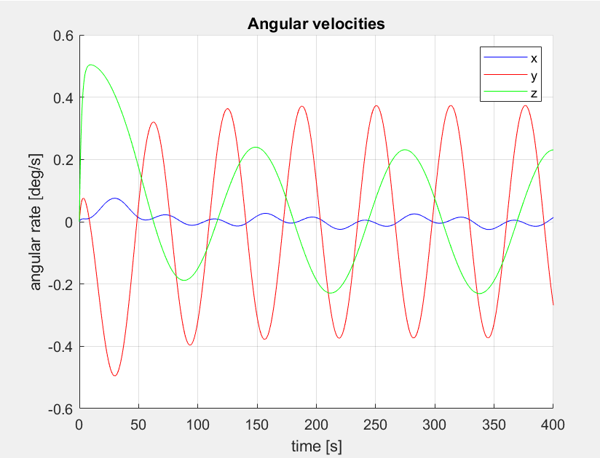
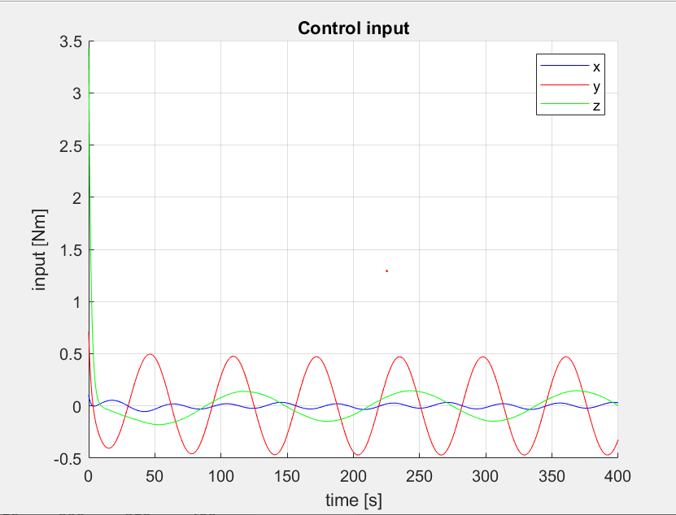
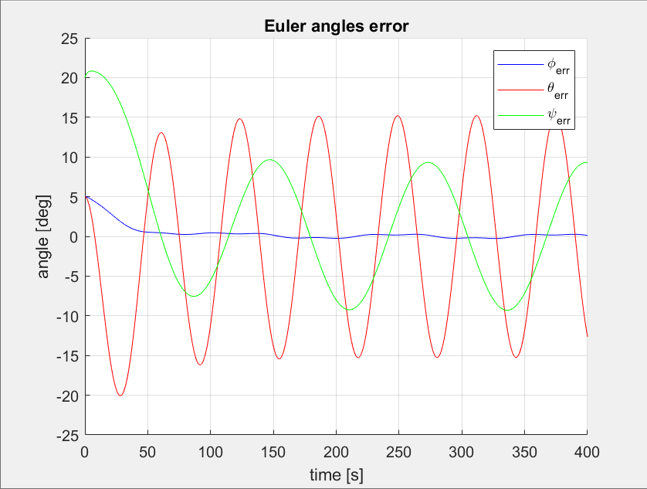
Code:
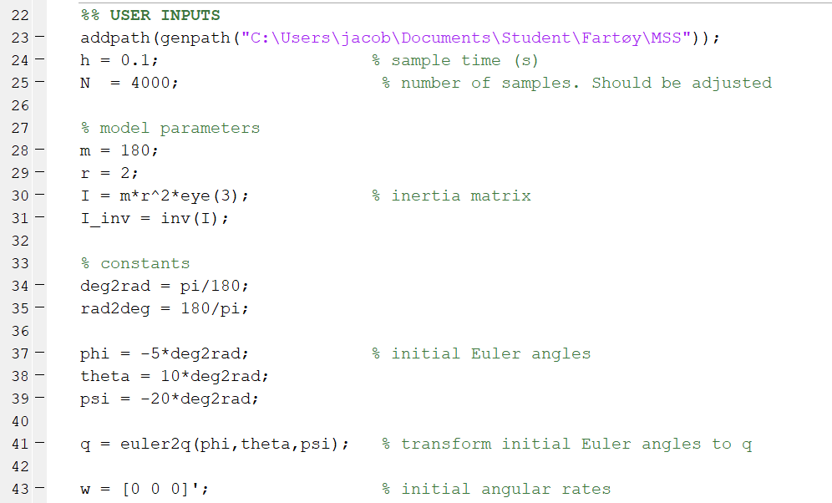
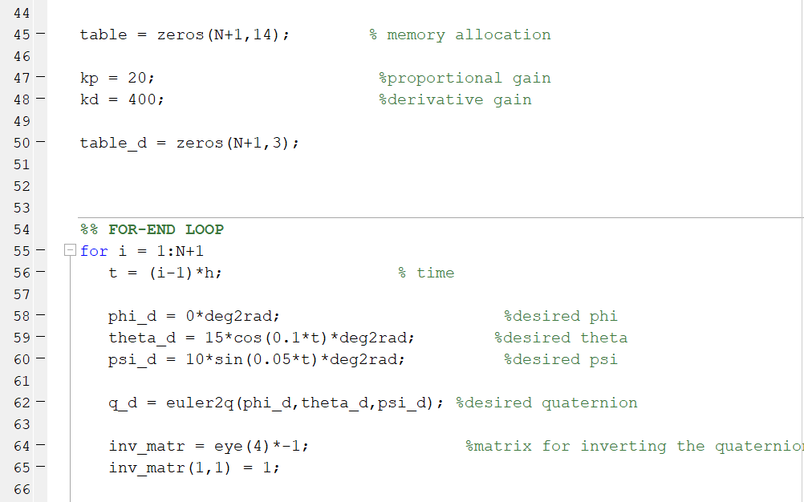
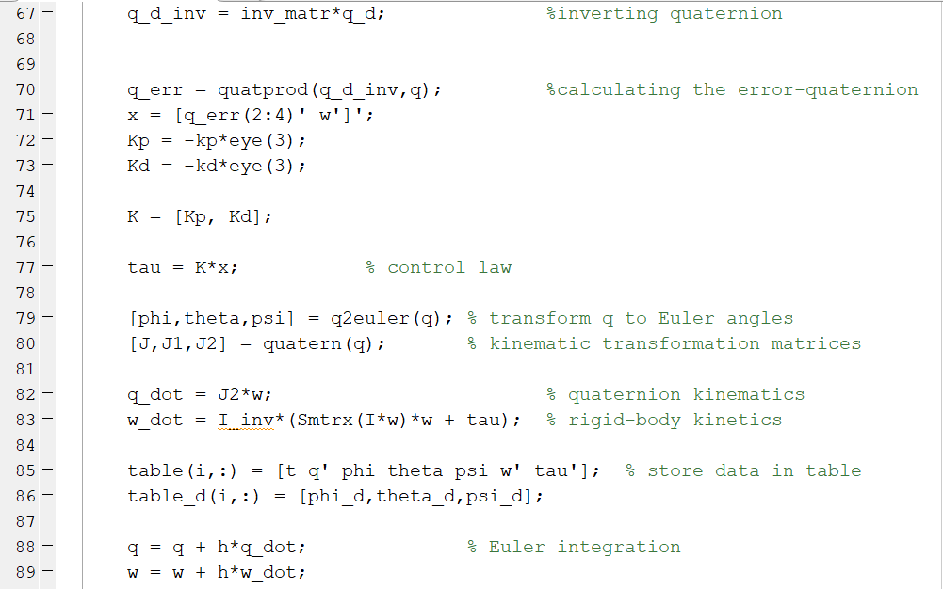
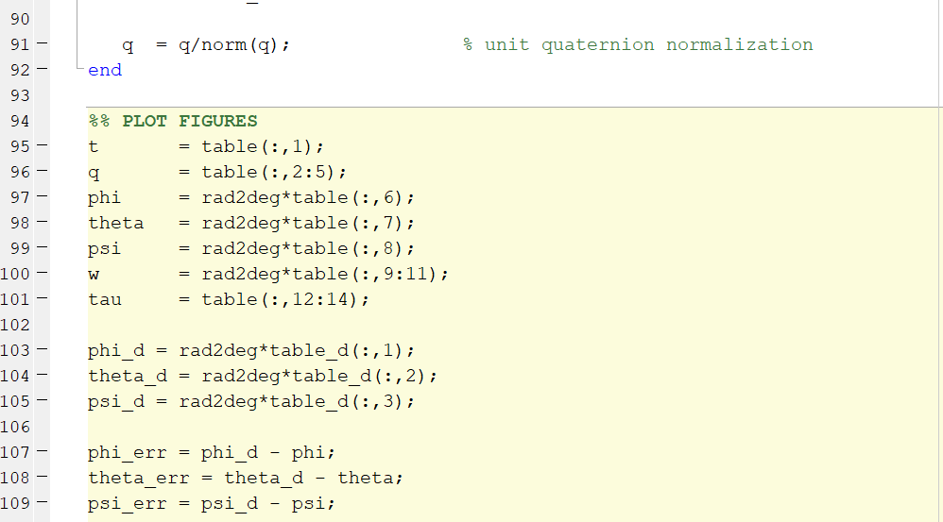
The system response is expected. We have no error-state in the omega so the error is quite large. We see the control input also get a sinusoidal shape which makes sense as we are tracking a sinusoidal reference. Since we switched to quaternions we do not get the issue with a singularity at 90 degrees that we would have had from euler angles, but the simulation shows that no state reaches 90 degrees anyways.

Task 1.6:
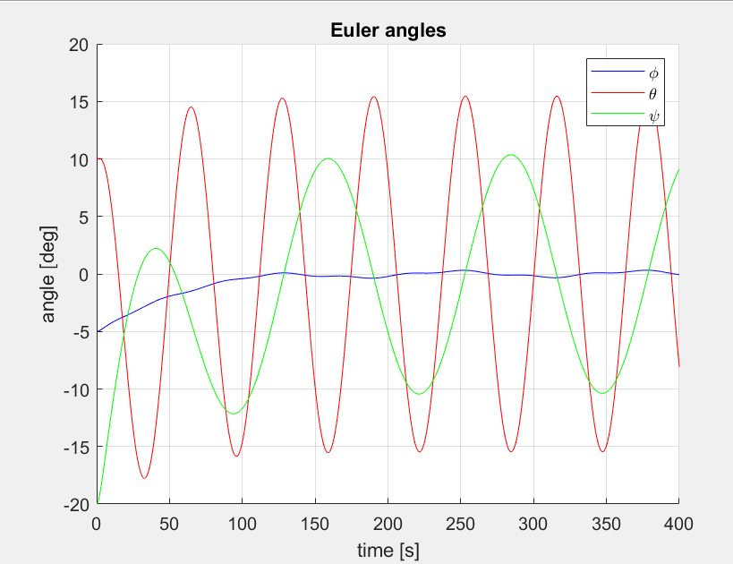
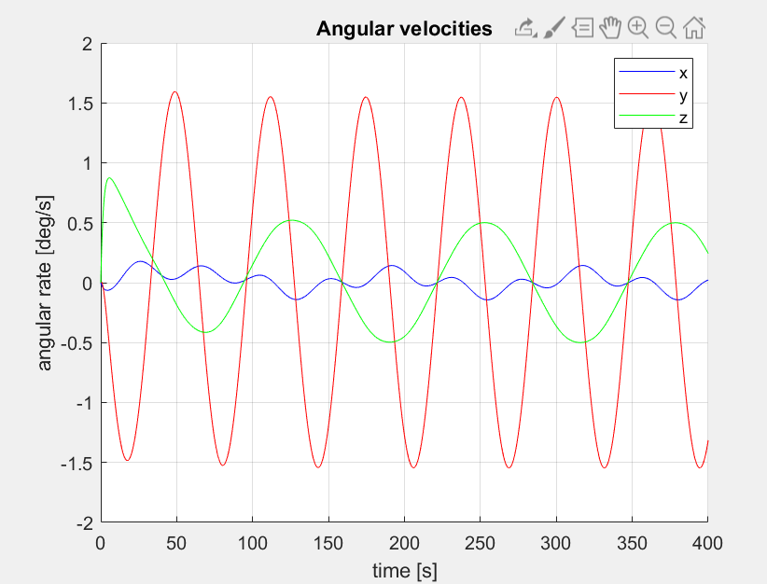
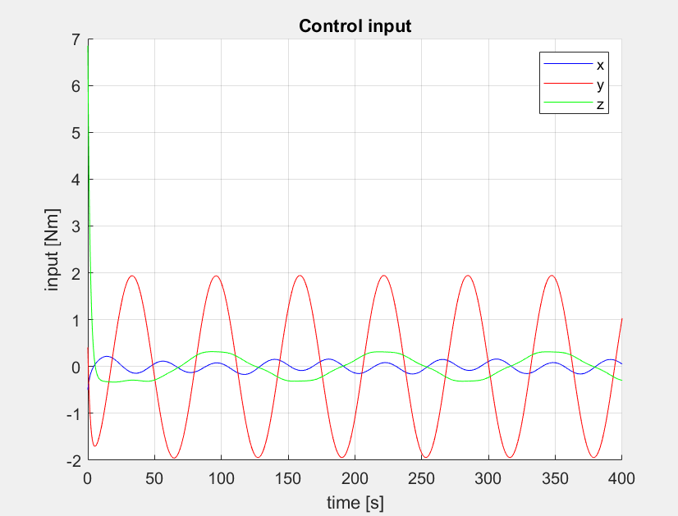
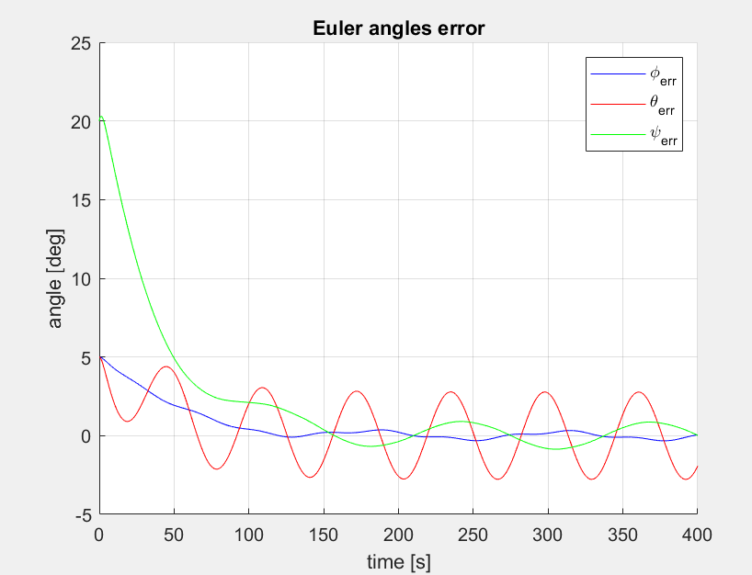
Code:
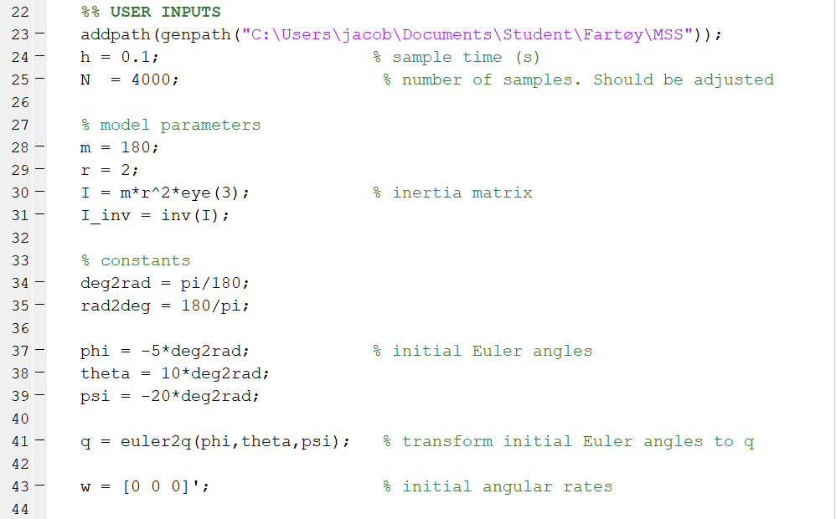
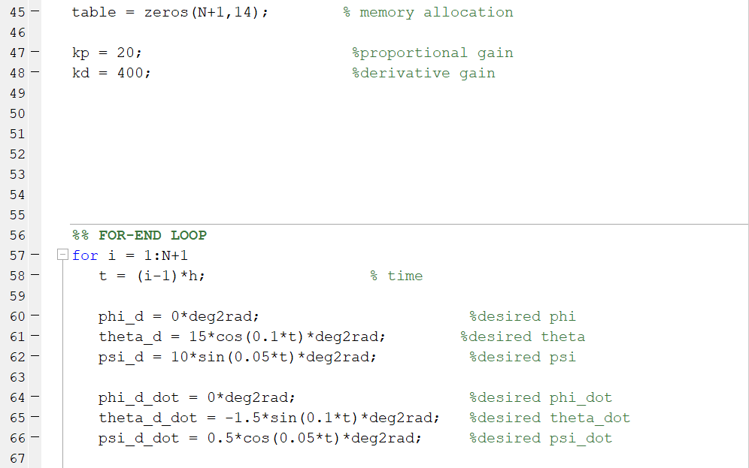
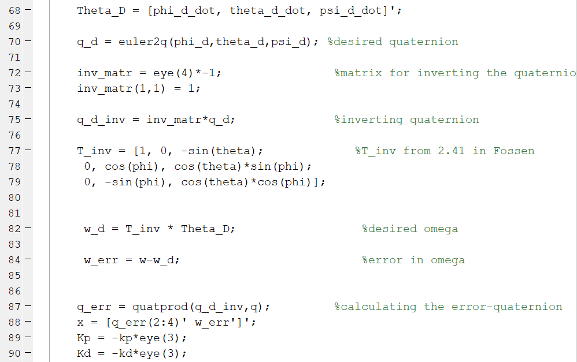
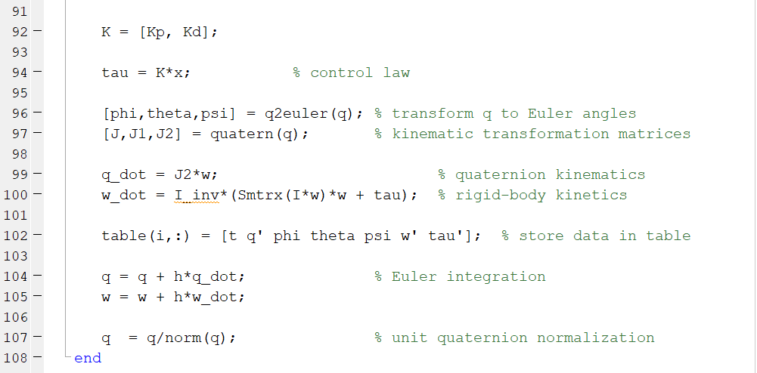

We see that the tracking-error is much lower now that we included the error-term in the omega. Adding integral action is a bad idea with a time-variant reference because of windup. With some anti-windup law it could perhaps improve the system, but as the system is already really slow, more delay with an integral worsens the system.
Since the reference is time-varying we might consider adding gain-scheduling into the control-law to make the response faster and to further reduce the tracking-error.

