There are 3 elements per correction:
- Old – the current version in the revised proof
- New – my correction
- Code – the latex code for making the correction

New Revisions

Page 6
Old: By mistake, I reused q to denote both the dimensionality of the extraneous covariate as well as an element of the variational family. Please add a footnote to Section 2 about this (not that in Code, I have written INSERT REMAINING CODE HERE since I was not sure how ACM does bolding for acronyms, e.g., “Kullback-Leibler (KL) divergence”, and I want to make sure it is consistent throughout the paper):
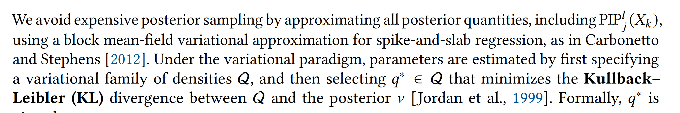
New: 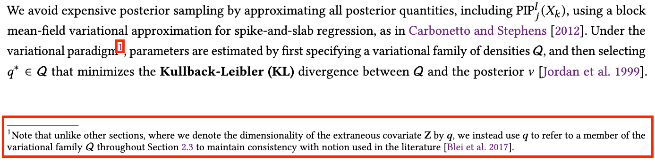
Code: Under the variational paradigm\footnote{Note that unlike other sections, where we denote the dimensionality of the extraneous covariate $\mathbf Z$ by $q$, we instead use $q$ to refer to a member of the variational family $\mathcal Q$ throughout~\cref{VI} to maintain consistency with notion used in the literature~\cite{blei_variational_2017}.}, parameters are estimated <INSERT REMAINING CODE HERE>

Page 16
Old: By mistake, I reused q to denote both the dimensionality of the extraneous covariate as well as an element of the variational family. Please add a sentence to Appendix B.1 about this: 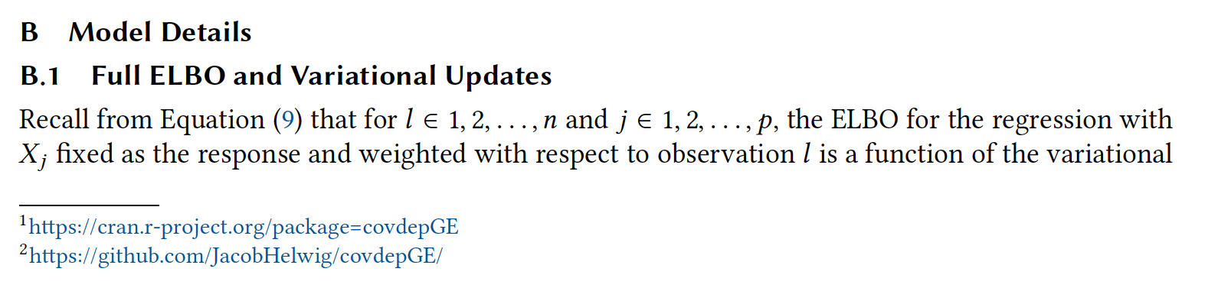
New: 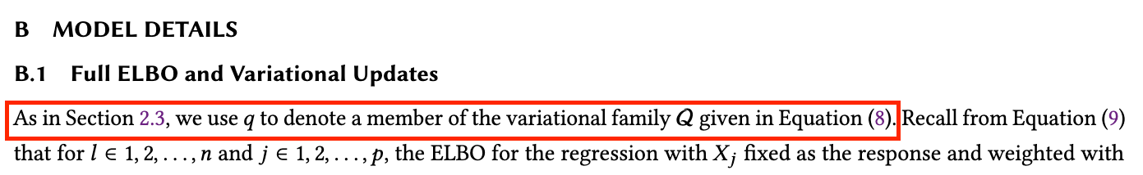
Code:
As in~\cref{VI}, we use $q$ to denote a member of the variational family $\mathcal Q$ given in~\cref{sns_Q}.

Page 1
Please delete the second in which I accidentally added, crossed out below:
Revision: Graphical models are used to capture complex multivariate relationships and have applications in diverse disciplines such as in biology, physics, and economics.

Page 3
Please correct the grammar error I made by changing differing to different:
Revision: In Section 3, we perform a thorough simulation study, studying differing different hyperparameter specification strategies,…

Page 5
Old:
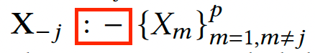
New:
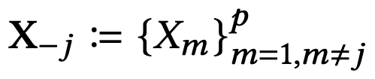
Code:
Use \usepackage{mathtools}
$ \coloneq$
Old: I accidentally used the same notation for L2 norm as for likelihood function in Equation 3:
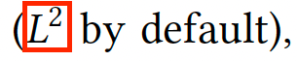
New:
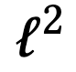
Code: $\ell^2$

Page 6
Old: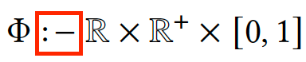
New: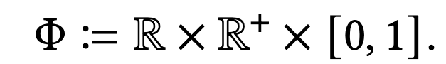
Code:
\usepackage{mathtools}
$ \coloneq$
Page 9
Old:
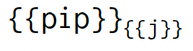
New:

Code:
$\texttt{pip}_\texttt{j}$

Page 10
Old:
Note: Please check that there is not a double space here.
Old:

Note: Please check that there is not a double space here.

Page 11
Old:
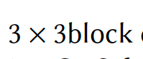
New:
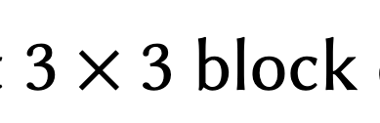

Code:
$3\times3$ block

Page 16
Old:
New:
Code: Later versions ($>$1.0.1) of \texttt{covdepGE} will be made available on CRAN\footnote{\url{https://cran.r-project.org/package=covdepGE}} and GitHub\footnote{\url{https://github.com/JacobHelwig/covdepGE/}}.

Page 17
Old:New:
Code:
Notation

Page 20
Old: 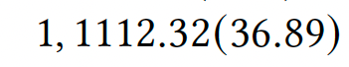
Revision: 11,112.32

Page 21
Old: 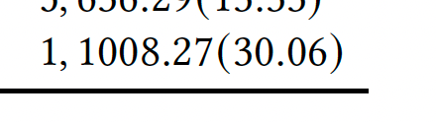
Revision: 11,008.27

Page 22
Old: 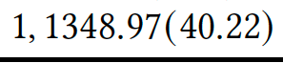
Revision: 11,348.97

Page 27
Old: 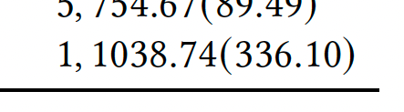
Revision: 11,038.74

