Thoughts:
- The number of speakers for and against the proposal is a great predictor of how controversial the project is. Likewise the length of the documents also corresponds to how controversial or how much work goes in to the project
- There are a lot of very simple projects that aren’t controversial. It’s important that we have a way to sift through those. This is especially true over time, lots more simple proejcts back in the day
- Surprisingly, the council member is rarely mentioned—maybe because their role comes in slightly later. But we will definitely want to have the voting records as well
- Affordable, elderly seems to make projects less controversial
- A lot of concerns seem to already be baked into the proposal by the time it hits the application stage. It’s rare to see something in the process that is doomed to fail. The BP and CB almost always support the project.
- If there was a transition period, we would expect there to be more controversy then as in more applications failing as norms change.
- Puzzle: why does opposition rise in the 2000s? Why doesn’t it rise before hand? Noone sees the planning process as a way to influence how government works before hand? Things were just not being built prior to the 2000s
Research Questions:
- How does the institutional setting affect the influence of NIMBYs?
- When did NiMBY concerns become an issue/start influencing the city government?
s

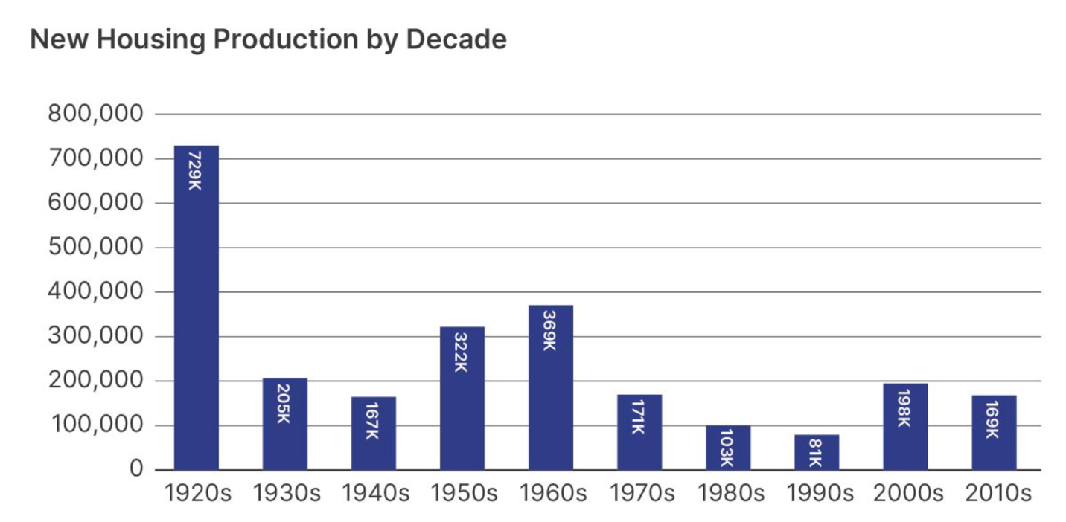

Notes to Resolve:
Tracking the number of speakers at each hearing in support and opposition would be cool
T003 Southeast Annadale Rezoning
This is a downzoning so the LLM might get confused over whether a concern about density is in support or opposition of the project.
T004 The Gardens At Forest Hills
If the local seeks rejection, does that count as being a concession?
Opponents did not ask for specific revision, just rejection. Coded request condition as 0.
Coded infrastructure services as being a concern because they were upset with plumbing issues.
City planning did add a number of conditions to this project but not in direct response to what locals had said.

A couple points of confusion:
- I undercounted mention of issue areas because I interpreted the question as being whether locals were concerned with those issues and not just whether those issues were mentioned in the report. I think it makes sense to code the conditions as you did and still flag them even if opposition did not raise the points exactly.
- I was sort of unwilling to classify pretty minor conditions as evidence of opposition from the borough president or community board. As an example, consider the 77Th St Boarding Home. The conditions added were:
- For a three year period, the property should be maintained in an attractive manner
- Health and social services should make regular visits to the site.
The borough president went along with these conditions. In my opinion these are pretty minor and shouldn’t lead to the coding of opposition from either the community board or borough president. Obviously, this creates a judgement call.
This also led us to code local_request_condition differently. Any time there was no verbal opposition at a hearing, I said there was not a local_request_condition where it seems like you did in this case because of the conditions.
- I called park housing an upzone because it was associated with the construction of increased density—upzone isn’t quite the right word here but seems like it should still be coded as a pro-development project.

