Information Retrieval CW
100389703

INTRODUCTION
The following will outline my system for Information Retrieval pertaining to a Video Game website. Although the website tested with was specialized, the system was built to be domain independent and would work just as well elsewhere.
I conducted, and allow the user to conduct experiments, such as whether to lemmatize, stem or neither, query expansion, spell checking and various methods of improving the time to index such as asyncIO, multiprocessing and multithreading.

OUTLINE OF THE SYSTEM

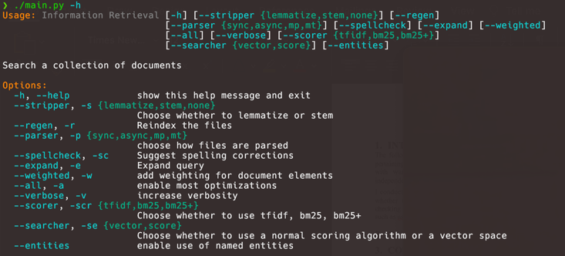
Figure 1 - Command Line Options
I will walk through a short summary of how the system works.
On startup, the user can provide command line options that dictate how the system operates. Notable flags include -v, which provides more information to the user as the system runs such as logging and function timing, --searcher, which allows the user to select whether to use the vector space model for searching or a naive total token score method (bag of words), -r which reindexes the documents and a few other options for improving search results.
The user is also provided with a few methods of indexing the documents, either async, multithreaded, multi-processed or synchronous. In experimentation I found multiprocessing parsed the documents the fasted, implying the parsing is in fact not IO bound but bound by processing power.
Table 1 - Parse time
Parser | Average time
Sync | 30.7s
Async | 29.7s
MP | 24.2s
MT | 57.6s
The parsing generates a modified Inverted Index that is then pickled, allowing for faster startup times. On startup or after parsing, the Inverted Index is used to create a vector space and document matrix, used for vector space searching.
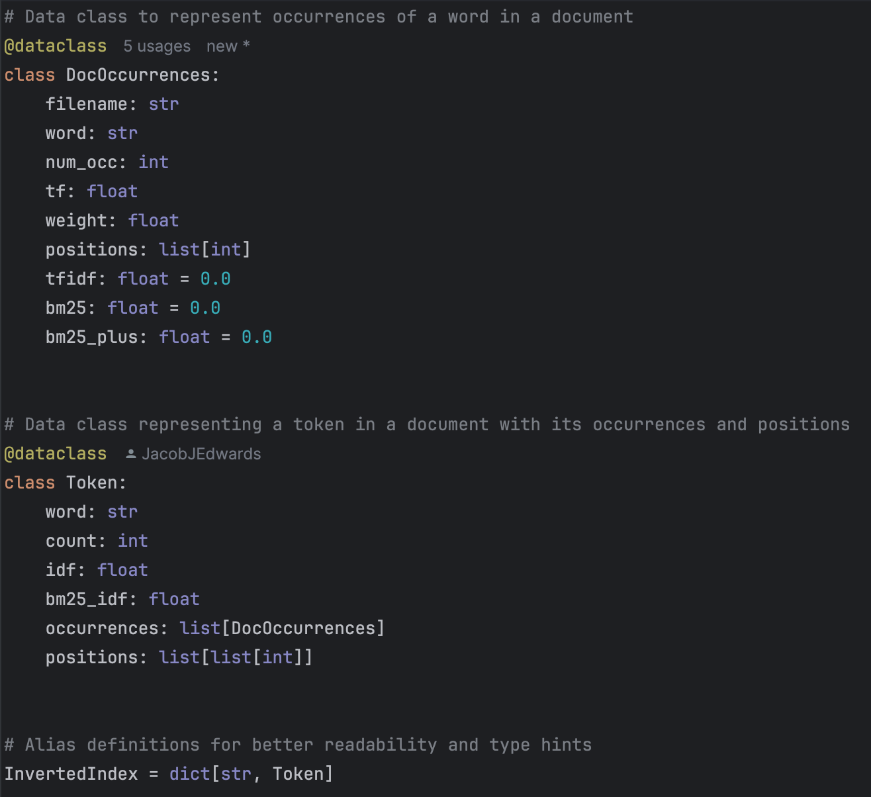
Figure 2 - Modified Inverted Index Types
The modifications I chose to make to a standard inverted index include pre-calculating what I can about term frequency and IDF, as well as providing other information used elsewhere. I found that this made it easier extract information when needed during searching, without requiring recalculation.
User queries are preprocessed in the same way as documents, and are in fact treated identical to a document, which is essential for any vector space calculations.
Lots of functions also make use of caching, particularly those to do with searching such as cosine similarity calculations, improving search times for the user.

CORE EXPERIMENTS

Query Expansion
The user has the option of using query expansion on their queries, which finds synonyms of each token in the query and adds them to the query. This increases the accuracy of results, as the user query does not have to exactly match tokens in a document for a document to be similar.
If the user has the weighting option enabled, the synonyms are given a weight of 0.3, compared to their terms which are given a weight of 1.0. This has also shown to provide more effective results closer to the user’s query, while still gaining the advantages listed above.
This is implemented using NLTK’s WordNet module, which contains a thesaurus. I did consider generating the thesaurus based on the documents (as a document is likely to contain similar terms, so an expanded query could expand the tokens based on the document tokens) but decided using a premade thesaurus would be more effective to maintain domain independence.

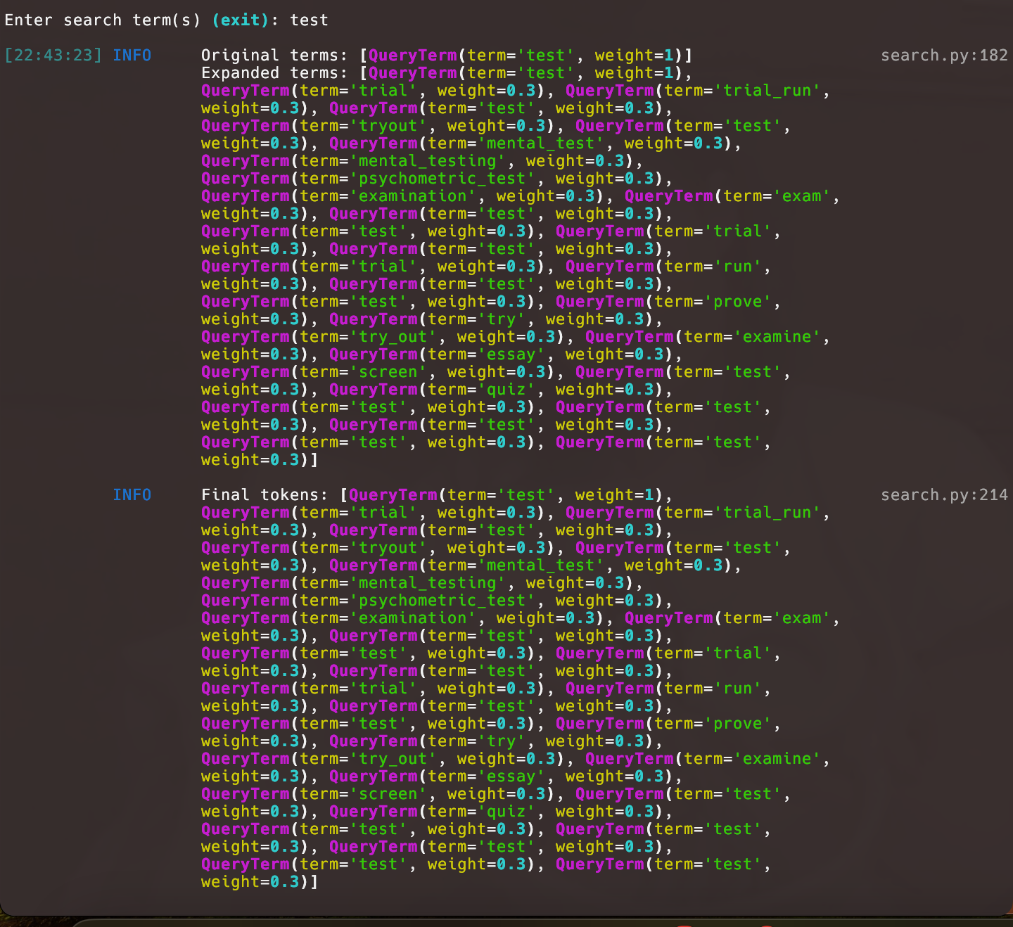
Figure 3 - Expanded Query

Lemmatization and Stemming
The user has the option to lemmatize, stem or leave the tokens as is.
During experimentation, I found lemmatization to be the most effective for this purpose as tries to preserve meaning, which means that games, gaming, and game will all become the same word. This means the user has more freedom when searching. However, it also takes the longest amount of time to parse the documents, which isn’t necessarily a bad thing for the user as they only need to parse the documents once, and their queries take very little time to parse as generally a user would enter small queries compared to the length of documents.

Spell Correction
Spell correction is implemented (but disabled by default) using the Levenshtein Distance formula to compare each query term with each token in the corpus. If the closest match is not the original query term, then the user is prompted a maximum of 3 times with potential corrections.

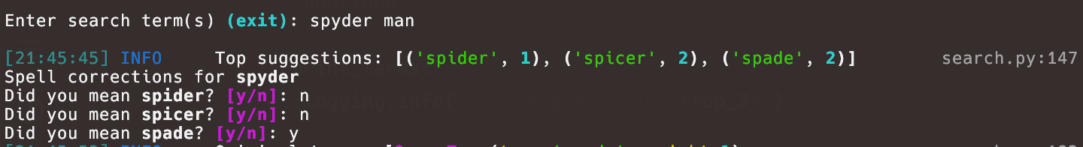
Figure 4 - Spell Correction
Original I used SymSpell.py with a dictionary but moved to my own implementation using only the corpus terms to provide more relevant corrections to the user (relevant to the domain of the system).
I would say this doesn’t directly improve the returned results but does improve the user experience. What could instead be done is implicit corrections, where the query term is replaced with the term in the corpus with the lowest distance from it, which will either be the term itself (if it exists in the corpus) or hopefully a correctly spelt term.
One thing I initially struggled with was because all the terms in the corpus had either been lemmatized or stemmed (depending on the options given), some correct words were given corrections. I fixed this issue by calculating the distances with a lemmatized or stemmed version of the term.

Scoring Methods
I experimented with and allowed the user to experiment with various scoring methods. These include TF-IDF, BM25, BM25+ and BM25F (which will be discussed in section 3.6).
Through experimentation I found that BM25+ outshines the other options as it considers more factors such as average document word count. Additionally, it uses alpha and k values to finetune the results. In a larger system, it would be worth tuning these based on the corpus, but when indexing a small number of documents assigning default values appears to be fine.
Interestingly, sometimes simple TF-IDF performed better than BM25 or BM25+, such as the search “Iron Man”. All methods retrieved the correct top result (iron man game), but TF-IDF also retrieved similar games such as Spider Man, whereas BM retrieved games seemingly unrelated (after iron man).

Vectorization
As an alternative to the bag of words model, where I just add up the score for each token in the query for each document, the user also has the option of using a vector space model to compare documents using cosine similarity. This treats the query and each document as a vector mapping terms to their scores.
I parse the inverted index into this model on startup based on the scoring method the user selects.
Based on experimentation, this model provides more accurate results as it selects similar documents to the query, as opposed to documents that just contain the query terms the most.
Both models, due to the scoring techniques, consider factors such as document length, but due to the normalization of the vectors in this model it does it more effectively, irrespective of scoring.
I used NumPy’s. ndarrays to store the vectors, but hand wrote the dot product and vector normalization functions so that I could take advantage of my own caching methods.

Weighting
The user also has the option of adding weighting for elements based on the type of HTML element they appear in in their document. This weight is then multiplied with the score (i.e. TF-IDF, BM25) to increase the weight for more important elements such as titles or H1’s.
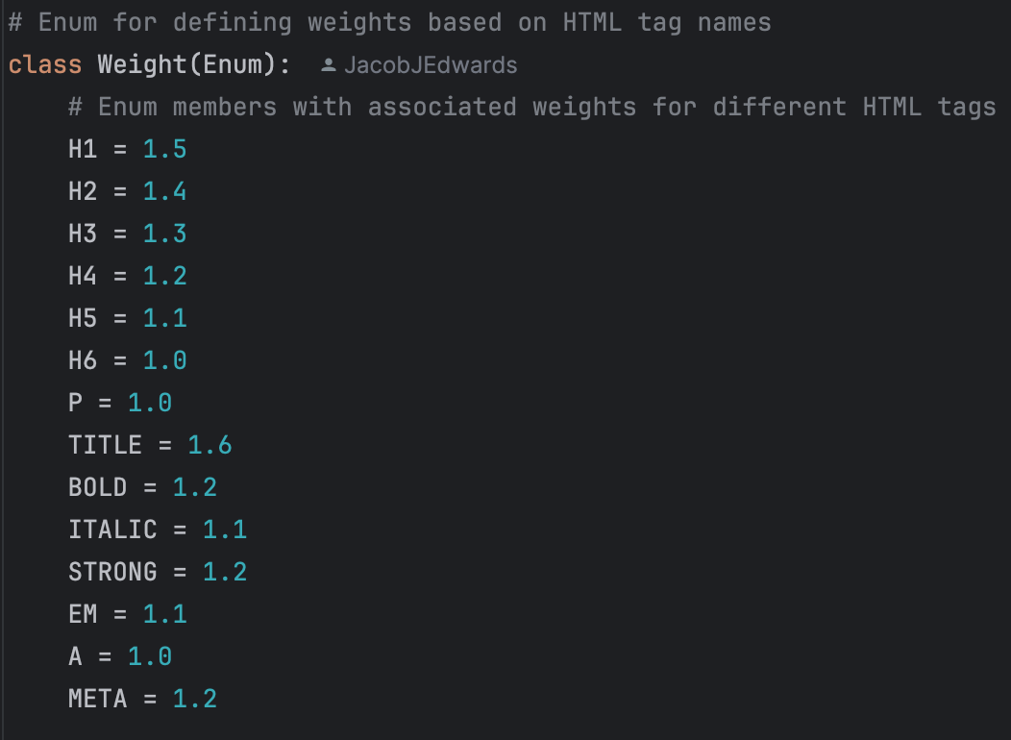
Figure 5 - Element Weighting
I experimented throughout with the weighting associated with each element and found this resulted in the most meaningful results.
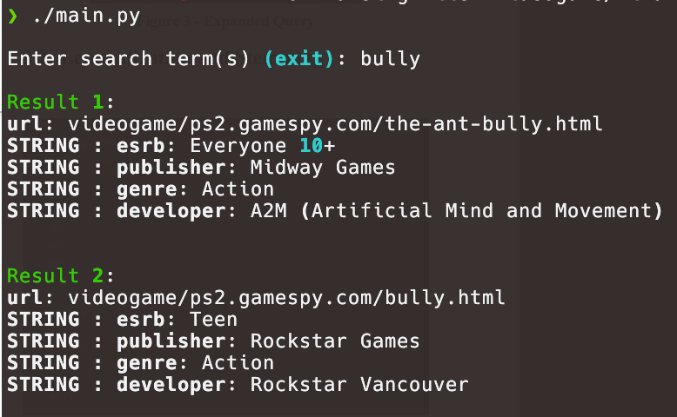
Figure 6 - Search without Weight
. 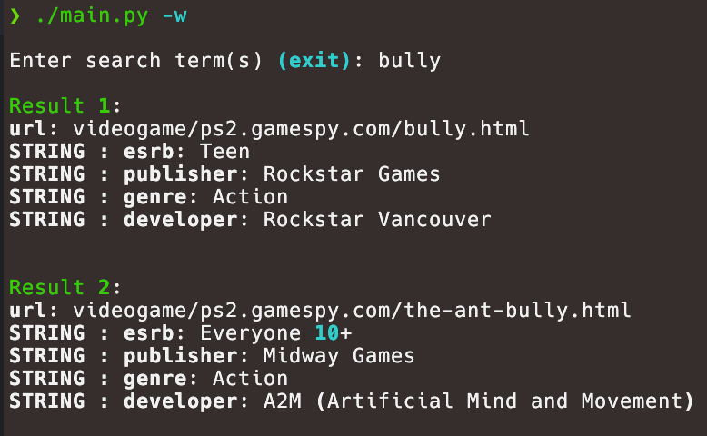
Figure 7 - Search with Weight

ACKNOWLEDGMENTS
Thanks to ACM SIGCHI for allowing us to modify templates they had developed and thank you to Liza and Mohammed for the support.

REFERENCES
- Bowman, B., Debray, S. K., and Peterson, L. L. Reasoning about naming systems. ACM Trans. Program. Lang. Syst., 15, 5 (Nov. 1993), 795-825.
- Ding, W., and Marchionini, G. A Study on Video Browsing Strategies. Technical Report UMIACS-TR-97-40, University of Maryland, College Park, MD, 1997.
- Fröhlich, B. and Plate, J. The cubic mouse: a new device for three-dimensional iput. In Proceedings of the SIGCHI conference on Human factors in computing systems
(CHI ’00) (The Hague, The Netherlands, April 1-6, 2000). ACM Press, New York, NY, 2000, 526-531.
- Lamport, L. LaTeX User’s Guide and Document Reference Manual. Addison-Wesley, Reading, MA, 1986.
- Sannella, M. J. Constraint Satisfaction and Debugging for Interactive User Interfaces. Ph.D. Thesis, University of Washington, Seattle, WA, 1994.

