Information Retrieval System

Student number

# INTRODUCTION

The following will outline my system for Information Retrieval pertaining to a Video Game website. Although the website tested with was specialized, the system was built to be domain independent and would work just as well elsewhere.

I conducted, and allow the user to conduct experiments, such as whether to lemmatize, stem or neither, query expansion, spell checking and various methods of improving the time to index such as asyncIO, multiprocessing and multithreading.

# OUTLINE OF THE SYSTEM

# CORE EXPERIMENTS

## Query Expansion

## Lemmatization and Stemming

## Spell Correction

Table 1. Table captions should be placed above the table

|  |  |  |  |
| --- | --- | --- | --- |
| **Graphics** | **Top** | **In-between** | **Bottom** |
| Tables | End | Last | First |
| Figures | Good | Similar | Very well |

## Scoring Methods

## Vectorization

## Weighting

# FIGURES/CAPTIONS

Place Tables/Figures/Images in text as close to the reference as possible (see Figure 1). It may extend across both columns to a maximum width of 17.78 cm (7”).

Captions should be Times New Roman 9-point bold. They should be numbered (e.g., “Table 1” or “Figure 2”), please note that the word for Table and Figure are spelled out. Figure’s captions should be centered beneath the image or picture, and Table captions should be centered above the table body.

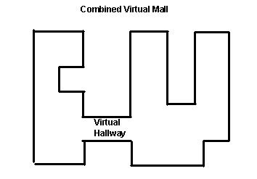

Figure 1. Insert caption to place caption below figure.

.

# SECTIONS

## Subsections

# ACKNOWLEDGMENTS

Our thanks to ACM SIGCHI for allowing us to modify templates they had developed.

# REFERENCES

1. Bowman, B., Debray, S. K., and Peterson, L. L. Reasoning about naming systems. *ACM Trans. Program. Lang. Syst., 15,* 5 (Nov. 1993), 795-825.
2. Ding, W., and Marchionini, G. *A Study on Video Browsing Strategies.* Technical Report UMIACS-TR-97-40, University of Maryland, College Park, MD, 1997.
3. Fröhlich, B. and Plate, J. The cubic mouse: a new device for three-dimensional iput. In *Proceedings of the SIGCHI conference on Human factors in computing systems   
   (CHI ’00)* (The Hague, The Netherlands, April 1-6, 2000). ACM Press, New York, NY, 2000, 526-531.
4. Lamport, L. *LaTeX User’s Guide and Document Reference Manual.* Addison-Wesley, Reading, MA, 1986.
5. Sannella, M. J. *Constraint Satisfaction and Debugging for Interactive User Interfaces.* Ph.D. Thesis, University of Washington, Seattle, WA, 1994.