**Design**

**Document**

*TalkBox Simulator/Configuration*

**Group 5:**

Sangheon Jae

Karmit Patel

Peter Saleeb

Apr 2019

**DESIGN DOCUMENT**

**TABLE OF CONTENTS**

Page #

A. GENERAL INFORMATION A-1

1.1 Design Goal A-1

B. UML DIAGRAMS B-1

2.1 UML Class Diagram B-1

2.2 UML Sequence Diagram B-2

C. TABLE OF MODULES C-1

3.1 Model C-1

3.2 View C-1

3.3 Controller C-1

D. SUMMARY OF TESTING PROCEDURES C-1

4.1 JUnit Tests Result D-1

**1.0 GENERAL INFORMATION**

# GENERAL INFORMATION

## 1.1 Design Goal

The development for this project will follow information hiding (by not letting users to access the private attributes in class), modularity (based on performance, classes will be separated by their features). Also, project will be developed with following design principle. Each module will follow single responsibility principle by letting each module is responsible for their own act. During the development, several Junit test cases will be used for regression testing. With the help of ‘gradle’ project will be easily tested to help with continuous development.

**2.0 GETTING STARTED**

# UML DIAGRAMS

## 2.1 UML Class Diagram

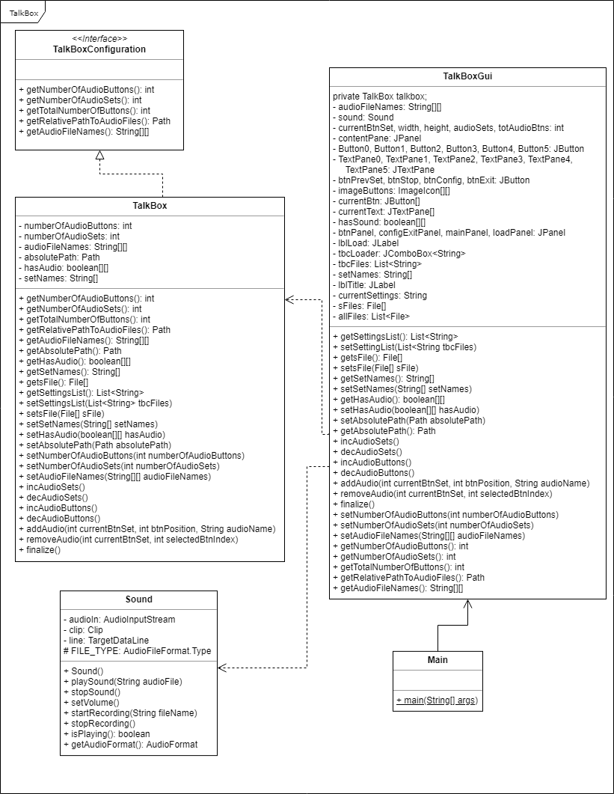

## 2.2 UML Sequence Diagram

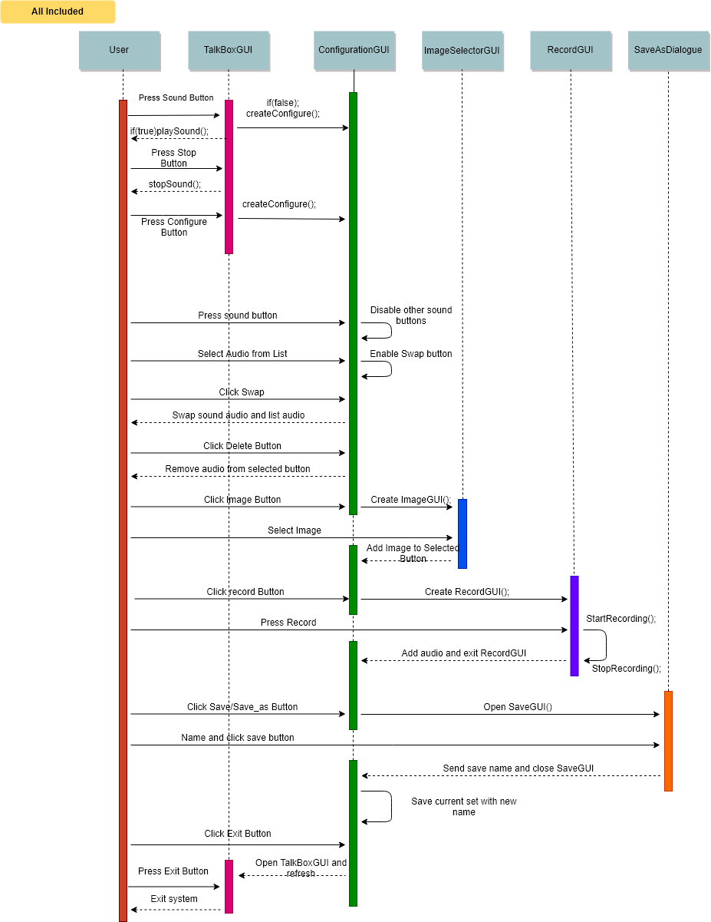

**3.0 TALKBOX SIMULATOR**

# TABLE OF MODULES

## 3.1 Model

|  |  |  |  |
| --- | --- | --- | --- |
| 1 | TALKBOXCONFIGURATION | **Responsibility**: a basic template for serializable object ‘TalkBox’. It has several methods that allow object attributes to change | **Alternative**: see TALKBOX |
| Abstract | **Secret**: none |

|  |  |  |  |
| --- | --- | --- | --- |
| 1.1 | TALKBOX | **Responsibility**: concrete implementation for ‘TalkBoxConfiguration’, it will have more methods that helps original methods to work efficiently | **Alternative**: see TALKBOXCONFIGURATION |
| Concrete | **Secret**: every attributes are ‘private’ so user can not access directly |

|  |  |  |  |
| --- | --- | --- | --- |
| 2 | SOUND | **Responsibility**: controls every feature that associate with sound | **Alternative**: none |
| Concrete | **Secret**: audio clip |

|  |  |  |  |
| --- | --- | --- | --- |
| 3 | CHECK | **Responsibility**: contains methods that return true/false based on their file type | **Alternative**: none |
| Concrete | **Secret**: none |

## 3.2 View

|  |  |  |  |
| --- | --- | --- | --- |
| 1 | TALKBOXGUI | **Responsibility**: started app for TalkBox, this app lets user to control the app with the GUI | **Alternative**: none |
| Concrete | **Secret**: none |

|  |  |  |  |
| --- | --- | --- | --- |
| 2 | CONFIGURATIONGUI | **Responsibility**: configuration app for TalkBox, this app lets user to control the app with the GUI | **Alternative**: none |
| Concrete | **Secret**: none |

|  |  |  |  |
| --- | --- | --- | --- |
| 3 | RECORDGUI | **Responsibility**: allow users to record audio file with GUI | **Alternative**: none |
| Concrete | **Secret**: none |

## 3.3 Controller

|  |  |  |  |
| --- | --- | --- | --- |
| 1 | MAIN | **Responsibility**: start TalkBoxGUI and logger | **Alternative**: none |
| Concrete | **Secret**: none |

**4.0 SUMMARY OF TESTING PROCEDURES**

# SUMMARY OF TESTING PROCEDURES

## 4.1 JUnit Tests Result

|  |  |  |
| --- | --- | --- |
| **Test file** | **Description** | **Passed** |
| SoundTest | testTrue() | ✓ |
| SoundTest | test() | ✓ |
| SoundTest | testExpectedExceptionFail() | ✓ |
| TalkBoxTest | AddAudio_test() | ✓ |
| TalkBoxTest | setNumberOfAudioSets_test() | ✓ |
| TalkBoxTest | setAndGetHasAudio_test() | ✓ |
| TalkBoxTest | RemoveAudio_test2_All() | ✓ |
| TalkBoxTest | setAudioFileNames_test2() | ✓ |
| TalkBoxTest | getNumberOfAudioButtons_test() | ✓ |
| TalkBoxTest | getRelativePathToAudioFiles_test() | ✓ |
| TalkBoxTest | setAndGetFile_test() | ✓ |
| TalkBoxTest | setAndGetImages_test() | ✓ |
| TalkBoxTest | setAndGetSetNames_test() | ✓ |
| TalkBoxTest | getTotalNumberOfButtons_test() | ✓ |
| TalkBoxTest | NumberOfAudioSets_increase_test() | ✓ |
| TalkBoxTest | NumberOfAudioButtons_increase_test() | ✓ |
| TalkBoxTest | NumberOfAudioSets_decrease_test() | ✓ |
| TalkBoxTest | setAndGetSettingsList_test() | ✓ |
| TalkBoxTest | NumberOfAudioButtons_decrease_test() | ✓ |
| TalkBoxTest | RemoveAudio_test() | ✓ |
| TalkBoxTest | setAudioFileNames_test() | ✓ |