**Requirements**

**Document 1.0**

**Group 5:**

Sangheon Jae

Karmit Patel

Peter Saleeb

Feb 2019

**Requirements Document**

**TABLE OF CONTENTS**

Page #

A. GENERAL INFORMATION A-1

1.1 System Overview A-1

1.2 System Requirement A-1

1.3 Client Overview and General Requirements A-1

B. TALKBOX SIMULATOR B-1

2.1 Client Requirements B-1

2.2 System Working B-1

Button 2.3 Client Use Case B-2

2.4 Acceptance Use Case: TalkBox App B-2

C. CONFIGURATION C-1

3.1 Client Requirements C-1

3.2 System Working C-1

3.3 System Testing C-2

3.4 Acceptance Use Case C-2

Appendix C-1

**1.0 GENERAL INFORMATION**

# GENERAL INFORMATION

## 1.1 System Overview

Software Development Project, TalkBox Simulator, a piece of software that simulates the behavior of any TalkBox device. Has a user interface similar to that of the device. The number of buttons and their functionality is configurable. Is fully tested to behave as the hardware device.

## 1.2 System Requirement

* In order to run this software, operating system should have Java Runtime Environment 1.8 (JRE-1.8)
* Screen size should be large enough to contain and display the entirety of the application.
* Device must have enough storage and memory to run the device.

## 1.3 Client Overview and General Requirements

The TalkBox device acts a way for user with speech impairments like lack of vocal cords, autism patients, patients with cognitive or motor dysfunction. The user can choose through a library of hundreds audio files that includes audio phrases, words, and songs, for people of all age groups. This device can also be used by kids as toys due to the easy of use, as well as people who do not speak English as their first language.

The user can also set desired audio sets allowing a vast amount of configurability depending on different users. The users can than save the configuration and port it to different device using an executable .jar file.

Also, users or caretakers can record custom audio and save it to an ever-expanding list of audio files. The users can than choose one of those files as a part of their configuration.

**2.0 TALKBOX SIMULATOR**

# TALKBOX SIMULATOR

## 2.1 Client Requirements

* A physical device integrated with an application using Java. The device must have buttons that when pressed provides a set audio output associated with that button.
* Allowing user to switch between multiple (possibly infinite) amounts of button sets, each with different audio outputs.
* Can stop the audio playback anytime during the playback.
* Interface is easy to use and intuitive.
* Can jump to any audio set at any time.
* Can enter the configuration settings easily.
* Can switch between configuration settings.

## 2.2 System Working

The program interface consists of 6 sound buttons, 2 arrow buttons , a stop, a configure, an exit, and a load button, as well as an audio set dropdown window.

## Button 2.3 Client Use Case

The system has a typical use case by users with verbal deficiency, being unable to speak from birth or through an accident, as well as clients with non-verbal deficiencies such as brain disorders, cognitive, sensory or motor. The software will allow the users to voice their emotion, discomfort, or requests at any given time, allowing a caretaker to tend to their needs. A sample button set would be titled emotions, and contain buttons that say words such as happy, sad or angry. Another sample button set could focus on the user’s needs, containing buttons that alert a caretaker that they need to use the bathroom, are hungry, or want to do an activity. This device can also be used as a toy for children due to the simplicity of operating this device.

Any user setting up the configuration of the device however must be able to follow the instructions found in the User manual, another document provided with the device. Any user with a mental impairment or disability may not be able to configure the application on their own, and thus require a caretaker to do so for them.

## 2.4 Acceptance Use Case: TalkBox App

Below are the Acceptance test cases for TalkBox application.

|  |  |  |
| --- | --- | --- |
| **Event** | **Expected Result** | **Test: Pass/Fail** |
|  |  |  |
| Start the Talkbox App | GUI opens and loads with the default tbc settings. | Pass |
| Audio button clicked | An audio output is provided depending on the button pressed. | Pass |
| ‘STOP’ button pressed | Audio playback is stopped if currently playing. | Pass |
| ‘>’ or ‘<’ button pressed | The next or previous set of audio buttons is loaded. | Pass |
| ‘CONFIGURE’ button pressed | Loads Configuration App and closes talkbox app. | Pass |
| ‘EXIT’ button pressed | Closes talkbox (current) application. | Pass |
| ‘Select Audio Set’ is pressed | A dropdown menu appears allowing the user to select any of the currently available audio sets to switch to. | Pass |
| ‘LOAD’ button pressed | A menu pops up, allowing the user to choose a configuration setting to load. | Pass |

**3.0 CONFIGURATION**

# CONFIGURATION

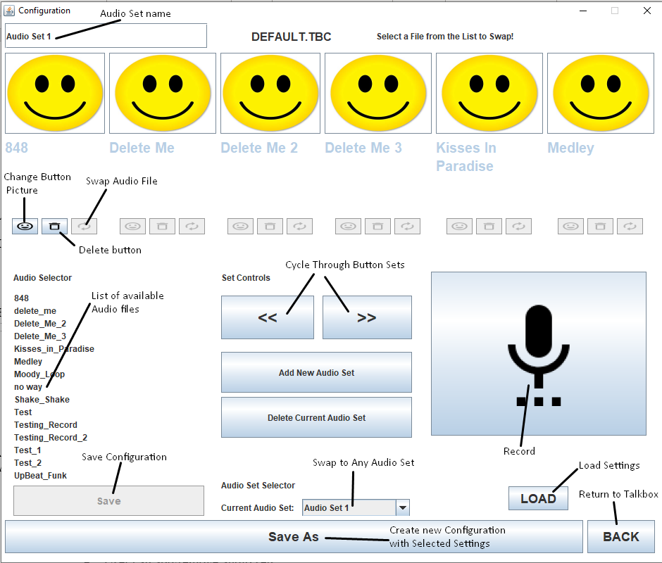

## 3.1 Client Requirements

* User can add/remove audio buttons from current sets.
* User can add/remove audio sets.
* User can record audio files to be assigned to a button.
* User can name recorded audio file.
* User can choose buttons from list of available audio files.
* User can swap to any audio set at any time.
* User can rename audio sets.
* User can give each button a unique picture, searching their device for such pictures.
* User can swap current button with another.
* User can save changed setting to current TBC file.
* User can save current settings as a new TBC file.
* User can return to TalkBox App at any time, discarding unsaved changes.

## 3.2 System Working

* Add and remove buttons allow user to add and remove selected buttons from current set.
* Add/delete audio Set allow user to create a new audio set or remove the current audio set.
* Record button allows user to record audio using device microphone if available. The user can also name and save the file using the text field provided.
* A library of pre-installed audio files has been given to the user as well as the ability to record more.
* Change picture button opens a menu allowing the user to browse their computer for pictures.

## 3.3 Acceptance Use Case

Below is the acceptance test case the Configuration Application.

|  |  |  |
| --- | --- | --- |
| **Event** | **Expected Result** | **Test: Pass/Fail** |
|  |  |  |
| Loading. .tbc configuration | Number of audio files, audio sets, current audio set and audio buttons are loaded in GUI | Pass |
| Saving .tbc configuration | Current configuration is saved to the file | Pass |
| ‘RECORD’ button is pressed | A popup appears and the user is prompted to name the record file | Pass |
| ‘RECORD’ button is pressed after naming the file | Recording starts using the device microphone | Pass |
| ‘RECORD’ button pressed again after previous event | Recording stops and the file is saved and listed in audio file list | Pass |
| ‘Add New Audio Set’ button pressed | Increase the set of audio-sets by 1 | Pass |
| ‘Delete Current Audio Set button pressed | Deletes the currently selected audio set, unless it is the only remaining audio set. | Pass |
| pressed after selecting a button | A popup menu appears prompting the user to find an image to display on selected button. | Pass |
| ‘>’ or ‘<’ button pressed | Switch the selected audio set to next or previous one. | Pass |
| pressed after selecting an audio file from available list | Button changes name and audio played when pressed to the selected audio file. Button image is set to default. | Pass |
| pressed after selecting a button | Button is removed and image is replaced with text asking to configure button. | Pass |
| ‘Current Audio Set’ button pressed | A dropdown menu appears allowing the user to select any of the currently available audio sets to switch to. | Pass |
| ‘Save as’ button pressed | Current configuration is saved to a new .tbc file, which is named by the user. | Pass |
| ‘Save’ button pressed | Current configuration is saved to the .tbc file. App is closed. | Pass |
| ‘Back’ button pressed | Current configuration is not saved to the .tbc file, configuration app is closed and talkbox App is opened with the previous settings. | Pass |
| Audio set name is pressed and changed | Upon saving, the set name will now be changed to what the user entered. | Pass |

**4.0 APPENDIX**

# Appendix

*This section describes and depicts all addition information about the system. Use screen prints as needed to depict examples of text under each heading.*