**User’s**

**MANUAL**

*TalkBox Simulator/Configuration*

**Group 5:**

Sangheon Jae

Karmit Patel

Peter Saleeb

Feb 2019

**USER'S MANUAL**

**TABLE OF CONTENTS**

Page #

A. GENERAL INFORMATION A-1

1.1 System Overview A-1

1.2 System Requirement A-1

B. GETTING STARTED B-1

2.1 Setting up JRE 1.8 B-1

2.2 Download Software B-1

C. TALKBOX SIMULATOR C-1

3.1 Audio Buttons C-1

3.2 Load Button C-1

3.3 Audio Set Selector C-1

D. CONFIGURATION C-1

4.1 Change Settings D-1

4.2 Record Audio D-1

4.3 Audio Sets/Buttons Setting D-2

4.4 Save Setting D-2

A. Appendix E-1

**1.0 GENERAL INFORMATION**

# GENERAL INFORMATION

## 1.1 System Overview

Software Development Project, TalkBox Simulator, a piece of software that simulates the behavior of any TalkBox device. It has a user interface similar to that of the device. The number of buttons sets and their functionality is configurable. Is fully tested to behave as the hardware device.

## 1.2 System Requirement

In order to run this software, operating system should have Java Runtime Environment 1.8 (JRE-1.8).

**2.0 GETTING STARTED**

# GETTING STARTED

## 2.1 Setting up JRE 1.8

Type ‘java -version’ in Terminal/PowerShell to check JRE version. If no JRE available or version is lower than 1.8, download JRE from link below

https://www.oracle.com/technetwork/java/javase/downloads/jre8-downloads-2133155.html

## 2.2 Download Software

<https://github.com/JacobJae/EECS2311_group5/releases>

Download the TalkBox.zip in releases. Latest version would be a best choice. Unzip the file in your desired location. Start the app by clicking ‘TalkBox.jar’. The app will show ‘default’ setting when you start the app. Settings can be changed by clicking ‘Load’ button in the top right corner of app.

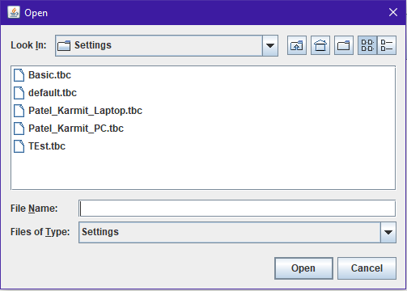

**3.0 TALKBOX SIMULATOR**

# TALKBOX SIMULATOR

Load

Button

Audio

Buttons

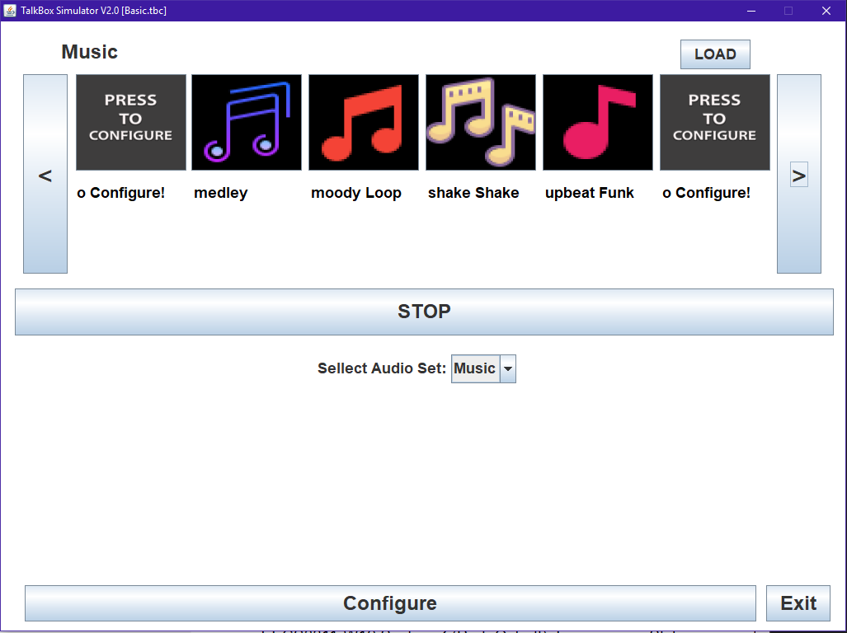

Audio

Description

Audio Set

Selector

Stop

Button

## 3.1 Audio Buttons

The top portion of software consist of audio buttons. When it’s clicked, corresponding sound will play. If the button is not set for audio, it will show the text ‘Press to configure’ and when it is clicked, it will launch the configuration app. Below part, the audio description simply tells user the name of audio buttons and descriptions. When audio is playing, by clicking the stop button will stop the audio play.

## 3.2 Load button

By clicking the load button, user can choose different kinds of setting. Also, the user can customize the setting by clicking ‘Configure’ button, which will allow configuration app to show up.

## 3.3 Audio Set Selector

In simulator app, there are 2 ways to change the audio set. Clicking the arrow button around the audio buttons will lets user to change audio set to next/previous audio set. The second way is by using the drop-down menu of audio set selector. It will show all the audio sets and user can select desired audio set.

**4.0 CONFIGURATION**

# CONFIGURATION

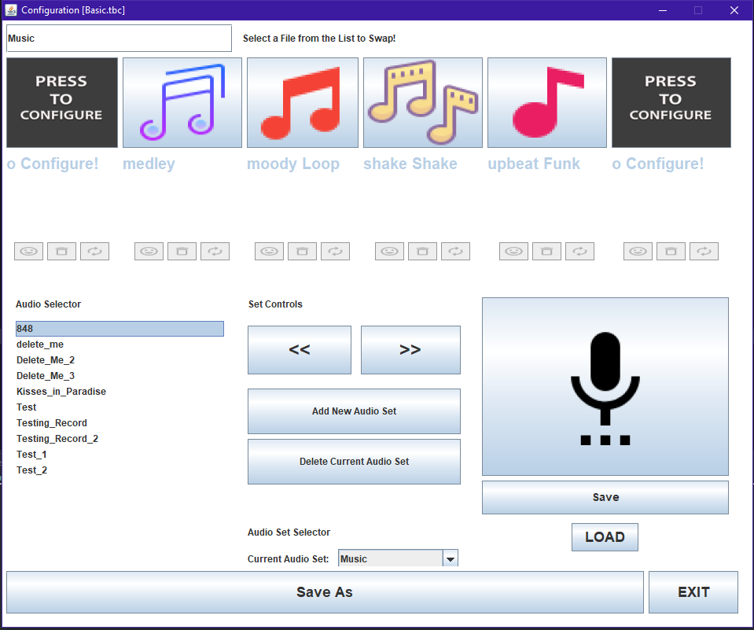

Control

Buttons

Audio Buttons Customize

Record

Button

Audio Buttons Control

Available

Audios

## 4.1 Change Settings

In configuration, user can change button settings. Top panel shows the buttons of current set. If there is any button that user don’t want to use, click the audio button and click middle button in audio buttons customize. It will delete the button and associated audio. If user want to add or change audio, click desired button position and click available audios in audio selector. It will enable the audio buttons customize section and clicking the right most button will make that position button to be associated with the desired audio. By clicking the left most button in audio buttons customize, it will allow user to set the desired image for the button. User can add their preferred images by putting in a ‘TalkBoxData/Images’ folder.

## 4.2 Record Audio

Clicking the record button will display new frame only for record. User must type the name of audio and click the triangle image to start record. When recording is done, clicking square image will create audio file.

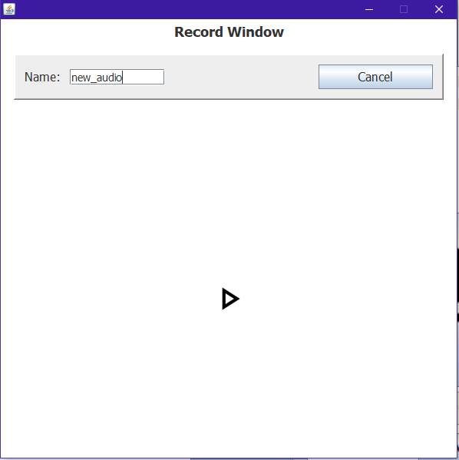

## 4.3 Audio Set/Buttons Setting

By clicking ‘Add New Audio Set’ and ‘Delete Current Audio Set’ buttons, users can change the number of audio sets in configuration. Increasing set will let you increase number of sets until memory limit. But decreasing set will only let you decrease until number of sets is 1. User can not decrease number of sets lower than 1.

## 4.4 Save Setting

When User satisfy with the change, clicking the ‘Save Setting’ button will make new file ‘configure.tbc’ which will be used in simulator.

**5.0 APPENDIX**

# Appendix

## Common Usage Scenarios

The TalkBox app allows only 8 audio buttons so setting up similar types of audios in same set would be the best way to use this software. Below example shows simple greeting and yes/no audios.

