**Requirements**

**Document**

**Group 5:**

Sangheon Jae

Karmit Patel

Peter Saleeb

Feb 2019

**Requirements Document**

**TABLE OF CONTENTS**

Page #

A. GENERAL INFORMATION A-1

1.1 System Overview A-1

1.2 System Requirement A-1

B. GETTING STARTED B-1

2.1 Setting up JRE 1.8 B-1

2.2 Download Software B-1

C. TALKBOX SIMULATOR C-1

3.1 Client Requirements C-1

3.2 System Working C-1

3.3 Client Use Cases C-2

D. CONFIGURATION APP C-1

4.1 Client Requirements D-1

4.2 System Functionality D-1

4.3 System Testing D-2

A. Appendix E-1

**1.0 GENERAL INFORMATION**

# GENERAL INFORMATION

## 1.1 System Overview

Software Development Project, TalkBox Simulator, a piece of software that simulates the behavior of any TalkBox device. Has a user interface similar to that of the device. The number of buttons and their functionality is configurable. Is fully tested to behave as the hardware device.

## 1.2 System Requirement

In order to run this software, operating system should have Java Runtime Environment 1.8 (JRE-1.8)

**2.0 GETTING STARTED**

# GETTING STARTED

## 2.1 Setting up JRE 1.8

Type ‘java -version’ in Terminal/PowerShell to check JRE version. If no JRE available or version is lower than 1.8, download JRE from link below

https://www.oracle.com/technetwork/java/javase/downloads/jre8-downloads-2133155.html

## 2.2 Download Software

Download and unzip ‘EECS2311_group5-master’ from link below

<https://github.com/JacobJae/EECS2311_group5/archive/master.zip>

## 2.3 Starting TalkBox.jar

Inside of ‘EECS2311_group5-master’ folder, go to ‘TalkBoxV2/vM’ and execute ‘TalkBoxV2’ jar file. Select ‘configure.tbc’ file inside of ‘TalkBoxV2/TalkBoxData’ which is default setting for new user.

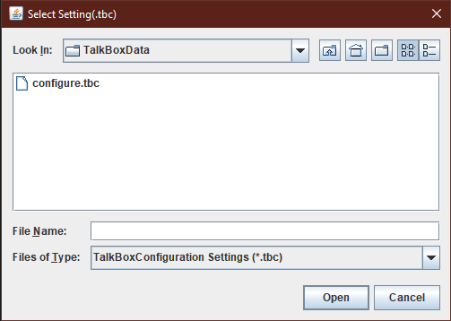

**3.0 TALKBOX SIMULATOR**

# TALKBOX SIMULATOR

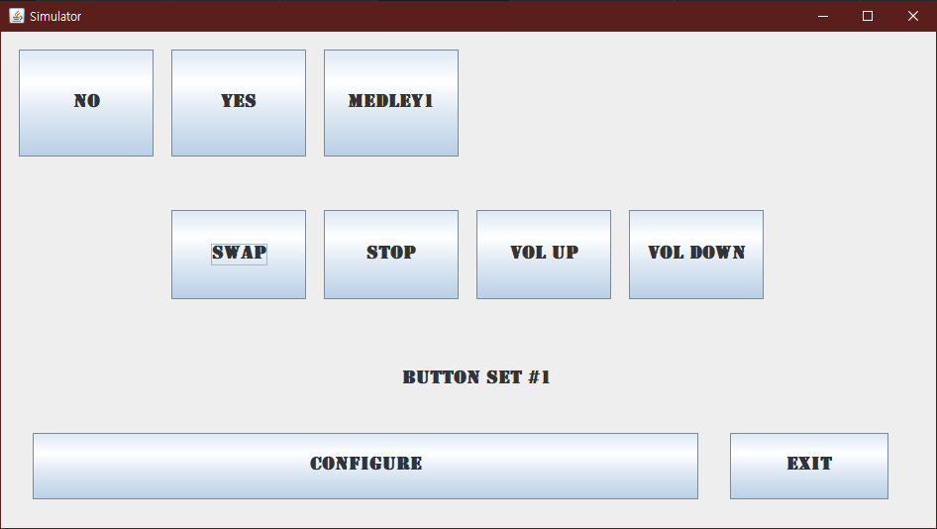

Control

Buttons

Audio

Buttons

## 3.1 Client Requirements

* A physical device integrated with an application using Java. The device must have buttons that when pressed provides a set audio output associated with that button.
* Allowing user to switch between multiple (possibly infinite) amounts of button sets, each with different audio outputs.
* Allowing user to adjust volume of the audio output.
* User can stop the audio playback anytime during the playback.

## 3.2 System Working

* The top portion of software consist of audio buttons. When it’s clicked, corresponding sound will play. If user want to make custom voice audio file, click ‘Configure’ button.
* ‘SWAP’ button sets the next set of audio buttons.
* ‘VOL UP/DOWN’ buttons control the volume of system. (not implemented yet)
* ‘STOP’ button stops the audio play.

## 3.3 Client Use Case

The system has a typical use case by users with verbal deficiency like unable to speak from birth or by accident as well as clients with non-verbal deficiency like brain disorder, cognitive, sensory or motor.

This device can also be used as a toy for children due to the simplicity of operating this device.

**4.0 CONFIGURATION**

# CONFIGURATION

Audio Buttons Control

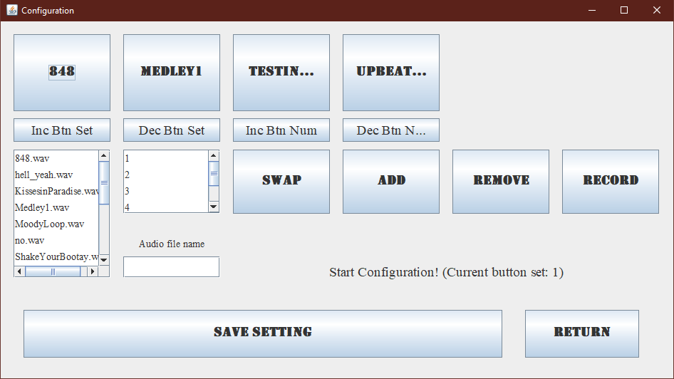

Audio Sets Control

Button

Index

Available

Audios

Control

Buttons

Record

Buttons

## 4.1 Client Requirements

* User can add/remove audio buttons from current sets.
* User can add/remove audio sets.
* User can record and save audio as per requirements.
* User can choose from hundreds of available audio files.

## 4.2 System Working

* Add and remove buttons allow user to add and remove selected buttons from current set.
* Inc./ Dec. btn Set allow user to change the current button set, and then change the buttons in that set.
* Record button allows user to record audio using device microphone if available. The user can also name and save the file using the text field provided.
* A library of pre-installed audio files has been given to the user as well as the ability to record more.

## 4.3 System Testing

Please refer to the testing document for the system testing for all the above-mentioned features.

**5.0 APPENDIX**

# Appendix

*This section describes and depicts all addition information about the system. Use screen prints as needed to depict examples of text under each heading.*