**User’s**

**MANUAL**

*TalkBox Simulator/Configuration*

**Group 5:**

Sangheon Jae

Karmit Patel

Peter Saleeb

Feb 2019

**USER'S MANUAL**

**TABLE OF CONTENTS**

Page #

A. GENERAL INFORMATION A-1

1.1 System Overview A-1

1.2 System Requirement A-1

B. GETTING STARTED B-1

2.1 Setting up JRE 1.8 B-1

2.2 Download Software B-1

C. TALKBOX SIMULATOR C-1

3.1 Audio Buttons C-1

3.2 Control Buttons C-1

3.3 Configure Button C-1

D. CONFIGURATION C-1

4.1 Change Settings D-1

4.2 Record Audio D-1

4.3 Audio Sets/Buttons Setting D-2

4.4 Save Setting D-2

A. Appendix E-1

**1.0 GENERAL INFORMATION**

# GENERAL INFORMATION

## 1.1 System Overview

Software Development Project, TalkBox Simulator, a piece of software that simulates the behaviour of any TalkBox device. Has a user interface similar to that of the device. The number of buttons and their functionality is configurable. Is fully tested to behave as the hardware device.

## 1.2 System Requirement

In order to run this software, operating system should have Java Runtime Environment 1.8 (JRE-1.8)

**2.0 GETTING STARTED**

# GETTING STARTED

## 2.1 Setting up JRE 1.8

Type ‘java -version’ in Terminal/PowerShell to check JRE version. If no JRE available or version is lower than 1.8, download JRE from link below

https://www.oracle.com/technetwork/java/javase/downloads/jre8-downloads-2133155.html

## 2.2 Download Software

Download and unzip ‘EECS2311_group5-master’ from link below

<https://github.com/JacobJae/EECS2311_group5/archive/master.zip>

## 2.3 Starting TalkBox.jar

Inside of ‘EECS2311_group5-master’ folder, go to ‘TalkBoxV2/vM’ and execute ‘TalkBoxV2’ jar file. Select ‘configure.tbc’ file inside of ‘TalkBoxV2/TalkBoxData’ which is default setting for new user.

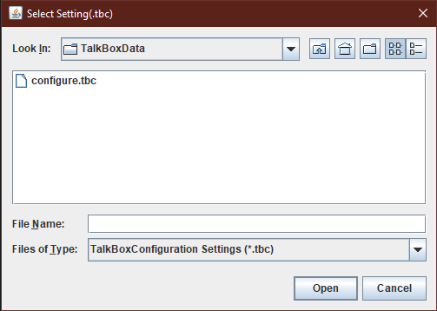

**3.0 TALKBOX SIMULATOR**

# TALKBOX SIMULATOR

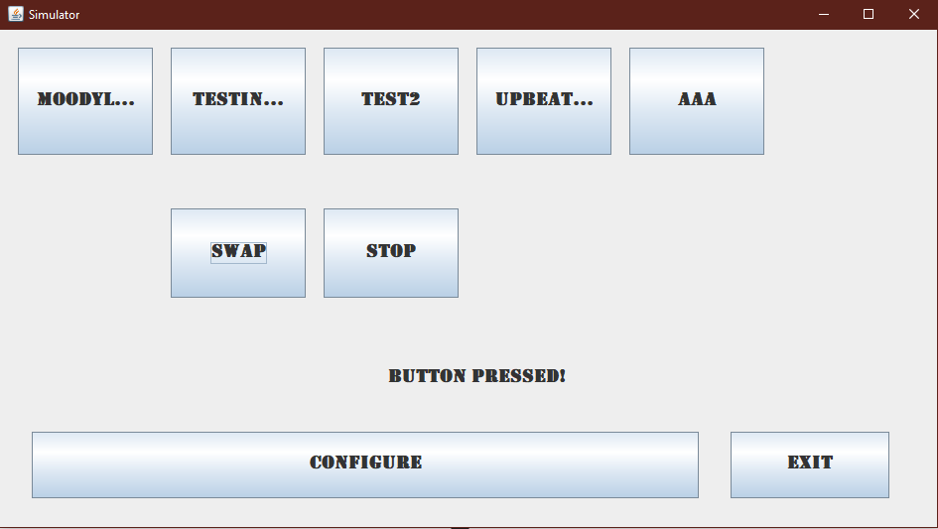

Control

Buttons

Audio

Buttons

## 3.1 Audio Buttons

The top portion of software consist of audio buttons. When it’s clicked, corresponding sound will play. If user want to make custom voice audio file, click ‘Configure’ button.

## 3.2 Control Buttons

Control Buttons help user to control the audio play. ‘SWAP’ button will set the next set of audio buttons. ‘STOP’ button will stop the audio play.

## 3.3 Configure Button

The configure button will load up new frame. In Configuration frame, user can change the number of buttons sets and number of audio buttons and contents of buttons in particular set. Also, user can record customize voice as an audio file.

**4.0 CONFIGURATION**

# CONFIGURATION

Audio Buttons Control

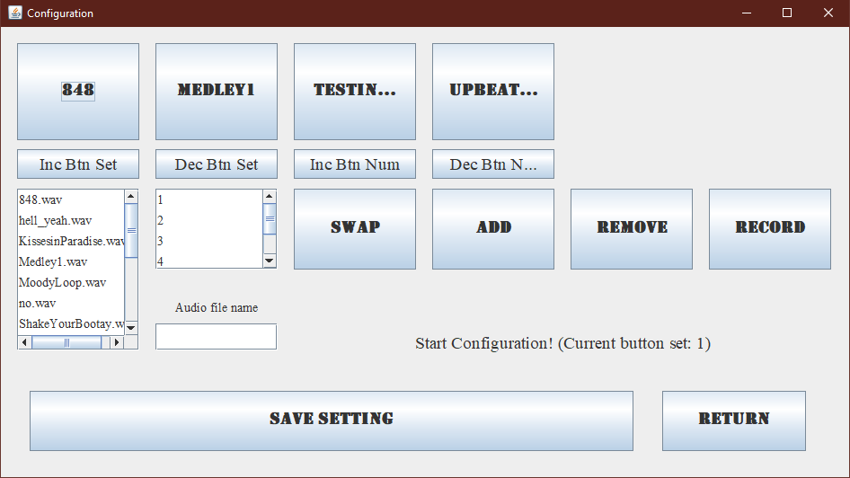

Audio Sets Control

Button

Index

Available

Audios

Control

Buttons

Record

Buttons

## 4.1 Change Settings

In configuration, user can change button settings. Top panel shows the buttons of current set. If there is any button that user don’t want to user, click the audio button and click ‘Remove’. It will remove button from current set. The ‘Swap’ button changes the button set and corresponding buttons will be displayed. In available audios section, all audio files will be displayed and button index section show the possible position of button can be set. In order to add new button, first select audio file and select button position. After that, clicking ‘Add’ button will add audio button into selected position.

## 4.2 Record Audio

Below the Button index box, there is a text field area where you could set the name of audio file that will be recorded. Only when file name is set, record button can be activated. Once record button is clicked, app starts to record voice and when record button is clicked again, recording will be stop.

## 4.3 Audio Set/Buttons Setting

By clicking ‘Inc Btn Set’ and ‘Dec Btn Set’ buttons, users can change the number of audio sets in configuration. Increasing set will let you increase number of sets until memory limit. But decreasing set will only let you decrease until number of sets is 1. User can not decrease number of sets lower than 1. Audio buttons control also work same as audio sets control.

## 4.4 Save Setting

When User satisfy with the change, clicking the ‘Save Setting’ button will make new file ‘configure.tbc’ which will be used in simulator.

**5.0 APPENDIX**

# Appendix

*This section describes and depicts all addition information about the system. Use screen prints as needed to depict examples of text under each heading.*