1. BFS

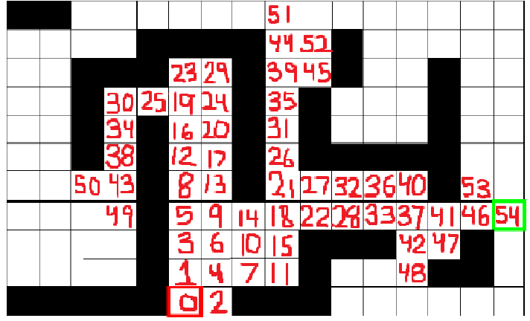

1. DFS (NESW)

1. DFS (WESN)

1. UCS

UCS Costs

