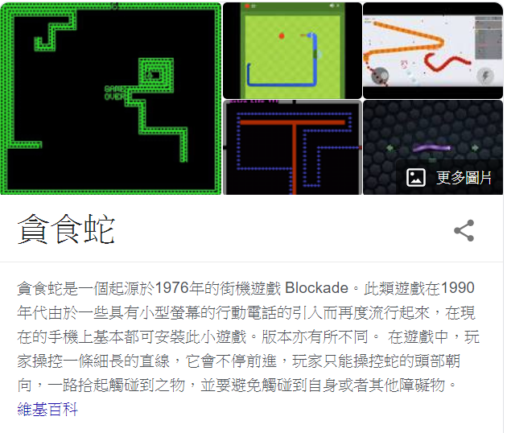

遊戲裡要記錄四種不同的東西，分別是空白格0，牆面1，蛇2，蘋果3。(你可以用別的代號，只要不重複即可)

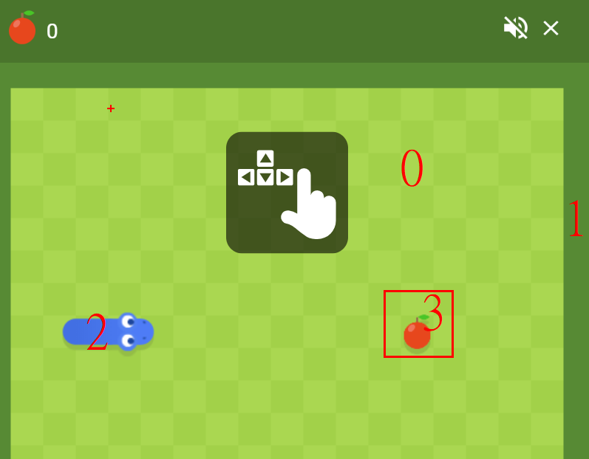

在C++裡面受限於繪圖，我們只用黑白方塊來呈現，空格用白方塊，其餘用黑方塊。

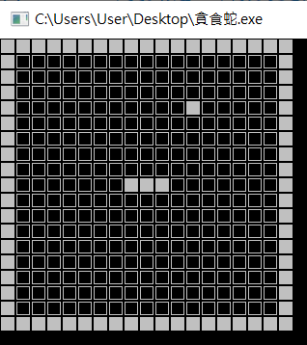

19*19方陣，可以宣告361格的陣列來存取。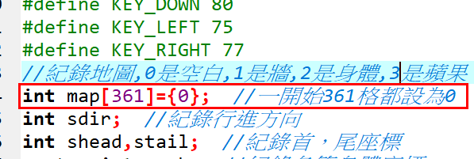

|  |  |  |  |  |  |  |  |  |  |  |  |  |  |  |  |  |  |  |
| --- | --- | --- | --- | --- | --- | --- | --- | --- | --- | --- | --- | --- | --- | --- | --- | --- | --- | --- |
|  |  |  |  |  |  |  |  |  |  |  |  |  |  |  |  |  |  |  |
|  |  |  |  |  |  |  |  |  |  |  |  |  |  |  |  |  |  |  |
|  |  |  |  |  |  |  |  |  |  |  |  |  |  |  |  |  |  |  |
|  |  |  |  |  |  |  |  |  |  |  |  |  |  |  |  |  |  |  |
|  |  |  |  |  |  |  |  |  |  |  |  |  |  |  |  |  |  |  |
|  |  |  |  |  |  |  |  |  |  |  |  |  |  |  |  |  |  |  |
|  |  |  |  |  |  |  |  |  |  |  |  |  |  |  |  |  |  |  |
|  |  |  |  |  |  |  |  |  |  |  |  |  |  |  |  |  |  |  |
|  |  |  |  |  |  |  |  |  |  |  |  |  |  |  |  |  |  |  |
|  |  |  |  |  |  |  |  |  |  |  |  |  |  |  |  |  |  |  |
|  |  |  |  |  |  |  |  |  |  |  |  |  |  |  |  |  |  |  |
|  |  |  |  |  |  |  |  |  |  |  |  |  |  |  |  |  |  |  |
|  |  |  |  |  |  |  |  |  |  |  |  |  |  |  |  |  |  |  |
|  |  |  |  |  |  |  |  |  |  |  |  |  |  |  |  |  |  |  |
|  |  |  |  |  |  |  |  |  |  |  |  |  |  |  |  |  |  |  |
|  |  |  |  |  |  |  |  |  |  |  |  |  |  |  |  |  |  |  |
|  |  |  |  |  |  |  |  |  |  |  |  |  |  |  |  |  |  |  |
|  |  |  |  |  |  |  |  |  |  |  |  |  |  |  |  |  |  |  |
|  |  |  |  |  |  |  |  |  |  |  |  |  |  |  |  |  |  |  |

|  |
| --- |
| #include <conio.h>  #include <iostream>  #include <vector>  #include <algorithm>  #include <time.h>  #include <windows.h>  using namespace std;  //定義方向鍵  #define KEY_UP 72  #define KEY_DOWN 80  #define KEY_LEFT 75  #define KEY_RIGHT 77  //紀錄地圖,0是空白,1是牆,2是身體,3是蘋果  int map[361]={0}; //一開始361格都設為0  int sdir; //紀錄行進方向  int shead,stail; //紀錄首，尾座標  vector<int> snk; //紀錄各節身體座標  int apple; //紀錄蘋果座標  //第一題，地圖繪製，0用白色方塊顯示，其餘用黑色方塊  void draw_map() {  }  //第二題，設定邊界與加入蛇，設定一開始位置 175 176 177，蛇的代號是2  void init_map() {  }  //第三題，加入蘋果 ，蘋果的代碼是3  void new_apple() {  }  int main(void)  {  init_map();  new_apple();  draw_map();  return 0;  } |

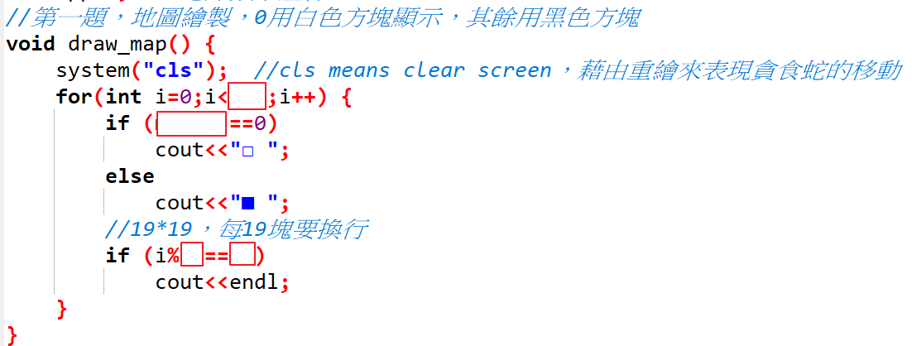

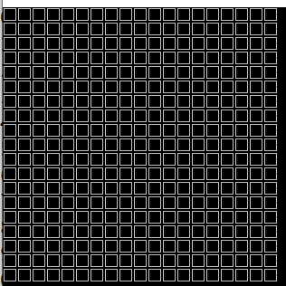

## 加分題

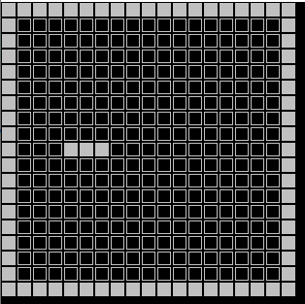

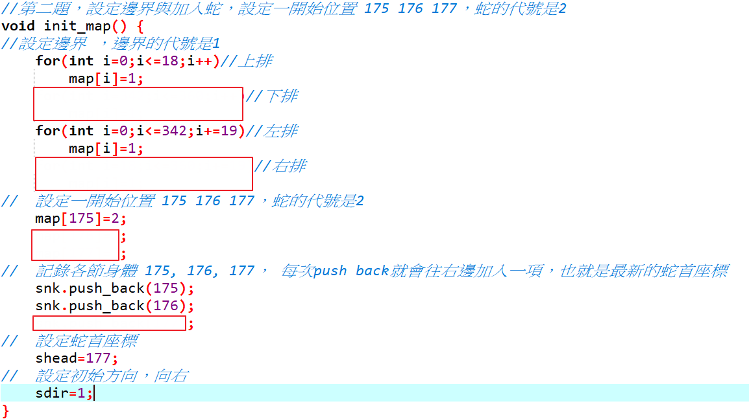

Vector 是 C++ 中一個非常好用的「容器」，是加強版的陣列，對自己的一些基本資訊提供成員函式來直接存取。

由於蛇是會移動的，比如現在有三節，我們要把座標175 176 177記錄下來。則snk現在有三個元素

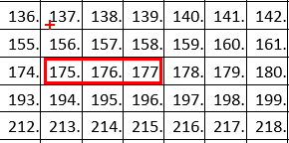

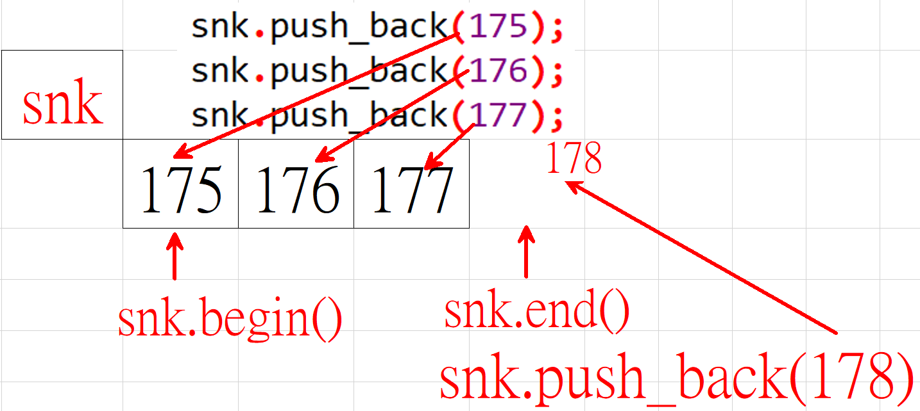

## 加加分題

