ITC293 – Introduction to the Web

Assessment 3

HTML, CSS and Design

Jacob Mounce-Stephens – Student 11775976

Personal Portfolio Website

Electric Cars

Image Source: [Bram Van Oost](https://unsplash.com/photos/parked-blue-coupe-beside-trees-during-daytime-eaPkue76Ip4)

Contents

Concept Map 3

CSS Design 4

Structure Chart 5

Navigation Map 5

Testing Plan 6

Index.html 8

Storyboard 8

Code 9

Validation 12

Personal Reflection 12

A2_about.html 14

Storyboard 14

Code 15

Validation 18

Personal Reflection 18

A1_resume.html 20

Storyboard 20

Code 21

Validation 24

Personal Reflection 24

A2_web_skills.html 25

Storyboard 25

Code 26

Validation 28

Personal Reflection 28

Portfolio.css 28

Code 28

Validation 35

Personal Reflection 36

Final Thoughts 36

TurnItIn 36

# Concept Map

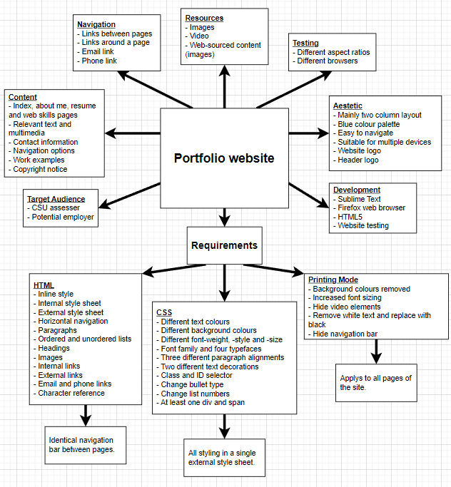

# CSS Design

The index, about, and web skills page all utilise the CSS layout below on the left.

In this layout, the header section will contain information such as name and contact information as well as a logo for the site. The two navigation bars will contain everything related to navigating the website. The two content sections will contain the website text, images, and video content. Finally, the footer will contain the copyright notice for the site.

The resume page, communication skills page, and the form page will instead use the layout below on the right, which uses only one content section instead of two. All other details will be the same.

# Structure Chart

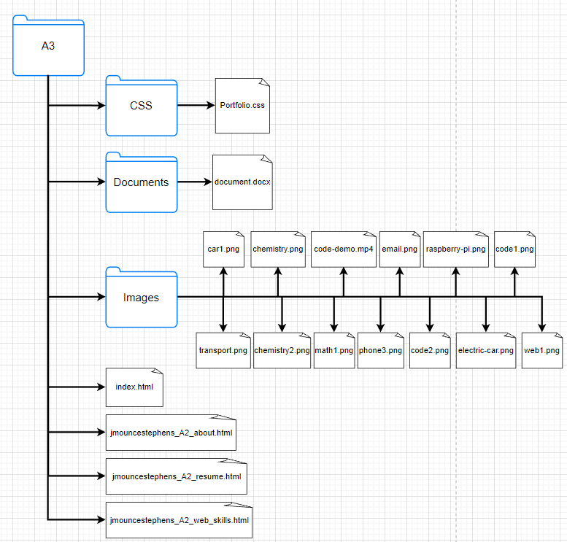

# Navigation Map

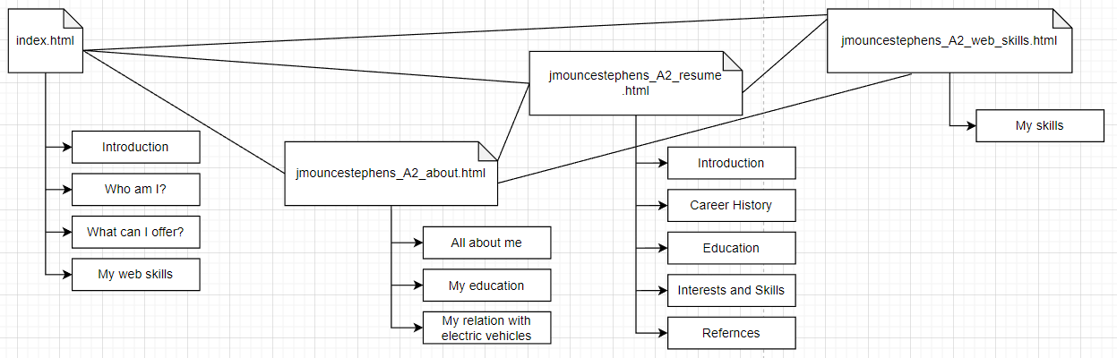

Each file is linked together using the navigation section at the top of each page. It is demonstrated below:

# Testing Plan

For a simple website such as what this one is planned to be, there will be two main aspects to test. The first is ensuring page navigation works across multiple browsers. The other is ensuring that the website can resize and appear as expected across multiple aspect ratios and browsers.

These can both be tested, to a reasonable extent, by opening the page on multiple devices and browsers. After this, linking can be tested by using the navigation buttons and the visuals of the site can be tested by scaling the browser window to adjust the aspect ratio, as demonstrated below.

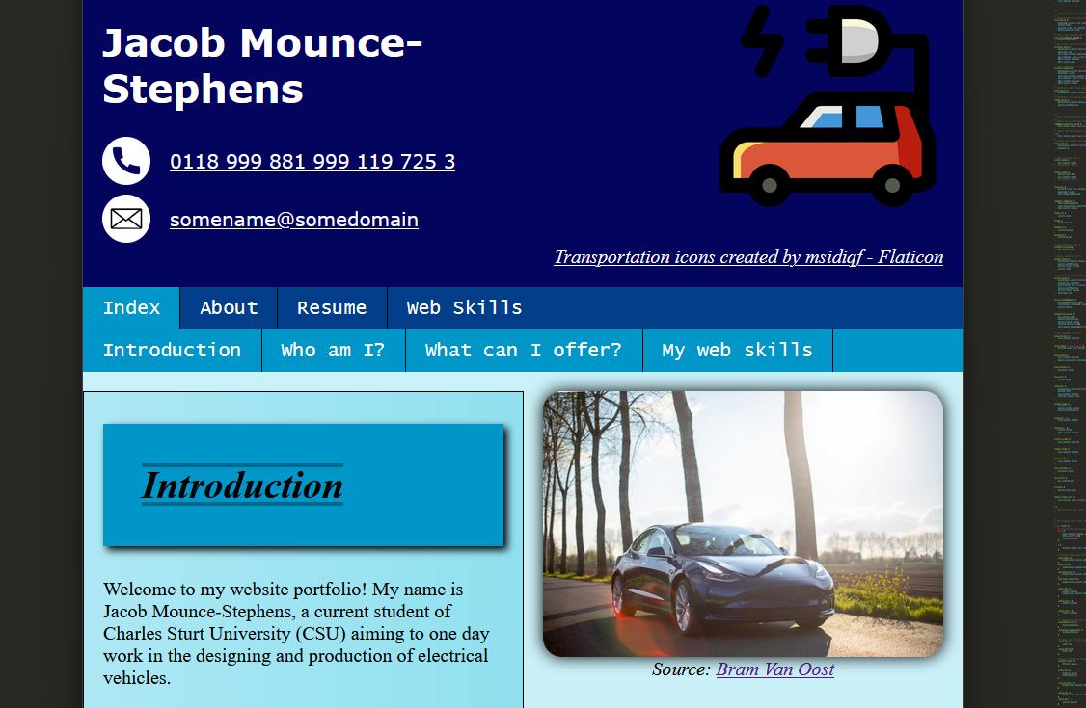

Above is in the firefox browser.

Above is in the edge browser.

Navigating around the website in this fashion can help to identify issues. For example, in the edge image, part of the email address is hidden due to the very unusual, narrow aspect ratio. It is considered beyond the scope of this task however in a different situation, that would be an issue that requires addressing. It is not corrected for this site because it likely would require dynamic text scaling for an edge case that is only worth considering if the website is intended to be used on a mobile device.

In regard to testing the HTML and CSS code, this can be accomplished using external HTML and CSS validators as demonstrated below. Finally, the printing mode of the site can be tested using built-in browser tools or by printing the website. The tools are demonstrated below:

# Index.html

## Storyboard

|  |  |  |  |  |  |  |
| --- | --- | --- | --- | --- | --- | --- |
| Page title | Index.html | | Screen ID | 1.0 | Date | 1/6/2024 |
|  | | | Elements | | | |
| Graphics | Basic icons will be used in the header of each page. Other images used will be relevant to an accompanying paragraph to enhance reading experience. | | |
| Text | The text present on this page will provide a summary of the text that will appear on the other pages on the site. | | |
| Audio/Video | None | | |
| Notes | - This website is designed using the CSS box model in mind to position elements.  - The general layout of this page uses two columns, one containing text and the other containing an image(s). | | |
| Description | | Website homepage. | | | | |
| Content | | A brief introduction from me and short summaries of what every other page on the website is going to contain. | | | | |
| Interactions | | Website navigation links: between pages and around the same page.  Phone and email links. | | | | |
| Media Creation | | Images not marked with a source are fully created by me and are original works. Images marked with “Source:” are derived from a website that hosts free use images licensed under Creative Commons. Any image modifications are made through CSS. | | | | |
| Navigation | | Navigation is made possible through the navigation bar at the top of the screen. It lists all pages on the website and also highlights the page the user is currently on. Furthermore, there are phone and email links to assist the user.  Additionally, this page contains a second navigation bar, below the first, which allows the user to navigate between headings on the current page easier.  Finally, each subheading on this page is related to a different page on the site and therefore contains a link to go to the related page. | | | | |

## Code

|  |
| --- |
| <!DOCTYPE html> |

## Validation

T

## Personal Reflection

Of all the pages that I had to create for the website, the index page took the longest and was the most complex, as such, it also will have a much longer reflection than the other pages.

For me, creating this page was the most challenging because it was the first page that I created for the website. This meant that before I could begin working on it I had to consider different ideas for how I eventually wanted the website to look and feel to use. This process took a decent amount of time because I struggle quite a lot when it comes to visual design of anything, and I also had to consider what the requirements and expectations were for the entire task.  
 After quite a bit of considering and storyboard planning, I settled on the basic design (from top to bottom) of header, navigation bar, two columns for content with text and images swapping sides and finally a footer. Another important consideration to be made was the colour palette and style I wanted for the site. After some consideration, and online research, I decided on a blue focused colour palette that ranges from darker shades to lighter shades.  
 Since the CSS style sheet can be applied across the entire website, this first page also laid the foundations for the style sheet. This meant I had to spend time tinkering with padding, margins, colours, element positions and more while constructing this first page. I spent a lot of time working on this page because I knew it would make the other pages much smoother to create. After my work I am quite happy with the overall feel and layout of the website and I cannot think of anything I would particularly change.  
 I did encounter a few challenges while setting up this page, however. There were several issues with positioning the navigation bar, getting its layout exactly how I wanted and ensuring it was always visible on the screen however I satisfactorily resolved those issues to create the current navigation bar and header. The main disappointment I have with the aesthetics of the site are a detail I was hoping to incorporate into the header however I could not get it to look and work how I wanted. Another challenge I faced was with the internal navigation bar. Originally, when using it, upon jumping to another point on the page, the title of that section was covered by the navigation bar. This was unacceptable and I struggled a lot with finding a solution. Eventually, however, I was able to come across a solution online involving nesting two <span> elements around the jump points. I have credited this solution throughout the website, leaving a note above the first time it is used on each page.  
 My plan for the header was the have an image on the right half that would split the header diagonally, making the header appear as two connected trapezoids, one containing the header content and the other an image. Unfortunately, I was unable to get this working how I wanted. The only other main issue I encountered, that I can recall, was in the divs that contained multiple images, I was hoping to stack the images on top of each other slightly because I believed it would be visually pleasing. The issue I encountered here is that I am not knowledgeable enough when it comes to CSS to create an effect like this while also ensuring the website maintained the same look and element ratios as what I was developing it with when viewed on other devices or platforms.

# A2_about.html

(File **jmouncestephens_A2_about.html**)

## Storyboard

|  |  |  |  |  |  |  |  |
| --- | --- | --- | --- | --- | --- | --- | --- |
| Page title | jmouncestephens_A2_about.html | | | Screen ID | 2.1 | Date | 1/6/2024 |
|  | | | Elements | | | | |
| Graphics | | Basic icons will be used in the header of each page. Other images used will be relevant to an accompanying paragraph to enhance reading experience. | | |
| Text | | The text on this page will talk about who I am as a person. This includes topics such as what my hobbies are. Furthermore, this page will cover my education and relation with electric vehicles. | | |
| Audio/Video | | A video of a program that I previously created. | | |
| Notes | | - This website is designed using the CSS box model in mind to position elements.  - The general layout of this page uses two columns, one containing text and the other containing an image(s) and a video. | | |
| Description | | About me page. | | | | | |
| Content | | A detailed ‘about me’ page describing a lot more about how I am as a person. Covers information about my private life such as hobbies. Additionally, details my experiences and journey through education and what my relationship with electric cars is. | | | | | |
| Interactions | | Website navigation links: between pages and around the same page.  Phone and email links. | | | | | |
| Media Creation | | Images not marked with a source are fully created by me and are original works. Images marked with “Source:” are derived from a website that hosts free use images licensed under Creative Commons. Any image modifications are made through CSS.  The video on this page is also fully created by me and is an original work. | | | | | |
| Navigation | | Navigation is made possible through the navigation bar at the top of the screen. It lists all pages on the website and also highlights the page the user is currently on. Furthermore, there are phone and email links to assist the user.  Additionally, this page contains a second navigation bar, below the first, which allows the user to navigate between headings on the current page easier. | | | | | |

## Code

|  |
| --- |
| <!DOCTYPE html> |

## Validation

T

## Personal Reflection

As described in the Index reflection, I do not have many comments to say about each individual page, however, here is my brief reflection for this page.

Overall, the process of creating the ‘about me’ page was very smooth. When I was planning it, I decided to swap the order of the columns so that the first text section would appear on the right instead of the left like the index page. This decision was made to help distinguish the two pages and keep the website feeling different on each page despite visually appearing extremely similar.  
 Furthermore, this page is where I better thought out who to write subheadings for text sections. This meant that I had to plan a style for them that would visually tie in with the heading styles while also keeping them unique. This was also an opportunity for me to experiment more with ‘text-decorations’ to fulfill another part of the assignment requirements.   
 Aside from what I described above, this page mostly came down to modifying the navigation bar from the first page and then adding in new text, images, and some new styles.

# A1_resume.html

(File **jmouncestephens_A2_resume.html**)

## Storyboard

|  |  |  |  |  |  |  |
| --- | --- | --- | --- | --- | --- | --- |
| Page title | jmouncestephens_A2_resume.html | | Screen ID | 2.2 | Date | 1/6/2024 |
|  | | | Elements | | | |
| Graphics | Basic icons will be used in the header of each page. Other images used will be relevant to an accompanying paragraph to enhance reading experience. | | |
| Text | The text on this page will be of a simple resume and thus all information that might be necessary for a resume. | | |
| Audio/Video | None | | |
| Notes | - This website is designed using the CSS box model in mind to position elements.  - This page utilises a single column for content and does not contain any images. | | |
| Description | | Resume page. | | | | |
| Content | | A basic resume about myself that informs the reader of who I am, what my work history is, what my educational achievements are and hopefully what I can offer to their company. | | | | |
| Interactions | | Website navigation links: between pages and around the same page.  Phone and email links. | | | | |
| Media Creation | | Images not marked with a source are fully created by me and are original works. Images marked with “Source:” are derived from a website that hosts free use images licensed under Creative Commons. Any image modifications are made through CSS. | | | | |
| Navigation | | Navigation is made possible through the navigation bar at the top of the screen. It lists all pages on the website and also highlights the page the user is currently on. Furthermore, there are phone and email links to assist the user.  Additionally, this page contains a second navigation bar, below the first, which allows the user to navigate between headings on the current page easier. | | | | |

## Code

|  |
| --- |
| <!DOCTYPE html> |

## Validation

T

## Personal Reflection

As described in the Index reflection, I do not have many comments to say about each individual page, however, here is my brief reflection for this page.

The resume page was extremely straightforward for me. I quickly decided that I did not think images or video would be appropriate for a resume page and so decided to remove the second column, widen the first column and then align all content to the centre of the page rather than either edge. This change was also useful for helping to distinguish the page from the previous ones to help give each page its own identity.  
 Aside from those details, this page was mostly taking a resume template I found and filling in the details of it while applying the previously created styles I used for my first two pages.

# Skill_1_communication.html

## Storyboard

|  |  |  |  |  |  |  |
| --- | --- | --- | --- | --- | --- | --- |
| Page title | skill_1_communication.html | | Screen ID | 2.3 | Date | 1/6/2024 |
|  | | | Elements | | | |
| Graphics | Basic icons will be used in the header of each page. | | |
| Text | The text on this page will outline some basic skills and abilities I have in relation to communication. | | |
| Audio/Video | None | | |
| Notes | - This website is designed using the CSS box model in mind to position elements.  - This page utilises a single column for content and does not contain any images. | | |
| Description | | Communication skills page. | | | | |
| Content | | A brief page that described some of my talents and capabilities regarding communication. This page covers three main topics: leadership, teamwork and general communication. | | | | |
| Interactions | | Website navigation links: between pages and around the same page.  Phone and email links. | | | | |
| Media Creation | | Images not marked with a source are fully created by me and are original works. Images marked with “Source:” are derived from a website that hosts free use images licensed under Creative Commons. Any image modifications are made through CSS. | | | | |
| Navigation | | Navigation is made possible through the navigation bar at the top of the screen. It lists all pages on the website and also highlights the page the user is currently on. Furthermore, there are phone and email links to assist the user. | | | | |

## Code

T

## Validation

T

## Personal Reflection

This page and the next two do not have much to comment on. By the point of creating them, most of the CSS and website design were already completed and finalised. As a result, these pages were just a case of essentially copying a previously made page and swapping out the information contained within them, adjusting any styling and formatting where appropriate.

# Skill_2_engineering.html

## Storyboard

|  |  |  |  |  |  |  |
| --- | --- | --- | --- | --- | --- | --- |
| Page title | skill_2_engineering.html | | Screen ID | 2.4 | Date | 1/6/2024 |
|  | | | Elements | | | |
| Graphics | Basic icons will be used in the header of each page. Other images used will be relevant to an accompanying paragraph to enhance reading experience. | | |
| Text | The text on this page will outline some basic skills and abilities I have in relation to engineering. | | |
| Audio/Video | None | | |
| Notes | - This website is designed using the CSS box model in mind to position elements.  - The general layout of this page uses two columns, one containing text and the other containing an image(s). | | |
| Description | | Engineering skills page. | | | | |
| Content | | A brief page that described some of my talents and capabilities regarding engineering. It describes previous education experiences and background knowledge. | | | | |
| Interactions | | Website navigation links: between pages and around the same page.  Phone and email links. | | | | |
| Media Creation | | Images not marked with a source are fully created by me and are original works. Images marked with “Source:” are derived from a website that hosts free use images licensed under Creative Commons. Any image modifications are made through CSS. | | | | |
| Navigation | | Navigation is made possible through the navigation bar at the top of the screen. It lists all pages on the website and also highlights the page the user is currently on. Furthermore, there are phone and email links to assist the user. | | | | |

## Code

T

## Validation

T

## Personal Reflection

The page has the same reflection as the previous page.

# Skill_3_problem_solving.html

## Storyboard

|  |  |  |  |  |  |  |
| --- | --- | --- | --- | --- | --- | --- |
| Page title | skill_3_problem_solving.html | | Screen ID | 2.5 | Date | 1/6/2024 |
|  | | | Elements | | | |
| Graphics | Basic icons will be used in the header of each page. | | |
| Text | The text on this page will outline some basic skills and abilities I have in relation to problem solving. | | |
| Audio/Video | None | | |
| Notes | - This website is designed using the CSS box model in mind to position elements.  - The general layout of this page uses two columns, one containing text and the other containing an image(s). | | |
| Description | | Problem solving skills page. | | | | |
| Content | | A brief page that described some of my talents and capabilities regarding problem solving. Referred to on the page and on other pages as “analytical skills” as that name is shorter than “problem solving skills.” Includes information about mathematical, scientific and programming skills. | | | | |
| Interactions | | Website navigation links: between pages and around the same page.  Phone and email links. | | | | |
| Media Creation | | Images not marked with a source are fully created by me and are original works. Images marked with “Source:” are derived from a website that hosts free use images licensed under Creative Commons. Any image modifications are made through CSS. | | | | |
| Navigation | | Navigation is made possible through the navigation bar at the top of the screen. It lists all pages on the website and also highlights the page the user is currently on. Furthermore, there are phone and email links to assist the user. | | | | |

## Code

T

## Validation

T

## Personal Reflection

The page has the same reflection as the previous two pages.

# Formpage.html

## Storyboard

|  |  |  |  |  |  |  |
| --- | --- | --- | --- | --- | --- | --- |
| Page title | skill_1_communication.html | | Screen ID | 3.0 | Date | 1/6/2024 |
|  | | | Elements | | | |
| Graphics | Basic icons will be used in the header of each page. | | |
| Text | The text on this page will outline some basic skills and abilities I have in relation to communication. | | |
| Audio/Video | None | | |
| Notes | - This website is designed using the CSS box model in mind to position elements.  - This page utilises a single column for content and does not contain any images. | | |
| Description | | Communication skills page. | | | | |
| Content | | A brief page that described some of my talents and capabilities regarding communication. This page covers three main topics: leadership, teamwork and general communication. | | | | |
| Interactions | | Website navigation links: between pages and around the same page.  Phone and email links. | | | | |
| Media Creation | | Images not marked with a source are fully created by me and are original works. Images marked with “Source:” are derived from a website that hosts free use images licensed under Creative Commons. Any image modifications are made through CSS. | | | | |
| Navigation | | Navigation is made possible through the navigation bar at the top of the screen. It lists all pages on the website and also highlights the page the user is currently on. Furthermore, there are phone and email links to assist the user. | | | | |

## Code

T

## Validation

T

## Personal Reflection

T

# A2_web_skills.html

(File **jmouncestephens_A2_web_skills.html**)

## Storyboard

|  |  |  |  |  |  |  |
| --- | --- | --- | --- | --- | --- | --- |
| Page title | jmouncestephens_A2_web_skills.html | | Screen ID | 2.6 | Date | 1/6/2024 |
|  | | | Elements | | | |
| Graphics | Basic icons will be used in the header of each page. Other images used will be relevant to an accompanying paragraph to enhance reading experience. | | |
| Text | The text on this page will outline some basic skills and abilities I have in relation to web development. | | |
| Audio/Video | None | | |
| Notes | - This website is designed using the CSS box model in mind to position elements.  - The general layout of this page uses two columns, one containing text and the other containing an image(s). | | |
| Description | | Web skills page. | | | | |
| Content | | A brief page that highlights some of my capabilities in relation to HTML and CSS. Provides a comparison between what a website might look like and the work that has to go into creating that happen through the use of an image showing the HTML and CSS used to create the page. | | | | |
| Interactions | | Website navigation links: between pages and around the same page.  Phone and email links. | | | | |
| Media Creation | | Images not marked with a source are fully created by me and are original works. Images marked with “Source:” are derived from a website that hosts free use images licensed under Creative Commons. Any image modifications are made through CSS. | | | | |
| Navigation | | Navigation is made possible through the navigation bar at the top of the screen. It lists all pages on the website and also highlights the page the user is currently on. Furthermore, there are phone and email links to assist the user. | | | | |

## Code

|  |
| --- |
| <!DOCTYPE html> |

## Validation

T

## Personal Reflection

As described in the Index reflection, I do not have many comments to say about each individual page, however, here is my brief reflection for this page.

The final page was very similar to the previous pages however I changed my mind set and decided to focus on created small HTML and CSS demonstrations to keep in line with the ‘web skills’ theme of the page. I did struggle a bit with thinking about what content might actually suit this page and so it is a bit shorter than the other pages however I think it is fine as I consider the entire website a demonstration of the web skills I possess already.  
 I decided early, however, that a unique idea for this page would be to move all text into the left column and then populate the right column with examples of some of the HTML and CSS code as well as an image filtering and distortion example. I think this is a nice way of showing both what the end product of web development looks like as well as what skills actually go into creating the end product.

# Portfolio.css

## Code

|  |
| --- |
| /** |

## Validation

T

## Personal Reflection

The biggest consideration that went into writing the CSS document was “How do I layout this file?” This question remained on my mind throughout the entire creation process for the website and I was constantly updated and shuffling around portions of this file as I deemed necessary. This was all to keep the file organised and logical. As such, this file underwent a lot of development and change. For example, I would add a class then decide it wasn’t needed then maybe add it straight back in or merge it into another class. If I realised that some CSS was only necessary for a single file, I would then take that section of the CSS file and integrate it into the individual pages style sheet.  
 Due to the nature of CSS and the reasons described above, this file was the most modified and used file throughout the entire process of creating my portfolio website. Right up until when I considered the assignment complete, I was still adding, removing, and changing this file around.

# Final Thoughts

At the end, I wanted to very briefly give a few overall thoughts that didn’t fit into any particular reflection.

Upon completing this assignment, I have once again come to appreciate the power and flexibility that is offered by both HTML and CSS and especially the power that comes from combining the two together. In almost every situation, I was able to think of an idea for how I wanted my website to look and then using the tools provided, was able to make that idea a reality.

# TurnItIn

