LBE as a reactor coolant

LBE refers to a nuclear reactor, molten metal coolant strategy typically involving approximately 45% Pb and 55% Bi. This mixture is chosen due to the eutectic point of 123.5C (melting point)

Reactor Handbook¹

Nuclear Reactions in Coolant
Pb

Bi
Po-210 is produced. Strong alphas. 138Day half life. Po binds with Pb. H₂Po is volitile.
Ni < 32 ppm

Fe < 10 ppm

Cr < 3ppm (as well as Al, Mn, and Ag)

Example Idea
From ScienceDirect
400C to 600C Primary dT
Velocity of 0.01m/s in natural convection
Σ
Natural Circulation
Point A is upper core tank; Point B is lower core tank.
P_{A} – P_{B} = ρ_{H} g H where ρ_{H} is the density of lead in the riser. The momentum equation for downcomer/cold leg is

P_{B} – P_{A} = - ρ_{C} g H + f₁ (H/D_{H}) (G₁^2/(2*ρ_{C}))

Hydraulic Diameter of concentric cylinders idea; D_{H} = 4A_{C}/P_{W}
Lets say 1m wide inner cylinder and 3m wider outer cylinder; of the 1m wide inner cylinder, half of the area is occupied by linked core elements such that the remaining liquid channel is an arrangement of pincells with steel clad and a couple meters of water above to reduce dose rate above the reactor.

Roughly 14 square pincells of 20cm x 20cm, some room around these blocks to allow LBE flow into cells and around them. The middle of the cell has a circle of 10cm diameter which allows coolant flow of LBE. There are about 24 different 10cm coolant passes.

Density of LBE = 11096 – 1.3236*T
Inner hot leg: ρ_{H} = (600C) 11096 – 1155.7 = 9940.3
Outer cold leg: ρ_{C} = 11096 – 890.98 = 10205

Boussinesq’s approximation: ρ_{C -} ρ_{H} = ρ_{C} β ΔT, β = 1.297e-4
Dynamic Viscosity at average temp = 4.94e-4 * exp(754.1/773.15) = 13.101e-4

Re = 618861.156 Completely turbulent and far from regional instability.

LBE Properties

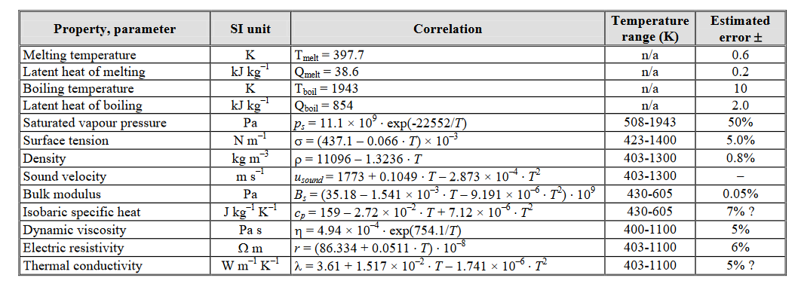
100 Mwt
6320 rods in reactor, only 4740 fueled
0.0211 MW/rod
volume of rod =

References

(1) Lead–Bismuth Eutectic (LBE):
A Coolant Candidate for Gen. IV
Advanced Nuclear Reactor Concepts
By Jinsuo Zhang

(2) https://www.iaea.org/NuclearPower/Downloadable/Meetings/2012/2012-02-29-03-02-TM-FR/11a_Tarantino-Cinotti.pdf

(3) Steel corrosion by LBE
https://www.sciencedirect.com/science/article/pii/S0010938X09000936

(4) MechE Perspective
https://nmfc.engineering.osu.edu/sites/nmfc.osu.edu/files/uploads/LBE%20Review.pdf

(5) RBEC LEAD-BISMUTH COOLED FAST REACTOR:
REVIEW OF CONCEPTUAL DECISIONS
http://www.iaea.org/inis/collection/NCLCollectionStore/_Public/33/015/33015242.pdf

