Chapter 12 Homework Problems

Problem 12.1

A 1 kg block sits on a rotating table as shown below. If the static coefficient of friction is assumed to be .4, what is the maximum angular velocity ($\dot{θ}$) that can be achieved before the block begins to slip?

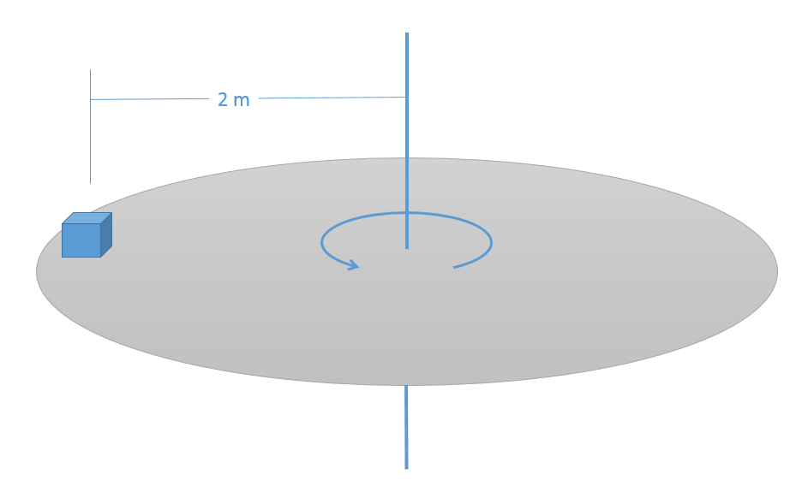(Solution: $\dot{θ}=1.4\frac{rad}{s}$)

Problem 12.2

A 5 kg instrument is held via a cable to a space station. The instrument and space station are both rotating at a rate of .5 rad/s when the space station begins retracting the cable at a constant rate of .25 m/s.

1. What is the tension in the cable at this instant?
2. What will the angular acceleration of the cable be ($\ddot{θ}$)?

(Hint: there are no forces in the theta direction)

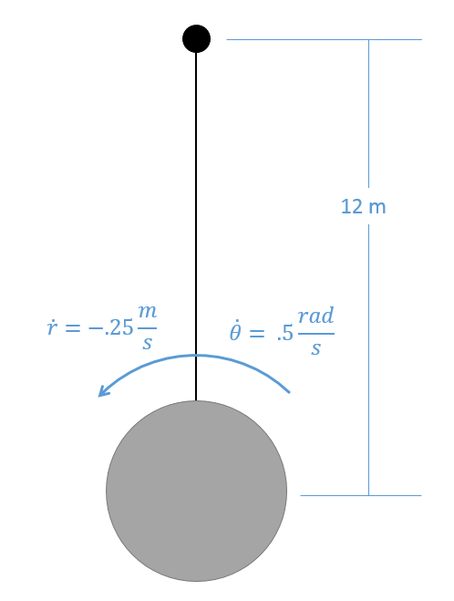

(Solution: T = 15 N, $\ddot{θ}=.0208\frac{rad}{s^{2}}$)