**Software Requirements and Design Document**

**For**

**Group <ResistorCalculator>**

Version 3.0

**Authors**:

Jorge Atencio

Jacob Hobson

Schmidt Jean

Ronald Nazaire

Vinzce Yadao

# Overview (5 points)

The application is a Resistor Calculator targeted towards FSU/FAMU College of Engineering Students/Faculty. We have shopped the idea around with several FSU/FAMU students and professors, they believe that this would be a very helpful tool to use during their class and labs. The tool calculates the ohm value and tolerance based on the resistor color codes. The calculator features the support of multi-band calculations (4-5 bands). The backend of the application supports user accounts to write reviews for the website and to participate in a leaderboard point based system. The front end will implement a cohesive and easy-to-understand UI that matches material design standards.

# Functional Requirements (10 points)

**0 = Done**

**1 = High Priority**

**2 = Medium Priority**

**3 = Low Priority**

**1) Resistor Calculation**: Decodes the information for color banded axial lead resistors. Able to select the number of bands, then the colors of the bands. Then calculates the value and tolerance of the resistors

**1) Multi-Band Implementation:** Support of 4, and 5 band resistors. Full Resistor Calculation functionality for multiple band values.

**2) Updating the Resistor Visually**: Should be able to see a visual representation of the Resistor when changing each band color.

**3) User Log In**: Users are able create an account and log in.

**3) Website Review**: Users are able to view previous reviews and review the website themselves

**3)** **Leaderboard**: Points gained towards specific events. Registration: 10 pts. Logging In: 5 pts. Save calculations: 3 pts. Writing a Review: 15 pts.

# Non-functional Requirements (10 points)

* Passwords should never be viewable at the point of entry or any other time
* Password recovery
* Display should be easily understandable with clear font and without truncating displayed text
* Program should be able to process calculations at a high rate of speed
* User calculations should be reliably stored under their account should they chose to save it
* All resistor calculations must be accurate
* Cohesive and Understandable UI design
* A stable non-crashing application
* Ability to run on any web browser

# Use Case Diagram (10 points)

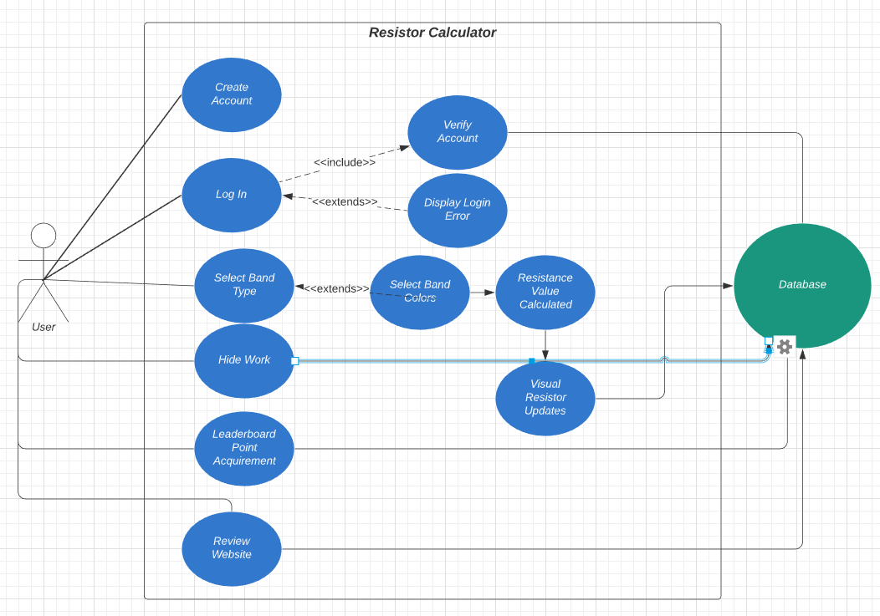

1. Name: Create Account

Participating actors: User

Entry condition: User enters the webpage URL

Exit condition: User clicks the back button

Flow of events:

1. User opens the web page

2. User is on the login page

3. User fills out registration information

4. User clicks the registration button

2. Name: Log In

Participating actors: User, DataBase

Entry condition: User enters the webpage URL

Exit condition:

User clicks the back button

Flow of events:

User opens webpage

User is on login page

User inputs log in information

User clicks the login button

3. Name: Select Band Type

Participating actors: User, Database

Entry condition:

User selects an option from the “Select Band Type” dropdown menu

Exit condition:

User selects the “Select Band Type Option” from dropdown menu

Flow of events:

Starting from the main page (Clicking the “Calcul” button)

User clicks on the “Select Band Type” dropdown menu

User selects desired number of bands

Database updates webpage to show the amount of desired bands

4. Name: Select Band Colors

Participating actors: User, Database

Entry condition:

User selects options from the “Band Color” dropdown menus (number of dropdown menus dependent on how bands selected)

Exit condition:

User clicks elsewhere

Flow of events:

After User selects the desired “Select Band Type” option from the dropdown menu

User clicks on the various Band Color dropdown menus

User selects desired Band Colors from dropdown menus

Database updates the resistor value(Resistance Value Calculated) and visualized resistor (Visual Resistor Updates) as bands are selected

Examples are given on the chart to the right of the calculator. Select the same amount of bands and the same colors to receive the same calculation stated to the right of the resistor.

5. Name: Leaderboard Point Acquirement

Participating actors: User, Database

Entry conditions:

User selects the “save calcul” button to acquire 3 points

Users first registration of an account to acquire 10 points

Each time a user logs in to acquire 5 points per log in

User writes a review to the website to acquire 15 points

Exit condition:

Once entry conditions are complete. Exit Condition happens

Flow of events:

User does either one of the four entry conditions

Database updates the Users total points based on what entry condition was done

Starting from the main page (Clicking the “Calcul” button)

User clicks on the “Leaderboard” button to see the Top 3 users with the most acquired points

To exit from Leaderboard. Click the “Calcul” button to return to Resistor Calculator (Main Page)

6. Name: Review Website

Participating actors: User, Database

Entry condition:

User clicks on the “Review” button

Exit condition:

User clicks on the “Calcul” button to return to the main page

Flow of events:

Starting from the main page (Clicking the “Calcul” button)

User clicks on the “Review” button

User is able to see reviews for website

User clicks on “Write a Review” button

User enters their name under the “Your Name:” window

User enters their review of the website under the “Your comments:” window

User clicks on the “post” button to post their review

User will be sent back to the “Review” page

User needs to click the “Calcul” button, then click the “Reviews” button to refresh the page to see their own review.

User scrolls to the bottom to see their review

6. Name: Hide Work

Participating actors: User

Entry condition:

User clicks on the “Hide Work” toggle

Exit condition:

User clicks on the “Hide Work” toggle

Flow of events:

Starting from the main page (Clicking the “Calcul” button)

User toggles the “Hide Work” toggle on the top left

# Class Diagram and Sequence Diagrams (15 points)

Class Diagram:

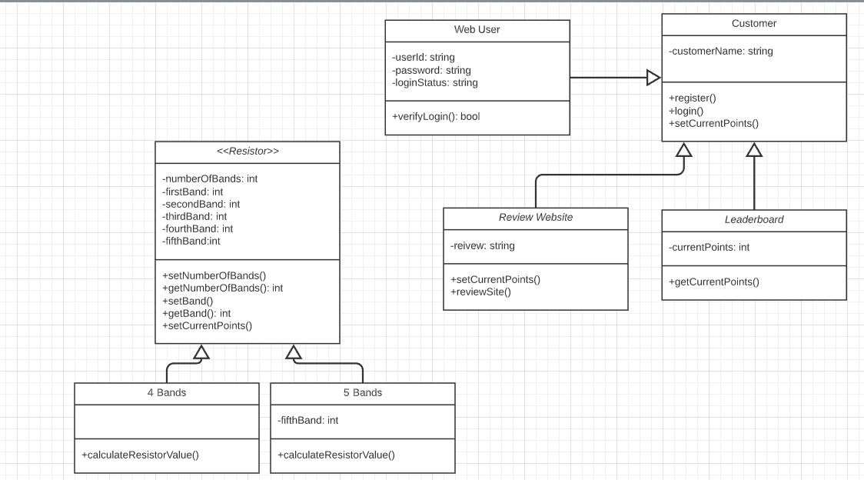

Sequence Diagram:

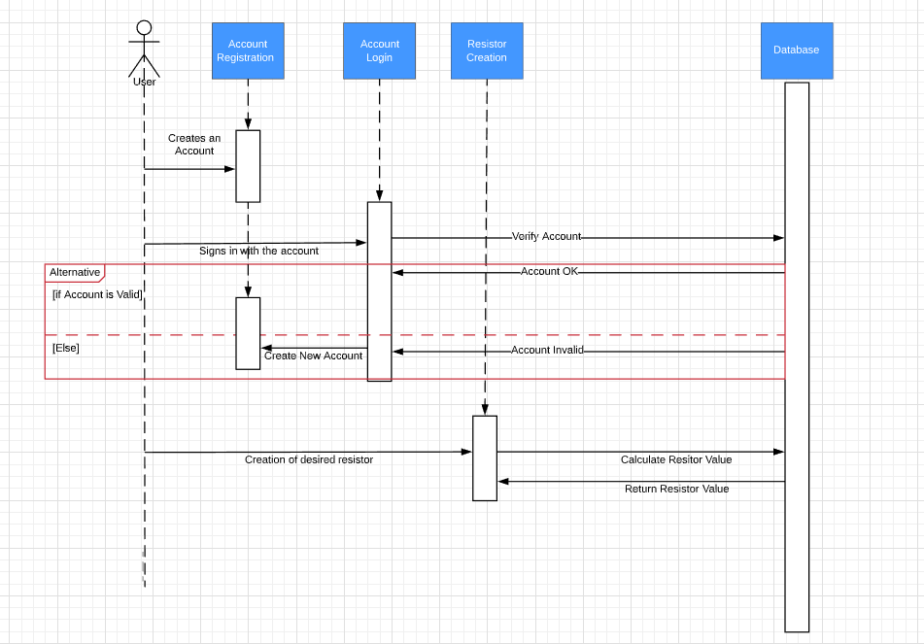

# Operating Environment (5 points)

Any web browser that has an internet connection and a valid google account

# Assumptions and Dependencies (5 points)

The application is depending on a SQL server in order for a user to login and register their account. The SQL server is also dependent on storing the saved resistor values.