Open a terminal in HPG

1. Module load gcc/4.7.2
2. Module load openmpi
3. This is taken from the amica wiki:
   1. This was the way SP performed the compilation in the past: “””mpif90 -I/opt/intel/mkl/include/ -fpp -qopenmp -O3 -mkl -static -static-intel -DMKL funmod2.f90 amica15.f90 -o amica15ub “””
   2. This is another option (NOT TESTED)A screenshot of a computer program

      AI-generated content may be incorrect.
4. (THIS WORKS) This is what I used: “”” mpif90 -I/opt/intel/mkl/include/ -fpp -qopenmp -O3 -mkl -static -static-intel -DMKL funmod2.f90 amica15.f90 -o amica15ub “””
   1. 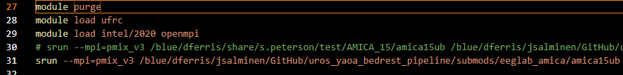
5. Maybe this works?: “”” mpif90 /Qopenmp /Qmkl /F2147483648 /DMKL /fpp /O3 /exe:amica15mkl.exe funmod2.f90 amica15.f90 “””

SP’s original compilation commands:

“””

#Building MPICH:

module load intel

tar xfz mpich-3.2.tar.gz

mkdir /ufrc/dferris/s.peterson/mpich-install

mkdir /ufrc/dferris/s.peterson/mpichBuild/mpich-3.2

cd /ufrc/dferris/s.peterson/mpichBuild/mpich-3.2

#Set enivronment variables for AMICA

export CC=icc

export CXX=icc

export FC=ifort

export F77=ifort

#Configure

/ufrc/dferris/s.peterson/mpich-3.2/configure \-prefix=/ufrc/dferris/s.peterson/mpich-install |& tee c.txt

#Build

make |& tee m.txt

#Install

make install |& tee mi.txt

#Set path as variable

export PATH=/ufrc/dferris/s.peterson/mpich-install/bin:$PATH

#Building AMICA:

module load intel

/ufrc/dferris/s.peterson/mpich-install/bin/mpif90 -I/apps/compilers/intel/2016/mkl/include/ -fpp -fopenmp -O3 -mkl -static-intel -DMKL funmod2.f90 amica15.f90 -o amica15ub

“””