Install Python

Version 3.7 works

Version 3.10 does not work

## Windows

<https://www.python.org/downloads/windows/>

(follow exe prompts using default installation suggestions, no need to extend path limit).

## Linux

Get a linux subsystem for windows (Ubuntu is good)

Use this command to get to your windows drive: “cd /mnt/c/”

From there navigate to your python tgz file and use this tutorial to install:

<https://medium.com/@lupiel/installing-python-from-a-tgz-file-a-step-by-step-guide-4cf5f4a17a86>

# Install Fooof

## Windows

For this example I will be using Python-3.7 from the MicrosoftStore, but for any other version you may replace the last 2 numbers after python (e.g., If I was using Python-3.6.5 I would use the command “python3.6” to access that version’s download)

Link: <https://github.com/fooof-tools/fooof_mat>

See for additional help: <https://irenevigueguix.wordpress.com/2020/03/25/loading-python-into-matlab/>

You may also configure your PATH variable to change how python3 command operates.

In windows command prompt:

“which python3.7”

“python3.7 –m pip install cpython”

“python3.7 –m pip install numpy”

“python3.7 –m pip install fooof”

If you are using a Microsoft version of Python the package data isn’t installed directly to your version of python, so you will need to manually install it to the python.exe of your choice using the full path length.

“C:\Users\<user>\AppData\Local\Programs\Python\Python37\python –m pip install cpython”

“C:\Users\<user>\AppData\Local\Programs\Python\Python37\python –m pip install numpy”

“C:\Users\<user>\AppData\Local\Programs\Python\Python37\python –m pip install matplotlib”

“C:\Users\<user>\AppData\Local\Programs\Python\Python37\python –m pip install fooof”

You may try opening your python install in the command window and typing:

“Import fooof”

Output:

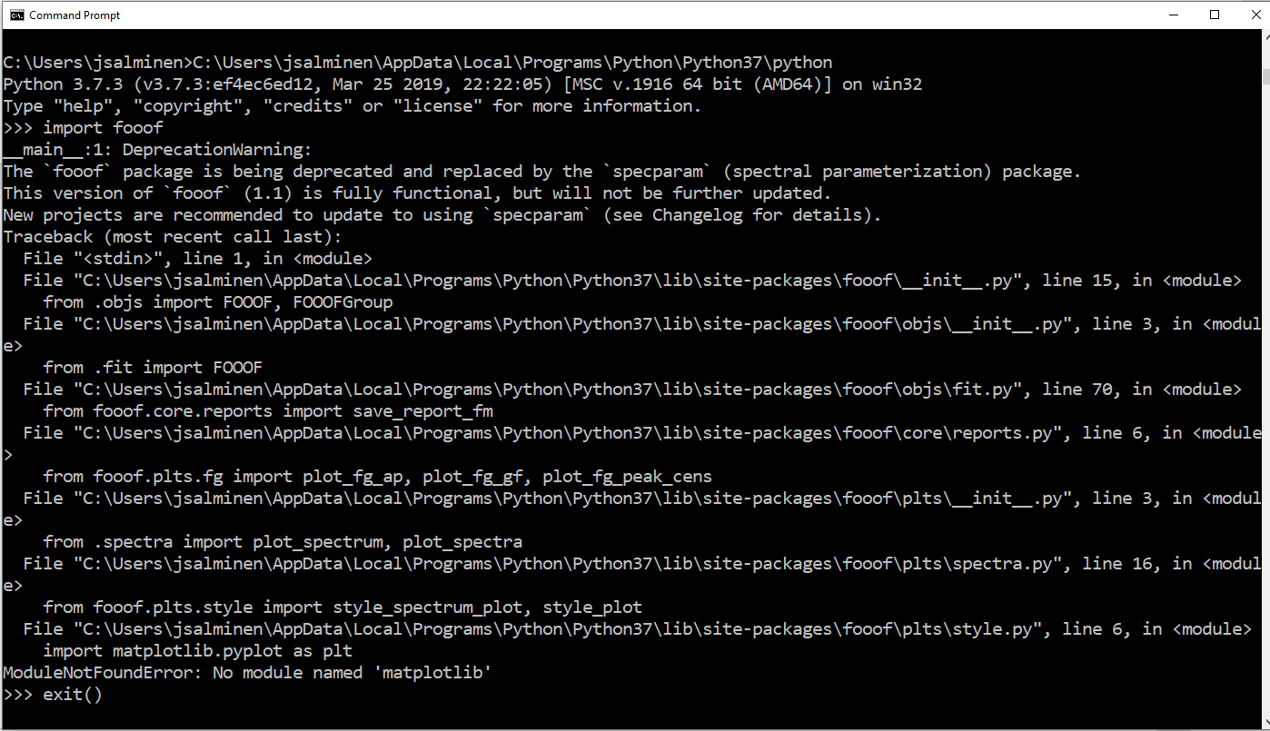

If there is an error try to resolve it then move on to using the install in MATLAB. In the example above I’m missing the matplotlib library even though the fooof setup.py says I don’t need it… I will pip install matplotlib and the package should import as desired.

# MATLAB

Type: “pyversion” 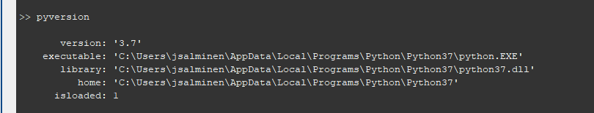

If anything other than your desired python is loaded you will need to find where the exectuable is located and added it using:

“pyversion(‘path/to/my/python.exe’);”

You may need to restart matlab before doing this.