Install Python

See. For a list of compatible versions of python for matlab: [Versions of Python Compatible with MATLAB Products by Release - MATLAB & Simulink (mathworks.com)](https://www.mathworks.com/support/requirements/python-compatibility.html?s_tid=srchtitle_site_search_1_python%20compatibility)

## Windows

<https://www.python.org/downloads/windows/>

(follow exe prompts using default installation suggestions, no need to extend path limit).

## Linux

Get a linux subsystem for windows (Ubuntu is good)

Use this command to get to your windows drive: “cd /mnt/c/”

From there navigate to your python tgz file and use this tutorial to install:

<https://medium.com/@lupiel/installing-python-from-a-tgz-file-a-step-by-step-guide-4cf5f4a17a86>

# Install Fooof

## Windows

I’m using python version 3.7 and MATLAB version 2020b for this example. Any other version check the compatible versions of python for MATLAB. Adapting this, you may replace the last 2 numbers after python (e.g., If I was using Python-3.6.5 I would use the command “python3.6” to access that version’s download)

Link: <https://github.com/fooof-tools/fooof_mat>

See for additional help: <https://irenevigueguix.wordpress.com/2020/03/25/loading-python-into-matlab/>

You may also configure your PATH variable to change how python3 command operates.

In windows command prompt:

“which python3.7”

“python3.7 –m pip install cpython”

“python3.7 –m pip install numpy”

“python3.7 -m pip install matplotlib”

“python3.7 –m pip install fooof”

NOTE: If you are using multiple python installations it can be easy for windows to confuse them, so its best to use absolute pathing to the python.exe:

“C:\Users\<user>\AppData\Local\Programs\Python\Python37\python –m pip install cpython”

“C:\Users\<user>\AppData\Local\Programs\Python\Python37\python –m pip install numpy”

“C:\Users\<user>\AppData\Local\Programs\Python\Python37\python –m pip install matplotlib”

“C:\Users\<user>\AppData\Local\Programs\Python\Python37\python –m pip install fooof”

You may try opening your python install in the command window and typing:

“Import fooof”

Output:

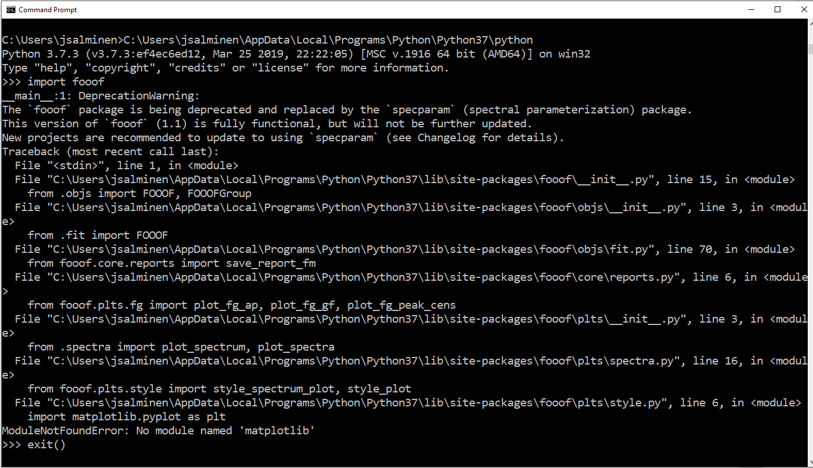

If there is an error try to resolve it then move on to using the install in MATLAB. In the example above I’m missing the matplotlib library even though the fooof setup.py says I don’t need it… I will pip install matplotlib and the package should import as desired.

# MATLAB

Type: “pyversion” 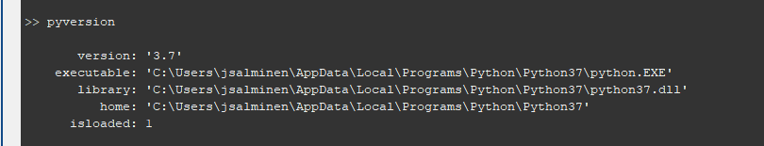

If anything other than your desired python is loaded you will need to find where the exectuable is located and added it using:

“pyversion(‘path/to/my/python.exe’);”

You may need to restart matlab before doing this.

# FOOOF For Blue Drive

You would need to contact IT and make them install CPython, Matplotlib, and FOOOF onto your desired python install.

See. For a list of compatible versions of python for matlab: [Versions of Python Compatible with MATLAB Products by Release - MATLAB & Simulink (mathworks.com)](https://www.mathworks.com/support/requirements/python-compatibility.html?s_tid=srchtitle_site_search_1_python%20compatibility)

I’ve tried:

* An installation of python using the windows installer (or linux) to the location on the blue drive.
* Creating a virtual environment using a loaded python version on a hipergator terminal (e.g., module load python/3.10 >> python -m venv ./venv). Hipergator doesn’t give you access to pip libraries for installation due to security issues.

The least buggy way, and unfortunately the slowest, is to use a downloaded python version for windows/mac and run it locally.

# UPDATES