# RESOURCES

* HiperGator MATLAB Website: https://help.rc.ufl.edu/doc/Matlab
* SLURM Documentation: <https://slurm.schedmd.com/documentation.html>
* Open-MPI Documentation: <https://www.open-mpi.org/>
* Comprehensive Linux Tutorial: <https://www.geeksforgeeks.org/introduction-to-linux-operating-system/>
* MATLAB **mcc** command documentation: <https://www.mathworks.com/help/compiler/mcc.html>
* MATLAB tool to get dependencies of a particular function: <https://www.mathworks.com/help/matlab/matlab_prog/identify-dependencies.html>

# Scripts Needed

* compile_mim_mcc_dipfit.sh
* compile_mim_mcc_dipfit.m
* run_mim_mcc_dipfit_exe.sh
* mim_mcc_dipfit.m
* mim_mcc_dipfit

# Overview

MATLAB is a great resource for automatizing the processing of EEG data. When MATLAB is ran on a super computer like the HiperGator, the potential for quick and efficient processing of EEG data has no limit. However, there is a lack of understanding of the resources available to users of the HiperGator because there are many interwoven programming languages and hardware systems that support the overall system we call the HiperGator.

For example, SLURM allows users to submit MATLAB scripts to HiperGator systems to run on a “computer” that has 64 processing cores and 1 Terabyte of RAM. SLURM alone does not accomplish this task. SLURM also needs open-mpi, Linux operating system, a working MATLAB license, and custom scripts designed by HiperGator staff.

Another limitation of MATLAB on an openly available system like the HiperGator, is licensing. There are a limited number of MATLAB licenses available to be checked out when running your MATLAB scripts using SLURM. A way to overcome this limitation is using the MATLAB compiler command **mcc**. The **mcc** command utilizes methods within the **matlab.codetools** class to analyze a function’s dependencies, files required to run a particular function, and syntax, a particular way a coding language wants the code to be formatted. This allows a user to compile a function or piece of code into a deployable executable that can be ran on various operating systems given that the operating system has a MCR (MATLAB Code Runtime Library). MCR is a collection of functions and data are required to run the MATLAB application. MCR is freely available which makes compiling code with the **mcc** command extremely useful for scientific reproducibility.

**Output:** 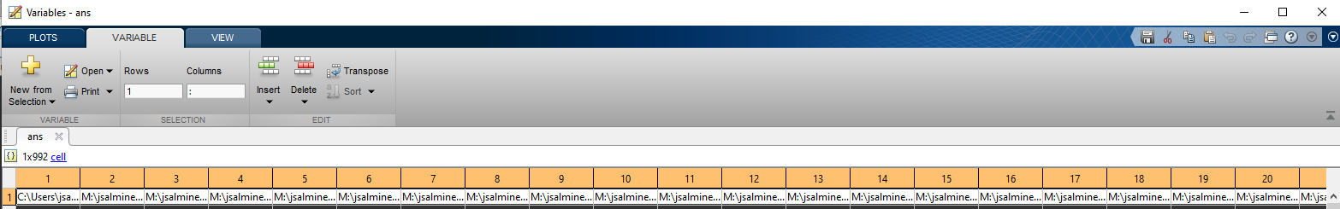

You can copy and paste this into a document editor by left clicking on the row index “1” and right clicking then left click “copy” in the dialog box

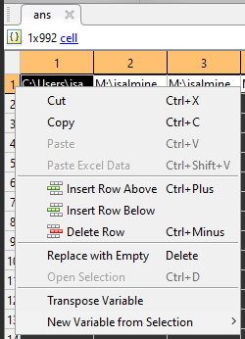

I recommend pasting it in Microsoft Word or Notepad++ and using the Find&Replace feature to remove the curly brackets “{“ “}”

Replace .mexw64 with .mexa64

Remove any “@” symbols within paths and make sure to copy and paste these files then change their names to remove the “@” symbol

Remove any folders with “private” in the name

**matlab.codetools.requiredfilesAndProducts**(mim_mcc_dipfit.m)