Compiling:

Error Log & Solving:

1. 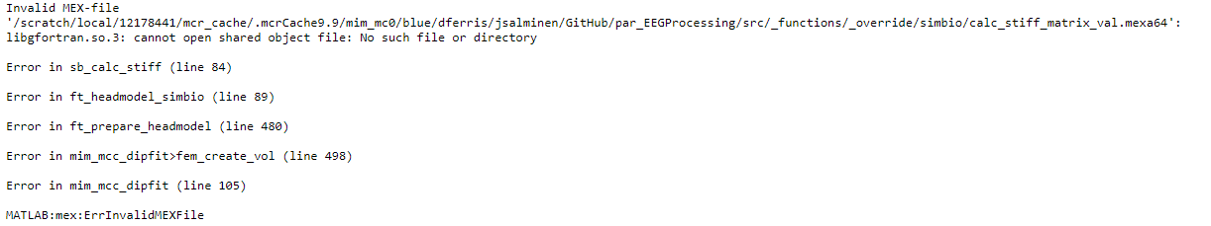
   1. Solution: compile using Matlab/2020a & run using MCR/2020a.
   2. Explanation: this particular mex file needs libraries from libgfortran.so.3 . 2020b has libgfortran.so.5 & 2020a has libgfortran.so.3. If you open up a hipergator terminal and type ldd –d libname.so <path-to-mex-file> you will see the required dependencies for that function and whether they are available or not under your current module configuration.

Helpful commands in linux:

* ldd –d libname.so <path-to-mex-file>
* ldconfig –p | grep <library-name.so>