(04/29/2025)  
messing around with the newtimef function and different TimeFreq decomps

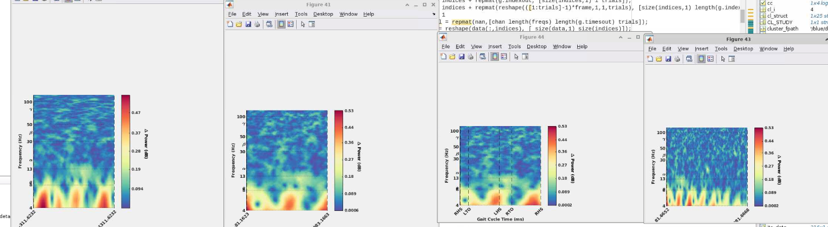

From left to right are:

1. Hanning window taper with some weird window size and n-times out
2. Hanning window taper with winsize = 188, timesout = 200, ntimes=200, padratio = 2^5.