|  |  |
| --- | --- |
| Operand | Value |
| %rax | 0x100 |
| 0x104 | 0xAB |
| $0x108 | 0x108 |
| (%rax) | 0xFF |
| 4(%rax) | 0xAB |
| 9(%rax, %rdx) | 0x11 |
| 260(%rcx, %rdx) | 0x13 |
| 0xFC(, %rcx, 5) | 0xFF |
| (%rax, %rdx,4) | 0x11 |

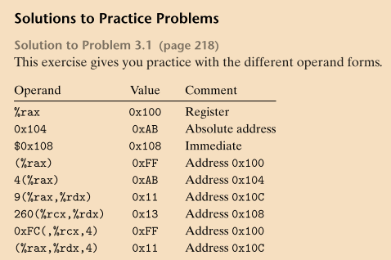short t = 10y + z + x*y

short arith3(short x, short y, short z)

{

Short p1 = z ^ y

Short p2 = z/2^9

Short p3 = -z

Short p4 = z - y

Return p4

}

