# Background

In the homework exercises, you are creating an application that will perform CRUD (Create, Read, Update, and Delete) operations on a MySQL database. This application connects to a DIY Project database and demonstrates many features of SQL and JDBC. Learning these skills will help prepare you for using these skills in the workplace.

As a reminder, in the last two weeks you used JDBC to connect to a MySQL database. Then, you diagrammed the project tables using Draw.io. Lastly, you wrote the CREATE TABLE statements for the five tables and created the tables in DBeaver.

In this week's exercises, you will begin development of the menu-driven application. You will use proper exception handling to gracefully manage any errors. You will write code to add project details to the project tables. This will involve properly creating and managing JDBC resources as well as database transactions.

In future exercises you will write code to read from a single table as well as from joined tables. Finally, you will write code to update and delete table rows.

# Objectives

In these exercises, you will:

* Learn to write a menu-driven application with correct exception handling.
* Implement a scanner to gather user input from the console.
* Learn how to work with BigDecimal objects.
* Use JDBC to correctly handle resources (Connections and PreparedStatements) ensuring that they are closed properly.
* Implement JDBC methods to insert a Project object into the project table.

# Instructions

**Points possible: 75**

**URL to GitHub Repository:**

**URL to Public Link of your Video :**

**———————————————————————————————————————————**

**Instructions:**

1. Follow the **Exercises** below to complete this assignment.

* + - In Eclipse, or an IDE of your choice, write the code that accomplishes the objectives listed below. Ensure that the code compiles and runs as directed.
    - Create a new repository on GitHub for this week’s assignment and push your completed code to this dedicated repo, including your entire Maven Project Directory (e.g., mysql-java) and any .sql files that you create. In addition, screenshot your ERD and push the screenshot to your GitHub repo.
    - Include the screenshots into this Assignment Document indicated by: 
    - Create a video showcasing your work:
      * In this video: record and present your project verbally while showing the results of the working project.
      * Easy way to Create a video: Start a meeting in Zoom, share your screen, open Eclipse with the code and your Console window, start recording & record yourself describing and running the program showing the results.
      * Your video should be a maximum of 5 minutes.
      * Upload your video with a public link.
      * Easy way to Create a Public Video Link: Upload your video recording to YouTube with a public link.

2. In addition, please include the following in your Coding Assignment Document:

* + - The requested screenshots, indicated by: 
    - The URL for this week’s GitHub repository.
    - The URL of the public link of your video.

3. Save the Coding Assignment Document as a .pdf and do the following:

* + - Push the .pdf to the GitHub repo for this week.
    - Upload the .pdf to the LMS in your Coding Assignment Submission.

**———————————————————————————————————————————**

# Important

In the exercises below, you will see this icon: . This means to take a screen shot or snip showing the results of the action or the code in the editor.

# Exercises

In these exercises you will write code to create a menu-driven application. You will display menu selections to the user and will write the code to add project details to the DIY project tables. This will demonstrate the use of the INSERT statement (the Create part of CRUD).

Complete these exercises as directed. If you get hopelessly stuck, please see the "Solutions" section below.

In these exercises, you will often be told to call a method prior to creating it. This is a good approach. You set up the return type by assigning to a variable and set up the parameters. Then, Eclipse can correctly create the method.

## Cleanup

In this section, you are working with ProjectsApp.java in the projects package.

1. Delete the debugging line (DbConnection.getConnection();) in the main method. The method should now be empty.
2. Remove the import statement: import projects.dao.DbConnection;

## Build the Menu Application

The exercises in this section build a menu-driven application. This application displays a list of available operations. The user selects which operation to perform. A switch statement then routes the selection to the appropriate method. Along the way you will add in proper exception handling. This is an important step to get right when building any application.

The purpose of the menu application is to perform CRUD operations on a relational database that holds information on DIY projects. Throughout the coming weeks you will add to this application to insert project rows, then materials, steps, and categories. You will fetch projects as a list and fetch an individual project with all the details. You will modify rows and delete an entire project with all associated detail (child) rows.

In this section, you are working with ProjectsApp.java in the projects package.

1. In order to display a list of menu options you must store them somewhere. In this step you will write the code that holds the list of operations.
   1. Add a private instance variable named "operations". The type is List<String>. Initialize it using List.of with the following value: "1) Add a project". To prevent the Eclipse formatter from reformatting the list, surround the variable declaration with // @formatter:off and // @formatter:on so that it looks like this:

This list of operations will be printed on the console so that the user will be reminded which selection to make.

1. In this step you will use a Scanner to obtain input from a user from the Java console. A Scanner is a Java object that can be used to read from a variety of sources. When you create the Scanner, you will set its input source to System.in, which is the opposite of System.out. You use System.out to print to the console. You will use the Scanner to read from the console. So, the user types in selections and the Scanner reads the input and gives it to the application.

Add a private instance variable named scanner. It is of type java.util.Scanner. Initialize it to a new Scanner object. Pass System.in to the constructor. This will set the scanner so that it accepts user input from the Java console. It should look like this:

Picture 38

1. In this step you will call the method that processes the menu. In the main() method, create a new ProjectsApp object and call the method: processUserSelections() method. The method takes zero parameters and returns nothing.

Picture 22

1. Now you can create the processUserSelections() method as an instance method. This method displays the menu selections, gets a selection from the user, and then acts on the selection. Let Eclipse create the method for you by waving your mouse over the compiler error in the main() method (over the red squigglies). Eclipse will pop up a menu. Select "Create method processUserSelections()".

In method processUserSelections():

* 1. Add a local variable:

Picture 24

* 1. Add a while loop below the local variable. Loop until the variable done is true.

* 1. Inside the while loop, add a try/catch block. The catch block should catch Exception. Inside the catch block print the Exception message. Call the toString() method on the Exception object provided to the catch block. This is done by simply concatenating the Exception object onto a String literal. When you do this Java implicitly calls the toString() method behind the scenes.
  2. Inside the try block, assign an int variable named selection to the return value from the method getUserSelection(). The method should now look like this:

1. Create the method getUserSelection(). It takes no parameters and returns an int. This method will print the operations and then accept user input as an Integer. In the getUserSelection() method:
   1. Make a method call to the method printOperations(). This method takes no parameters and returns nothing.
   2. Add a method call to getIntInput(). Assign the results of the method call to a variable named input of type Integer. The method getIntInput(), which you haven't written yet. It will return the user's menu selection. The value may be null. Pass the String literal "Enter a menu selection" as a parameter to the method.
   3. Add a return statement that checks to see if the value in local variable input is null. If so, return -1. (The value -1 will signal the menu processing method to exit the application.) Otherwise, return the value of input. The method should look like this:

1. Create the method printOperations(). It takes no parameters and returns nothing. This method does just what it says, it prints each available selection on a separate line in the console. In the printOperations() method:
   1. Print a line to the console:

Picture 28

* 1. Print all the available menu selections, one on each line. Each line should be indented slightly (2 or 3 spaces). Use any strategy that you choose to print the instructions. If you use a Lambda expression as shown in the video, it should look like this:

Picture 29

Every List object must implement the forEach() method. forEach() takes a Consumer interface object as a parameter. Consumer has a single abstract method, accept(). The accept() method takes a single parameter and returns nothing. The Lambda expression has a single parameter and System.out.println returns nothing. The Lambda expression thus matches the requirements for the accept() method.

If you don't want to use a Lambda expression, you can use an enhanced for loop to print the instructions.

1. There will be several user input methods that return different types of objects. Due to the way the java.util.Scanner object was implemented, the safest way to get an input line from the user is to input it as a String and then convert it to the appropriate type. With this design, all the input methods will ultimately call the String input method, which actually prints the prompt and uses the Scanner to get the user's input. In this step, you will write a method that returns an Integer value.

Create the method getIntInput. It takes a single parameter of type String named prompt. This method accepts input from the user and converts it to an Integer, which may be null. It is called by getUserSelection() and will be called by other data collection methods that require an Integer. Inside the method body:

* 1. Assign a local variable named input of type String to the results of the method call getStringInput(prompt).
  2. Test the value in the variable input. If it is null, return null. Use Objects.isNull() for the null check.
  3. Create a try/catch block to test that the value returned by getStringInput() can be converted to an Integer. The catch block should accept a parameter of type NumberFormatException.
     1. In the try block, convert the value of input, which is a String, to an Integer and return it. If the conversion is not possible, a NumberFormatException is thrown. The message in the NumberFormatException is totally obscure so it will get fixed in the catch block. Here's what the contents of the try block should look like:

return Integer.valueOf(input);

* + 1. In the catch block throw a new DbException with the message, input + " is not a valid number. Try again."
  1. The method should look like this:

1. Now create the method that really prints the prompt and gets the input from the user. Create the method getStringInput(). It should have a single parameter of type String named prompt. This is the lowest level input method. The other input methods call this method and convert the input value to the appropriate type. This will also be called by methods that need to collect String data from the user. It should return a String. Inside the method:
   1. Print the prompt using System.out.print(prompt + ": ") to keep the cursor on the same line as the prompt. (Note: print and not println!)
   2. Assign a String variable named input to the results of a method call to scanner.nextLine().
   3. Test the value of input. If it is blank return null. Otherwise return the trimmed value.
   4. The method should look like this:

* 1. At this point the file should have no compile errors.

1. Now we want to add code that will process the user's selection. Since the user enters an Integer value (the menu selection number) you can use a switch statement to process the selection.

Back in the method processUserSelections():

* 1. Add a switch statement below the method call to getUserSelection(). Create a switch statement to switch on the value in the local variable selection.
  2. Add the first case of -1. Inside this case, call exitMenu() and assign the result of the method call to the local variable done. Make sure to add the break statement.
  3. Add the default case. Print a message: "\n" + selection + " is not a valid selection. Try again.".

1. Now that the menu code has been written you will need to test it to see if it works. Test the application two ways:
   1. This will test that a non-integer selection prints an error message and gracefully recovers. Run the application. Click in the Eclipse console so that input will go to the scanner. Enter "abc" (without quotes) and press Enter. You should get an error message and be prompted again to enter a valid selection. Now press Enter with no input. The application should quit. Take a screen shot to show the application output . It should look something like this:

* 1. This will test that entering a valid Integer without a corresponding case statement will print an error message and recover gracefully. Run the application. Click in the Eclipse console so that input will go to the scanner. Enter "5" (without quotes) and press Enter. You should get an error message and be prompted again to enter a valid selection. Now press Enter with no input. The application should quit. Take a screen shot to show the application output . It should look something like this:

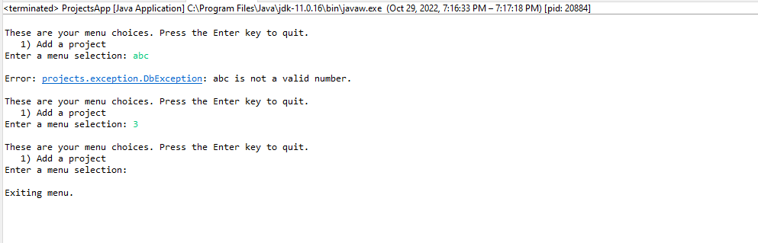

## Add project files from student resources

Promineo Tech has provided some resources so that you don't have to write every bit of code. In this section, you will add files into the mysql-java project from the student resources.

1. Drag the four files from the student resources /Homework/entity folder and drop them onto the projects.entity package in the Eclipse project. You may need to expand some folders in the package explorer to make the projects.entity package visible. When done you should see Category.java, Material.java, Project.java, and Step.java in the projects.entity package. There should be no errors visible in those files.
2. Drag the directory named "provided" from the student resources /Homework folder and drop it onto src/main/java in the package explorer. When done, there should be a new package named provided.util with a single file in it named DaoBase.java.

## Add a new project to the project table

You will now write the code to collect project information, create the project entities and insert the project row into the project table.

### Modifications to the main application file

This section will collect project information from the user and call the service class (not written yet) to store the project row. In this section you will be introduced to the BigDecimal class if you haven't seen it before.

The BigDecimal class exactly represents decimal numbers (numbers with decimal places). In this, the decimal numbers act like Integers with a known number of decimal places. Money is a good example of this. Your bank may perform operations on money that results in fractional pennies, but at the end of the day your account is credited or debited with an exact dollar and penny amount. Fractional pennies are transitive and are not persisted to your account.

The BigDecimal object is perfectly suited to handle the SQL DECIMAL data type. DECIMAL values have a fixed number of digits (precision) and a fixed number of decimal places (scale). In the CREATE TABLE statement, a column definition of DECIMAL (5, 2) means that the value can range from -999.99 to 999.99. There are a maximum of five digits (precision) with two decimal places (scale).

BigDecimal contains immutable values – once created they cannot be changed. Any operation performed on BigDecimal results in a new BigDecimal object. BigDecimals can be created using a constructor, then the scale can be set by calling the setScale() method. To set the scale to 2 (two decimal places) do something like this:

BigDecimal bd = new BigDecimal("1234.5678").setScale(2);

The JDBC driver has methods to natively handle BigDecimal. The driver automatically converts from Java BigDecimal to SQL DECIMAL and vice versa.

In this section you will be working in ProjectsApp.java.

1. At the top of the class, add a private instance variable of type ProjectService named projectService and call the zero-argument constructor to initialize it. Let Eclipse create the ProjectService class. Make sure the class is created in the projects.service package. (Hint: wave the mouse over ProjectService, which should have red squigglies under it. When the menu pops up, click "Create class 'ProjectService'". When the Java Class wizard pops up, change the value in the field "Package" from "projects" to "projects.service".) The editor will switch over to ProjectService.java. Switch back to ProjectsApp.java.
2. In this step, you will add code in the switch statement to handle user selection "1", which will call a method to collect project details and save them in the project table.

In the method processUserSelections(), add case 1 to the switch statement. Inside the case, call the method createProject(). This method takes no parameters and returns nothing. Remember to add the break statement.

1. Now write the method to gather the project details from the user. Once collected, they will be put into a Project object. Then, another method will be called to save the project details.

Create the method createProject(). It is private, takes no parameters, and returns nothing. In this method:

* 1. Add local variable String projectName. Assign the value to the result of calling getStringInput("Enter the project name").
  2. Add local variable BigDecimal estimatedHours. Assign the value to the result of calling getDecimalInput("Enter the estimated hours"). You may need to add the import statement for BigDecimal. It is in the java.math package.
  3. Add local variable BigDecimal actualHours. Assign the value to the result of calling getDecimalInput("Enter the actual hours").
  4. Add local variable Integer difficulty. Assign the value to the result of calling getIntInput("Enter the project difficulty (1-5)"). Note that the instructions don't include code to validate that the input is valid. You can do this if you want.
  5. Add local variable String notes. Assign the value to the result of calling getStringInput("Enter the project notes").
  6. Create a new variable of type Project named project. Initialize it to a new Project object by calling the zero-argument constructor. Import the Project class from the projects.entity package. The Project class should have been added to the Eclipse project in the section "Add project files from student resources." If Eclipse can't find the import, follow the instructions in that section.
  7. Call the appropriate setters on the Project object to set projectName, estimatedHours, actualHours, difficulty and notes. For example, to add the project name on the Project object, call setProjectName() and pass it projectName.
  8. Call the addProject() method on the projectService object. Pass it the Project object. This method will be created shortly. This method should return an object of type Project. Assign it to variable dbProject.
  9. Print a success message to the console "You have successfully created project: " + dbProject. The value returned from projectService.addProject() is different from the Project object passed to the method. It contains the project ID that was added by MySQL.

The method should look like this. (There will be an error on the line that calls the projectService object and the lines that call getDecimalInput()).

1. To get rid of the compilation errors, you will need to create two methods. In this step you will create the method getDecimalInput().

Create the method getDecimalInput(). The easiest way to do this is to create the method body, then copy the method contents from getIntInput() and paste it into the method body. Fix the following lines:

* 1. The line in the try block. Change it to:

Picture 33

This will create a new BigDecimal object and set the number of decimal places (the scale) to 2.

* 1. The message in DbException. Change it to:

Picture 36

1. Now create the second method that will fix the compilation errors. Wave the mouse over "projectService.addProject()". When the menu pops up, select "Add method 'addProject(project)' in in type 'ProjectService'".
2. Save all files. All compiler errors should now be gone.

### Modifications to project service

The service layer in this small application is implemented by a single file, ProjectService.java. *Mostly* this file acts as a pass-through between the main application file that runs the menu (ProjectsApp.java) and the DAO file in the data layer (ProjectDao.java).

In this section you will be working in ProjectService.java.

1. In this step, you will create the DAO class and initialize a variable of that type. At the top of the class, add a private instance variable of type ProjectDao named projectDao. Assign the variable to a new ProjectDao object by calling the constructor with no parameters. If possible, let Eclipse create the class for you. In any event, create a ProjectDao class in the projects.dao package. Make sure that ProjectDao extends DaoBase from the provided.util package. Save all files. You should have no compile errors. The editor will probably change to the ProjectDao class. Change back to the ProjectService class.
2. In method addProject(), call the method insertProject() on the projectDao object. The method should take a single parameter. Pass it the Project parameter and return the value from the method. The addProject() method should look like this:

public Project addProject(Project project) {

}

1. Wave the mouse over insertProject() (with the red squigglies) and select "Create method 'insertProject(Project)' in type 'ProjectDao'". Save all files. You should have no compile errors.

### Modifications to project DAO

Now you want to create the class that will read and write to the MySQL database. In this section you will write the values that were collected from the user and that are contained in a Project object to the project table using JDBC method calls.

In this section you will be working in file ProjectDao.java in the projects.dao package. If you followed the steps above, ProjectDao should extend DaoBase. If it doesn't, do that now or you will run into problems later.

#### Add constants

First, you should add some constants with the table names. It's a good idea to add constants for values that are used over and over again in a class. The table names are used by all the methods that write to or read from the tables.

In this section, you will be adding constants into the ProjectDao class. These are placed at the top of the class just inside the class body. Java does not have a "constant" keyword. Instead, a constant is specified using static final. Constants can either be public or private. In this file all the constants should be private.

1. Add the constant for the category table named CATEGORY_TABLE. Set the value to "category".
2. Add the constant for the material table named MATERIAL_TABLE. Set the value to "material".
3. Add the constant for the project table named PROJECT_TABLE. Set the value to "project".
4. Add the constant for the project-category table named PROJECT_CATEGORY_TABLE. Set the value to "project_category".
5. Add the constant for the step table named STEP_TABLE. Set the value to "step".

The constants should look like this:

#### Save the project details

There are several steps that must be taken to save the project details. First, you must create the SQL statement. Then you will obtain a Connection and start a transaction. Next you will obtain a PreparedStatement and set the parameter values from the Project object. Finally, you will save the data and commit the transaction. Follow the steps below to save the project details.

In this section, you will be working exclusively in the method insertProject() in ProjectDao.java.

1. Write the SQL statement that will insert the values from the Project object passed to the insertProject() method. Remember to use question marks as placeholder values for the parameters passed to the PreparedStatement. Add the fields project_name, estimated_hours, actual_hours, difficulty, and notes. Make sure to add the correct blank spaces between words or it won't work. It should look like this:

1. Obtain a connection from DbConnection.getConnection(). Assign it a variable of type Connection named conn in a try-with-resource statement. Catch the SQLException in a catch block added to the try-with-resource. From within the catch block, throw a new DbException. The DbException constructor should take the SQLException object passed into the catch block.

1. Start a transaction. Inside the try block, start a transaction by calling startTransaction() and passing in the Connection object. startTransaction() is a method in the base class, DaoBase.
2. Obtain a PreparedStatement object from the Connection object. Inside the try block and below startTransaction(), add another try-with-resource statement to obtain a PreparedStatement from the Connection object.
   1. Pass the SQL statement as a parameter to conn.prepareStatement().
   2. Add a catch block to the inner try block that catches Exception. In the catch block, roll back the transaction and throw a DbException initialized with the Exception object passed into the catch block. This will ensure that the transaction is rolled back when an exception is thrown.
   3. The method should look like this at this point:

Transaction rolled back

Transaction started

1. In this step you will set the project details as parameters in the PreparedStatement object. Inside the inner try block, set the parameters on the Statement. Use the convenience method in DaoBase setParameter(). This method handles null values correctly. (See the JavaDoc comments on that method for details.) Add these parameters: projectName, estimatedHours, actualHours, difficulty, and notes. When done it should look like this:

1. Now you can save the project details. Perform the insert by calling executeUpdate() on the PreparedStatement object. Do not pass any parameters to executeUpdate() or it will reset all the parameters leading to an obscure error.
2. Obtain the project ID (primary key) by calling the convenience method in DaoBase, getLastInsertId(). (See the JavaDoc documentation on that method for details.) Pass the Connection object and the constant PROJECT_TABLE to getLastInsertId(). Assign the return value to an Integer variable named projectId.
3. Commit the transaction by calling the convenience method in DaoBase, commitTransaction(). Pass the Connection object to commitTransaction() as a parameter.
4. Set the projectId on the Project object that was passed into insertProject and return it. At this point there should be no compile errors. The method should now look like this:

### Test it

After all that coding, it's a good idea to test that it actually works. You need to ensure that you can add a project row to the project table with no errors.

1. Run the application.
2. Enter the menu selection "1".
3. Enter project name, estimated hours, actual hours, difficulty and notes.
4. Take a screen shot  of the console output showing the data entry and the printed Project object. It should look something like this:

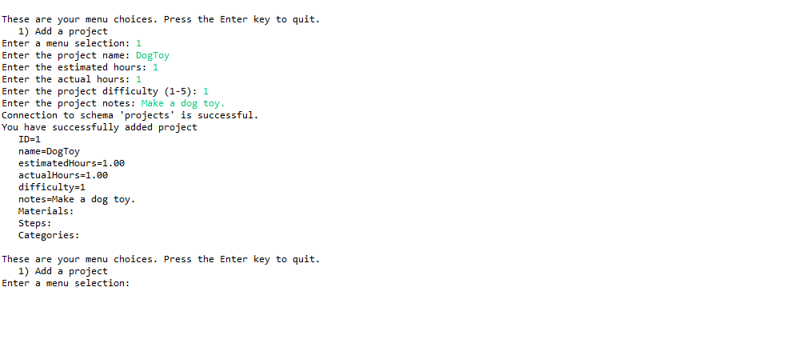

# Solutions

These solutions are provided as a reference. Please work through the exercises on your own as best you can.

## ProjectsApp.java

## ProjectService.java

## ProjectDao.java

