# Background

We have been developing a menu-driven application that demonstrates how to perform CRUD (Create, Read, Update, Read) operations on a DIY project database. Thus far, we have learned how to create a connection to a MySQL database and how to insert records into a table. In this section, we will apply our knowledge of querying data to list all projects without project details, and to list a single project with all details.

# Objectives

In these exercises, you will expand the menu application to list all projects (name and ID). Then, you will write code to select a project to edit. This will involve returning a selected project along with all project details. This will further our pursuit of implementing CRUD operations on database tables.

In these exercises, you will:

* Hone your SQL query skills by writing SQL statements to fetch a List of Project records.
* Learn how to perform multiple queries in a single transaction.
* Write an inner join to fetch category rows related to a project row.
* Use an Optional to either return a project record or to throw a custom Exception.
* Practice writing Lambda expressions both to list the projects and to throw a custom Exception from an Optional.

# Important

In the exercises below, you will see this icon: . This means to take a screen shot or snip showing the results of the action or the code in the editor.

Also important: you should take the variable names and method names as suggestions. They're good suggestions, but if you want to deviate from them, feel free to do so. However, don't go crazy and change listProjects() to emptyMyBankAccountByBuyingAJeep(). You should follow Java best practices. Method names should describe what the method does in the interest of self-documentation.

# Instructions

**Points possible : 75**

**URL to GitHub Repository: https://github.com/JacobUdel/mysql-java-projects**

**URL to Public Link of your Video: https://youtu.be/oACmT3KFwvQ**

**———————————————————————————————————————————**

**Instructions :**

1. Follow the **Exercises** below to complete this assignment.

* + - In Eclipse, or an IDE of your choice, write the code that accomplishes the objectives listed below. Ensure that the code compiles and runs as directed.
    - Create a new repository on GitHub for this week’s assignment and push your completed code to this dedicated repo, including your entire Maven Project Directory (e.g., mysql-java) and any .sql files that you create. In addition, screenshot your ERD and push the screenshot to your GitHub repo.
    - Include the screenshots into this Assignment Document indicated by: 
    - Create a video showcasing your work:
      * In this video: record and present your project verbally while showing the results of the working project.
      * Easy way to Create a video: Start a meeting in Zoom, share your screen, open Eclipse with the code and your Console window, start recording & record yourself describing and running the program showing the results.
      * Your video should be a maximum of 5 minutes.
      * Upload your video with a public link.
      * Easy way to Create a Public Video Link: Upload your video recording to YouTube with a public link.

2. In addition, please include the following in your Coding Assignment Document:

* + - The requested screenshots, indicated by: 
    - The URL for this week’s GitHub repository.
    - The URL of the public link of your video.

3. Save the Coding Assignment Document as a .pdf and do the following:

* + - Push the .pdf to the GitHub repo for this week.
    - Upload the .pdf to the LMS in your Coding Assignment Submission.

**———————————————————————————————————————————**

# Exercises

Complete these exercises as directed. If you get hopelessly stuck, please see the "Solutions" section below.

In these exercises, you will often be told to call a method prior to creating it. This is a good approach. You set up the return type by assigning it to a variable and setting up the parameters. Then, Eclipse can correctly create the method.

## List projects

In this section, you will add code to return and print a list of projects. Several application methods will call this method to let the user select a project from a list. To get the list of projects, you will add the menu option and method in the menu class, then you will add a method in the service class. The DAO class will perform the actual work of fetching the list using JDBC method calls.

### Modifications to menu app

In this section you will add another option to the list of available options. Then you will add another case to the switch method along with the method to call the service to retrieve the list of projects.

In this section, you will be working in ProjectsApp.java.

1. Add this line to the list of operations at the top of ProjectsApp.java: "2) List projects".
2. Add case 2 to the switch statement in processUserSelection(). In the case, call method listProjects(). Don't forget to add the break statement.
3. Have Eclipse create the method listProjects(). It should take no parameters and should return nothing. In the method:
   1. Create a variable to hold a List of Projects named projects. Assign the variable the results of a method call to projectService.fetchAllProjects().
   2. Print "\nProjects:" (without quotes) to the console.
   3. For each Project, print the ID and name separated by ": ". Indent each line with a couple of spaces.
   4. At this point, the method should look like this:

* 1. Have Eclipse create the method fetchAllProjects() in the ProjectService class, or create it yourself.
  2. Save all files. At this point the project should have no errors.

### Modifications to project service

You need to fill in the method in the service class to call the DAO class. This method will simply return the results of the method call to the DAO class. The service class in out small application does not do very much. But it allows us to properly separate concerns of input/output, business logic, and database reads and writes. If you always structure your code like this it will be much easier to understand and make changes if needed.

In this section, you will be working in ProjectService.java.

1. In the method fetchAllProjects, call the fetchAllProjects() method on the projectDao object.
2. Have Eclipse create the method fetchAllProjects() in ProjectDao.java or create it yourself. It takes no parameters and returns a List of Projects.

### Modifications to project dao

Now you need to write the code to retrieve all the projects from the database. It is structured similarly to the insertProject() method, but it will also incorporate a ResultSet to retrieve the project row(s).

To implement this method, first you will write the SQL statement that instructs MySQL to return all project rows without any materials, steps, or categories. Then, you will obtain a Connection and start a transaction. Next, you will obtain a PreparedStatement from the Connection object. Then, you will get a ResultSet from the PreparedStatement. Finally, you will iterate over the ResultSet to create a Project object for each row returned.

In this section, you will be working in ProjectDao.java.

1. In the method fetchAllProjects():
   1. Write the SQL statement to return all projects not including materials, steps, or categories. Order the results by project name.
   2. Add a try-with-resource statement to obtain the Connection object. Catch the SQLException in a catch block and rethrow a new DbException, passing in the SQLException object.
   3. Inside the try block, start a new transaction.
   4. Add an inner try-with-resource statement to obtain the PreparedStatement from the Connection object. In a catch block, catch an Exception object. Rollback the transaction and throw a new DbException, passing in the Exception object as the cause.
   5. Inside the (currently) innermost try-with-resource statement, add a try-with-resource statement to obtain a ResultSet from the PreparedStatement. Include the import statement for ResultSet. It is in the java.sql package.
   6. Inside the new innermost try-with-resource, create and return a List of Projects.
   7. Loop through the result set. Create and assign each result row to a new Project object. Add the Project object to the List of Projects. You can do this by calling the extract method:

or by doing it manually like this:

### Test it

Test your solution by running ProjectsApp. Select "List projects". The app should return a list of projects that you have created. Make sure that you have created at least one project. Take a screen shot showing the console with the menu selections, your input, and the listed project(s). 

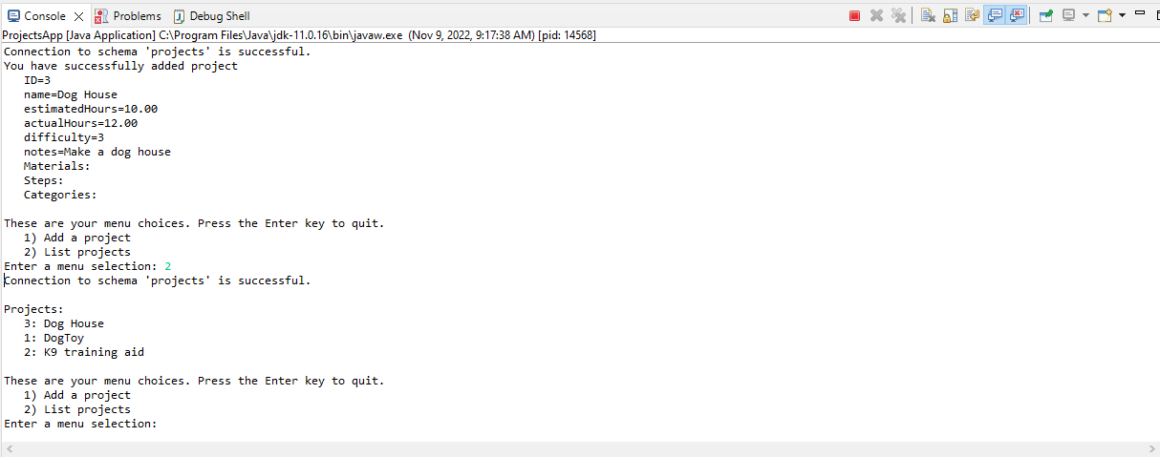

## Select a project

In this section you will write code to select a current project. With a current project selected, you will be able to add materials, steps, and categories in future exercises. This will involve more code than it sounds like on the surface. When you select a current project using the project ID, you will query the project tables to fetch all project details (materials, steps, and categories) within a single transaction.

### Modifications to menu app

In this section, you will add a new option to the selections available to the user. Then you will add a method to select the current project. After selecting the current project, you will modify the printOperations() method to display the currently selected project, if any. It will print all project details including materials, steps, and categories.

In this section you will be working in ProjectsApp.java.

1. Add an instance variable of type Project named curProject.
2. Add a new operation: "3) Select a project".
3. Add a case to the switch to handle the operation. Call method selectProject().
4. In this step you will create the method, selectProject(). This method will list the project IDs and names so that the user can select a project ID. Once the ID is entered, the service is called to return the project details. If successful, the current project is set to the returned project. Follow these instructions to write the method.

Add a new method named selectProject(). It takes no parameters and returns nothing.

* 1. Call listProjects() to print a List of Projects.
  2. Collect a project ID from the user and assign it to an Integer variable named projectId. Prompt the user with "Enter a project ID to select a project".
  3. Set the instance variable curProject to null to unselect any currently selected project. This is done in case the call to the service results in an exception being thrown. Rather than leave the current project selected in that case, it is unselected first.
  4. Call a new method, fetchProjectById() on the projectService object. The method should take a single parameter, the project ID input by the user. It should return a Project object. Assign the returned Project object to the instance variable curProject. Note that if an invalid project ID is entered, projectService.fetchProjectById() will throw a NoSuchElementException, which is handled by the catch block in processUserSelections().
  5. At the end of the method, add a check to see if curProject is null. If so, print "Invalid project ID selected." on the console.
  6. The method should look like this:

1. In this step, you will add code to print the current project when the available menu selections are displayed to the user. To do this, find the method printOperations(). At the bottom of method printOperations(), check if curProject is null. If null, print a message: "\nYou are not working with a project.". Otherwise, print the message: "\nYou are working with project: " + curProject.

### Modifications to project service

In this section you will create a method in the project service that will call the DAO to retrieve a single Project object with all details, including materials, steps, and categories. This method will throw an exception if the project with the given ID does not exist.

Note that you will temporarily assign the results of a method call to the DAO to an Optional<Project> object. This will cause Eclipse to create the return type on the DAO method as Optional<Project>. Once the method has been created, you can delete the assignment and return the Project, if successful. If not successful, the method will throw a NoSuchElementException.

In this section you will be working in ProjectService.java.

1. Create method fetchProjectById(). It returns a Project object and takes an Integer projectId as a parameter. Inside the method:
   1. Temporarily assign a variable of type Optional<Project> to the results of calling projectDao.fetchProjectById(). Pass the project ID to the method.

Picture 37

This temporary assignment will cause Eclipse to create the correct return value (Optional<Project>) in ProjectService.java.

* 1. Let Eclipse create the method for you in the ProjectDao class. The editor will display ProjectDao.java. Return to ProjectService.java. Save all files.
  2. Replace the variable and assignment with a return statement. This will cause a compilation error, which you will correct next.
  3. Add a method call to .orElseThrow() just inside the semicolon at the end of the method call to projectDao.fetchProjectById(). Use a zero-argument Lambda expression inside the call to .orElseThrow() to create and return a new NoSuchElementException with the custom message, "Project with project ID=" + projectId + " does not exist.". The method should look like this:

Save all files. At this point there should be no compilation errors.

### Modifications to project dao

In this section you will write the code that will retrieve a project row and all associated child rows: materials, steps, and categories. The method will start with the usual try-with-resource statement to obtain the Connection. Then you will add a try/catch before obtaining the PreparedStatement. This is done so that after obtaining the project details, the materials, steps, and categories can be retrieved within the same transaction.

If you get stuck and don't understand the instructions, please refer to the "Solutions" section at the end of this assignment.

In this section you will be working in ProjectDao.java.

1. In the method fetchProjectById():
   1. Write the SQL statement to return all columns from the project table in the row that matches the given projectId. Make sure to use the parameter placeholder "?" in the SQL statement.
   2. Obtain a Connection object in a try-with-resource statement. Add the catch block to handle the SQLException. In the catch block throw a new DbException passing the SQLException object as a parameter.
   3. Start a transaction inside the try-with-resource statement.
   4. Below the method call to startTransaction(), add an inner try/catch. The catch block should handle Exception. Inside the catch block, rollback the transaction and throw a new DbException that takes the Exception object as a parameter.
   5. Inside the try block, create a variable of type Project and set it to null. Return the Project object as an Optional object using Optional.ofNullable(). Save the file. You should have no compilation errors at this point but you may see some warnings. This is OK. Here is the method at this point.

* 1. Inside the inner try block, obtain a PreparedStatement from the Connection object in a try-with-resource statement. Pass the SQL statement in the method call to prepareStatement(). Add the projectId method parameter as a parameter to the PreparedStatement.
  2. Obtain a ResultSet in a try-with-resource statement. If the ResultSet has a row in it (rs.next()) set the Project variable to a new Project object and set all fields from values in the ResultSet. You can call the extract() method for this.
  3. Below the try-with-resource statement that obtains the PreparedStatement but inside the try block that manages the rollback, add three method calls to obtain the list of materials, steps, and categories. Since each method returns a List of the appropriate type, you can call addAll() to add the entire List to the List in the Project object:

Picture 26

* 1. Commit the transaction. Here's what the method should look like now:

1. In this step you will write the methods that will return materials, steps, and categories as Lists. Each method is structured similarly. Since the Connection object is passed into each method, you won't have to obtain the Connection from DbConnection.getConnection().

Also, you won't need to add catch blocks to the try-with-resource statements because the caller makes the method calls within a try block. It won't hurt to catch the SQLException and turn it into an unchecked exception as you have been doing. But it won't hurt to simply declare the exception in the method signature either. It's your choice. So, this:

Picture 27

Add the "throws" declaration

versus this:

Or catch the Exception

Follow these instructions to write the three methods to return materials, steps, and categories. Each method should return a List of the appropriate type. At this point there should be no compilation errors.

* 1. Each method should take the Connection and the project ID as parameters.
  2. Each method should return a List of the appropriate type (i.e., List<Material>).
  3. Each method is written in the same way as the other query methods with the exception that the Connection is passed as a parameter, so you don't need to call DbConnection.getConnection() to obtain it.
  4. Each method can add throws SQLException to the method declaration. This is because the method call to each method is within a try/catch block.
  5. Here is a sample method (all three methods should have the identical structure). However, when you fetch the categories, you will need to join with the project_category join table as shown below.

### Test it

Now it's time to test that the code works. Since you haven't written the code to add materials, steps, and categories yet, you will have to add some rows manually.

#### Instructions for DBeaver

1. Create a connection to the projects schema in DBeaver if you haven't already.
2. Right-click on the connection name and select "SQL Editor" / "Recent SQL Script".

#### Instructions for MySQL CLI

1. Start up MySQL CLI. Enter the root password.
2. Type "use projects;" (without the quotes).

#### The test

1. Add one or more categories. You don't have to enter the category ID, MySQL will manage that for you.

INSERT INTO category (category_name) VALUES ('Doors and Windows');

1. Make sure you have added one or more projects. In the editor type this to find a valid project_id:

SELECT * FROM project;

1. Add one or more material records. If your project_id is 1, enter something like this:

INSERT INTO material (project_id, material_name, num_required)

VALUES

(1, '2-inch screws', 20);

1. Add one or more step records. If your project_id is 1, enter something like the following:

INSERT INTO step (project_id, step_text, step_order)

VALUES

(1, 'Screw door hangers on the top and bottom of each side of the door frame', 1);

1. Add one or more project_category records. This is a join table that contains two foreign keys. One foreign key points to a project row and the other points to a category row. So, if your project ID is 1 and the category ID for 'Doors and Windows' is 2, enter the join row like this:

INSERT INTO project_category (project_id, category_id)

VALUES

(1, 2);

1. Run ProjectsApp as a Java application. Enter "3" to select a project. Enter a project ID. Take a screen shot showing that the project is selected.  It should look something like this:

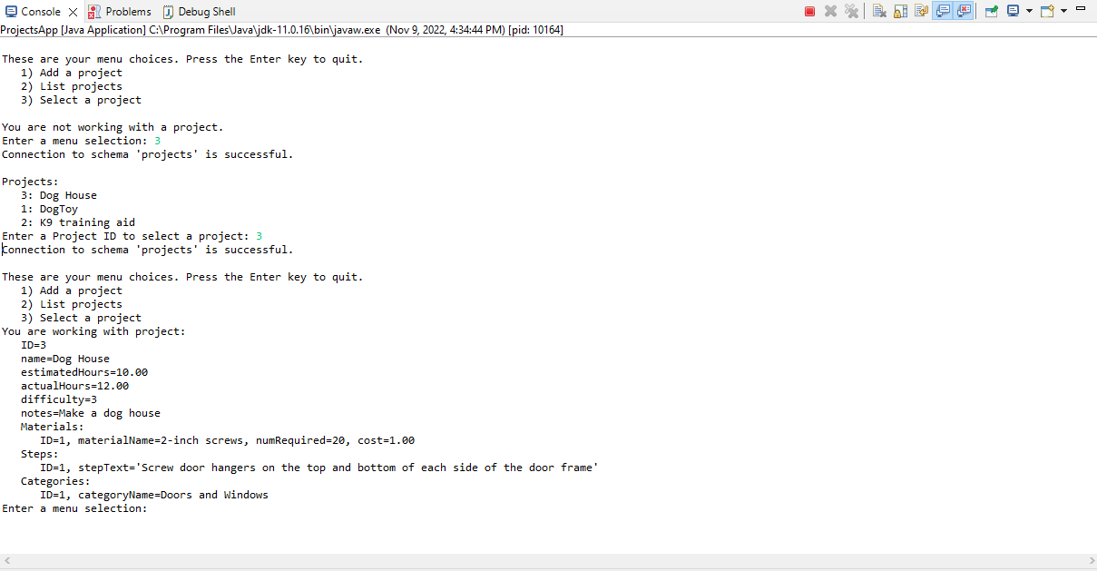

You should see project details, a list of materials, a list of steps, and a list of categories. If you do not get a result like that shown above, check the console for errors. If you can't figure it out there are two things you can try:

* In the catch block in method processUserSelection(), print the entire stack trace of the exception like this:

catch(Exception e) {

System.out.println("\nError: " + e + " Try again.");

e.printStackTrace();

}

* Start the application in debug mode. Load ProjectsApp.java into the editor. Right-click in editor and select "Debug As" / "Java Application". Set breakpoints as appropriate. Work through the application until you find the error.
* This article on debugging is a little dated but still applicable. You don't need to worry about the section on remote debugging. <https://www.eclipse.org/community/eclipse_newsletter/2017/june/article1.php>

1. Now test with an invalid project ID. Run the application. Enter "3" to select a project. Enter an invalid number. Take a screen shot of the console.  It should look something like the screen shot below.

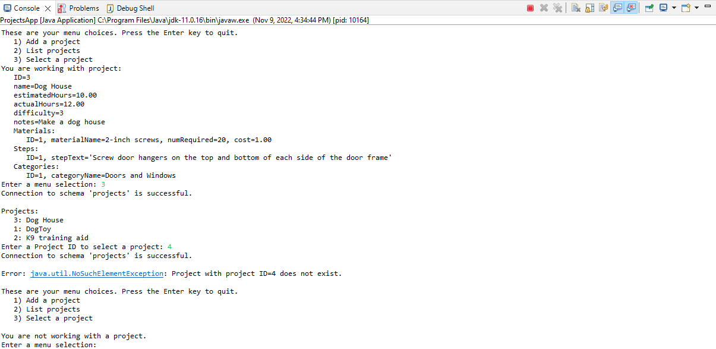

Here's the error

# Solutions

These solutions are provided as a reference. Please work through the exercises on your own as best you can.

## ProjectsApp.java

These screen shots do not contain the entire Java file. Only the parts changed since the prior exercises are shown.

## ProjectService.java

These screen shots do not contain the entire Java file. Only the parts changed since the prior exercises are shown.

## ProjectDao.java

These screen shots do not contain the entire Java file. Only the parts changed since the prior exercises are shown.

