

Software Design Document

for

Minecraft Item Crafter

Version 1.0

Prepared by

Group Name: The Blondies

|  |  |  |
| --- | --- | --- |
| Noah Scarbrough | 11663725 | noah.scarbrough@wsu.edu |
| Jacob van Tol | 11568824 | jacob.vantol@wsu.edu |
| Jared Kangas | 11588980 | jared.kangas@wsu.edu |

|  |  |
| --- | --- |
|  |  |
| Date: | November 8, 2019 |
|  |  |

Content

Revisions iii

1 **ACTIVITY DIAGRAMS** 1

1.1 1

2 Structural modeling 3

2.1 3

3 behavioral modeling 5

3.1 5

3.2 5

3.3 5

Revisions

| Version | Primary Author(s) | Description of Version | Date Completed |
| --- | --- | --- | --- |
| 1.0 | Jacob van Tol  Noah Scarbrough  Jared Kangas | The initial draft for the SDD. Includes designs for Minecraft Item Crafter 1.0 | 11/08/19 |

# 

# 

# Activity Diagrams

# Structural Modeling

# Behavioral Modeling

## Querying **Database with** Recipe from **Crafting Table**

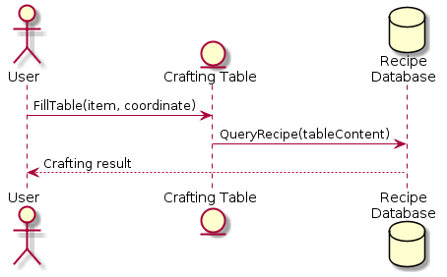

## **Querying Database with Selected Item**

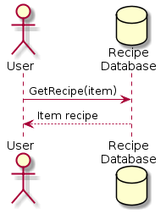

## **Website-User Interaction**

