SPLUNK SOC LAB
Nmap Threat Detection & Risk Triage
Security Operations Center — Detection Engineering Project
Prepared by
Vijay S
SOC Analyst / Penetration Tester (Candidate)
reachvijays20@gmail.com
github.com/JacobVijay26 · linkedin.com/in/vijaycybersecurity
Splunk Enterprise 10.4.0 · Kali Linux · Metasploitable2
Isolated VMnet1 Host-Only Lab Environment

1. Executive Summary
This project demonstrates an end-to-end Security Operations Center (SOC) workflow built in Splunk Enterprise. Output from a live penetration test against a Metasploitable2 target — specifically an Nmap scan revealing 23 open TCP ports — was ingested into Splunk and engineered into a functioning detection and triage capability.
Rather than simply storing scan data, the project parses raw events into structured fields, classifies each exposed service by risk severity, visualizes the results in a two-panel SOC dashboard, and configures a scheduled alert that fires when critical backdoor services are detected. The result is a compact but realistic demonstration of the analyst skill set: ingest, parse, classify, visualize, and alert.
OUTCOME A reusable Splunk pipeline that converts raw Nmap output into a severity-ranked SOC dashboard and an automated detection alert for instant-root backdoor services.

2. Lab Environment
All work was performed inside an isolated, host-only virtual network to ensure no exploit traffic could reach external systems.
Component | Detail
SIEM Platform | Splunk Enterprise 10.4.0 (Windows host)
Attacker | Kali Linux — scan origin, host label "kali-attacker"
Target | Metasploitable2 — intentionally vulnerable Linux host
Network | Isolated VMnet1 host-only (no internet egress)
Data Source | Nmap scan output (scan1.txt), sourcetype nmap_scan

3. Methodology

3.1 Data Ingestion
The Nmap scan output was uploaded via Settings → Add Data → Upload, configured with a custom, reusable sourcetype and a meaningful host label representing the scan origin:
- Sourcetype: nmap_scan (custom)
- Host: kali-attacker
- Index: default (main)
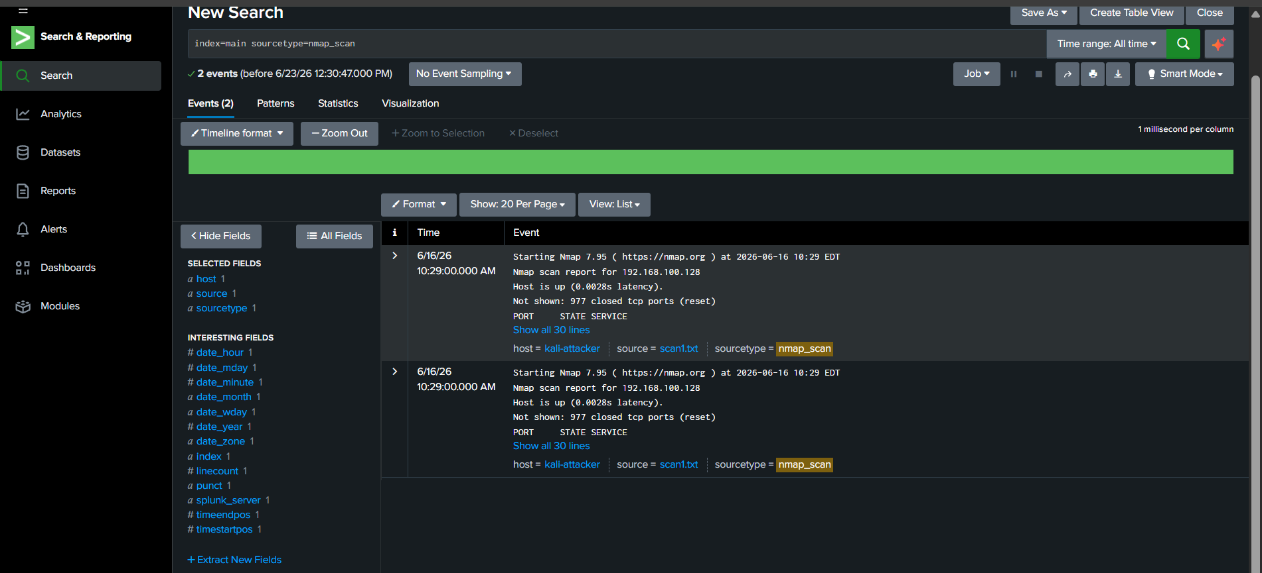
Figure 1. Raw Nmap events as ingested into Splunk, showing host, source, and sourcetype fields.

3.2 Baseline SPL Searches
Initial Search Processing Language (SPL) queries confirmed ingestion and demonstrated threat-hunting for known-malicious ports:
index=main host="kali-attacker"index=main sourcetype=nmap_scan "open"index=main sourcetype=nmap_scan ("1524" OR "445" OR "21")index=main sourcetype=nmap_scan | stats count

3.3 Field Extraction
Splunk's default extraction captures only the first regex match per event. Using max_match=0 extracts every port/service pair from the raw scan text:
index=main sourcetype=nmap_scan| rex max_match=0 field=_raw "(?<port>\d+)\/tcp\s+open\s+(?<service>\S+)"| table port, service

This correctly extracted all 23 open ports (ftp, ssh, telnet, smtp, samba, mysql, postgresql, vnc, irc, ingreslock, and others).
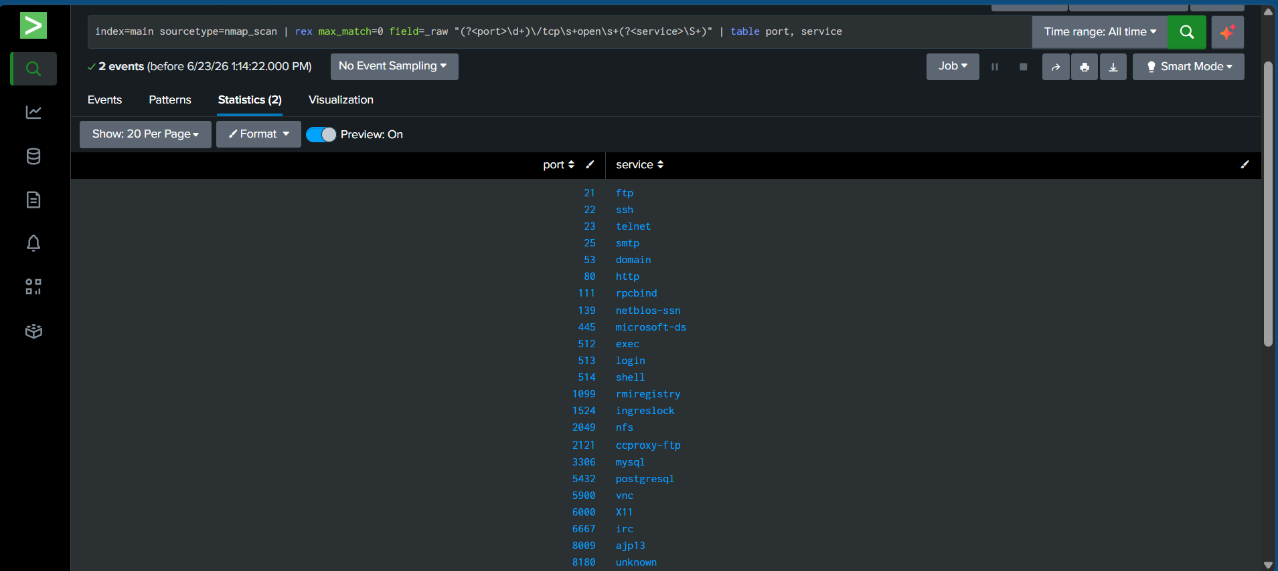
Figure 2. Field extraction result showing all open ports and services parsed from the raw Nmap event.

3.4 Multivalue Expansion, Deduplication & Risk Classification
The extracted fields were multivalue (lists held within a single event), which prevented per-row logic. They were split into discrete rows, deduplicated to remove duplicate ingested events, then classified by risk severity:
index=main sourcetype=nmap_scan earliest=0| rex max_match=0 field=_raw "(?<port>\d+)\/tcp\s+open\s+(?<service>\S+)"| eval pairs=mvzip(port, service, "|")| mvexpand pairs| eval port=mvindex(split(pairs,"|"),0), service=mvindex(split(pairs,"|"),1)| dedup port, service| eval risk=case( service=="ingreslock" OR service=="shell" OR service=="login" OR service=="exec", "Critical", service=="telnet" OR service=="vnc" OR service=="rmiregistry" OR service=="irc", "High", service=="ftp" OR service=="mysql" OR service=="postgresql" OR service=="nfs", "Medium", 1==1, "Low")| eval risk_rank=case(risk=="Critical",4, risk=="High",3, risk=="Medium",2, risk=="Low",1)| sort - risk_rank| table port, service, risk

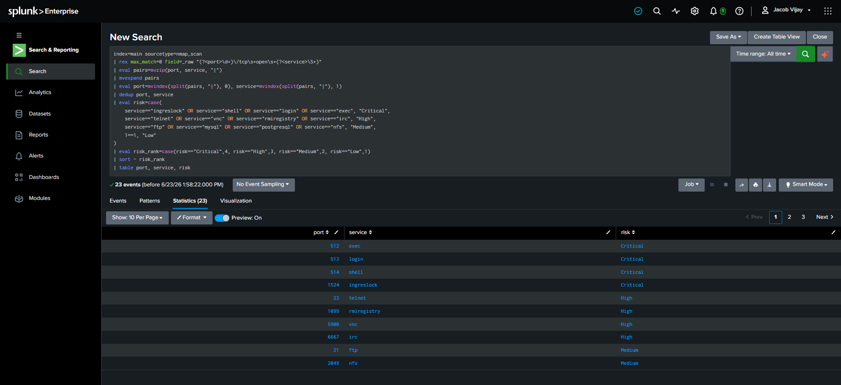
Figure 3. Risk-classified port inventory, sorted Critical → High → Medium.

4. Risk Classification Model
Each exposed service was assigned a severity tier based on real-world exploitability, informed directly by the penetration test against the same target.
Risk | Services | Rationale
Critical | ingreslock, shell, login, exec | Instant-root backdoors and unauthenticated remote command execution; exploited directly during the pentest
High | telnet, vnc, rmiregistry, irc | Legacy / weak protocols, cleartext credentials, known remote code execution vectors
Medium | ftp, mysql, postgresql, nfs | Commonly misconfigured services exposing data or weak authentication
Low | all remaining services | Standard services requiring deeper contextual review

5. SOC Dashboard
A Classic Dashboard titled "Metasploitable2 SOC Dashboard" was built with two statistics-table panels that together form a triage view:
- Open Ports — Metasploitable2 Scan: complete raw port/service inventory.
- Port Risk Classification: severity-tagged view, sorted Critical → High → Medium → Low for analyst triage.
DESIGN NOTE The two-panel layout mirrors a real SOC triage screen — a full asset inventory beside a prioritized severity view — so an analyst can move from "what is exposed" to "what must be addressed first" at a glance.

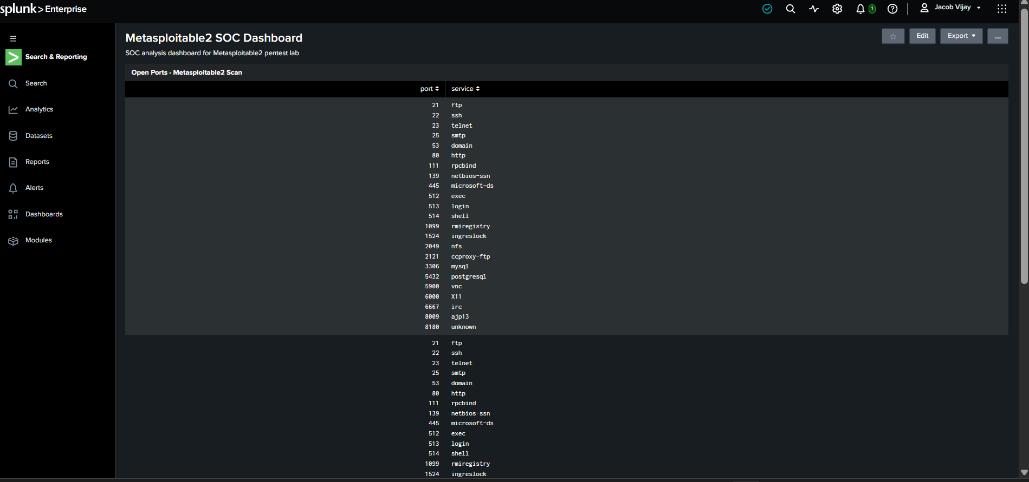
Figure 4. Metasploitable2 SOC Dashboard — Open Ports panel.
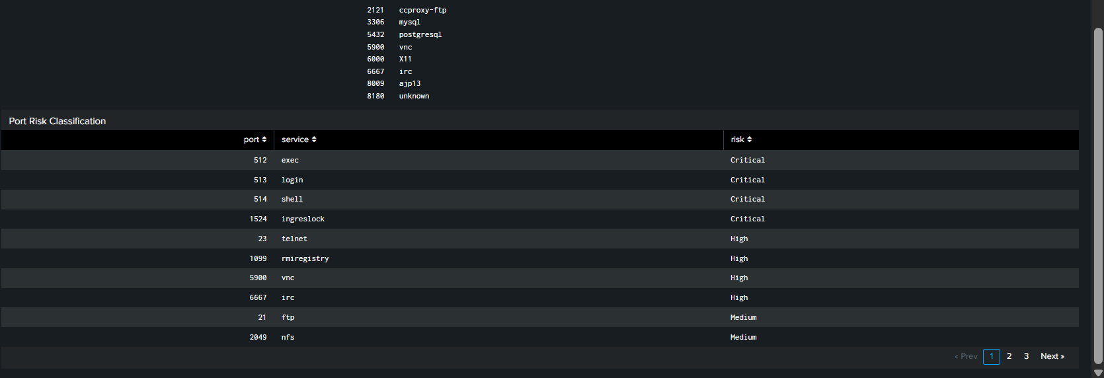
Figure 5. Metasploitable2 SOC Dashboard — Port Risk Classification panel.

6. Detection Alert
A scheduled alert named "Critical Backdoor Service Detected" was configured to monitor for instant-root backdoor services. The underlying search isolates only Critical-tier findings:
index=main sourcetype=nmap_scan earliest=0| rex max_match=0 field=_raw "(?<port>\d+)\/tcp\s+open\s+(?<service>\S+)"| eval pairs=mvzip(port, service, "|")| mvexpand pairs| eval port=mvindex(split(pairs,"|"),0), service=mvindex(split(pairs,"|"),1)| dedup port, service| where service IN ("ingreslock","shell","login","exec")

Setting | Value
Schedule | Hourly (0 minutes past the hour)
Trigger Condition | Number of results is greater than 0
Trigger Action | Add to Triggered Alerts
Permissions | Private (owner: jacob)

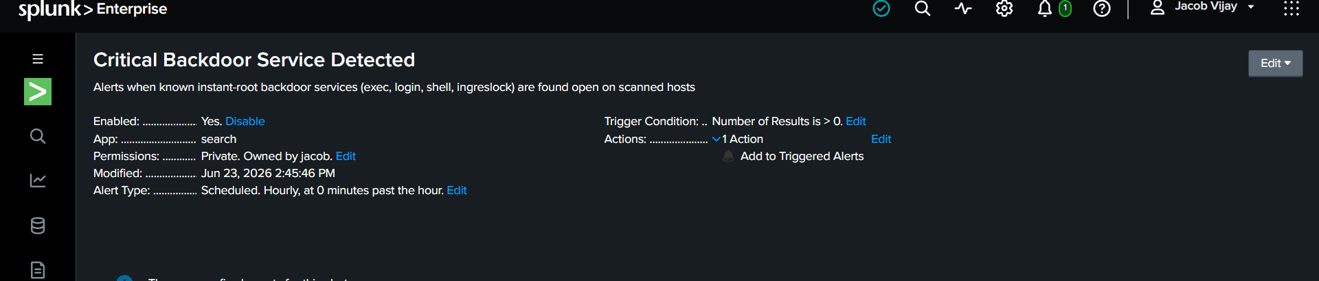
Figure 6. Saved alert configuration — Critical Backdoor Service Detected.

7. Lessons Learned
Several Splunk-specific behaviors were encountered and resolved during the build. These reflect real operational knowledge a SOC analyst is expected to hold.
- Splunk is append-only. Re-uploading a file duplicates rather than overwrites data; duplicates require | delete or dedup.
- delete is privilege-gated. Even the Administrator account lacks the delete_by_keyword capability by default — a deliberate least-privilege control that must be granted at the role level.
- Inline UI field extractions capture only the first match. Multivalue extraction needs max_match=0 in-search, or MV_ADD=true in transforms.conf.
- The time-range picker does not persist for scheduled alerts. Reliable scheduling requires hardcoding the range into the search text (earliest=0).
- Manually running an alert search does not fire its actions. Only the scheduler firing on the configured cron triggers the alert action.
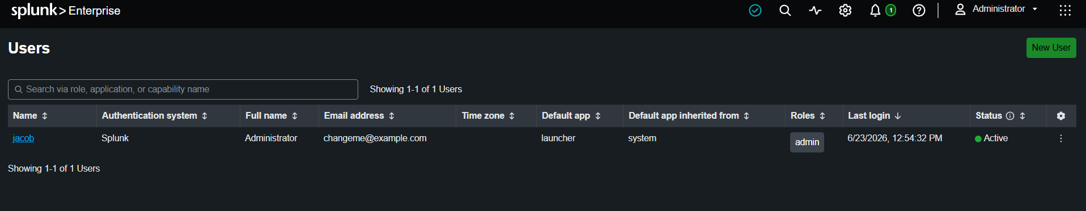
Figure 7. User-role assignment confirming the admin role before granting the delete_by_keyword capability.

8. Skills Demonstrated
Skill | Implementation
Data ingestion | Custom sourcetype nmap_scan, host kali-attacker
SPL | Field filtering, Boolean search, stats, keyword highlighting
Field extraction | rex with max_match=0 for full multivalue capture
Multivalue handling | mvzip + mvexpand + mvindex(split())
Deduplication | dedup to collapse duplicate events
Risk classification | eval case() severity tiering
Result ranking | rank field + sort for severity ordering
Dashboards | Classic dashboard, two statistics-table panels
Detection alerting | Scheduled alert with trigger + action
RBAC / capabilities | Granted delete_by_keyword at role level
Time-range scoping | earliest=0 for reliable scheduled search

9. Next Steps
- Ingest additional data sources (Metasploit exploit logs, DVWA access logs, Wireshark exports) for multi-source correlation.
- Add visualization panels such as a severity-distribution bar or pie chart.
- Build correlation searches that link reconnaissance, exploitation, and post-exploitation stages.
- Progress toward Splunk Core Certified User / Power User certification.
End of Report

