Jacob Andrews Portfolio Design

Andrews,Jacob
2026
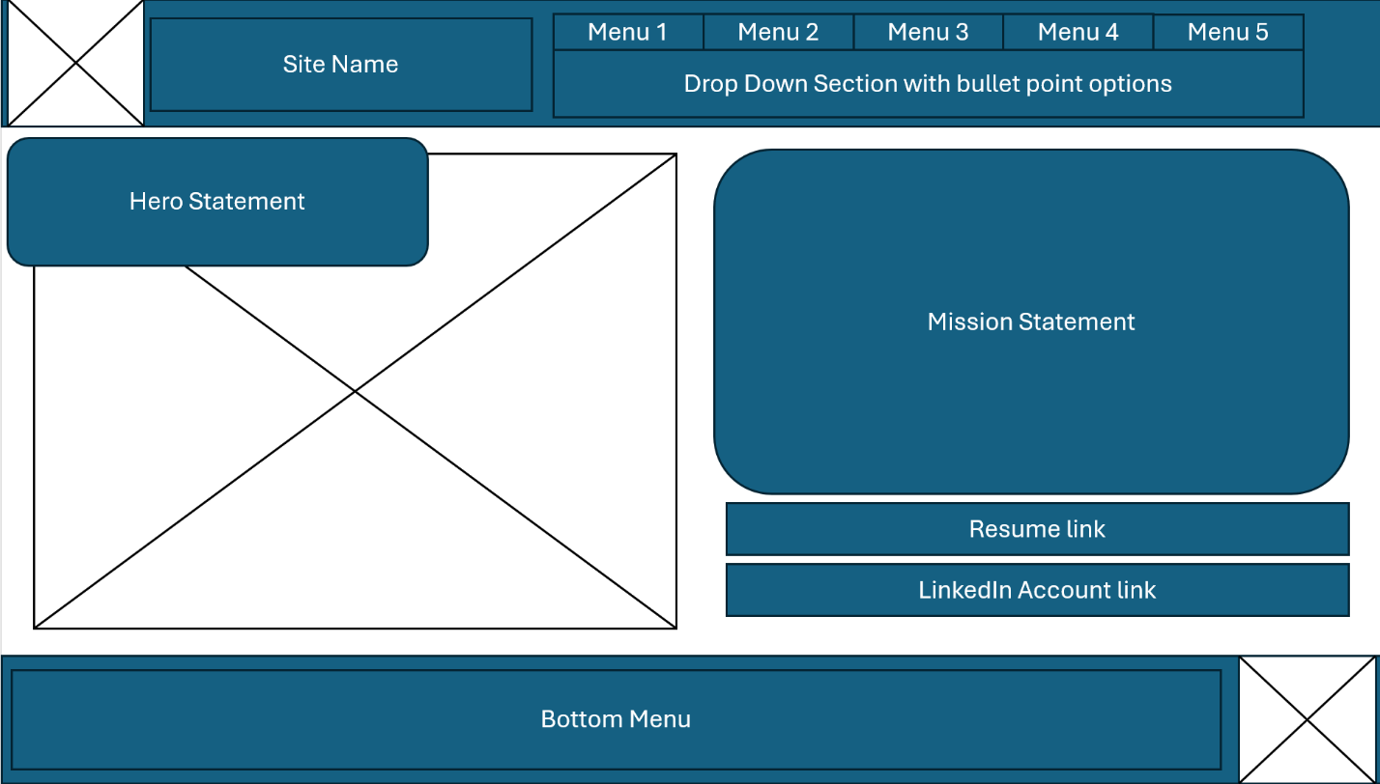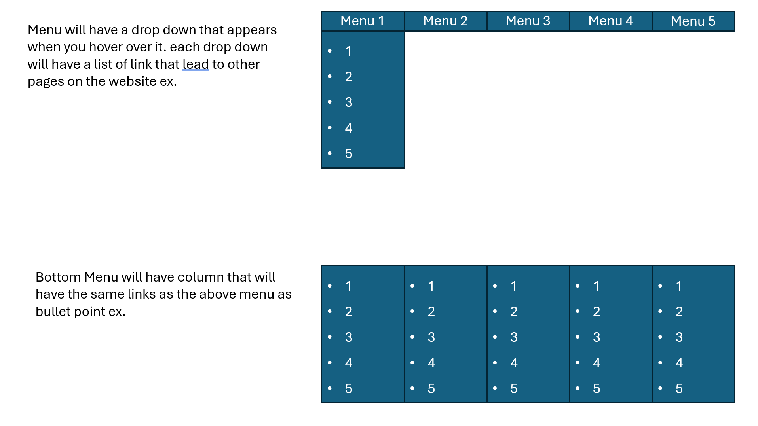
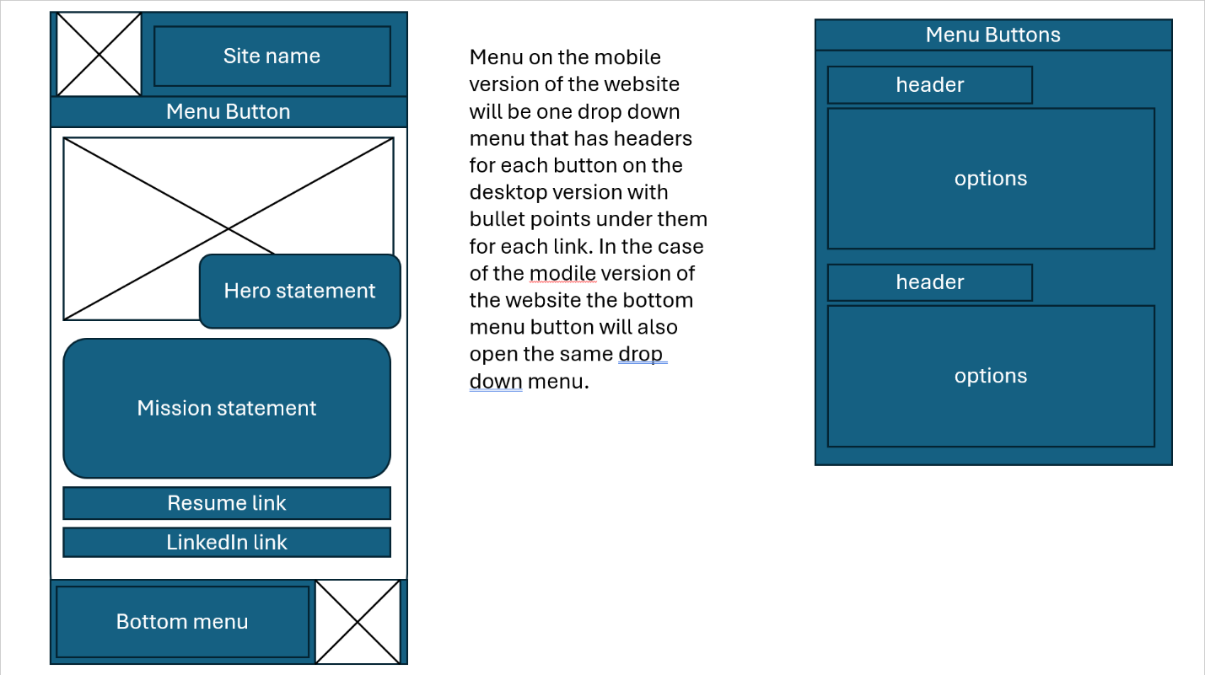

from | comments | Accepted/reject | reason
Jack | Make animation on skills faster and not get as large as they currently do as they overlap slightly. | Accepted | After it was pointed out to me that it doesn’t have much impact as slow as it was. Also, the overlap was hard not to notice after jack pointed it out.
Naima | Add hamburger menu to mobile version for convenience. | Rejected | I think I will investigate more into it though since if I can style it right it could look good. But for now, it doesn’t work with my concepts.
Wing | Add home button to return to top of page at any point.  Also, after I pointed out animating the page movement he realized I should also do that. | Accepted | The home button will remove the inconvenience of having to scroll all the way back up or down to get to the menu section
What I said | Naima  Loop video on site so it doesn’t abruptly stop since the sudden stop is kind of jarring. | Jack  Darken text on full version for readability. Also change the animated links into animated buttons. | Wing  Animate moving to section of website instead of instantly moving to be less jarring.

