3. Specific Requirements

This section contains all the functional and quality requirements of the system. It gives a detailed description of the system and all its features.

3.1 External Interface Requirements

This section provides a description of all inputs and outputs of the system. It also gives a description of hardware and software that will be used to implement the system.

3.1.1 User Interfaces

A user accessing the web-based application for the first time should see an area that accesses a login page or the ability to create a new account.

Once the user has setup an account they can use the web application to view a calendar that will show only available appointments that they can schedule.

After a new account is created or an appointment is scheduled a message will notify a doctor’s assistant on their terminal. The doctor’s assistant will then be able to enter the new account into a secure database, and add the scheduled appointment to the calendar. At this time a verification e-mail stating the users name will be sent as confirmation of the appointment time.

The assistant’s terminal will also allow for new information to be added to the account such as old prescriptions, image’s, and audio files.

The doctors will be able to access patient account information via a tablet. Also, the assistants will add notes taken during a visit to the patient’s account after the visit. The doctors will also have the ability to change their calendars. This information will be sent to the assistant who will then notify a patient of any conflicts and help them reschedule.

3.1.2 Hardware Interfaces

Since the patients’ computers will handle the web-based access and the doctors will interface with a tablet, most of the requirements will be handled by the operating systems of the devices. The assistants’ terminals will be the only ones to access the patient account database.

3.1.3 Software Interfaces

The web-based application will interface through the web to send information to the terminals located at the clinic. The tablets used by the doctors will not have access to the web and will transmit new information over a private network.

3.1.4 Communications Interfaces

Communication between the systems is important since they depend each other to have the most up-to-date information. Communication from the patient to the clinic will be handled over secure web interface, while the doctor’s tablets will not have access to the Internet at all. While the terminal is logged-in to have access to the database, Internet access will be suspended to insure the security of patient records.

3.2 Functional Requirements

This section includes the requirements that specify the fundamental actions of the software system.

3.2.1 User Class 1 – The Patient

3.2.1.1 Functional Requirement 1.1

**ID: FR1**

TITLE: Create patient account

DESC: Given that a user has access to the website, the user should be able to register and account. The user must include a name, e-mail address, past medical history, and insurance information.

RAT: In order for a user to schedule an appointment.

DEP: None

3.2.1.2 Functional Requirement 1.2

**ID: FR2**

TITLE: Schedule an appointment

DESC: Given that a user has successfully registered an account he/she will be able to see a list of available appointments and secure the one of their choosing.

RAT: In order to secure an appointment time.

DEP: FR1

3.2.1.3 Functional Requirement 1.3

**ID: FR3**

TITLE: Reschedule an appointment

DESC: Given that a user has successfully registered for an account and scheduled an appointment, the user should be able to login and reschedule an appointment as long as there is more than 24 hours before the appointment.

RAT: In order to reschedule an appointment.

DEP: FR2

3.2.1.4 Functional Requirement 1.4

**ID: FR4**

TITLE: Request a referral to a specialist

DESC: Given the patient is an ongoing client of the clinic the patient should be able to obtain a doctor’s referral to a specialist if the circumstances of the ailment are beyond the doctor’s scope.

RAT: In order to obtain a referral to a specialist.

DEP: FR1

3.2.1.5 Functional Requirement 1.5

**ID: FR5**

TITLE: Request a refill on a prescription

DESC: Given a patient has been given a prescription by a onsite doctor, the user should be able to request a refill for a prescription.

RAT: In order to obtain a refill for a prescription.

DEP: FR1

3.2.1.6 Functional Requirement 1.6

**ID: FR6**

TITLE: Ask a nurse

DESC: Given a registered patient is feeling bad, and an appointment time is several days out. The patient should be able to ask a nurse a few questions that may direct the patient to temporary relief of the current ailment that is affecting the patient.

RAT: In order to ask a nurse a few questions.

DEP: FR2

3.2.2 User Class 2 – Doctor’s Assistant

3.2.2.1 Functional Requirement 2.1

**ID: FR7**

TITLE: Assistant user access

DESC: Given a user is a qualified employee of the clinic he/she should have access to the terminal located onsite. This access will include access to the web, and private doctor network as well as access to the database.

RAT: In order to give a qualified employee access to the system.

DEP: None

3.2.2.2 Functional Requirement 2.2

**ID: FR8**

TITLE: Add new accounts to the database

DESC: Given either a new account is generated in office by a patient or over the web interface the assistant should have the ability to access the database and add and newly formed account to it.

RAT: In order to add a new account to the database.

DEP: FR7

3.2.2.3 Functional Requirements 2.3

**ID: FR9**

TITLE: Edit account information in database.

DESC: Given a patient has medical history such as old prescriptions, old image files, or old audio notes from previous doctors the assistant should be able to update the information in the database. This includes future visits conducted by doctors at the clinic.

RAT: In order to update patient information in the database.

DEP: FR7

3.2.2.4 Functional Requirement 2.4

**ID: FR10**

TITLE: Reschedule appointments at doctors request.

DESC: Given an assistant has access he/she should be able to reschedule appointments if the doctor’s schedule changes and there are conflicts with patient appointments.

RAT: In order to reschedule appointments.

DEP: FR7

3.2.2.5 Functional Requirement 2.5

**ID: FR11**

TITLE: Direct communication with doctors

DESC: Given an assistant has access he/she should be able to communicate with the doctors over the private network established in the clinic. This will allow the assistant to get permission from a doctor to refill a prescription or create a referral to another doctor.

RAT: in order to communicate with a doctor over private network.

DEP: FR7

3.2.2.6 Functional Requirement 2.6

**ID: FR12**

TITLE: Fulfill or deny prescription refill request

DESC: Given an assistant’s access and a doctor’s approval he/she should be able to fulfill or deny a patient’s request for a prescription refill.

RAT: In order to deny or fulfill a patient’s prescription refill request.

DEP: FR11

3.2.2.7 Functional Requirement 2.7

**ID: FR13**

TITLE: Fulfill or deny a patient’s request for a referral

DESC: Given an assistant’s access and a doctor’s approval he/she should be able to fulfill or deny a patient’s request for a referral to another doctor.

RAT: In order to deny or fulfill a patient’s request for a referral.

DEP: FR11

3.2.2.8 Functional Requirement 2.8

**ID: FR14**

TITLE: Send appointment verification to patient.

DESC: Given an assistant has access he/she should be able to verify an appointment with the patient who scheduled it.

RAT: In order to verify an appointment with a patient.

DEP: FR2

3.2.2.9 Functional Requirement 2.9

**ID: FR15**

TITLE: Send appointment reminders to patients

DESC: Given access an assistant should be able to send a reminder of an upcoming appointment to a patient at their preferred contact type.

RAT: In order to remind a patient of an upcoming appointment.

DEP: FR2

3.2.2.10 Functional Requirement 2.10

**ID: FR16**

TITLE: Answer patient’s questions on common symptoms

DESC: Given access an assistant should be able to console the doctor for answers to a patient’s common symptoms, if the patient’s earliest appointment is a few days out.

RAT: In order to answer a patient’s questions on common symptoms.

DEP: FR11

3.2.2.11 Functional Requirement 2.11

**ID: FR17**

TITLE: Prepare a doctor’s day by adding scheduled appointments to his/her tablet

DESC: Given access the assistant should be able to setup a doctor’s tablet with the days scheduled appointments. This will give the doctor the ability to go from one appointment to the next without having to update the appointments on the hardware.

RAT: In order to prepare the doctor’s day on a tablet.

DEP: FR7

3.2.2.12 Functional Requirement 2.12

**ID: FR18**

TITLE: Generate summary report of visit

DESC: Given system access, assistant should be able to generate a summary report of a patients visit along with any prescriptions written during the appointment. A summary report will be sent from the doctor’s tablet to the assistant’s terminal, which the assistant will be able to print and distribute to the patient.

RAT: In order to print a summary report.

DEP: RE11

3.2.2.13 Functional Requirement 2.13

**ID: FR19**

TITLE: Accept co-payment from patient

DESC: Given system access, the assistant should be able to refer to the patients account and find a payment amount that is due based on the insurance information. The assistant should be able to accept the payment and update the patient’s account.

RAT: In order to accept a co-payment from a patient.

DEP: None

3.2.3 User Class 3 – Doctor

3.2.3.1 Functional Requirement 3.1

**ID: FR20**

TITLE: Doctor User access

DESC: Given a user is a Doctor, he/she will be allowed to login to the doctor’s tablet as well as the assistant’s terminal.

RAT: In order for a doctor to login to system software.

DEP: None

3.2.3.2 Functional Requirement 3.2

**ID: FR21**

TITLE: Communicate with doctor’s assistant

DESC: Given access, a line of communication should be open between the doctor’s tablet and the assistant’s terminal.

RAT: In order to communicate with doctor’s assistant

DEP: FR20

3.2.3.3 Functional Requirement 3.3

**ID: FR22**

TITLE: View data preloaded by assistants

DESC: Given access, the doctor should be able to view the medical data of the patients with scheduled appointments that day. The doctor’s assistants will preload this data every morning.

RAT: In order to view medical data of current patient.

DEP: FR20

3.2.3.4 Functional Requirement 3.4

**ID: FR23**

TITLE: Record data during exam

DESC: Given access, the doctor should be able to record information, form vitals to notes on the condition of the patient. This information will be part of the compiled report generated at the end of the appointment.

RAT: In order to record data during exam.

DEP: FR22

3.2.3.5 Functional Requirement 3.5

**ID: FR24**

TITLE: Generate a summary of patient’s visit.

DESC: Given access, a doctor should be able to generate a summary report of a patient’s visit to be delivered electronically to the assistant. The assistant shall print and distribute to the patient.

RAT: In order to generate a summary report.

DEP: FR23

3.2.3.6 Functional Requirement 3.6

**ID: FR25**

TITLE: Generate prescriptions

DESC: Given access, the doctor should be able to generate prescriptions for a patient during an appointment that will be sent electronically to the assistant. The assistant shall print and distribute the prescriptions.

RAT: In order to generate a prescription.

DEP: FR23

3.3 Use Cases

This section contains specific use cases that include brief descriptions along with a uml diagram of the use case.

3.3.1.1 Use Case 1.1

**ID: UC1**

TITLE: Create an account

DESC: To create an account a patient must choose the “create an account” button on the website. They will be prompted for details, such as name, address, phone number, and e-mail. At this time insurance information will be submitted along with pertinent medical history. Options such as a user name and password along with preferred contact will be submitted. Once the patient has submitted all the information it will be forwarded to a doctor’s assistant that will verify, via the preferred method of communication, with the patient that the information has been received and the account has been created. An account could also be created in person.

DEP: None

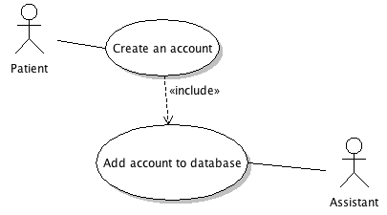

3.3.1.2 Use Case 1.2

**ID: UC2**

TITLE: Schedule, Reschedule, or cancel an appointment

DESC: To schedule, reschedule, or cancel an appointment, a patient must login to their created account, and choose to schedule, reschedule or cancel appointment. If they choose to schedule and appointment a calendar will appear that shows days and times that an appointment can be scheduled. Once a date and time are chosen an electronic message will be sent to the assistant at which time the assistant will schedule the appointment on the master calendar and then confirm the appointment with patient via their preferred method of communication. Rescheduling an appointment will be handled similarly with the exception that when reschedule is selected a list of current appointments will be displayed, the patient will choose the appointment they wish to reschedule and then choose a new day and time from the calendar. This information will be sent to the assistant that will update the master calendar appropriately. Cancelling an appointment will follow the same steps as rescheduling with the exception that the patient will not be given a chance to schedule another appointment at the time of this transaction.

DEP: UC1

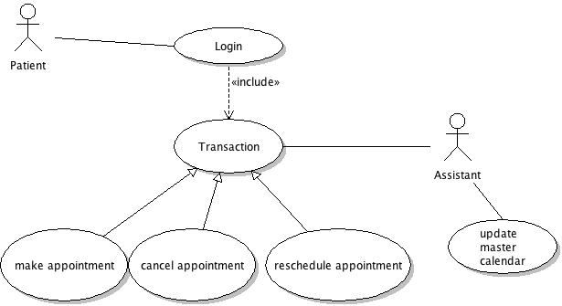

3.3.1.3 Use Case 1.3

**ID: UC3**

TITLE: Make additional request

DESC: In addition to appointment scheduling a patient may have other request that will be granted or denied by the assistant once the assistant has communicated the patient’s request with a doctor. All three transactions, request a prescription refill, request a referral, or ask about common symptoms, will require an open communication between the assistant and the doctor. If a patient request to have a prescription refilled the request will go to the assistant who will then forward the request to the doctor. Once the doctor approves or denies the request the assistant will translate this back to the patient. This holds true for a request for referral to another doctor of specialist. Asking about common symptoms will only be an option if the patient makes an appointment that is several days out and may need advice on OTC medication to purchase while waiting on the appointment. This appointment could also be expedited if the doctor feels the needs of the patient warrant an earlier appointment.

DEP: UC1, UC2

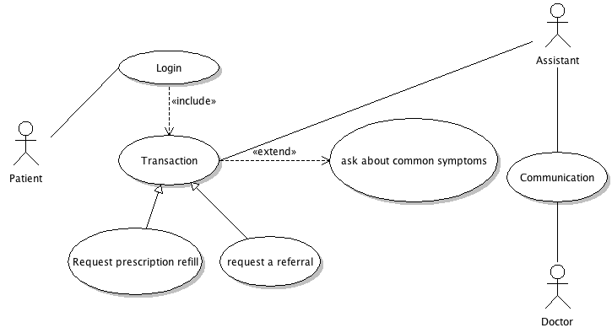

3.3.1.4 Use Case 1.4

**ID: UC4**

TITLE: Adding an account to the database

DESC: Once an assistant receives the information from a patient to create a new account, the assistant will first verify with the patient via the preferred method of communication that they have received the information. Second the assistant will login to the clinic database and add the account.

DEP: UC1

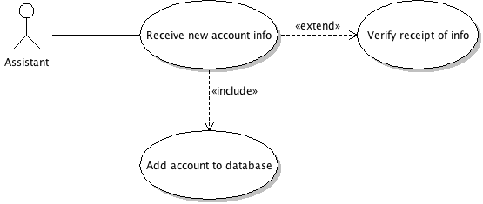

3.3.1.5 Use Case 1.5

**ID: UC5**

TITLE: Scheduling, rescheduling, or cancelling a patient appointment

DESC: When the assistant, regardless of a new scheduled appointment, a rescheduled appointment, or a cancelled appointment, receives scheduling information he/she will make the necessary changes to the master calendar and notify the patient via the preferred contact means that the changes have been made.

DEP: UC2

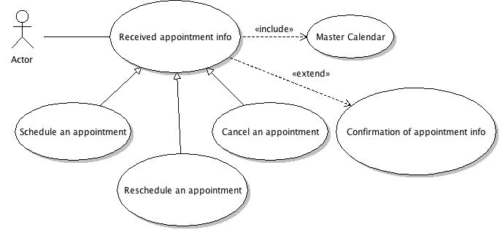

3.3.1.6 Use Case 1.6

**ID: UC6**

TITLE: Handling of other requests by patients

DESC: When the assistant receives a request by the patient in the form of a prescription refill request, a referral to another doctor or specialist, the assistant will communicate this request with the doctor. The doctor will approve or deny the request. The assistant via the preferred method of communication will communicate this to the patient. When a appointment is not available for several days the patient while have the option to ask the assistant questions pertaining to their ailment. These questions will be forwarded to the doctor. The doctor will respond by recommending OTC medication to take until the appointment, or may decide to expedite the appointment. The doctor’s response will be communicated by the assistant to the patient via the preferred means of contact.

DEP: UC3

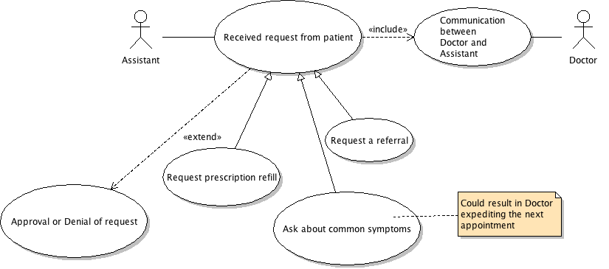

3.3.1.7 Use Case 1.7

**ID: UC7**

TITLE: Adding old information to a patient’s account

DESC: Assistant will add hand written scripts, images, and audio files. While adding files, information will be transcribed into the new systems format. Those objects will be linked to the scanned files.

DEP: None.

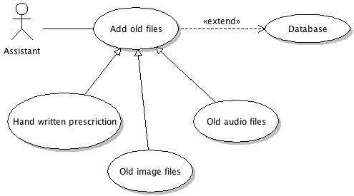

3.3.1.8 Use Case 1.8

**ID: UC8**

TITLE: Collect co-pay for appointment

DESC: The assistant will be notified how much is owed at the time of the appointment. The patient’s payment will be recorded in their account information.

DEP: None

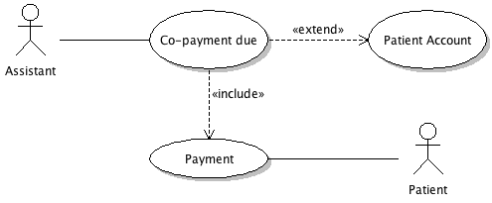

3.3.1.9 Use Case 1.9

**ID: UC9**

TITLE: Generate report of appointment

DESC: An assistant will be sent via the private clinic network a summary of the patient’s visit and any prescriptions the doctor may have issued. The assistant will print this report along with prescriptions and give them to the patient during the checkout process. After the patient has completed checking out, the assistant will update the patient’s account in the clinic database.

DEP: None

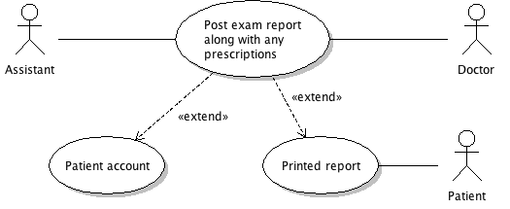

3.3.1.10 Use Case 1.10

**ID: UC10**

TITLE: Prepare Doctor’s day

DESC: The assistant will be able to pull the accounts of patients with an appointment scheduled on the current day. They will order the appointments and load patient information on the doctor’s tablet. This information will be able to be updated based on last minute cancellations or inability to make the co-payment at the time of the appointment.

DEP: None.

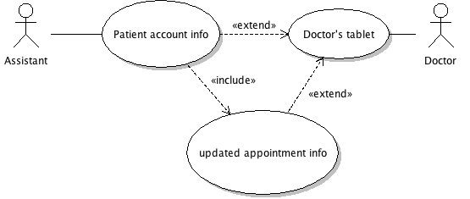

3.3.1.11 Use Case 1.11

**ID: UC11**

TITLE: Create patient info during appointment

DESC: The doctor is able, during the appointment to add notes, or other information such as vitals to his/her tablet.

DEP: None

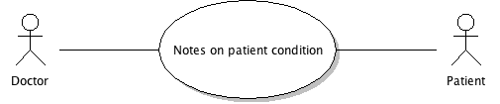

3.3.1.12 Use Case 1.12

**ID: UC12**

TITLE: Answer questions by assistant

DESC: During the course of a day the assistant may receive questions that only the doctor has the authority to answer. The doctor will be able to receive a message on his/her tablet and be able to send a response message back to the assistant.

DEP: None

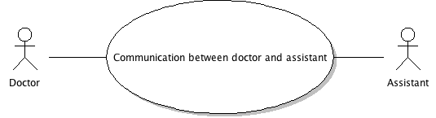

3.3.1.13 Use Case 1.13

**ID: UC13**

TITLE: Reschedule appointment

DESC: The doctor will be able to change his/her calendar based on workload, or emergency appointments. This information will be sent to the assistant who will then update the master calendar, and contact all parties that are affected by the change.

DEP: UC5

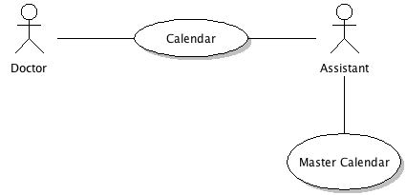

3.3.1.14 Use Case 1.14

**ID: UC14**

TITLE: Generate post appointment report

DESC: The doctor will be able to generate and send a report containing all information gathered during the exam to the assistant. This report will also include prescriptions or other tests that have been ordered by the doctor. The assistant will be responsible for printing and distributing the report along with prescriptions to the patient at the check out phase of the appointment.

DEP: UC11

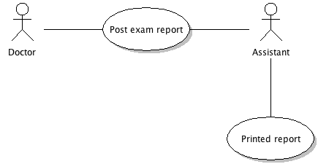

3.4 Classes

This section will give a list of classes to be used along with a brief description of each class. The section will be concluded with a UML diagram of the classes.

3.4.1.1 Class 1.1

**ID: C1**

TITLE: Type

DESC: This class will hold the information on the type of appointment that has been scheduled. Examples could include: initial, or follow-up.

DEP: None.

3.4.1.2 Class 1.2

**ID: C2**

TITLE: Appointment

DESC: This class will hold the information that is associated with an appointment. Such information includes, but is not limited to type, and date.

DEP: C1

3.4.1.3 Class 1.3

**ID: C3**

TITLE: Audio Notes

DESC: This class will hold audio notes that has been composed by a clinic doctor or could be an old audio note that an assistant will add at a later date.

DEP: None

3.4.1.4 Class 1.4

**ID: C4**

TITLE: Images

DESC: This class will hold image files such as x-rays or ultra sounds. These images could be part of a current appointment or added later to a past appointment.

DEP: None

3.4.1.5 Class 1.5

**ID: C5**

TITLE: Prescriptions

DESC: This class will hold prescriptions that are issued during an appointment or added later to a past appointment.

DEP: None.

3.4.1.6 Class 1.6

**ID: C6**

TITLE: Notes

DESC: This class will hold non-audio notes that are taken at the time of an appointment, or added to past appointments.

DEP: None

3.4.1.7 Class 1.7

**ID: C7**

TITLE: Appointment Data

DESC: This class will hold all the data collected during an appointment. This class can also be generated to add previous medical history to an established patient.

DEP: C2

3.4.1.8 Class 1.8

**ID: C8**

TITLE: Medical History

DESC: This class will hold a patients medical history in the form of appointment data.

DEP: C7

3.4.1.9 Class 1.9

**ID: C9**

TITLE: Insurance Info

DESC: This class will hold the insurance information of the patient.

DEP: None

3.4.1.10 Class 1.10

**ID: C10**

TITLE: Patient Info

DESC: This class will hold the personal information of the patient. The information will be in the form of a name, an address, phone number, and e-mail address.

DEP: None

3.4.1.11 Class 1.11

**ID: C11**

TITLE: Patient Account

DESC: This class will be composed of the class Patient Info (C10), Insurance Info (C9), and Medical History (C8).

DEP: C10, C9, and C8

3.4.1.12 Class 1.12

**ID: C12**

TITLE: Clinic Database

DESC: This class will be composed of a number of the class Patient Account (C11).

DEP: C11

3.4.1.13 Class 1.13

**ID: C13**

TITLE: Doctor Calendar

DESC: This class will be the calendar that the doctor updates. When he/she makes changes to this calendar it will be updated to the master calendar by the assistant.

DEP: None

3.4.1.14 Class 1.14

**ID: C14**

TITLE: Patient Calendar

DESC: This class will be the calendar that a patient updates with an appointment. It will inherit its information from Calendar (C15). The assistant will update the master calendar when a patient schedules an appointment.

DEP: None

3.4.1.15 Class 1.15

**ID: C15**

TITLE: Calendar

DESC: This class is composed of a Patient Calendar (C14), and Doctor Calendar (C13). This class inherits its information from a Master Calendar (C16).

DEP: C13, C14

3.4.1.16 Class 1.16

**ID: C16**

TITLE: Master Calendar

DESC: This class houses the master calendar that is updated by the assistant. Each change that is made to Calendar (C15) the assistant than transcribes to the master calendar, with the Doctor Calendar (C13) have precedence of Patient Calendar (C14).

DEP: C15

3.4.2.1 Class UML Diagram

