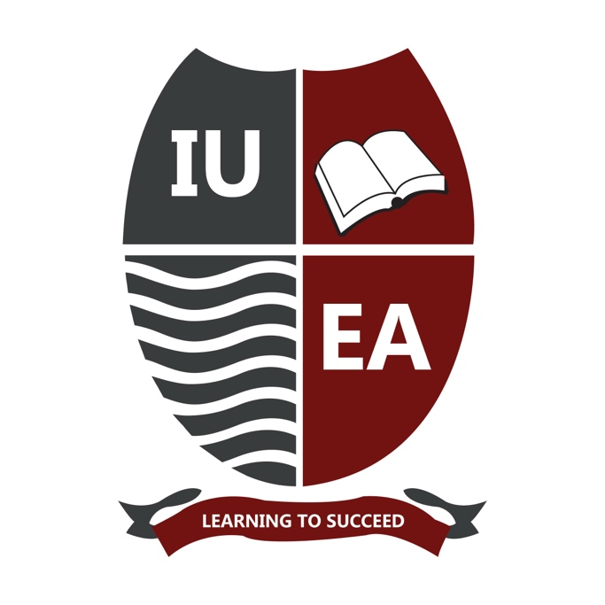



Community Outreach
2023

INTERNATIONAL UNIVERSITY OF EAST AFRICA
‘Learning to Succeed’
ANNUAL COMMUNITY OUTREACH
& ENGAGEMENT REPORT 2023
A University Without Boarders: Transforming Lives, Building Communities
Reporting period: January – December 2023
Plot 1112/1121 Kansanga Ggaba Road, P.O. Box 35502, Kampala, Uganda
www.iuea.ac.ug · info@iuea.ac.ug · Toll-free 800 335 335
Prepared by the Office of the Vice Chancellor with the Marketing and Outreach Department

Contents
01 Message from the Vice Chancellor
02 Message from the Deputy Vice Chancellor
03 About this report
04 Our philosophy: Ubuntu and the university without borders
05 Our community engagement framework
06 Where we work
07 The year at a glance
08 Pillar one — Access to education: scholarship programmes
09 Regional and diplomatic scholarship initiatives
10 Voices from our community
11 Pillar two — An open campus: community access to our facilities
12 Pillar three — Health, dignity and wellbeing
13 Pillar four — Food security, nutrition and livelihoods
14 Pillar five — Environment and stewardship
15 Pillar six — Innovation, skilling and enterprise
16 Supporting public institutions and national development
17 Children and vulnerable groups
18 The partnerships that made this possible
19 Our people in service
20 Institutional milestones
21 How we measure our impact
22 Challenges and lessons learned
23 Looking ahead: our commitments
24 A message from the Chancellor
25 Conclusion and acknowledgements
26 How to work with us

01
Message from the Vice Chancellor
This was the year the charter was conferred, and the year we installed our second Chancellor. Both events invite an institution to look inward. We chose to look outward instead.
In 2023 we launched special scholarships for the West Nile region, recognising educational challenges that geography alone imposes on communities in that part of Uganda. We established a dedicated scholarship fund to place our access commitments on a permanent financial footing rather than an annual one. And our work on climate action and food security was recognised regionally — recognition that matters to us only because those problems are lived daily by the communities around our sites.
The theme of this year’s report is the widening of a circle. When the university began, our community was the few streets around the Kansanga campus. It is now a set of regions, and it will shortly include a sub-region where we intend to build rather than merely visit.
I record with sadness the passing of our founding Chancellor, Prof. Emmanuel Tumusiime-Mutebile, who gave this institution its first decade of standing. The scholarship fund launched this year is, in part, a continuation of what he believed a university owed the country around it.

Prof. Emeka Akaezuwa
Vice Chancellor, International University of East Africa
Giving back is one of our core values as a university.

02
Message from the Deputy Vice Chancellor
A scholarship offered once is generosity. A scholarship fund is a commitment. This year we moved from the first to the second, and in doing so we told every future cohort in West Nile, in Karamoja and in the communities around us that access to this university does not depend on whether a given year has been financially comfortable.
The Deputy Vice Chancellor’s portfolio covers research, innovation and extension — and it is extension, the least visible of the three, that carries most of the work described in this report. Extension is the discipline of taking what a university knows and placing it where it is needed, without waiting to be asked and without expecting payment.
Every activity recorded in the pages that follow was delivered by named people: lecturers who gave weekends, students who gave holidays, and staff who added community work to a full timetable. The institution takes the credit in documents like this one. They did the work.

Prof. Lakshmi Bhabuu
Deputy Vice Chancellor

03
About this report
Reporting period | January – December 2023
Prepared by | Office of the Vice Chancellor, in consultation with the Marketing and Outreach Department
Scope | All community outreach and engagement activity undertaken by the university and its students and staff during the period, within Uganda.
Purpose | To account publicly for what the university did beyond its teaching and research obligations, to record it in a form that communities and partners can verify, and to identify where the work must improve.
Method | Compiled from departmental records, event documentation, partner correspondence and photographic record. Where a figure is not recorded, this report says so rather than estimating.
HOW TO READ THIS REPORT
The report is organised around six pillars of community engagement rather than by department, because communities experience the university as one institution rather than as a set of offices. Sections 8 to 15 follow those pillars. Sections 16 to 20 record wider contributions, partnerships and institutional context. Sections 21 to 23 assess how we performed and what we commit to next.
Where this report states a number, that number comes from a record we hold and can produce. Where a number should exist but was not collected, the text says so plainly. We would rather publish an honest gap than a confident estimate.

04
Our philosophy
UBUNTU
IUEA operates on the principle of Ubuntu — the belief in a universal bond of sharing that connects all humanity. We do not see ourselves as an institution separate from the community, but as an integral part of it, co-creating solutions for a shared future.
The practical consequence of that belief is a refusal to treat the campus boundary as a moral boundary. A university sits on land that a community once used for something else. It draws water, electricity and labour from its surroundings. It attracts traffic, noise and construction. In exchange it holds laboratories, libraries, sports grounds, medical services, meeting halls and expertise that the surrounding community, in most cases, cannot access anywhere else. To hold those assets behind a gate and describe the arrangement as neutral would be a failure of reasoning as much as of generosity.
A university’s greatness is measured not by the number of students enrolled, but by the depth of its impact on the communities it serves.

A UNIVERSITY WITHOUT BORDERS
The phrase that titles this report is meant literally. It describes an institution whose gymnasium is used by people who have never enrolled, whose parking serves congregations at weekends, whose conference hall hosts national agencies without charge, whose laboratories receive schoolchildren who have never seen one, and whose farm in Karamoja gives away part of what it grows.
It also describes a geographic reach that has grown beyond Kampala. Our scholarship commitments now extend to Karamoja and the West Nile, to South Sudan and Nigeria through diplomatic partnership, and to eight African states through country allocations. A university without borders is not a slogan about openness in the abstract; it is a description of where our obligations are currently held.

05
Our community engagement framework
Our outreach is organised around six pillars. They are not departments and they do not correspond to budget lines; they describe the different ways an institution of this kind can be useful to the people around it.
Pillar | Focus | What it means in practice
One | Access to education | Scholarships across merit, innovation, sport, gender, vulnerability and region, so that ability rather than means determines who studies here.
Two | An open campus | Free community access to laboratories, sports facilities, the gymnasium, conference space and parking.
Three | Health, dignity and wellbeing | Medical camps, blood donation drives, free counselling, menstrual health and hygiene provision, sexual violence awareness, and access to vaccination.
Four | Food security and livelihoods | Agricultural demonstration and production in Karamoja, with a standing commitment to donate part of the harvest.
Five | Environment and stewardship | Clean-up campaigns, waste recovery research and climate-smart practice.
Six | Innovation and enterprise | Open innovation facilities, skilling, incubation and professional mentorship for community innovators.


A seventh strand runs across all six: partnership. Almost nothing recorded in this report was done by the university alone.

06
Where we work
OUR IMMEDIATE NEIGHBOURHOOD
The university sits in Kansanga, in Makindye East Division of Kampala. Six communities form the core of our immediate outreach footprint, and they appear throughout this report.
Kansanga | The community in which the campus stands. Recipient of community scholarships, food relief, sanitary pad distribution, market clean-up campaigns and open facility access.
Kitalanga | Reached through food relief and hygiene distribution, and through community scholarship awards.
Kibbaati | Reached through food relief and hygiene distribution.
Kiwempe | Reached through food relief and hygiene distribution.
Bunga | Reached through food relief and community outreach.
Konge | Reached through food relief and community outreach.
BEYOND KAMPALA
Karamoja sub-region | Scholarships for Karamoja; the Agriculture School and commercial farm at Moruita, Nakapiripirit District; and the Mining School in the same district.
West Nile region | Regional scholarships since 2023, and participation in the secondary school visitation programme.
National | Free conference facilities for national institutions; the NIRA National ID renewal platform; annual fasting packages to Muslim communities across Uganda.
Regional and continental | Country scholarship allocations to Uganda, Kenya, Rwanda, Burundi, South Sudan, the Democratic Republic of the Congo, Somalia and Nigeria; embassy partnerships with South Sudan and Nigeria.

07
The year at a glance
2  NEW REGIONAL PROGRAMMES | 6  SCHOLARSHIP CATEGORIES | 6  COMMUNITIES SERVED | 5  NATIONAL INSTITUTIONS HOSTED

SUMMARY OF ACTIVITY
Initiative | Scope | Outcome
West Nile scholarships launched | Students from the West Nile region | Special regional scholarships introduced to improve access in an underserved region
IUEA Scholarship Fund established | All scholarship categories | A dedicated fund placing access commitments on a permanent footing
South Sudan Embassy scholarships | South Sudanese students | Annual full scholarships to the Government of South Sudan continued
Nigerian Embassy partnership | Nigerian students | Special scholarships awarded in partnership with the Nigerian diplomatic mission
Secondary school visitation | Schools across Uganda, including West Nile | Free laboratory tours, sports access and career guidance
Community sports and gym access | Surrounding communities | Free use of the university gymnasium and sports facilities
Parking facilities | Nearby churches and community groups | Free parking for community functions and events
Medical camps | Local communities | Free health screenings and medical consultations
Blood donation drives | Students, staff and community members | Voluntary blood donation drives held on campus in support of the national blood supply
Kansanga Market clean-up | Kansanga | Environmental stewardship and community hygiene
Orphanage outreach | Orphanage schools in the area | Donation drives and morale visits by students
Free conference space | Uganda Police, NCHE, URA, Bank of Uganda, Uganda Airlines | Facilities provided at no charge to national stakeholders
Innovation Lab community access | Community innovators and entrepreneurs | Open access for skilling and innovation

08
Pillar one — Access to education
IUEA is committed to making quality education accessible regardless of background or circumstance. The scholarship programme was designed in the founders’ spirit of giving back to the community and making education available to all regardless of race, gender, class, religion or economic status. It is open to both prospective and continuing students.
The programme recognises exceptional talent and achievement, and it recognises the need to close the opportunity gap for vulnerable and disadvantaged groups, particularly women. Recipients are expected to exhibit a high standard of work and academic performance, or a high level of creativity and innovation, and to give something back in turn.
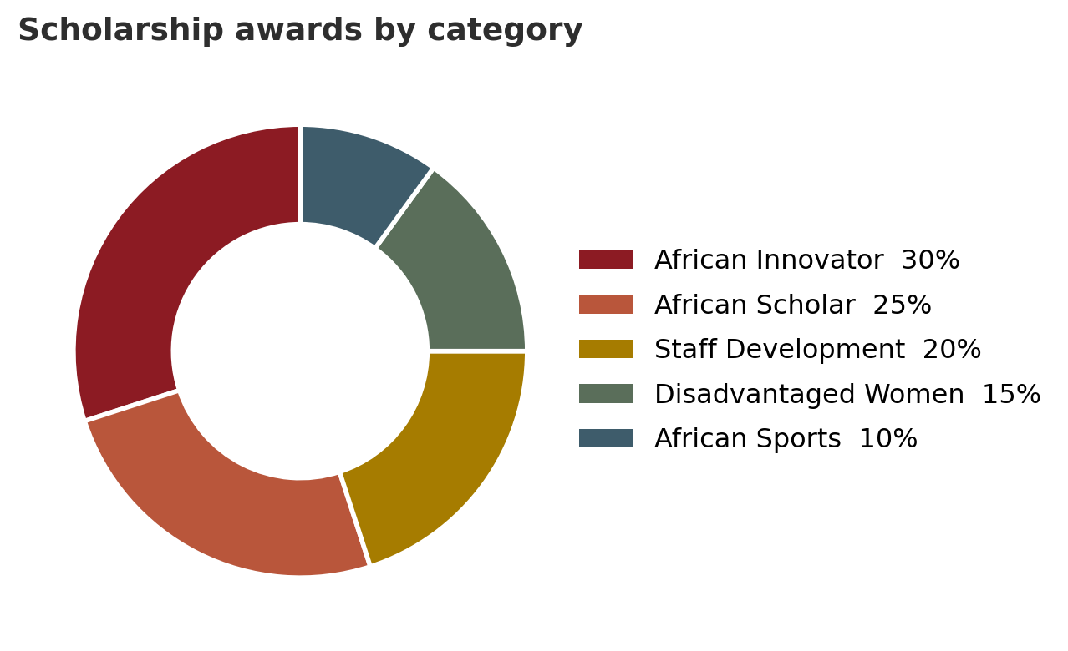
Allocation of scholarship awards across the standing categories
SCHOLARSHIP CATEGORIES
Category | Allocation | Target group
African Innovator Scholarship | 30% | Those who create new technology. Recipients receive the resources and skills needed to turn ideas into reality, and must show technical ability to develop practical solutions to local, regional or global problems.
African Scholar Scholarship | 25% | Those who excel academically, supported with the tools needed to succeed as researchers or scholars.
IUEA Staff Development | 20% | Academic and administrative staff of at least two years’ standing, providing upward mobility within the institution.
Disadvantaged Women Scholarship | 15% | Women from disadvantaged families, supported with financial and entrepreneurial assistance.
African Sports Scholarship | 10% | Those who excel in sport at a competitive level.
Vulnerable Scholarship | Varies | Students facing financial hardship.
SELECTION CRITERIA
Academic awards
- New students must meet the advertised academic requirements for their programme.
- Continuing students must maintain the required cumulative grade point average.
- A minimum of ten hours of community service to the university.
- Demonstrated good character.
Innovation awards
- Evidence of technical ability to develop relevant, practical solutions to local, regional or global problems.
- Demonstrated desire to pursue innovation seriously and consistently, with respect for the process as well as the product.
- Ability to take responsibility for a significant piece of work without waiting to be told.
Sports awards
- Excellence in sport at a competitive level, with continuing students maintaining a CGPA of 3.5 or higher.
Disadvantaged Women awards
- Gender-based, awarded to women from disadvantaged families, with demonstrated talent and desire to succeed, and a CGPA of 3.5 or higher for continuing students.
THE IUEA CODE
All recipients, whatever the category, commit to the same code: to keep time at all times; to take responsibility for their work and work with integrity; to work independently rather than wait to be told what to do; and to be dedicated to quality and professionalism. All are required to participate in community service, and several categories require recipients to mentor other students.
HOW TO APPLY
Applicants apply for admission to IUEA, receive an admission letter, collect a scholarship application form from the Marketing Office, and submit it with supporting documentation. Awards run for the duration of the programme subject to performance, which is reviewed at the end of every semester.
DISTRIBUTION AND ADMINISTRATION
Scholarships are distributed across the three annual intakes — January 20%, May 20% and August 60% — with defined application windows and no late applications processed. The programme is administered by the Academic Registrar’s office, supported by a scholarship committee whose members must be individually competent in innovation, in sport and in social issues, so that each category is assessed by someone qualified to assess it.
GOVERNANCE AND COUNTRY ALLOCATIONS
Beyond the standing categories, the university reserves scholarships for specific countries and for its own governing bodies. Eight countries each hold five scholarships every five years — Uganda, Kenya, Rwanda, Burundi, South Sudan, the Democratic Republic of the Congo, Somalia and Nigeria. These are awarded through Ambassadors, who are required to select on merit, with gender balance, and from different parts of the countries they represent. Each member of the Board of Directors and of the University Council additionally holds two scholarships to award every three years.

09
Regional and diplomatic scholarship initiatives
Scholarships for the West Nile region
From 2023 the university began awarding special scholarships to students from the West Nile region, recognising the particular educational challenges faced by communities there. The West Nile hosts one of the largest displacement-affected populations in the country, and access to tertiary education has lagged behind the rest of Uganda. These awards form part of a broader commitment to improving access in underdeveloped regions, and they run alongside the secondary school visitation programme, which has drawn participating schools from the same region.
The IUEA Scholarship Fund
A dedicated scholarship fund was launched during the year, giving the university’s access commitments a permanent financial basis and allowing awards to be planned across cohorts rather than budgeted annually. The distinction matters more than it sounds. A fund allows a fifteen-year-old in Arua to be told, credibly, that a place will exist when she is ready for it.
South Sudan Embassy scholarships
The annual commitment of full scholarships to the Government of South Sudan, first extended in April 2021 through Ambassador Simon Duku Michael, was honoured again during this period.
Nigerian Embassy scholarships
The university’s partnership with the Nigerian Embassy provides special scholarships to Nigerian students, reflecting a Pan-African collaboration that also has deep institutional roots — the Kano State Government of Nigeria sent 191 students to IUEA for ICT training in 2014.


10
Voices from our community
The following testimonies were given by scholarship recipients. They are reproduced because they describe, better than any summary can, what a scholarship changes.
- Receiving this scholarship gave me the opportunity to continue my studies when I was beginning to lose hope. I now feel that I have a real chance to build the future I want.”
— Mr. Daniel Lokiru, Information Technology student, who received support that enabled him to continue his university education after facing financial difficulties.

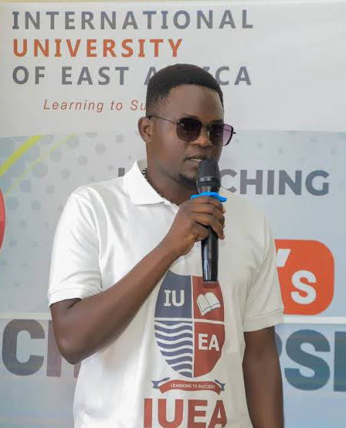
- “Growing up in Karamoja has taught me to work hard and remain determined. What many young people need is an opportunity to turn that determination into something meaningful.”
— Mr. Peter Lotee, Business Administration student, reflecting on the challenges and opportunities facing young people in the region.

11
Pillar two — An open campus
IUEA treats its facilities as community assets. The principle is simple: a resource that stands idle outside teaching hours, and that the surrounding community cannot obtain anywhere else, should be open.
SECONDARY SCHOOL VISITATION PROGRAMME
Recognising the importance of early exposure to higher education environments, the university operates a programme that allows students from secondary schools to visit the campus free of charge.
What is offered
- Laboratory tours. Students explore laboratories across engineering, ICT and the sciences — in many cases the first working laboratory they have entered.
- Sports arenas. Access to the university’s sports facilities, including courts, fields and the gymnasium.
- Career guidance. Informal sessions with faculty and current students, designed to make a university course feel like a decision rather than a distant abstraction.
What it achieves
- Hundreds of secondary school students have benefited from the programme.
- Students gain early exposure to university-level facilities and to career paths they may not have known existed.
- Schools from as far as the West Nile region have participated in these visits.
- The programme builds a pipeline of talent from secondary school into higher education.
COMMUNITY ACCESS TO GYMNASIUM AND SPORTS FACILITIES
IUEA believes in building strong minds and strong bodies. Students and community members alike have access to a fully equipped gymnasium with professional equipment and trainers, expansive sports facilities including courts, fields and pools, and regular fitness events that bring the community together.
Access is free of charge to community members in the surrounding areas, open to individuals and groups who wish to maintain their physical wellness, and forms part of the university’s commitment to holistic community health. Physical wellbeing plays a substantial role in academic and professional success, and the same is true outside the campus gate.
PARKING FACILITIES FOR CHURCHES AND COMMUNITY FUNCTIONS
In a demonstration of community solidarity, the university makes its parking available free of charge to nearby churches and community groups whenever they host functions. Local churches have used the facility during major religious events, and community groups during weddings, funerals and other gatherings. Arrangements are coordinated with the facilities team.
It is a small thing. It is also the kind of small thing that determines whether an institution is experienced as a neighbour or as an obstruction.

12
Pillar three — Health, dignity and wellbeing
Menstrual health and hygiene
Work on menstrual health continued through the year, building on the distribution and education programme established in Sankara Zone, Kansanga, with Reach a Hand Uganda and Msichana Uganda.
Medical camps
Free health screenings and medical consultations continued to be delivered to surrounding communities through the university’s medical camp programme, addressing urgent health needs and promoting preventive healthcare.
Blood donation drives
Voluntary blood donation drives continued on campus, drawing donors from students, staff and community members in support of the national blood supply.
Free counselling services
Professional counselling remained open without charge to students and community members alike.


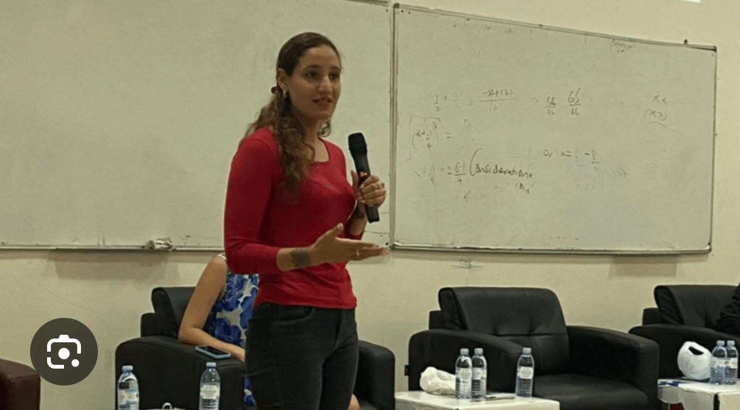

Student Donating blood and a photo of IUEA counsellor, Shurina Stokes. Speaking at Mental Health Seminar for young people.

13
Pillar four — Food security and livelihoods
Food security work during this period was concentrated in the communities immediately surrounding the campus, through relief distribution and through the community scholarship and skilling routes that address household income rather than food supply directly.
FOOD RELIEF
During the height of the COVID-19 pandemic the university partnered with Reach a Hand Uganda to distribute relief food and hygiene kits to vulnerable young mothers living in Kampala. That outreach extended to the communities of Kitalanga, Kibbaati, Kiwempe, Kansanga, Bunga and Konge, and the relationship with those six communities continues to define the university’s outreach footprint.
LOOKING TOWARD KARAMOJA
Planning was under way during this period for an agricultural demonstration and commercial facility in the Karamoja sub-region, intended to combine practical training under a climate-smart agriculture programme with production that would supply surrounding communities directly.
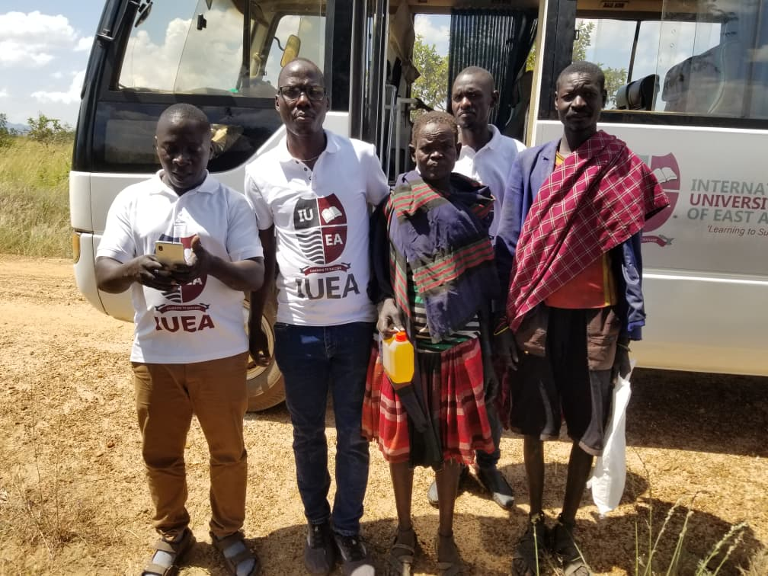

14
Pillar five — Environment and stewardship
KANSANGA MARKET CLEAN-UP CAMPAIGN
Students and staff have actively participated in cleaning Kansanga Market, demonstrating a commitment to environmental hygiene and community wellness. The market is the commercial centre of the neighbourhood in which the university sits, and its condition affects the health of everyone who trades and shops there.
WASTE RECOVERY AND THE CIRCULAR ECONOMY
The university’s Recycling Laboratory conducts applied research and prototyping in waste recovery, materials reuse and circular economy approaches, connecting environmental science teaching to working recovery processes. Its outputs are intended to be deployable in the surrounding community rather than confined to publication.
The IUEA Recycling Innovation facility was launched with the support of the European Union, German Cooperation, UKaid, the Government of Uganda, GIZ and the Natural Resources Stewardship Programme (NatuReS). That combination of partners matters: it places a university laboratory inside a national and international resource-stewardship agenda rather than leaving it as an isolated campus facility.
ENVIRONMENTAL DIMENSIONS OF OUR OTHER WORK
Environmental benefit is embedded in several programmes described elsewhere in this report. Reusable sanitary pads reduce disposal waste as well as household cost. Climate-smart agriculture in Karamoja addresses soil conservation and water efficiency. The e-mobility research centre develops electric transport. Solar generation has been installed on campus. We record these here because environmental stewardship at this institution is rarely a standalone activity; it is usually a property of something else we are doing.
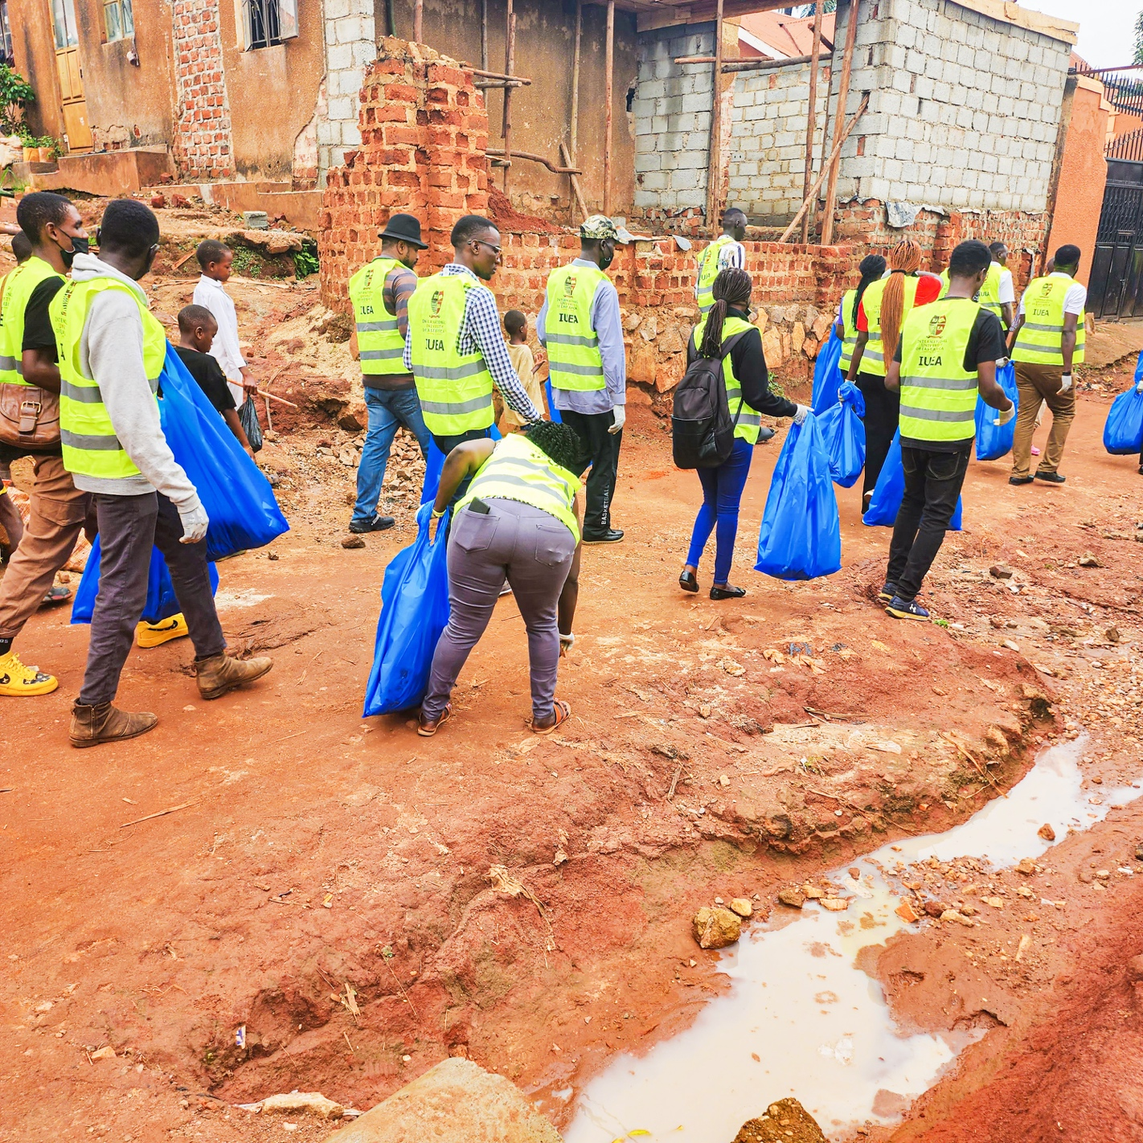

15
Pillar six — Innovation, skilling and enterprise
THE IUEA SUSTAINABLE INNOVATION LAB
The Sustainable Innovation Lab is a facility that opens its doors to the community for skilling and innovation. It is built on a Four Skills Model that deliberately combines three groups who rarely work together:
- Juakalis — practical, technical and resourceful individuals without formal education but with critical technical expertise.
- Students — bringing theoretical knowledge from class.
- Scientists and lecturers — providing academic rigour and guidance.
This collaborative framework has generated numerous innovations, demonstrating that by combining practical skills, innovative thought and theoretical knowledge, sustainable technological solutions emerge organically. The lab provides training in practical skills, access to equipment and resources, mentorship and guidance, and a collaborative environment for problem-solving.
“The truth is external actors are not interested in developing technical expertise for the country but themselves. Africa’s failure for a technological breakthrough has been hampered not from a lack of competent African engineers and scientists but from a dependency mentality.”
— Prof. Emeka Akaezuwa, Vice Chancellor
NEXUS AND ENTERPRISE INCUBATION
NEXUS is the university’s incubation programme, supporting students and graduates to develop business ideas into operating startups through mentorship, workspace, technical support and access to the wider innovation infrastructure. It is the route by which an idea developed in a laboratory becomes a registered company — and, in time, an employer.
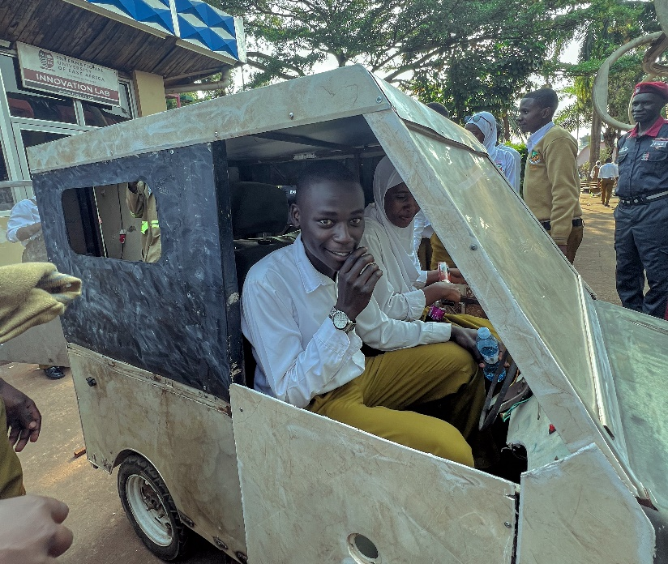

School visit at the Innovation Lab with a car built by IUEA

16
Supporting public institutions
FREE CONFERENCE SPACE FOR NATIONAL STAKEHOLDERS
IUEA has provided its conference facilities free of charge to key national institutions. The university holds one of the larger auditoria in the country, seating over 1,600, and making it available at no cost is a direct contribution to national development beyond the education sector.
Institution | Purpose
Uganda Police | Strategic planning meetings
National Council for Higher Education | Stakeholder consultations
Uganda Revenue Authority | Public engagement forums
Bank of Uganda | Financial literacy workshops
Uganda Airlines | Corporate planning sessions
NATIONAL ID RENEWAL PLATFORM
The university provides a free platform for the National Identification and Registration Authority to conduct National ID renewal. The service has reached hundreds of community members who would otherwise face long queues and considerable logistical difficulty, and it demonstrates a use of campus infrastructure that costs the institution very little and saves citizens a great deal.
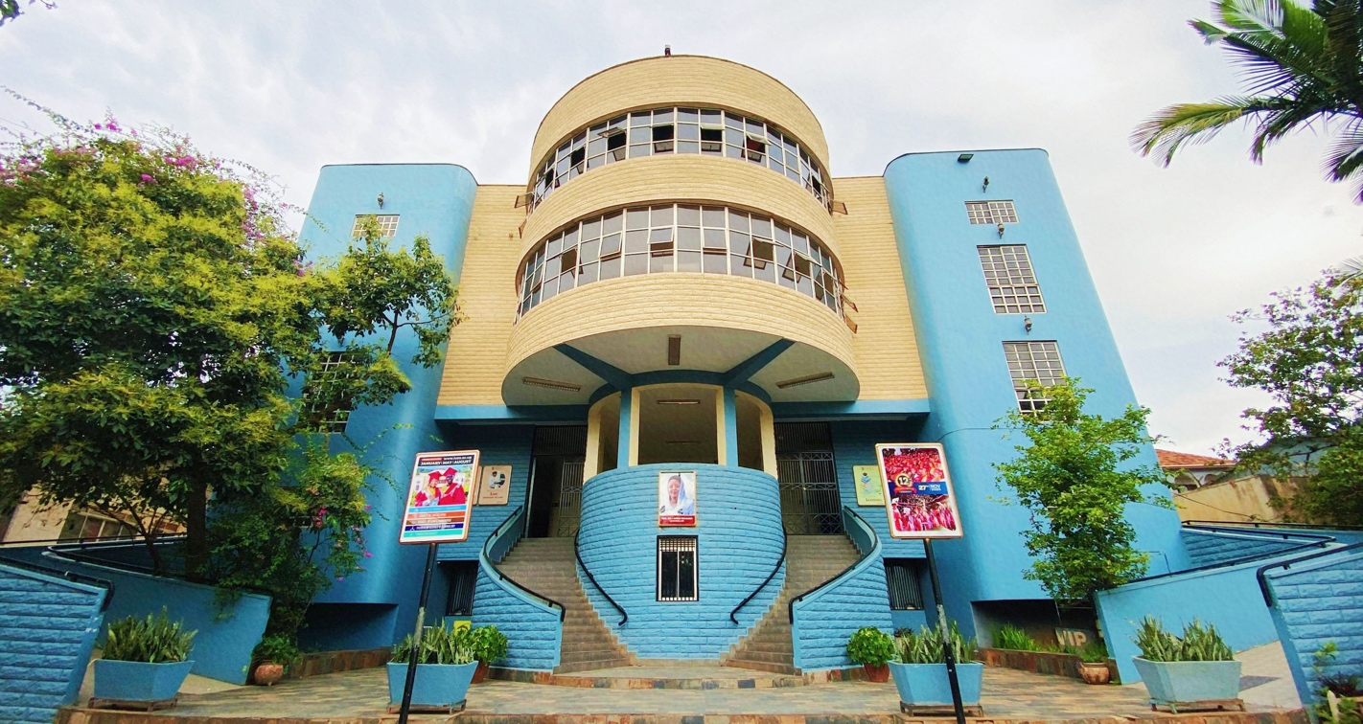

17
Children and vulnerable groups
ORPHANAGE OUTREACH AND DONATIONS
Students regularly visit orphanage schools in the area, conducting donation drives and morale-boosting visits. These initiatives provide both material support and emotional encouragement to vulnerable children, and they are organised and led by students themselves rather than by the administration.
ANNUAL FASTING PACKAGES
The university distributes fasting packages to Muslim communities at mosques across Uganda each year, reflecting the multi-denominational character of the institution and its student body.
GIRLS AND YOUNG WOMEN
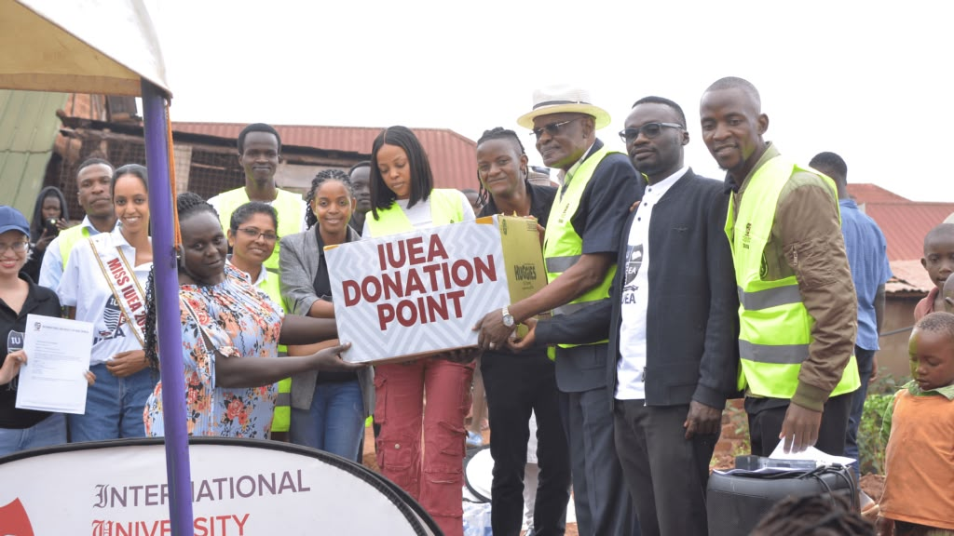
Several strands of this report converge on the same group. The Disadvantaged Women Scholarship, the Gabzy Scholarship, the menstrual health and dignity programme, and the school visitation programme all address, from different directions, the barriers that keep girls out of classrooms and young women out of universities.

18
The partnerships that made this possible
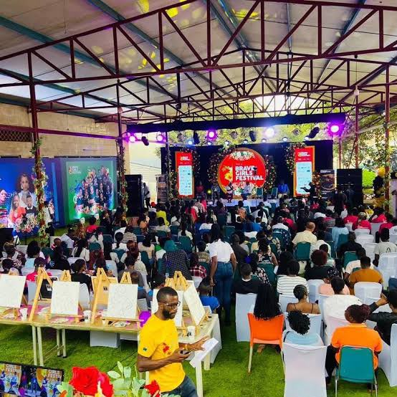

Almost nothing recorded in this report was accomplished by the university alone.
Partner | Contribution
Reach a Hand Uganda | Menstrual health and hygiene outreach; distribution of relief food and hygiene kits to vulnerable young mothers.
Msichana Uganda | Reusable sanitary pad provision and menstrual health education.
Sauti Media Group | Co-host of the reusable sanitary pad launch and associated fundraising.
Uganda Institution of Professional Engineers | Establishment of the Innovation Clinic; professional mentorship and certified internship supervision.
Embassy of South Sudan | Annual full scholarship partnership since April 2021.
Embassy of Nigeria | Scholarship partnership for Nigerian students.
Nakapiripirit District Local Government | Recognition of and collaboration on the Agriculture School and commercial farm; district coordination.
National Identification and Registration Authority | Community National ID renewal services hosted on campus.
European Union, German Cooperation, UKaid, GIZ and NatuReS | Support for the launch of the IUEA Recycling Innovation facility and its community skilling role.
Women’s Probono Initiative | Sexual violence awareness programming on campus, including a session led by Josephine Kamisya during Sexual Assault Awareness Month.
National blood transfusion service | Voluntary blood donation drives hosted on campus.
Community leadership | Local council and community leaders in Kansanga, Kitalanga, Kibbaati, Kiwempe, Bunga and Konge, who identify need and make outreach possible.

19
Our people in service
Community outreach at this university is not delivered by a dedicated department with a separate payroll. It is delivered by students who give up holidays, faculty who give up weekends, and administrative staff who add it to a full workload.
STUDENTS
Student societies organise orphanage visits, market clean-ups and donation drives. Karamoja scholarship recipients lead a national student association and have launched their own regional initiative. Engineering students staff the Innovation Clinic. Every scholarship category requires community service, which means that the university’s access programme and its outreach programme are structurally the same programme.
STAFF
Faculty deliver training, run medical and health sessions, supervise student outreach and staff the counselling service. The Marketing and Outreach Department coordinates. The estates and facilities teams make open access to the gymnasium, grounds, auditorium and parking practically possible — work that is invisible when it goes well.
“We encourage our students not just to study to get jobs but to study to create and to be global leaders.”
— The Chancellor
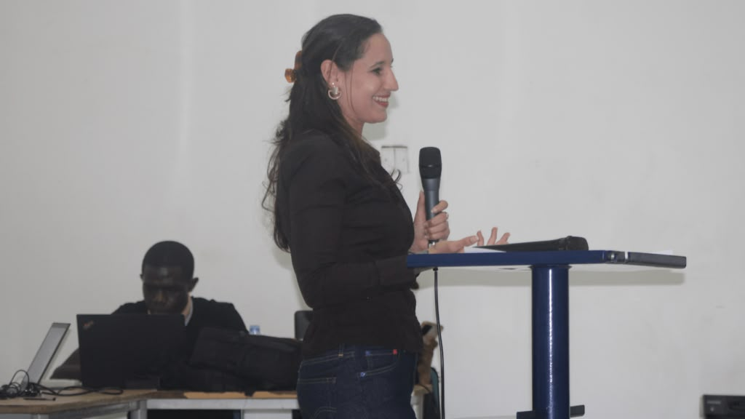

20
Institutional milestones
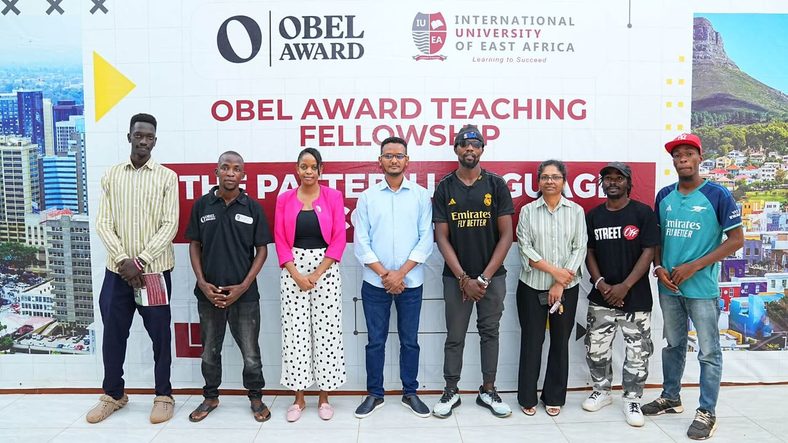
Community outreach does not happen in isolation from the university’s wider development. The milestones below shaped the capacity available to the communities we serve.
When | Milestone
2023 | University charter conferred following approval in September 2022
2023 | Amb. Dr. Amina Chawahir Mohammed installed as the second Chancellor, succeeding the late Prof. Emmanuel Tumusiime-Mutebile
2023 | IUEA Scholarship Fund launched
2023 | Faculty of Music and Performing Arts established
2023 | Obel Fund for Architecture received
2023 | Best Climate Action and Food Security Innovation in East Africa, and Best Partners in Climate Action in East Africa — East Africa Quality Brands Awards

21
How we measure our impact
We are conscious that much of this report describes activity rather than counting it. That is a weakness and we prefer to state it here rather than let a reader discover it.
WHAT WE CURRENTLY RECORD
- Scholarship awards by category, recipient and duration, administered through the Academic Registrar’s office.
- Scholarship performance, reviewed at the end of every semester.
- Event documentation and photographic record for outreach activities.
- Partner correspondence and formal recognition from district and national authorities.
WHAT WE DO NOT YET RECORD CONSISTENTLY
- Beneficiary numbers for facility access — gymnasium, sports grounds, counselling and parking.
- Attendance at medical camps, and the number of people screened or treated.
- The monetary value of donated facility use, produce and materials.
- Retention, progression and completion rates for scholarship recipients, disaggregated by category and region.
OUR COMMITMENT
From the next reporting period the university will apply a single beneficiary record across all outreach activity, capturing numbers reached, disaggregated by sex and location, and the value of in-kind contribution. A future edition of this report should be able to state, rather than describe, what the university gave and whom it reached.

22
Challenges and lessons learned
An annual report that records only success is a marketing document. The following are the lessons this period taught us.
Regional access requires regional presence.
Awarding scholarships to students from a distant region is only the first barrier removed. Travel, accommodation, orientation and the experience of arriving alone in Kampala all remain. Regional scholarship programmes need an accompanying social support structure, not only a fee waiver.
A fund changes the conversation.
Establishing a dedicated scholarship fund altered how partners, embassies and prospective donors engaged with us. A permanent instrument invites contribution in a way that an annual budget line does not.
Recognition is not impact.
The university received significant regional recognition this year for climate and food security work. Awards attract attention and open doors, but they measure visibility rather than outcome. We are conscious of the difference and intend our future reporting to reflect it.
STANDING CONSTRAINTS
- Demand exceeds capacity. Applications for every scholarship category substantially exceed available places, and each award made is a larger number of applicants turned away.
- Outreach depends on volunteered time. Most activity here was delivered by people adding it to a full workload, which caps how much can be sustained and makes delivery vulnerable to teaching pressure.
- Geography is expensive. Reaching Karamoja and the West Nile costs materially more per beneficiary than reaching Kansanga, and regional commitments require budgeting accordingly.

23
Looking ahead: our commitments
Building on this year’s work, the university commits to the following.
- 1. Launch of a dedicated scholarship initiative for the Karamoja sub-region.
- 2. Establishment of a formal innovation clinic linking engineering students to professional practice.
- 3. Extension of menstrual health work through partnership with reusable sanitary pad producers.
- 4. Development of a commercial and demonstration farm in Karamoja to support food security and practical training.
- 5. Introduction of structured social and academic support for regional scholarship recipients.
We invite you to join us. Together we can build a more inclusive, innovative and prosperous society.

24
A message from the Chancellor
“We encourage our students not just to study to get jobs but to study to create and to be global leaders.”
— Amb. Dr. Amina Chawahir Mohammed, Chancellor
The spirit of innovation and leadership is the cornerstone of the IUEA experience. Our community outreach programmes are designed to nurture that spirit, ensuring that our graduates are not only academically excellent but also socially conscious global citizens.
A graduate who leaves this university able to earn a living has been served adequately. A graduate who leaves able to create a living for others has been educated. The difference between those two outcomes is largely made outside the lecture theatre — in the clinics, the farms, the laboratories opened to strangers, and the communities that let our students practise on their real problems.
We express our deepest gratitude to our students, staff and all partners who have made this year’s outreach initiatives a success.

25
Conclusion and acknowledgements
IUEA’s community outreach initiatives demonstrate an unwavering commitment to the communities we serve. From scholarships that transform lives to skills training that builds sustainable livelihoods, from health camps that meet urgent need to innovation spaces that create solutions, we are proud to be your partner in progress.
As we look to the future, we invite you to join us in this journey. Together, we can build a more inclusive, innovative and prosperous society.
ACKNOWLEDGEMENTS
This report would not exist without the students who gave their time, the faculty and staff who carried outreach alongside a full workload, the partner organisations named in section 18, the diplomatic missions that entrusted us with their nationals, the district and national authorities that worked with us, and above all the communities of Kansanga, Kitalanga, Kibbaati, Kiwempe, Bunga and Konge — and of Karamoja and the West Nile — who allowed us to be useful.
“Giving back is one of our core values as a university.”
— Prof. Emeka Akaezuwa, Vice Chancellor

26
How to work with us
The university welcomes collaboration with individuals, organisations, government bodies and diplomatic missions that share our commitment to widening access and strengthening communities.
WAYS TO PARTNER
- Fund a scholarship. Full and half awards are available across every category, and sponsors receive reporting on their recipients’ progress.
- Co-deliver an outreach programme. Health, menstrual hygiene, skilling and environmental programmes are all delivered in partnership and have capacity for more partners.
- Use our facilities. Conference and auditorium space is available to national institutions and community organisations.
- Support the Karamoja programme. The Agriculture School and commercial farm, and the Scholarships for Karamoja initiative, both accept partner support.
- Contribute expertise. Professional mentorship through the Innovation Clinic and NEXUS is delivered by practitioners from outside the university.
CONTACT
Institution | International University of East Africa
Address | Plot 1112/1121, Kansanga Ggaba Road, P.O. Box 35502, Kampala, Uganda
Toll-free | 800 335 335
Mobile and WhatsApp | +256 705 722 300
Email | info@iuea.ac.ug
Website | www.iuea.ac.ug
Office hours | 8:00 a.m. – 5:00 p.m.
Outreach enquiries | [ name, title and email of the outreach focal point ]

Follow us to stay updated on our next philanthropic adventure.
Facebook · X · Instagram · YouTube · LinkedIn — IUEA Uganda

