Documentation for RPG Store Simulator in console.

For AIE by Jacob Cooper.

**Unit testing:**

**CreateItem(string name, string description, int cost, string category, int rarity, string[] stats)**

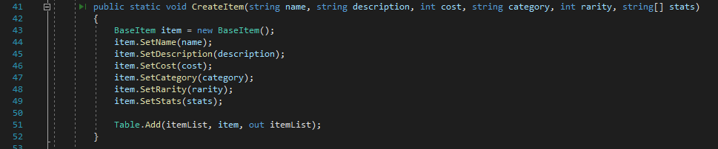

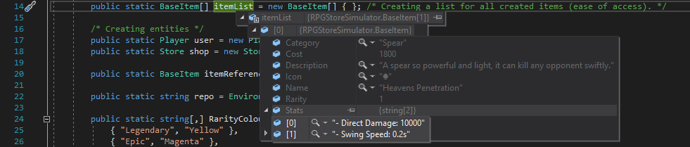

**Note:** CreateItem was successful in creating the item and inserting it into the itemList. All the variables were inputted as seen above after breaking the first item creation.

**When does it break?**  
 

It only breaks when you input the wrong ‘Type’ into the argument field, like the example above, I put an integer into a string field so the program throws this back:



**class Commands**

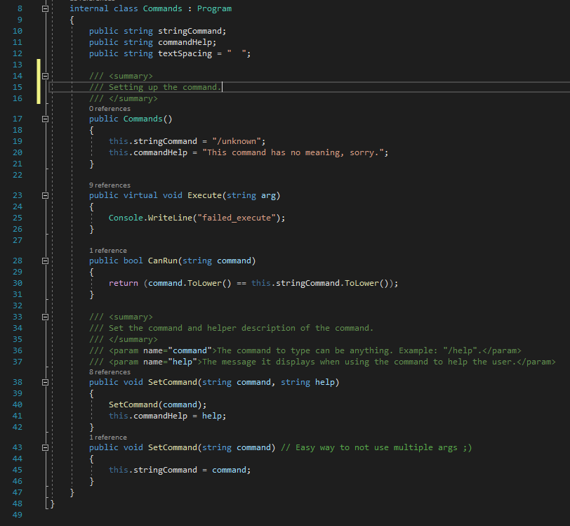

**Note:** This subsystem which acts as a derivative (base class for inheritance) is successful, it achieves its purpose by creating a base template for other commands to work off.  
  
**When does it break?**

  
When the command (a class which inherits Commands) has an argument that is not a string it will break. It throws this back:



**Required Features**Complete the following table by providing the class name or file name, along with the line number, to show where you have implemented each feature.

|  |  |  |
| --- | --- | --- |
| **Feature** | **Class/File** | **Line Number** |
| The program implements a base *Item* class, and two or more sub-classes | Classes/Inventory/BaseItem.cs | 8 |
| The program stores items in a *player* inventory array and a *store* inventory array |  |  |
| The program loads both inventory arrays from a text file upon launch |  |  |
| The program saves both inventory arrays to a text file before exit |  |  |
| The program contains at least 2 classes containing four or more variables |  |  |
| The program overrides an object constructor at least once |  |  |
| The program implements text commands to buy and sell items, and view item descriptions |  |  |
| Unit testing has been conducted on at least two sub-systems. These projects are included in the submission |  |  |
| Code is well commented (i.e., each function and class is commented) |  |  |