Unit Testing for RPG Store Simulator in console.

For AIE by Jacob Cooper.

**Unit testing:**

**CreateItem(string name, string description, int cost, string category, int rarity, string[] stats)**

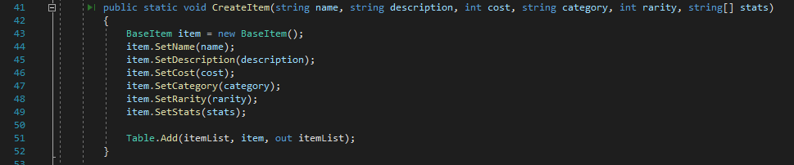

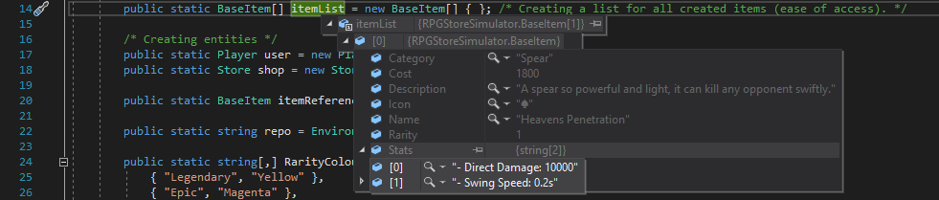

**Note:** CreateItem was successful in creating the item and inserting it into the itemList. All the variables were inputted as seen above after breaking the first item creation.

**When does it break?**  
 

It only breaks when you input the wrong ‘Type’ into the argument field, like the example above, I put an integer into a string field so the program throws this back:



**class Commands**

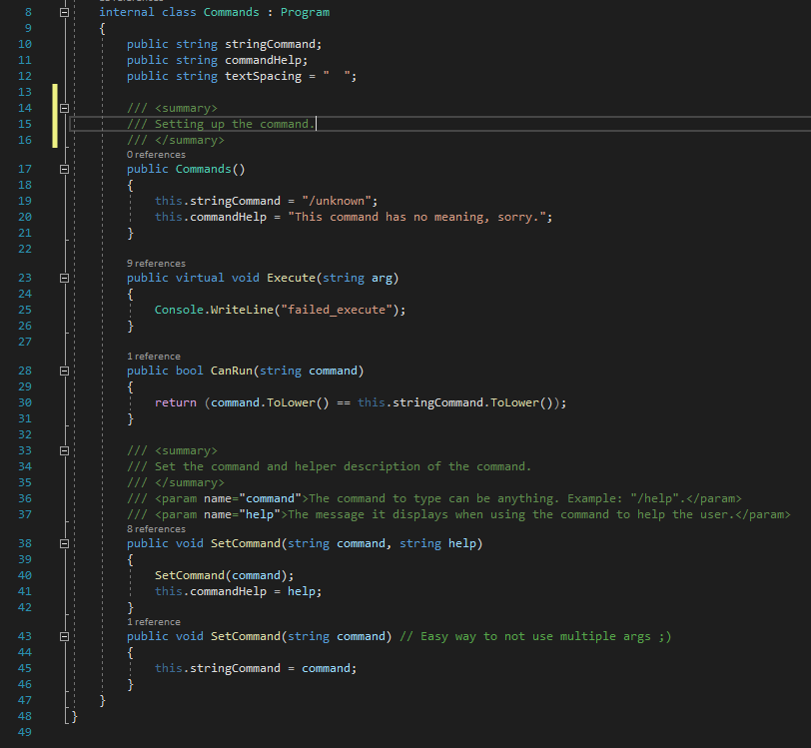

**Note:** This subsystem which acts as a derivative (base class for inheritance) is successful, it achieves its purpose by creating a base template for other commands to work off.  
  
**When does it break?**

  
When the command (a class which inherits Commands) has an argument that is not a string it will break. It throws this back:

