CS 340 README
Grazioso Salvare Rescue Dog Dashboard
Jacobsin Enriquez | CS 340 Client/Server Development | October 2026

About the Project/Project Title
This project is a full-stack web application built for Grazioso Salvare, an international rescue-animal training company. It consists of three layers: a MongoDB database containing the Austin Animal Center Outcomes data set (Austin Animal Center, 2020), a custom Python module (CRUD_Python_Module.py) that provides Create, Read, Update, and Delete (CRUD) access to that database, and an interactive dashboard (ProjectTwoDashboard.ipynb) built with the Dash framework. The dashboard allows Grazioso Salvare staff to filter shelter animals by rescue type, browse the matching records, compare the breeds in the current view, and locate each candidate on a map without writing database queries.

Motivation
Grazioso Salvare needs to identify specific profiles of dogs for search-and-rescue training based on criteria like age, breed, and sex. Instead of executing manual database shell commands, staff select a rescue type on the dashboard and the application runs the matching query through the CRUD module. This reduces user errors and training time, ensures data integrity, and keeps database access behind secure authentication. Because the client asked for the code to be open source, the module and dashboard are written to be reusable so that similar organizations can adapt them.

Required Functionality
The dashboard was built to the Dashboard Specifications Document provided by the Global Rain UI/UX developer. Each required component is listed below, and Figures 1 through 5 in the Screenshots section show the dashboard in its starting state and after each filter is applied.
- Branding: The Grazioso Salvare logo appears in the page header and links to the client home page (www.snhu.edu), as requested by the client. The unique identifier “Grazioso Salvare Dashboard - Jacobsin Enriquez” credits the dashboard creator.
- Interactive filter options: A set of radio items offers Water Rescue, Mountain or Wilderness Rescue, Disaster or Individual Tracking, and Reset. Radio items render a set of buttons for single-option selection from multiple choices (Plotly, n.d.-e), which prevents conflicting filters from being applied at the same time.
- Interactive data table: A Dash DataTable, an interactive table that supports sorting, filtering, and paging (Plotly, n.d.-a), displays the selected records ten rows per page with single-row selection. Each rescue filter reloads the table, selects the first row, returns to page one, and clears any column sorting or filtering, so Reset restores every widget to its original, unfiltered state.
- Breed chart: A horizontal bar chart shows the ten most common breeds in the current table view, with the total number of animals in the chart title. The chart responds both to the rescue filters and to the table’s own column filters.
- Geolocation chart: A Dash Leaflet map, a wrapper of the open-source Leaflet library for interactive maps (Dash Leaflet, n.d.), places a marker on the animal selected in the table and centers the view on it. Hovering over the marker shows the animal’s name and breed, and clicking it opens a popup with the name, breed, age, sex, and Animal ID that staff need for screening.

Rescue Type Queries
The filter queries were built from the Rescue Type and Preferred Dog Breeds table in the Dashboard Specifications Document. Each query combines four conditions: animal_type equal to Dog, breed matched against the preferred breed list with the $in operator, sex_upon_outcome equal to the preferred sex, and age_upon_outcome_in_weeks bounded by the $gte and $lte comparison operators (MongoDB, n.d.-e). The three profiles are stored in a single dictionary, and one function assembles the query document for any profile, so a new rescue type can be added without writing a new query.
- Water Rescue: Labrador Retriever Mix, Chesapeake Bay Retriever, or Newfoundland; Intact Female; 26 to 156 weeks. Returns 17 dogs.
- Mountain or Wilderness Rescue: German Shepherd, Alaskan Malamute, Old English Sheepdog, Siberian Husky, or Rottweiler; Intact Male; 26 to 156 weeks. Returns 19 dogs.
- Disaster or Individual Tracking: Doberman Pinscher, German Shepherd, Golden Retriever, Bloodhound, or Rottweiler; Intact Male; 20 to 300 weeks. Returns 28 dogs.
- Reset: An empty query that returns all 10,000 records.
Breed matching required a design decision. The specification lists breed names such as “German Shepherd,” while the mockups show mixed breeds such as “German Shepherd Mix” and “Bloodhound Mix” in the filtered results. Both styles were unit tested. Exact matching returned 5 Mountain and 4 Disaster candidates, while matching any breed that contains a preferred name returned 19 and 28. Every record in both styles met the sex and age rules. The “contains” style was selected because it matches the client’s mockups, follows the client’s own inclusion of “Labrador Retriever Mix,” and gives Grazioso Salvare a larger candidate pool. The trade-off is that crosses such as “Pit Bull/German Shepherd” are included, so the setting is a single line (BREED_MATCH_MODE) that can be switched back to “exact” if the client prefers stricter results. No Chesapeake Bay Retriever or Newfoundland records met the Water Rescue sex and age criteria, so all 17 Water Rescue candidates are Labrador Retriever Mix.

Tools and Rationale
The application follows the Model-View-Controller (MVC) design pattern. MongoDB holds the model, the Dash layout provides the view, and Dash callbacks act as the controller by calling the CRUD module whenever the user interacts with the dashboard.

MongoDB (Model)
MongoDB was chosen as the model component because its document structure fits shelter records and interfaces naturally with Python. A MongoDB document is composed of field-and-value pairs and stored as BSON, a binary representation of JSON (MongoDB, n.d.-b). Through PyMongo, each document arrives in Python as a dictionary, so query results pass directly into a pandas DataFrame and the DataTable without custom conversion code. MongoDB’s query predicates, including $in, $gte, $lte, and $regex (MongoDB, n.d.-e), express each rescue profile as a single query document. MongoDB also provides role-based access control, in which a user is granted roles that determine its access to database resources (MongoDB, n.d.-f). The aacuser account holds only the readWrite role on the aac database, so the dashboard connects with the minimum access it needs. The data set was loaded with mongoimport, which imports CSV and other export formats (MongoDB, n.d.-d).

PyMongo (Python Driver)
The module uses PyMongo, a Python package for connecting to and communicating with MongoDB (MongoDB, n.d.-c). PyMongo was selected because it is officially maintained by MongoDB, which ensures compatibility with current server versions and native support for credential-based authentication through a connection string (MongoDB, n.d.-a). It also maps MongoDB documents directly to Python dictionaries, allowing records to be inserted and queried without additional data conversion. Its core methods, insert_one(), find(), update_many(), and delete_many(), correspond directly to the four CRUD operations required for this project. Finally, PyMongo is extensively documented and is pre-installed in the Codio development environment.

Dash Framework (View and Controller)
Dash provides both the view and the controller for the web application. A Dash app is composed of a layout, which describes what the app looks like (Plotly, n.d.-c), and callbacks, which are functions that Dash calls automatically whenever an input component’s property changes in order to update an output component (Plotly, n.d.-d). Dash was selected because the entire dashboard, including the interface and its interaction logic, is written in Python, the same language as the CRUD module, so no separate HTML or JavaScript code base is required. The dashboard maps to MVC as follows:
- Model: MongoDB and the AnimalShelter class in CRUD_Python_Module.py.
- View: The layout, which contains the logo header, radio items, DataTable, bar chart, and map.
- Controller: Four callbacks. update_dashboard runs the rescue query and reloads the table; update_graphs redraws the breed chart; update_map moves the marker and map view; and update_styles highlights a selected table column.

Supporting Libraries and Environment
- Dash DataTable and dcc.RadioItems: Interactive table and filter controls (Plotly, n.d.-a, n.d.-e).
- Dash Leaflet: Interactive geolocation map (Dash Leaflet, n.d.).
- Plotly Express: The breed chart is drawn with px.bar and orientation=‘h’ for a horizontal layout (Plotly, n.d.-b).
- pandas: Converts query results into DataFrames for the table, chart, and map.
- JupyterDash, Jupyter Lab, and Codio: The dashboard runs from a Jupyter notebook in the Codio environment, which hosts the MongoDB server and serves the dashboard through a proxy link.

Resources and Software Links
- MongoDB: https://www.mongodb.com/
- PyMongo: https://www.mongodb.com/docs/languages/python/pymongo-driver/current/
- Dash: https://dash.plotly.com/
- Dash Leaflet: https://www.dash-leaflet.com/
- Plotly for Python: https://plotly.com/python/
- pandas: https://pandas.pydata.org/
- Project Jupyter: https://jupyter.org/
- Codio: https://www.codio.com/
- Apache JMeter: https://jmeter.apache.org/
- Austin Animal Center Outcomes data set: https://doi.org/10.26000/025.000001

Getting Started
The following steps reproduce the project from a clean environment. In Codio, MongoDB and the Python packages are pre-installed, so steps 1 and 2 can be skipped.
- Install the software. Install MongoDB and Python 3, then install the Python packages:
pip install pymongo pandas dash jupyter-dash dash-leaflet plotly
- Import the data set. From the folder containing aac_shelter_outcomes.csv, load the data into the animals collection of the aac database:
mongoimport --type=csv --headerline --db aac --collection animals --drop ./aac_shelter_outcomes.csv
- Create the database user. In mongosh, create aacuser in the admin database with the readWrite role on aac:
use admin
db.createUser({ user: "aacuser", pwd: passwordPrompt(), roles: [ { role: "readWrite", db: "aac" } ] })
- Place the files together. Put CRUD_Python_Module.py, ProjectTwoDashboard.ipynb, and Grazioso Salvare Logo.png in the same folder.
- Set the credentials. The username and password are hard coded near the top of the notebook. AnimalShelter defaults to localhost, port 27017, database aac, and collection animals; pass different values to the constructor if the database runs elsewhere.
- Run the dashboard. Open ProjectTwoDashboard.ipynb in Jupyter Lab, run the cell, and open the “Dash app running on” link printed below it. If port 8050 is already in use, restart the kernel and run the cell again.
- Use the dashboard. Select a rescue type to filter the table, chart, and map. Select a row to move the map to that animal, click the marker for details, and select Reset to return to all records.
- Verify the queries. Run ProjectTwoQueryTests.ipynb in the same folder. The expected results are 17 Water Rescue, 19 Mountain or Wilderness Rescue, 28 Disaster or Individual Tracking, and 10,000 of 10,000 records for Reset, each marked PASS.

Steps Taken to Complete the Project
- Database setup (Module Three): The data set was imported with mongoimport, and the aacuser account was created with readWrite access to the aac database (Figures 9 and 10).
- CRUD module (Project One): The AnimalShelter class was developed with create, read, update, and delete methods and tested in ProjectOneTestScript.ipynb (Figures 11 through 13).
- Dashboard authentication (Module Five): A first Dash prototype passed a username and password from the page through to MongoDB to confirm that the CRUD module could serve a web interface.
- Data table and map (Module Six): An unfiltered DataTable populated with a “retrieve all” query and a geolocation chart linked to the selected row were added.
- Completed dashboard (Project Two): The specifications were reviewed, the rescue queries were built and unit tested, radio item filters and the filter callback were added, the breed chart was created, the map was upgraded, the dashboard was tested in Codio, and this README was written.

Testing
Three kinds of testing were performed. Unit testing confirmed each piece of code on its own, integration testing confirmed that the pieces work together through the callbacks, and regression testing confirmed that new code did not break existing features.
- Unit testing: ProjectOneTestScript.ipynb verified each CRUD method. ProjectTwoQueryTests.ipynb runs every rescue query by itself and checks each returned record against its breed, sex, age, and animal type rules. All three queries passed in both matching styles, Reset returned 10,000 of 10,000 records, and the column layout used by the dashboard was confirmed (Figures 7 and 8).
- Integration testing: Each filter was applied in the running dashboard, and the table, breed chart, and map were checked to confirm that they updated together. The animal counts in the chart titles (17, 19, 28, and 10,000) match the unit test results (Figures 1 through 5).
- Regression testing: After each change, including the filter callback, the map upgrade, and the switch to “contains” breed matching, the existing features were rechecked: the identifier and logo, pagination, sorting, column filtering, single-row selection, the map popup, column highlighting, and Reset (Figure 6). Much like rechecking an entire production line after replacing one component, this confirmed that each change stayed contained. Before deployment to Codio, the callback functions were also exercised with stand-in components and a small sample of records to confirm empty-result and missing-data handling.
- Performance testing (recommended): Load testing was not performed for this release. Apache JMeter, a Java application designed to load test functional behavior and measure performance (Apache Software Foundation, n.d.), is recommended before the dashboard is deployed to many simultaneous users, because the unfiltered view loads all 10,000 records.

Challenges and Solutions
- Input validation (Project One): During the development of the Create and Read methods, the primary challenge was preventing application crashes when invalid or empty data was passed to the functions. This was resolved by implementing try/except blocks and explicit variable checks. When the Update and Delete methods were added, an empty query passed to delete_many() would have removed every document in the collection, so the delete() method rejects an empty query and returns 0.
- Credential encoding (Module Five): The starter code URL-encoded the username and password before passing them to AnimalShelter, which already encodes them in its constructor. Encoding twice would break any password containing special characters, so the raw values are passed to the constructor.
- Starter placeholders: The starter notebook imported a placeholder module name (animal_shelter) that does not exist in the project and used a placeholder password that does not match the aacuser account, so it could not connect to the data. The import and credentials were updated to the Project One module and the aacuser account.
- ObjectId column and column positions: MongoDB returns an _id field of type ObjectId, which crashes the DataTable, so it is dropped from every result. The starter map code also read latitude, longitude, breed, and name by column position, which only works after _id is removed. Every query now passes through one helper function that drops _id, and the map reads fields by column name, so a change in column order cannot move the marker to the wrong location.
- Table state after filtering: A selected row, page number, or column filter from a previous view could point outside a new, smaller result set. The filter callback now resets the selection to the first row, returns to page one, and clears column sorting and filtering, which also makes Reset a true return to the original state.
- Empty results: A query with no matches returns no _id column and no rows. The helper function ignores the missing column, and the chart and map display a message instead of failing.
- Chart readability: The starter suggested a pie chart, but the unfiltered view contains far more breeds than a pie chart can display legibly; the ten most common breeds alone range from 3,009 Domestic Shorthair Mix records to 108 Bat records. A horizontal bar chart of the ten most common breeds keeps every label readable in both filtered and unfiltered views (Plotly, n.d.-b).
- Map view: With a fixed Austin center, animals near the edge of the region appeared at the edge of the map or out of view. The map now centers on the selected animal, and each animal’s map receives a unique ID so that the view refreshes on every selection.
- Breed matching: Exact and “contains” matching were compared with unit tests before one was chosen, as described in the Rescue Type Queries section.

CRUD Python Module Reference

CRUD Attributes and Functionality
The AnimalShelter class is created with a username and password. Optional host, port, database name, and collection name arguments default to localhost, 27017, aac, and animals. When an object is created, the constructor URL-encodes the credentials, opens an authenticated MongoClient connection using authSource=admin, and stores three attributes:
- client: the MongoClient connection to the MongoDB server.
- database: a reference to the aac database.
- collection: a reference to the animals collection, which every CRUD method uses.
The class provides four methods. Each method validates its input, wraps the database call in a try/except block, and prints a descriptive error message rather than allowing the calling program to crash:
- create(data): Accepts a dictionary of key/value pairs and inserts it as a new document using insert_one(). Returns True if the insertion is acknowledged, otherwise False.
- read(query): Accepts a dictionary of key/value lookup pairs and calls find(). The cursor returned by find() is converted into a list, so the method returns a list of matching documents, or an empty list if nothing matches or an error occurs. The dashboard uses this method for every rescue query and for the unfiltered view.
- update(query, new_values): Accepts a lookup dictionary and a dictionary of changes, such as {"$set": {"outcome_type": "Adoption"}}, and calls update_many() so every matching document is changed. A plain dictionary of fields is automatically wrapped in $set. Returns the number of documents modified.
- delete(query): Accepts a lookup dictionary and calls delete_many() to remove every matching document. Returns the number of documents removed. An empty query is rejected to prevent the accidental deletion of the entire collection.

Code Example
The module is utilized by importing the AnimalShelter class, providing the database credentials, and calling the CRUD methods. The dashboard uses the same pattern for its rescue queries:
from CRUD_Python_Module import AnimalShelter
shelter = AnimalShelter("aacuser", "password123")
shelter.create({"animal_id": "TEST_LUNA_002", "name": "Luna"}) # True
shelter.read({"animal_id": "TEST_LUNA_002"}) # [ {...} ]
shelter.update({"animal_id": "TEST_LUNA_002"},
{"$set": {"outcome_type": "Adoption"}}) # 1
shelter.delete({"animal_id": "TEST_LUNA_002"}) # 1
shelter.read({"animal_type": "Dog",
"sex_upon_outcome": "Intact Female",
"age_upon_outcome_in_weeks": {"$gte": 26, "$lte": 156}})

Project One Tests
The CRUD functionality was tested in a separate Jupyter Notebook, ProjectOneTestScript.ipynb, which imports CRUD_Python_Module and instantiates an AnimalShelter object with the aacuser account. A single test record was carried through all four operations to verify each method:
- Create: a dictionary for a Labrador Retriever mix named Luna (animal_id TEST_LUNA_002) is passed to create(), which returns True.
- Read: a query dictionary searching for TEST_LUNA_002 is passed to read(), which returns a list containing the newly created document.
- Update: Luna’s outcome_type is changed from Transfer to Adoption. update() returns 1, and reading the document back confirms the change.
- Delete: delete() removes Luna and returns 1. The Module Four test record (Sparky) is also removed, and a final read returns an empty list.
- Error handling: updating or deleting a record that does not exist returns 0 without raising an error.

Future Improvements
- Load testing: Measure dashboard response times under multiple simultaneous users with Apache JMeter before a wider rollout.
- Credential storage: Move the hard-coded username and password into environment variables or a configuration file excluded from the public repository.

Contact
Jacobsin Enriquez

Screenshots
Dashboard Functionality
Each screenshot shows the Grazioso Salvare logo and the unique identifier. The chart title reports the number of animals in the current view.
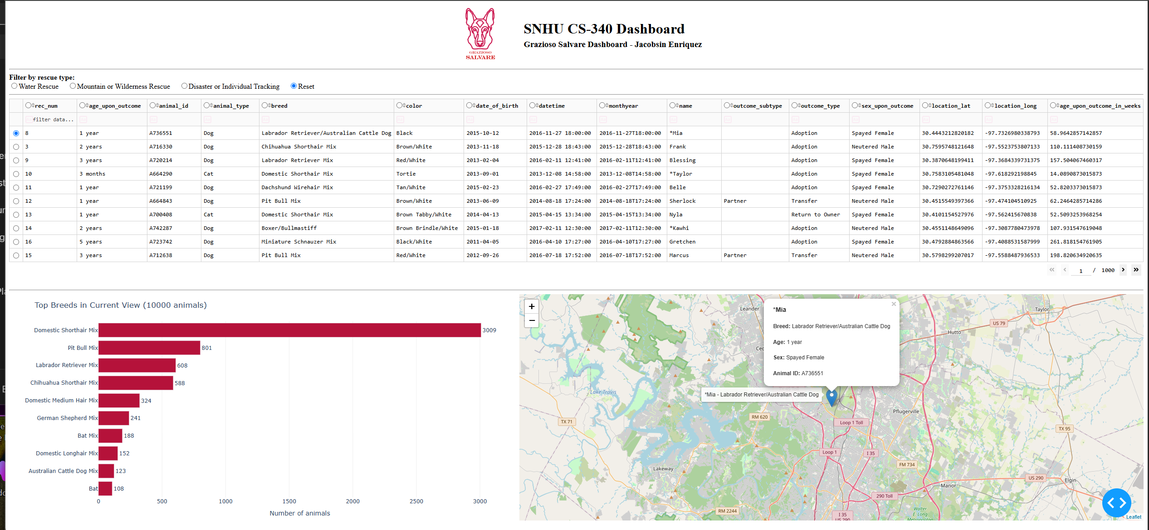
Figure 1. Starting state: all 10,000 records, breed chart, and map with the selected animal’s popup

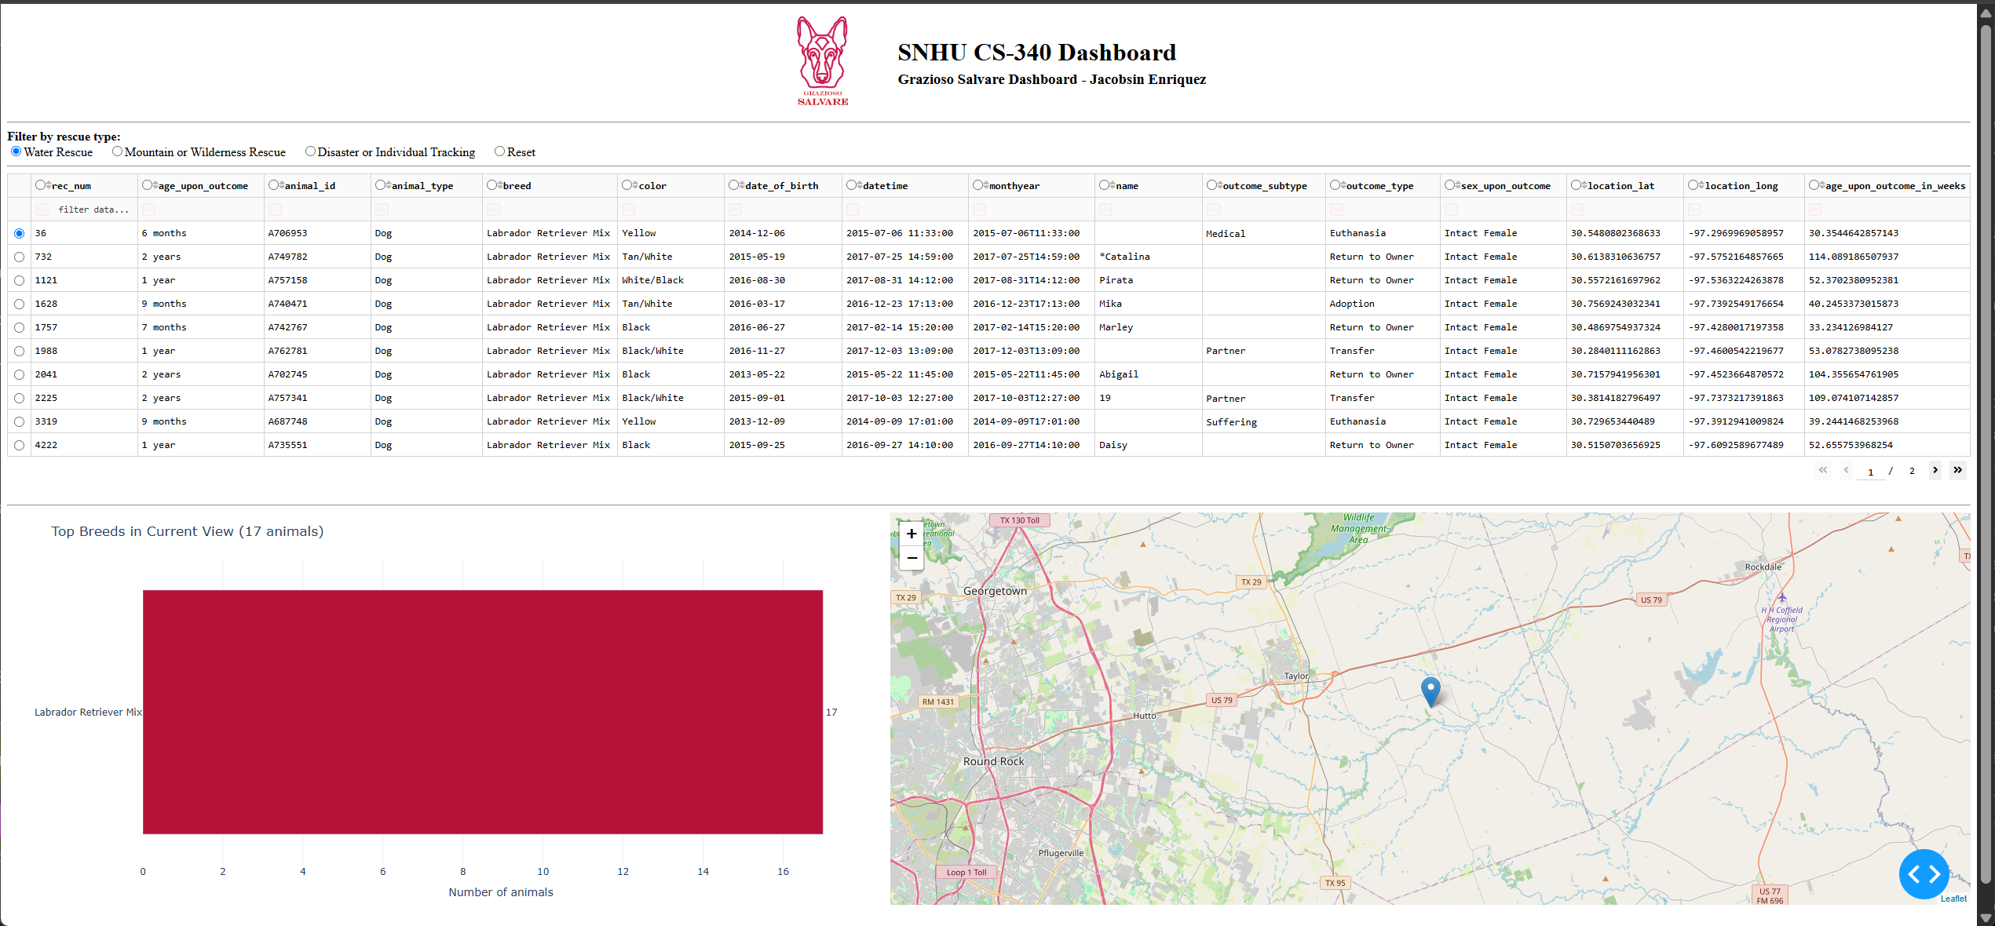
Figure 2. Water Rescue filter applied: 17 dogs, all Labrador Retriever Mix and Intact Female

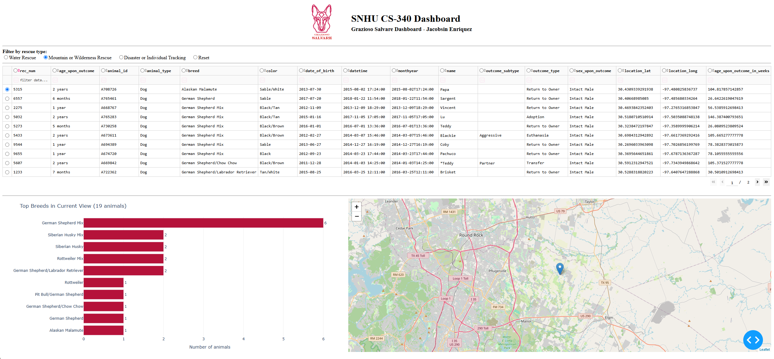
Figure 3. Mountain or Wilderness Rescue filter applied: 19 dogs

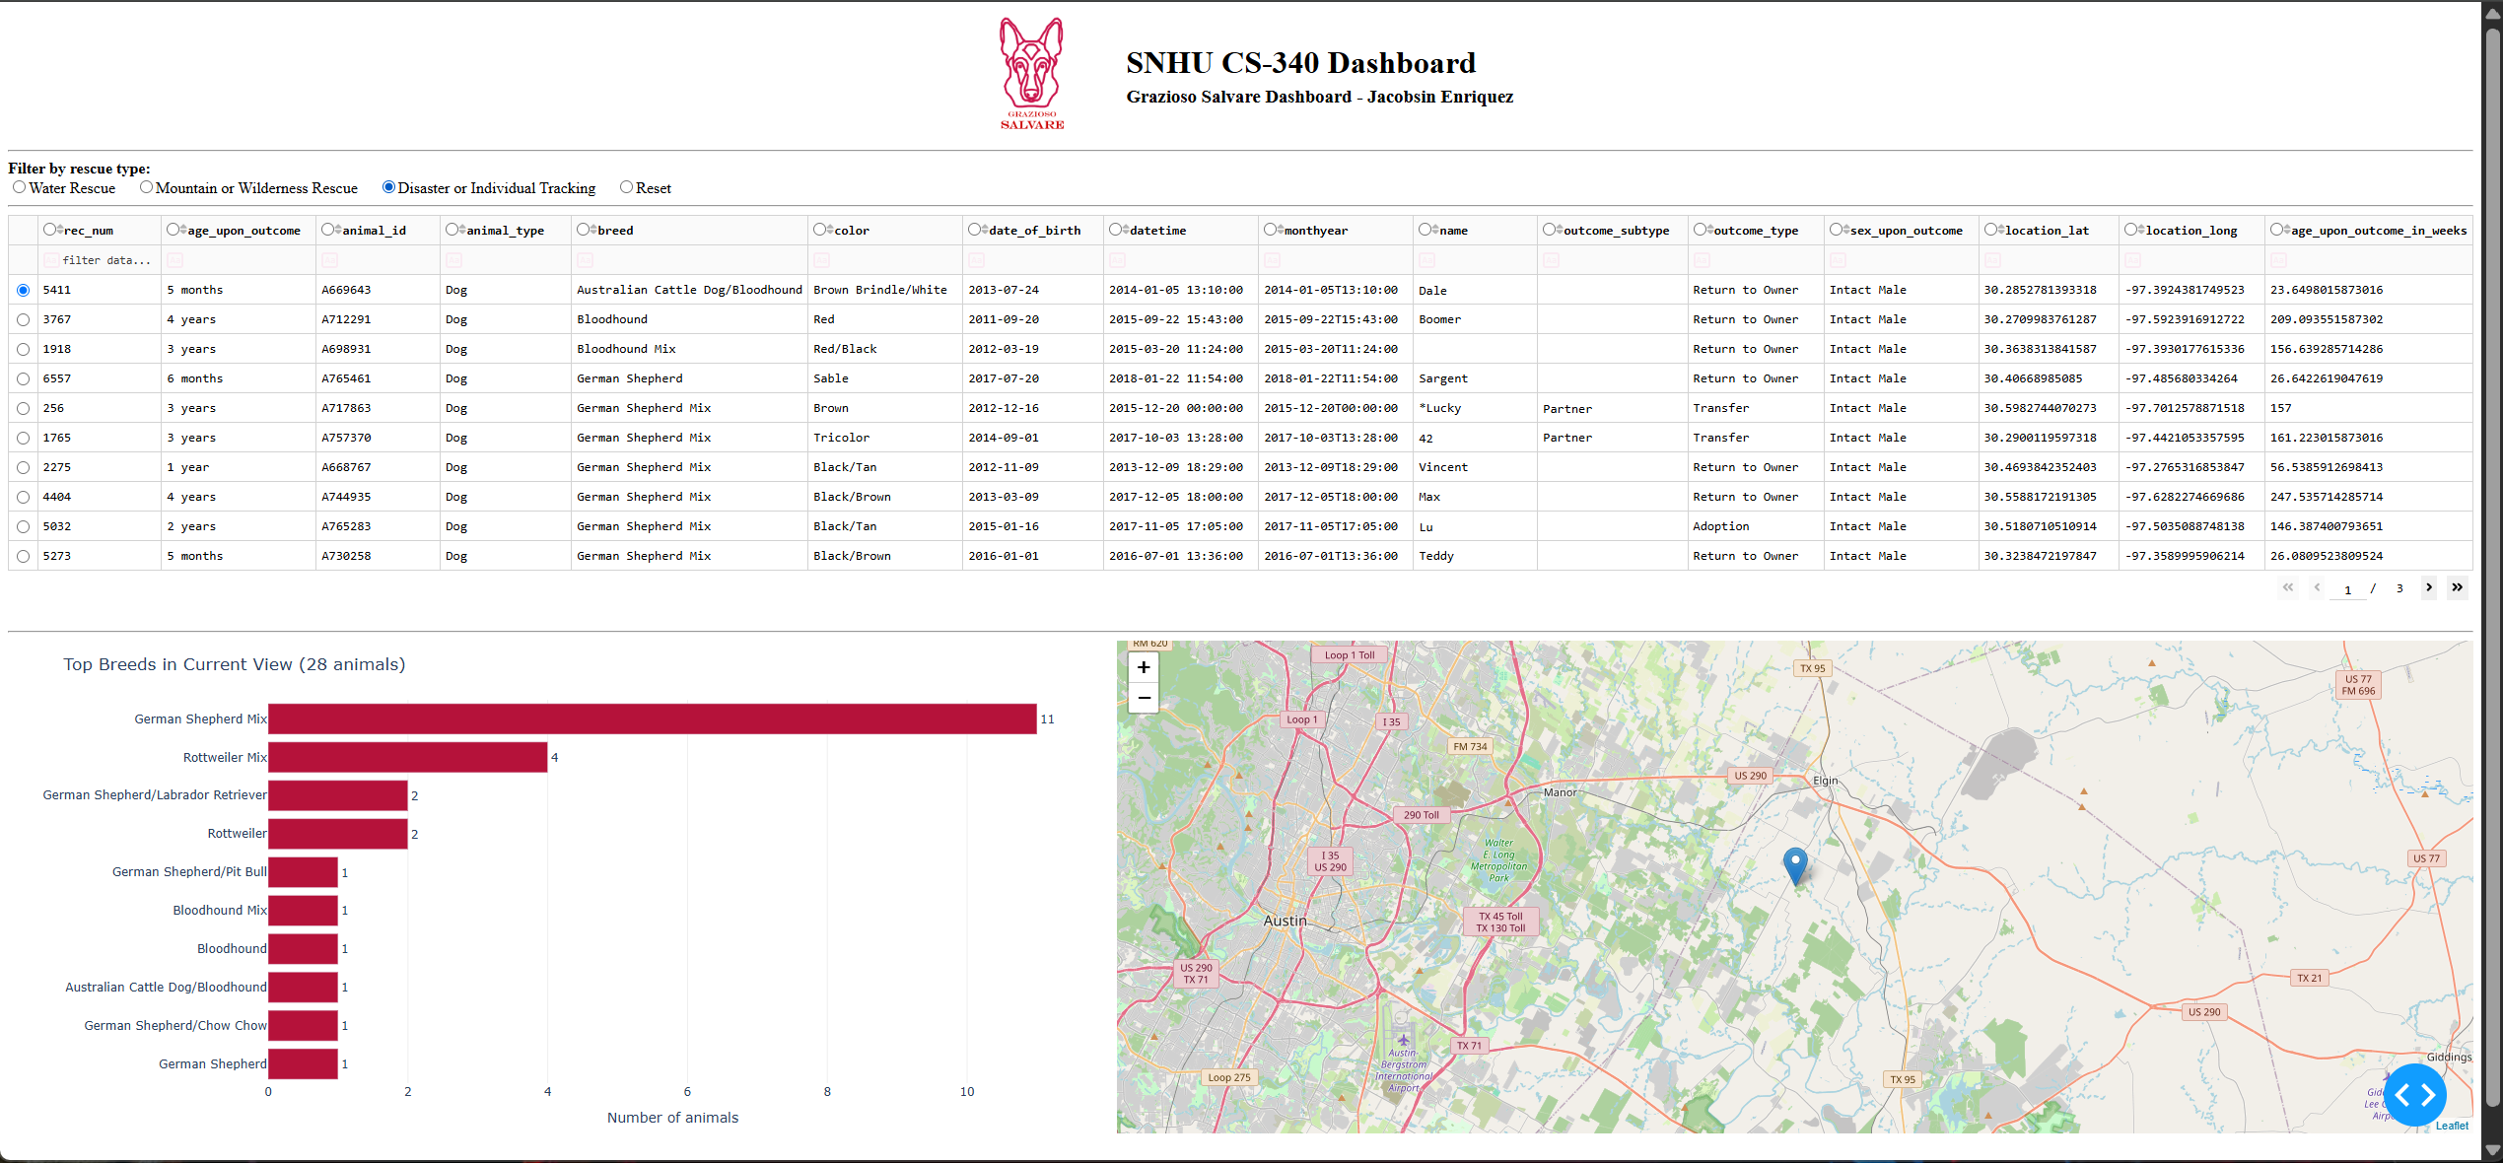
Figure 4. Disaster or Individual Tracking filter applied: 28 dogs

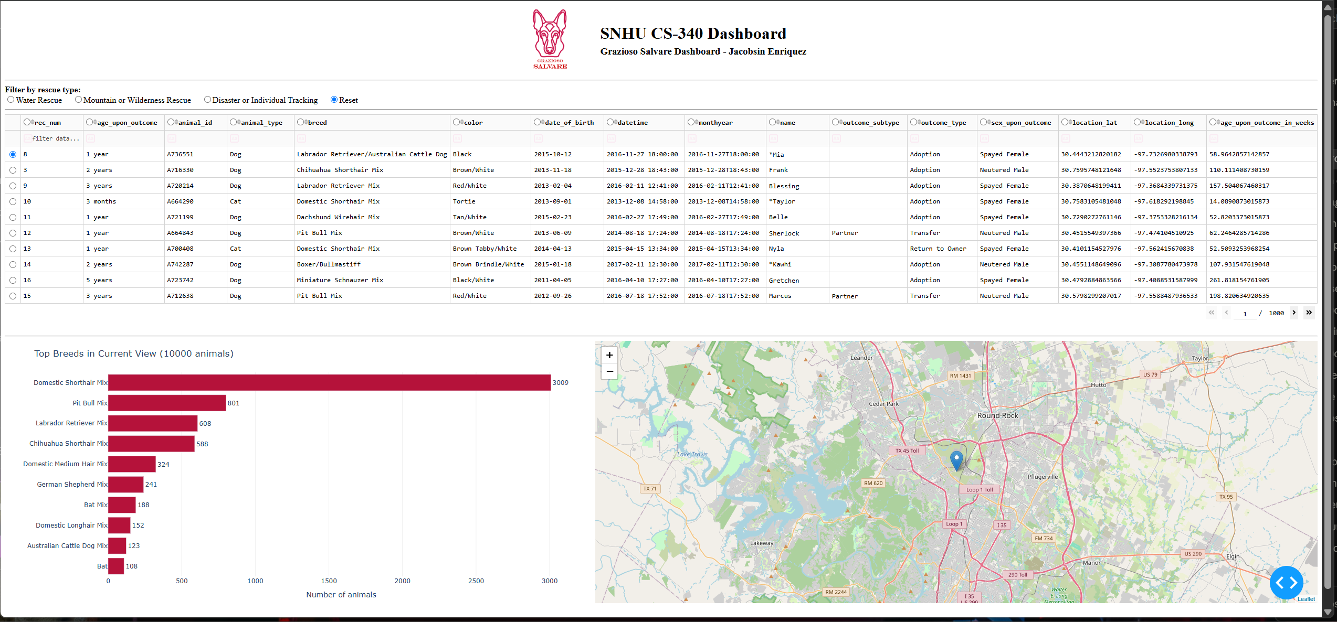
Figure 5. Reset: all widgets returned to the original, unfiltered state

Regression Check
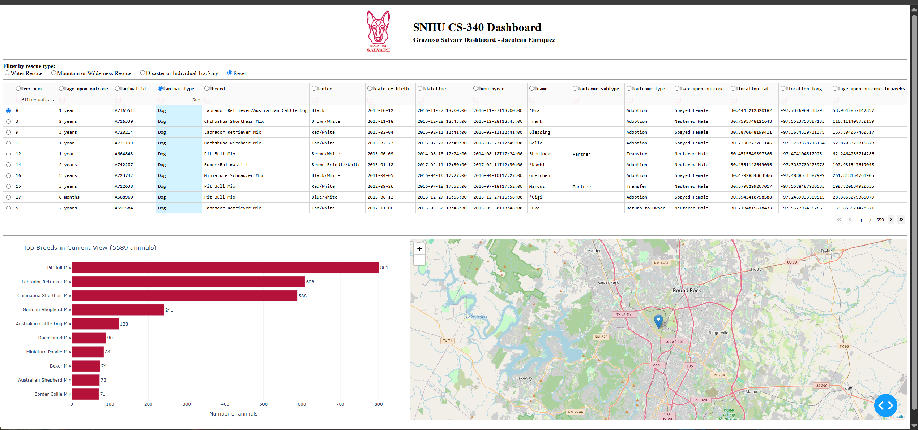
Figure 6. Regression check: animal_type column highlighted and filtered to Dog; the table and breed chart update to 5,589 animals

Query Unit Tests
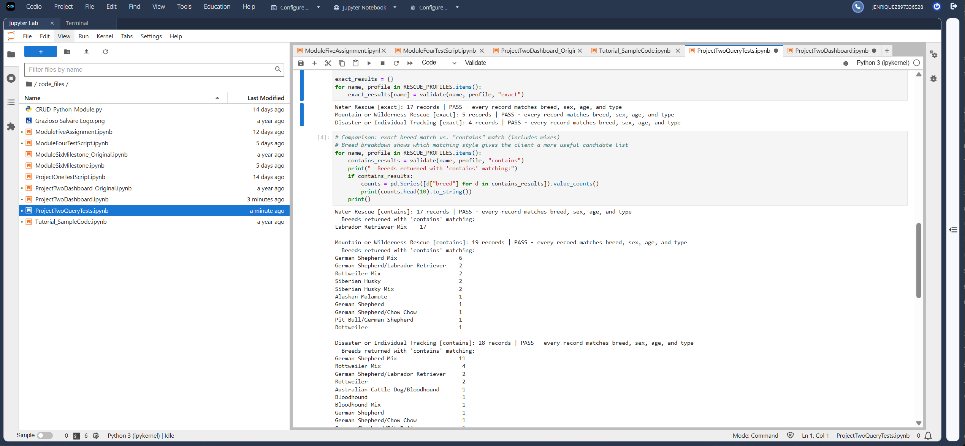
Figure 7. Query unit tests: exact and “contains” matching results, all PASS

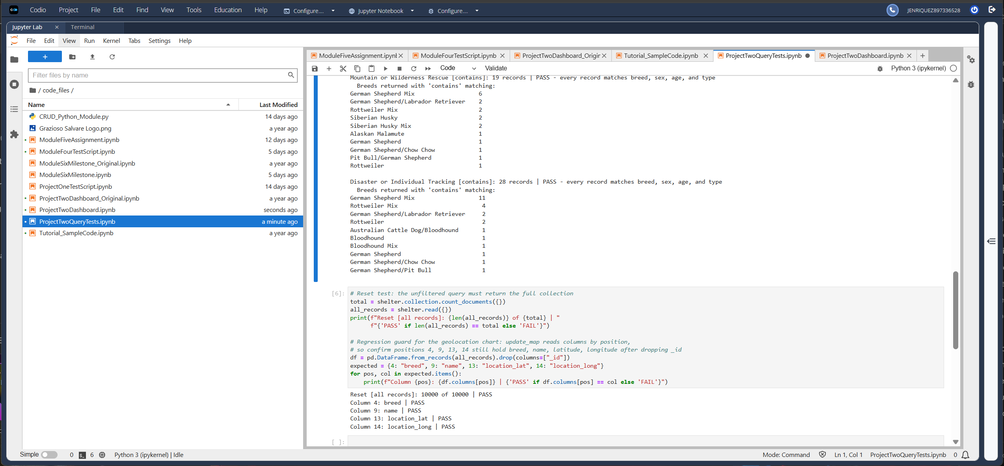
Figure 8. Query unit tests: “contains” breed breakdown, Reset, and column layout checks, all PASS

Database Setup and CRUD Module (Project One)
MongoDB Import
The mongoimport tool loads aac_shelter_outcomes.csv into the animals collection of the aac database. The first attempt failed because the file path was missing the datasets folder; the corrected command imported all 10,000 documents.
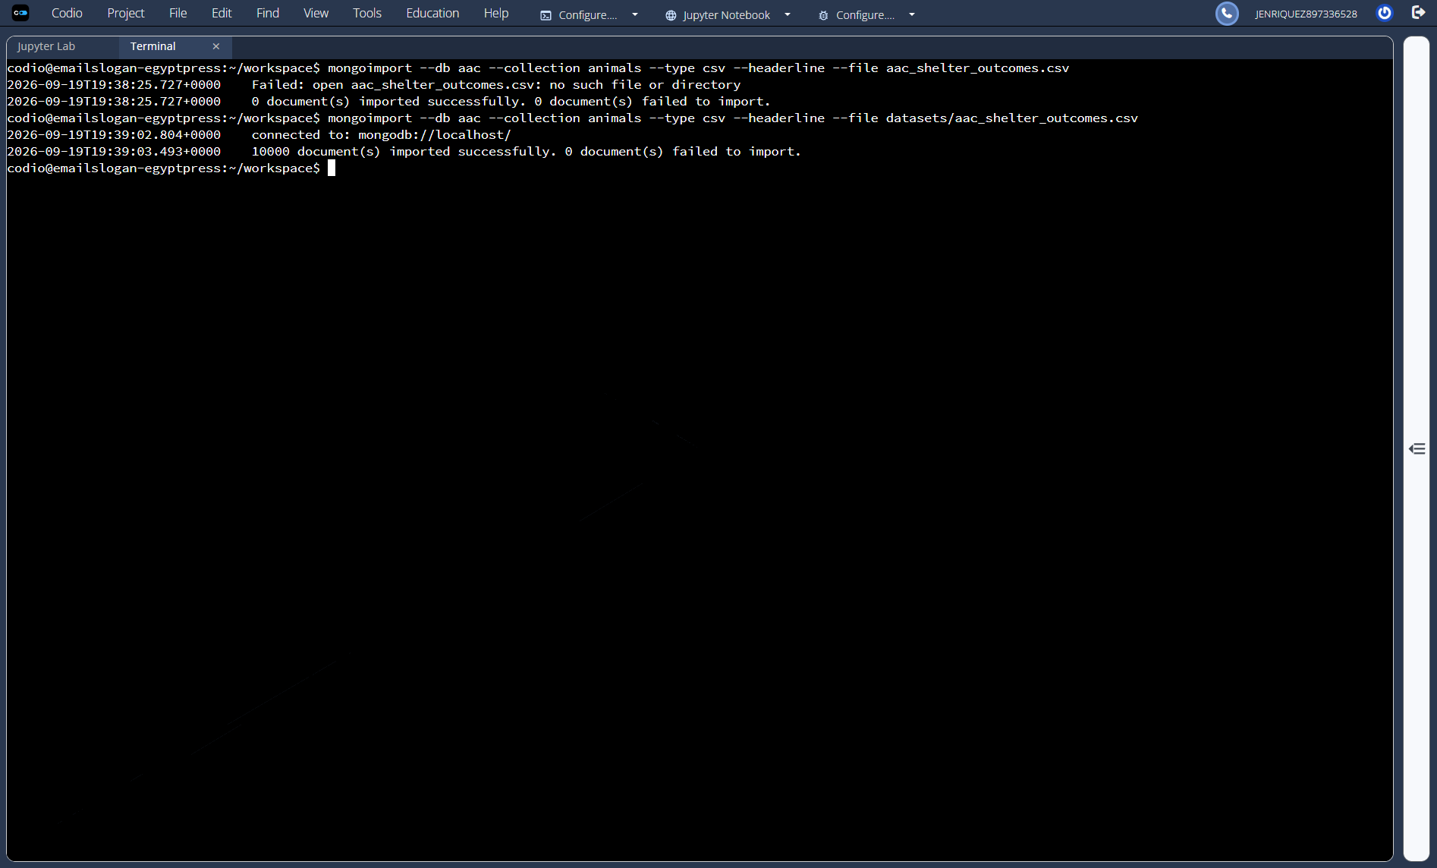
Figure 9. mongoimport command and execution

User Authentication
The aacuser account is created in the admin database with the readWrite role on aac. db.auth() logs in as aacuser, and connectionStatus confirms the authenticated user and its role.
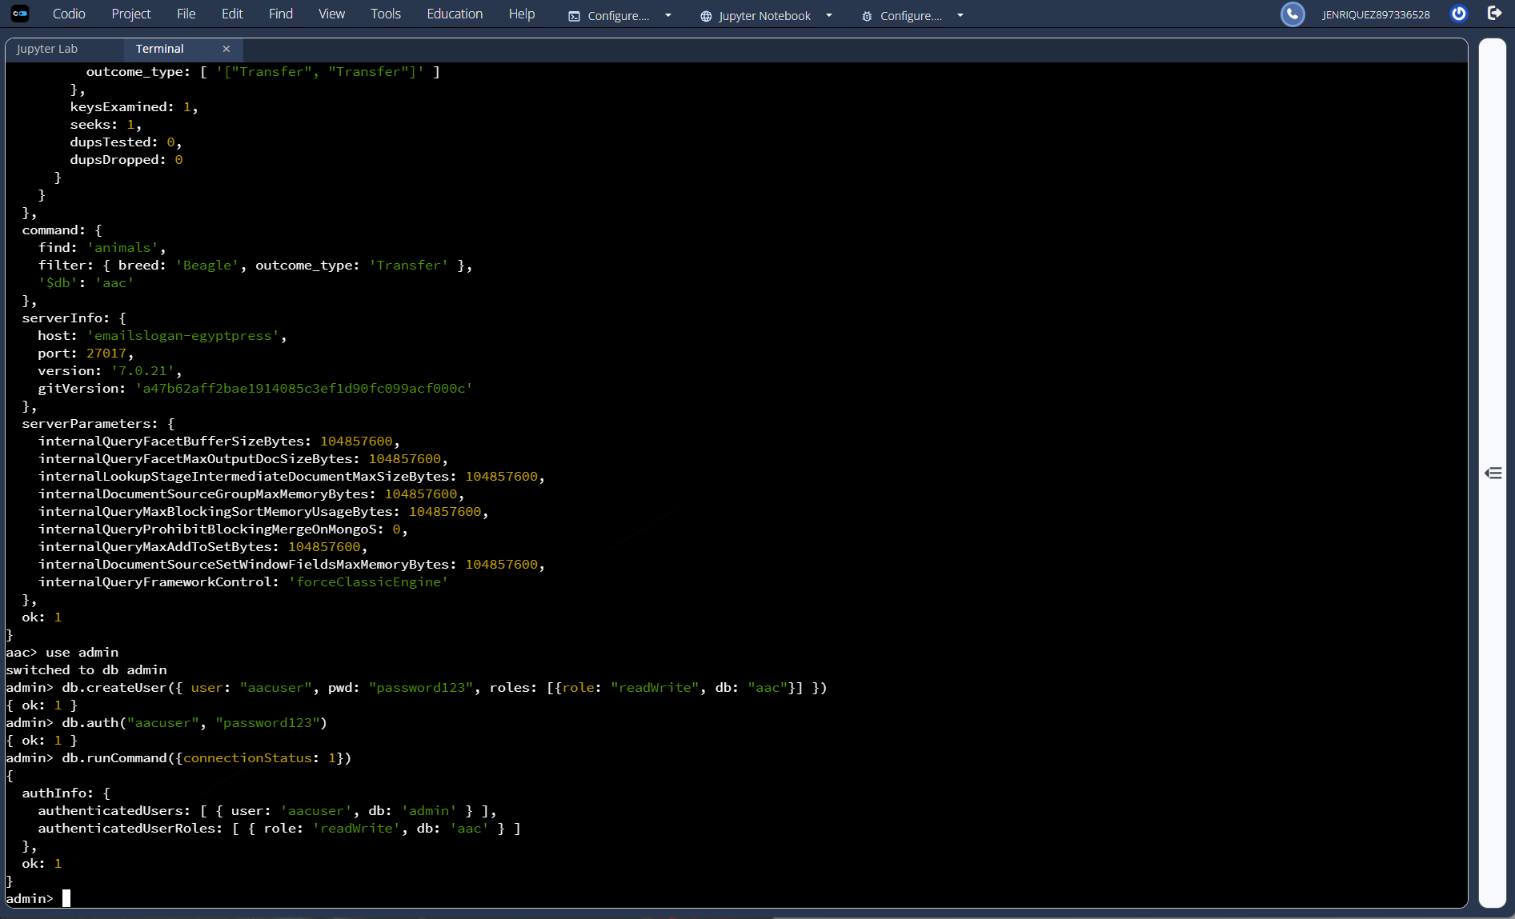
Figure 10. Creating and logging in as aacuser in the mongo shell

CRUD Functionality Test Execution
The Create and Read methods were initially verified in the Module Four test script:
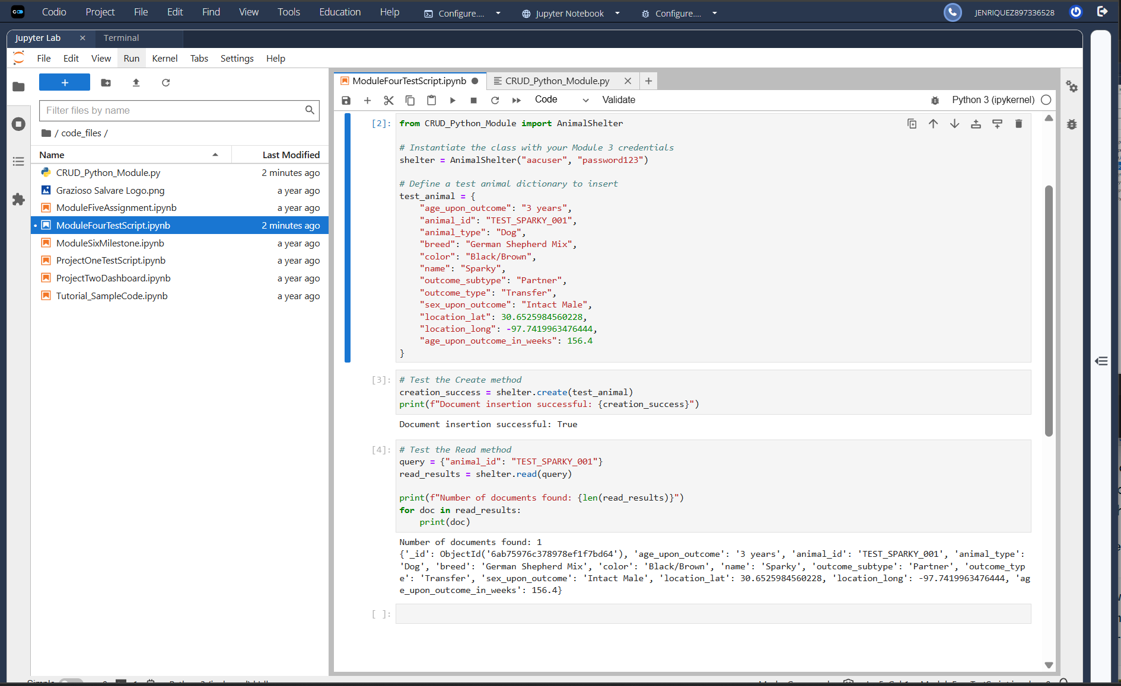
Figure 11. Create and Read test execution (Module Four)

The completed Project One test script verifies all four CRUD operations:
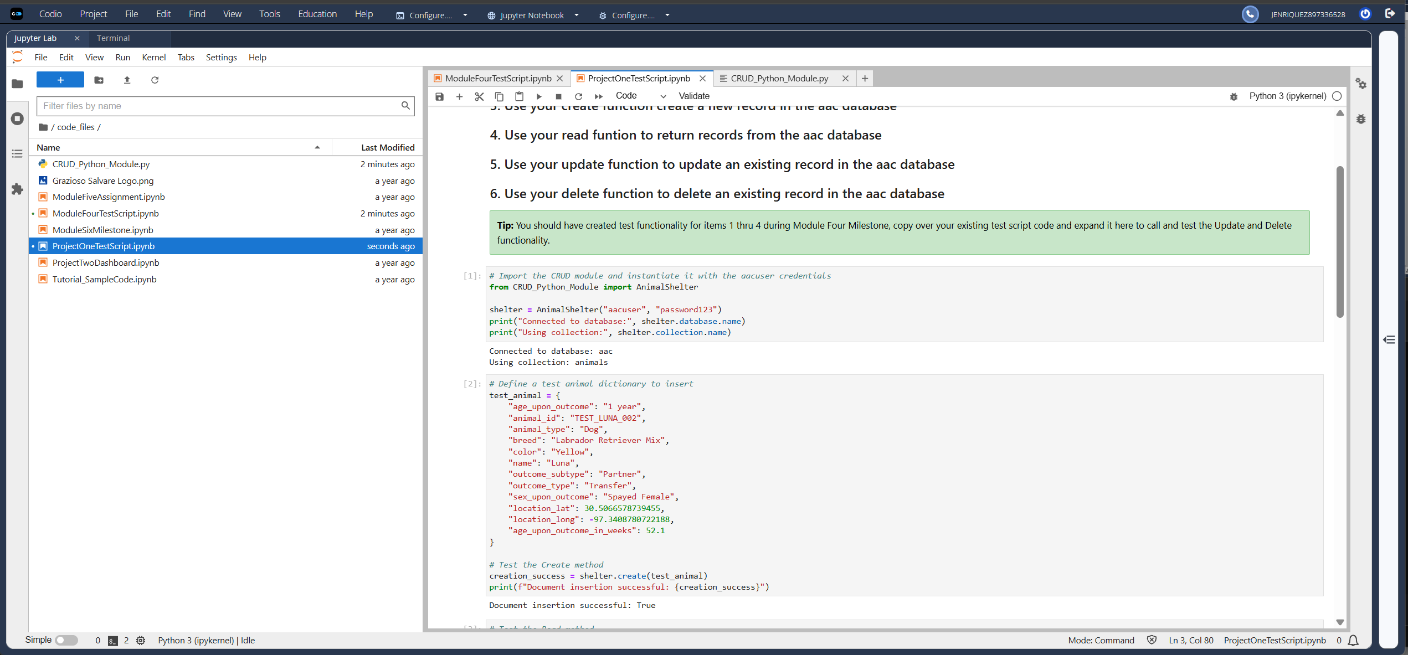
Figure 12. Project One test execution: import, instantiation, and Create

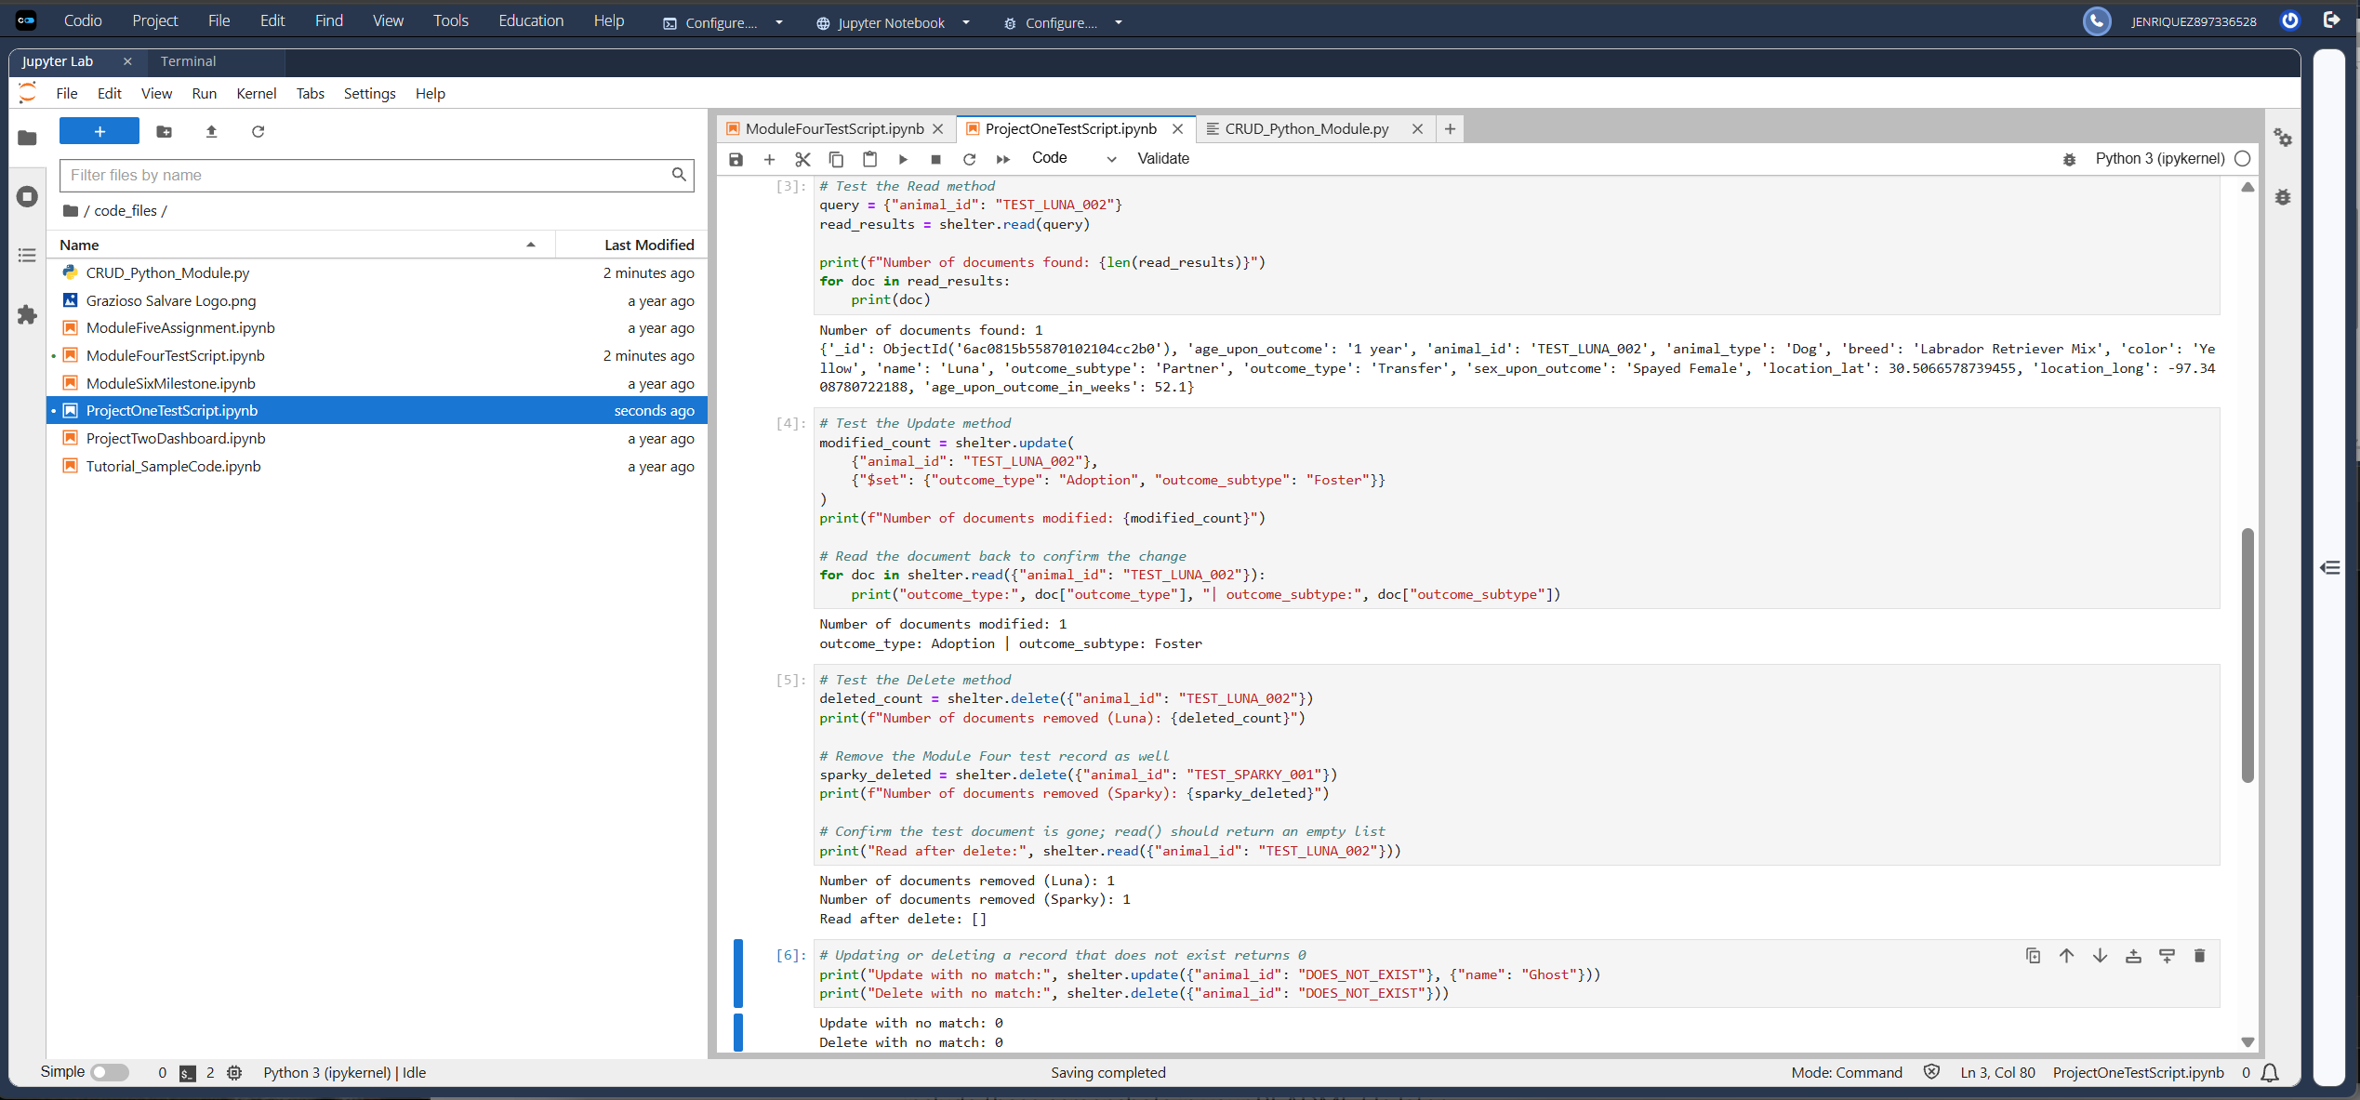
Figure 13. Project One test execution: Read, Update, Delete, and no-match handling

References
Apache Software Foundation. (n.d.). Apache JMeter. https://jmeter.apache.org/
Austin Animal Center. (2020). Austin Animal Center outcomes [Data set]. City of Austin, Texas Open Data Portal. https://doi.org/10.26000/025.000001
Dash Leaflet. (n.d.). Dash Leaflet. https://www.dash-leaflet.com/
MongoDB. (n.d.-a). Connection string options. MongoDB Database Manual. https://www.mongodb.com/docs/manual/reference/connection-string-options/
MongoDB. (n.d.-b). Documents. MongoDB Database Manual. https://www.mongodb.com/docs/manual/core/document/
MongoDB. (n.d.-c). Get started with PyMongo. PyMongo Driver Documentation. https://www.mongodb.com/docs/languages/python/pymongo-driver/current/get-started/
MongoDB. (n.d.-d). mongoimport. MongoDB Database Tools. https://www.mongodb.com/docs/database-tools/mongoimport/
MongoDB. (n.d.-e). Query predicates. MongoDB Database Manual. https://www.mongodb.com/docs/manual/reference/operator/query/
MongoDB. (n.d.-f). Role-based access control in self-managed deployments. MongoDB Database Manual. https://www.mongodb.com/docs/manual/core/authorization/
Plotly. (n.d.-a). Dash DataTable. Dash Python User Guide. https://dash.plotly.com/datatable
Plotly. (n.d.-b). Horizontal bar charts in Python. https://plotly.com/python/horizontal-bar-charts/
Plotly. (n.d.-c). Part 1. Layout. Dash Python User Guide. https://dash.plotly.com/layout
Plotly. (n.d.-d). Part 2. Adding interactivity. Dash Python User Guide. https://dash.plotly.com/basic-callbacks
Plotly. (n.d.-e). RadioItems. Dash Python User Guide. https://dash.plotly.com/dash-core-components/radioitems

