MEMORANDUM

FROM: [Your Name]
TO: Professor Bilal
DATE: May 23, 2026
RE: The “R” Project: Graphics and Plot Examples

I. Introduction to R, RStudio, and Code-Based Graphics
R is a free, open-source programming language and statistical computing environment first released in 1993 as an open-source implementation of the S and S+ languages developed at Bell Labs. What began as a tool for academic statisticians has evolved into a comprehensive ecosystem for data manipulation, statistical modeling, and publication-quality visualization. Today, R is maintained by the Comprehensive R Archive Network (CRAN), which hosts over 20,000 community-contributed packages spanning fields from genomics and econometrics to spatial analysis and machine learning.

RStudio (now rebranded as Posit) is the dominant integrated development environment (IDE) for R. It organizes the workflow into four panes: a source code editor, an interactive R console, an environment and history browser, and a files/plots/packages panel. This layout allows analysts to write scripts, inspect objects, and preview graphics within a single window. RStudio also supports R Markdown and Quarto, which let users weave code, results, and narrative prose into polished HTML, PDF, or Word reports — an important capability for reproducible research.

The graphics system in R is layered and extensible. Base R ships with a full plotting library capable of scatter plots, histograms, box plots, and more, all controlled via function calls with named parameters. The more widely adopted ggplot2 package, built on Hadley Wickham’s “grammar of graphics” framework, allows analysts to construct visualizations by declaring data mappings, geometric layers (geoms), facets, and themes independently — treating a chart as a composable object rather than a single function call. Additional libraries such as plotly, lattice, and ggvis extend this further into interactivity and multi-panel displays. Critically, all graphics output is driven by reproducible code rather than GUI clicks, meaning a chart can be regenerated exactly by re-running the script.

II. Comparing R with Tableau and Excel
Coming from Tableau and Excel, the most immediate difference in R is the absence of a graphical drag-and-drop interface. In Tableau, a user connects to a data source and builds a view by dragging dimensions and measures onto shelves; the result is interactive, shareable as a packaged workbook, and visually polished with minimal configuration. Excel sits in a similar category — charts are inserted through menu dialogs, and formatting is applied through point-and-click ribbon options. Both tools lower the barrier for quick exploratory visualization but create proprietary artifacts (Tableau .twbx files, Excel .xlsx workbooks) that are tied to their respective platforms.

R inverts this model. Every chart is the output of written code, which means the path from raw data to final figure is fully documented and reproducible. A colleague can run the same script on the same dataset and get an identical result. This transparency is a significant advantage in academic research and regulated industries where auditability matters. However, the learning curve is steeper: a beginner must become comfortable with R syntax, package installation, data frame manipulation, and debugging before producing their first polished chart.

Tableau excels at interactive dashboards and rapid prototyping with large datasets, leveraging its VizQL engine for responsive filtering. Excel is unmatched for quick ad-hoc calculations and sharing with non-technical stakeholders. R, by contrast, shines when analysis involves custom statistical modeling tightly coupled with visualization — for example, overlaying a regression curve, faceting by a categorical variable, or embedding a chart directly into a reproducible report. The code-as-output philosophy also means R graphics are version-controllable with Git, a workflow discussed further in the Github section. For complex, long-lived analytical projects, R’s scripted approach ultimately reduces rework and increases trust in results.

III. R Graphics Examples
The two figures below were created in R and represent the two primary graphics systems described above. Figure 1 uses Base R to produce a scatter plot from the built-in mtcars dataset, while Figure 2 uses ggplot2 to produce a faceted box plot from the diamonds dataset. Both scripts are provided in the accompanying Github repository.

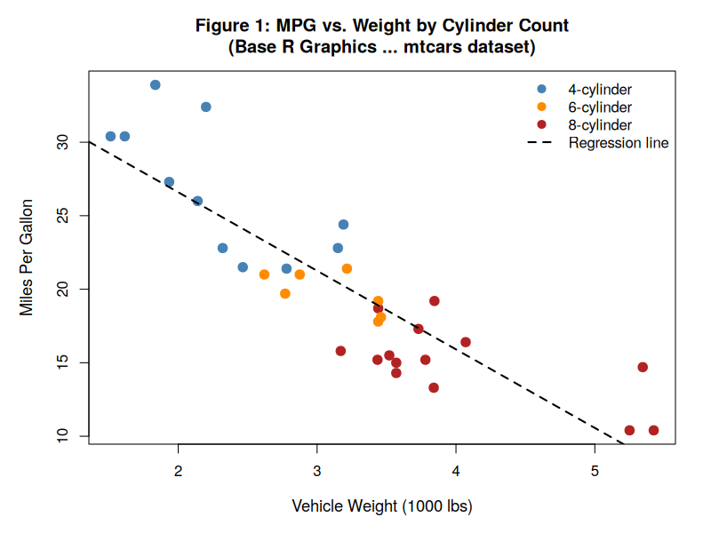
Figure 1 — Base R scatter plot of vehicle weight vs. fuel economy (mtcars), colored by cylinder count with OLS regression line.
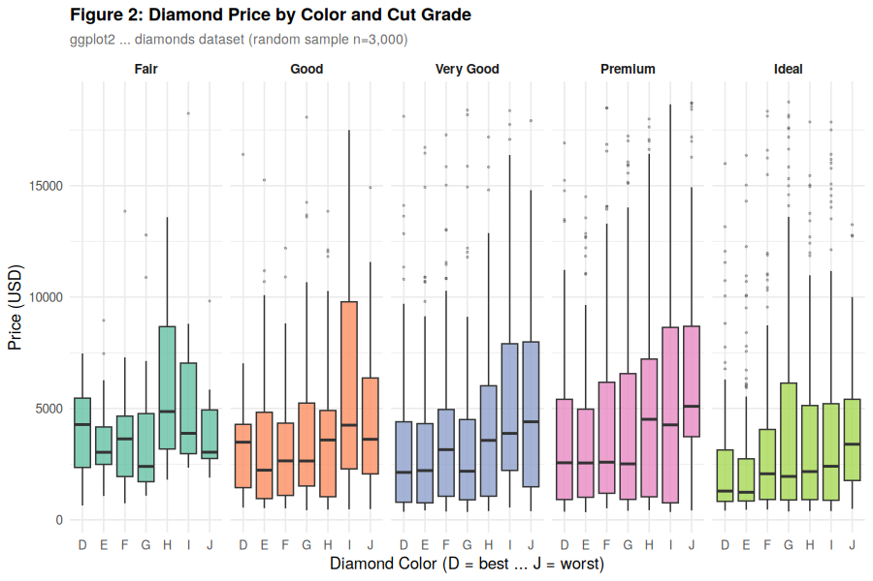
Figure 2 — ggplot2 faceted box plot of diamond price by color grade, faceted by cut quality (diamonds dataset, n=3,000).

Figure 1 was produced with roughly ten lines of Base R code, illustrating how compactly a publication-ready scatter plot with a regression overlay and legend can be expressed. Figure 2 demonstrates ggplot2’s layered grammar: a single ggplot() call with aesthetic mappings, a geom_boxplot() layer, facet_wrap() for the cut variable, scale and theme declarations, and informative labels — each concern handled by its own function, making the code easy to modify or extend.

