**第1题**

选取被引次数最高的三篇文章作为代表作：

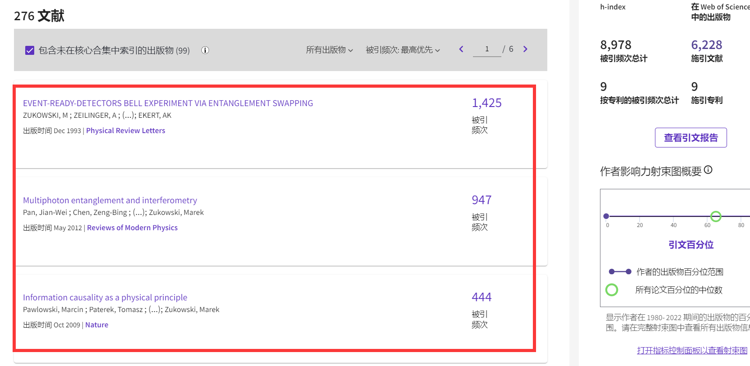

**第2题**

检索结果：

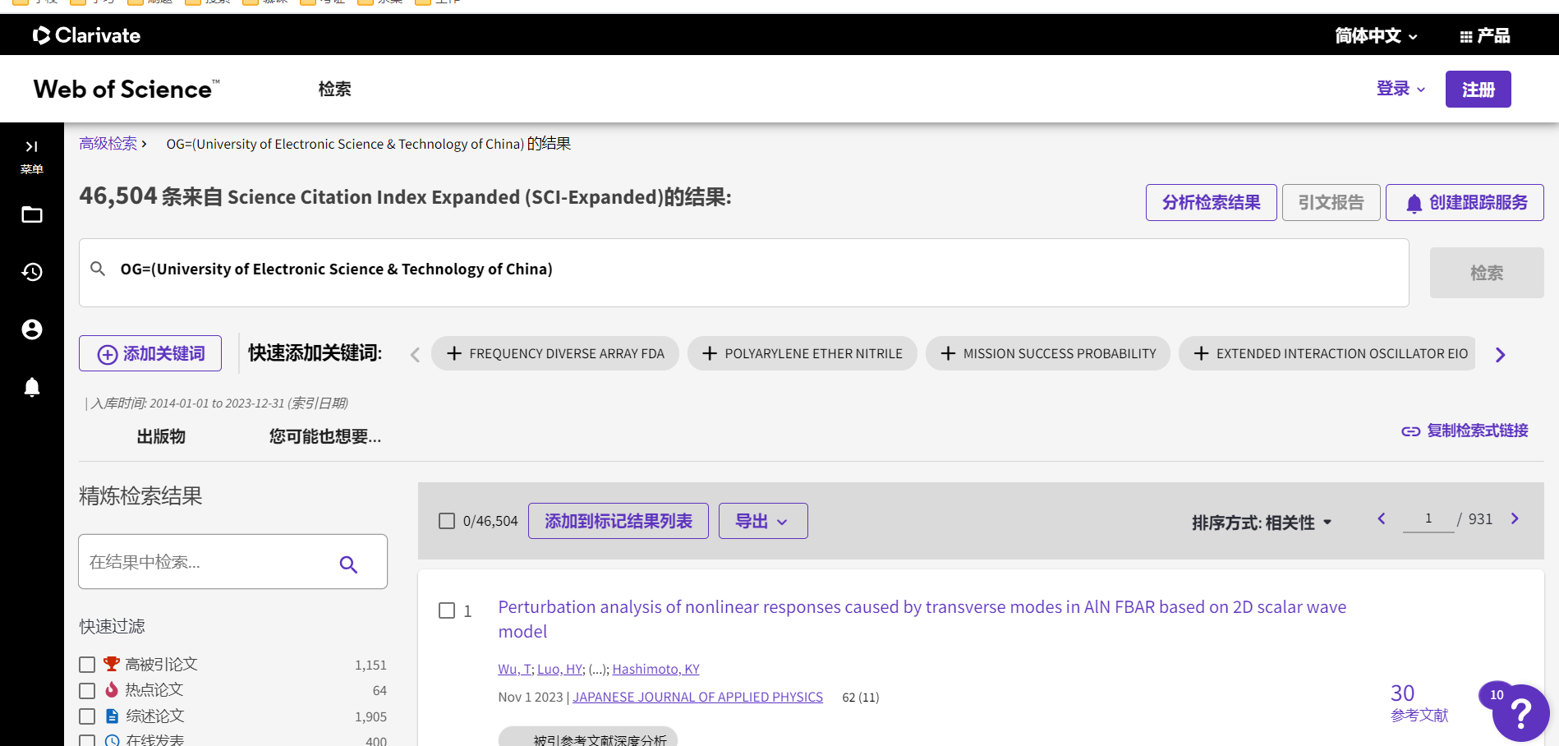

**第3题**

我选择的题目是：Wireless Sensor Networks Time Sychronization（无线传感器时间同步）

插入的参考文献如下：[1-10]

**References:**

[1]. Hong, Y.W. and A. Scaglione, A scalable synchronization protocol for large scale sensor networks and its applications. IEEE JOURNAL ON SELECTED AREAS IN COMMUNICATIONS, 2005. 23(5): p. 1085-1099.

[2]. Wu, Y.C., Q. Chaudhari and E. Serpedin, Clock Synchronization of Wireless Sensor Networks. IEEE SIGNAL PROCESSING MAGAZINE, 2011. 28(1): p. 124-138.

[3]. Simeone, O., et al., Distributed synchronization in wireless networks. IEEE SIGNAL PROCESSING MAGAZINE, 2008. 25(5): p. 81-97.

[4]. Elson, J., et al., Fine-grained network time synchronization using reference broadcasts, in USENIX ASSOCIATION PROCEEDINGS OF THE FIFTH SYMPOSIUM ON OPERATING SYSTEMS DESIGN AND IMPLEMENTATION. 2002: 5th Symposium on Operation Systems Design and Implementation (OSDI 02). p. 147-163.

[5]. Chen, C., D.X. Wang and L.G. Xiao, Genetic Based Time Synchronization Optimize Algorithm for Wireless Sensor Networks, in PROCEEDINGS OF THE INTERNATIONAL CONFERENCE ON LOGISTICS, ENGINEERING, MANAGEMENT AND COMPUTER SCIENCE, Z. Zhixian, C. Guiran and L. Zhen, Z. Zhixian, C. Guiran and L. Zhen^Editors. 2014: International Conference on Logistics Engineering, Management and Computer Science (LEMCS). p. 1-4.

[6]. Sichitiu, M.L., et al., Simple accurate time synchronization for wireless sensor networks, in WCNC 2003: IEEE WIRELESS COMMUNICATIONS AND NETWORKING CONFERENCE RECORD, VOLS 1-3. 2003: IEEE Wireless Communications and Networking Conference. p. 1266-1273.

[7]. Sivrikaya, F. and B. Yener, Time synchronization in sensor networks: A survey. IEEE NETWORK, 2004. 18(4): p. 45-50.

[8]. He, J.P., et al., Time Synchronization in WSNs: A Maximum-Value-Based Consensus Approach. IEEE TRANSACTIONS ON AUTOMATIC CONTROL, 2014. 59(3): p. 660-675.

[9]. Su, W.L. and I.F. Akyildiz, Time-diffusion synchronization protocol for wireless sensor networks. IEEE-ACM TRANSACTIONS ON NETWORKING, 2005. 13(2): p. 384-397.

[10]. Elson, J. and K. Römer, Wireless sensor networks:: A new regime for time synchronization. ACM SIGCOMM COMPUTER COMMUNICATION REVIEW, 2003. 33(1): p. 149-154.

**第4题**

我选择的题目是：Wireless Sensor Networks Time Sychronization（无线传感器时间同步）

