Following are the results of the Test Phase.

Small Input File:
File weight: about 700 kb

Huffman Algorithm:
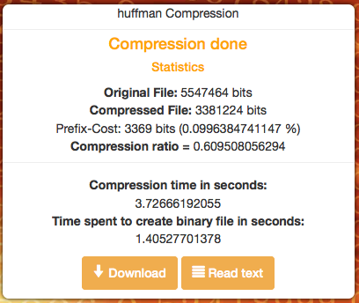
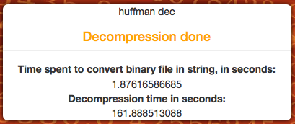



Time spent to compress: about 5 seconds
Time spent to decompress: about 3 minutes
RESULTS: OK

Mod1:
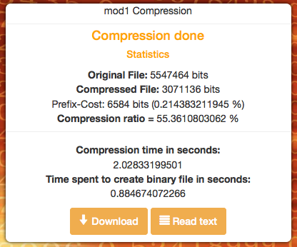
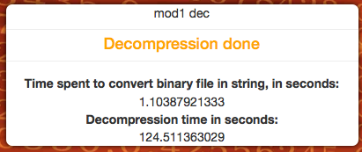

Time spent to compress: about 3 seconds
Time spent to decompress: about 2 minutes
RESULTS: OK

Mod2:
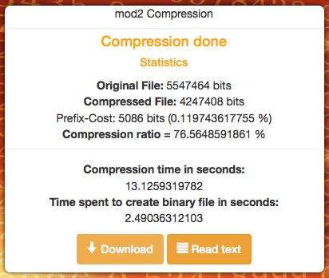
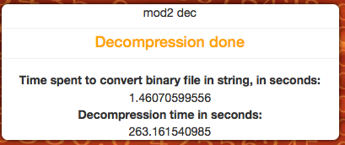
Time spent to compress: about 15 seconds
Time spent to decompress: about 4 minutes
RESULTS: OK

Medium Input File:
File weight: about 7 mb

Huffman Algorithm:
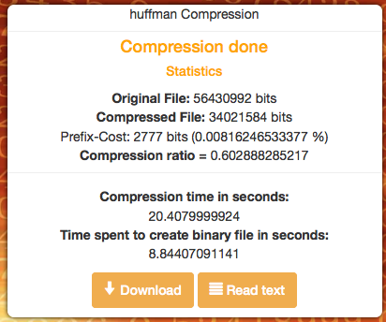
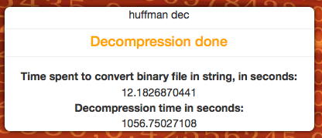



Time spent to compress: about 30 seconds
Time spent to decompress: about 18 minutes
RESULTS: OK

Mod1:
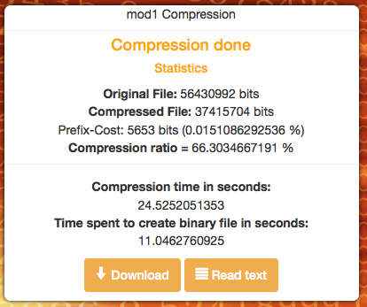
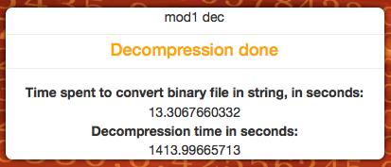

Time spent to compress: about 35 seconds
Time spent to decompress: about 25 minutes
RESULTS: OK

Mod2:

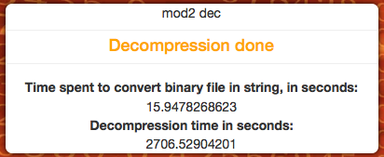
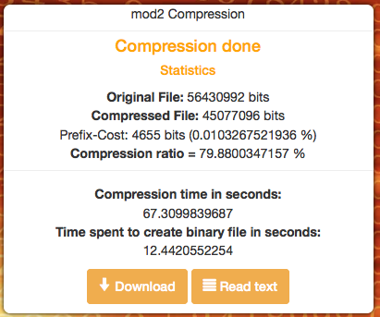
Time spent to compress: about 80 seconds
Time spent to decompress: about 45 minutes
RESULTS: OK

Big Input File:
File weight: about 40 mb

Huffman Algorithm:
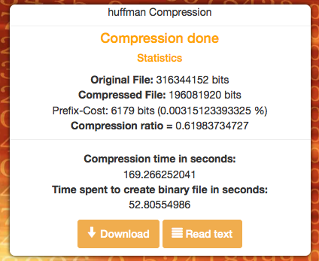
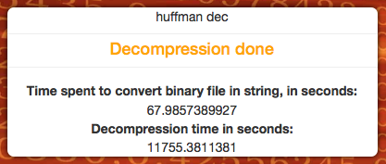



Time spent to compress: about 4 minutes
Time spent to decompress: about 3 hours
RESULTS: OK

Mod1:
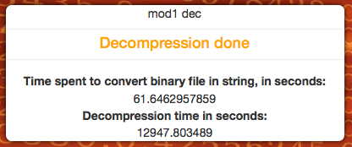
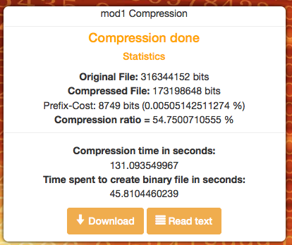

Time spent to compress: about 3 minutes
Time spent to decompress: about 3 hours and half.
RESULTS: NOK

Mod2
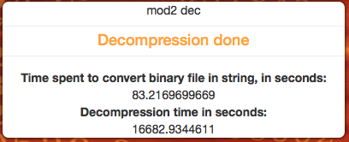
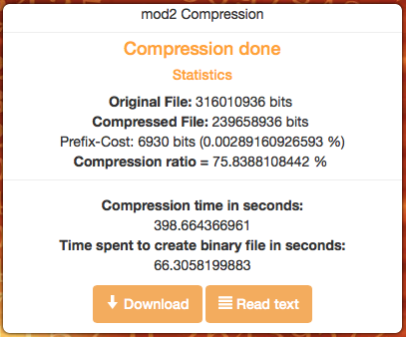

Time spent to compress: about 8 minutes
Time spent to decompress: about 5 hours.
RESULTS: NOK

Very big Input File

Test not executed yet.
Maybe it's better spend time to optimize the decompression code before.

