Computer Architectures  02LSEOV | Delivery date:  November 22th 2025, 11.59 PM
Laboratory  6 | Expected delivery of lab_06.zip must include:  - Solutions of exercises 1, 3, and 4.  - This file, filled with information and possibly compiled in a pdf format.

This lab will continue to delve into ARM programming.
- Write a program using the ARM assembly that performs the following operations:
  - Initialize registers R3, R4, and R5 with arbitrary (chosen by you) signed values.
  - Subtract R3 to R4 (R4 – R3) and store the result in R6.
  - Sum R4 to R5 (R4 + R5) and store the result in R7.
- Using the debug log window, change the values ​​of the written program in order to set the following flags to 1, one at a time and when possible:
    - carry
    - overflow
    - negative
    - zero
Report the selected values in the table below:
 | Hexadecimal representation of the obtained values
Updated flag | R4 – R3 |  | R4 + R5
 | R4 | R3 | R4 | R5
Carry = 1 | 0x0000000A | 0x00000005 | 0xFFFFFFFF | 0x00000002
Carry = 0 | 0x00000002 | 0x00000001 | 0x00000001 | 0x00000001
Overflow | 0x80000000 | 0x00000001 | 0x7FFFFFFF | 0x00000001
Negative | 0xFFFFFFFE | 0xFFFFFFFF | 0xFFFFFFFF | 0x00000000
Zero | 0x00000001 | 0x00000001 | 0x00000000 | 0x00000000
Please explain the cases where it is not possible to force a single FLAG condition:
- Non è possible ottenere il bit di overflow V=1 senza che il flag negativo N sia 1 poiché l’overflow va a sovrascrivere con 1 il bit di segno trasformando il numeo in negativo, in tuttui gli altri casi viene imposta il bit carry C a 1

- Write two versions of a program that performs the following operations:
  - Initialize registers R1 and R2 with arbitrary (chosen by you) signed values.
  - Compare the two registers:
    - If they differ, store in register R8 the maximum among R1 and R2.
    - Otherwise, perform a logical right shift of 1 on R1 (is it equivalent to what?), then subtract this value from R2 and store the result in R9 (i.e., R4 = R2 – (R1 >> 1)).

The first version should be based on a traditional assembly programming approach using conditional branches, while the second version should be based on a conditional statement execution approach.
Considering a CPU clock frequency (clk) of 16 MHz, report the number of clock cycles (cc) and the simulation time in milliseconds (ms) in the following table:
 | R2 == R3 [cc] | R2 == R3 [ms] | R2 != R3 [cc] | R2 != R3 [ms]
1) Traditional | 10,72 | 0,00067 | 14,72 | 0,00092
2) Conditional Execution | 13,28 | 0,00083 | 13,28 | 0,00083
Note: you can change the CPU clock frequency by following the brief guide at the end of the document.

- Write a program that calculates the parity bit of a variable. The parity bit is used for error detection and indicates whether the number of 1s in the binary data is odd (parity = 1) or even (parity = 0), calculated by performing an XOR operation on all bits of the variable: for example, the parity of 0b00000101 is 0 (even parity) because it has two 1s. The variable to be checked is in R10 that you have to initialize to 0b00110101. After calculating the parity, store the result (0 or 1) in R13.

To recap, implement ASM code that does the following:
- Calculate the parity bit of R10 by XORing all its bits together.
- Store the parity bit result in R13 (0 for even parity, 1 for odd parity).

- Assuming a 15 MHz clk, report the code size and execution time in the following table:
Code size [Bytes] | Execution time
564 | 0,00000625 s
- Add some comments regarding the solution you wrote: Ad ogni iterazione applico una maschera con un operazione di AND contenente un solo uno che poi viene shiftata a sinistra per prendere in considerazione il bit successivo. Se l’applicazione della maschera è diverso da zero incremento il contatore di “1”. Al termine del loop applico una maschera al contatore che contiene un solo uno al LSB ottenenedo così la parità.

How to set the CPU clock frequency in Keil

- Launch the debug mode and activate the command console.
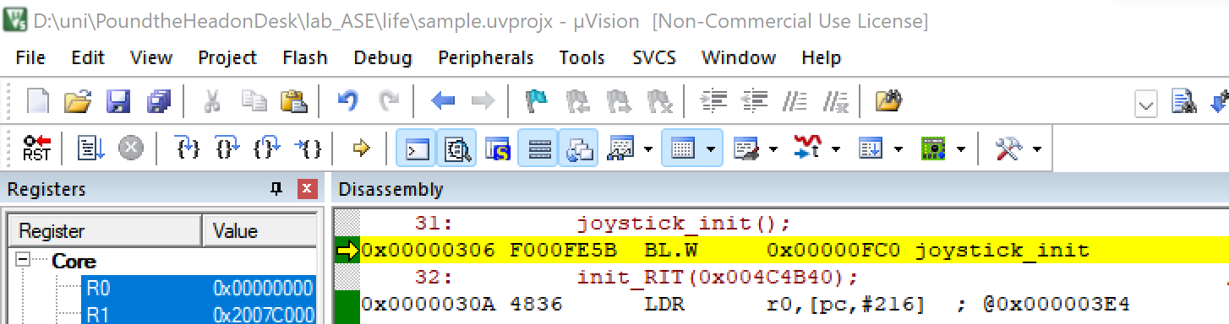
- A window will appear:
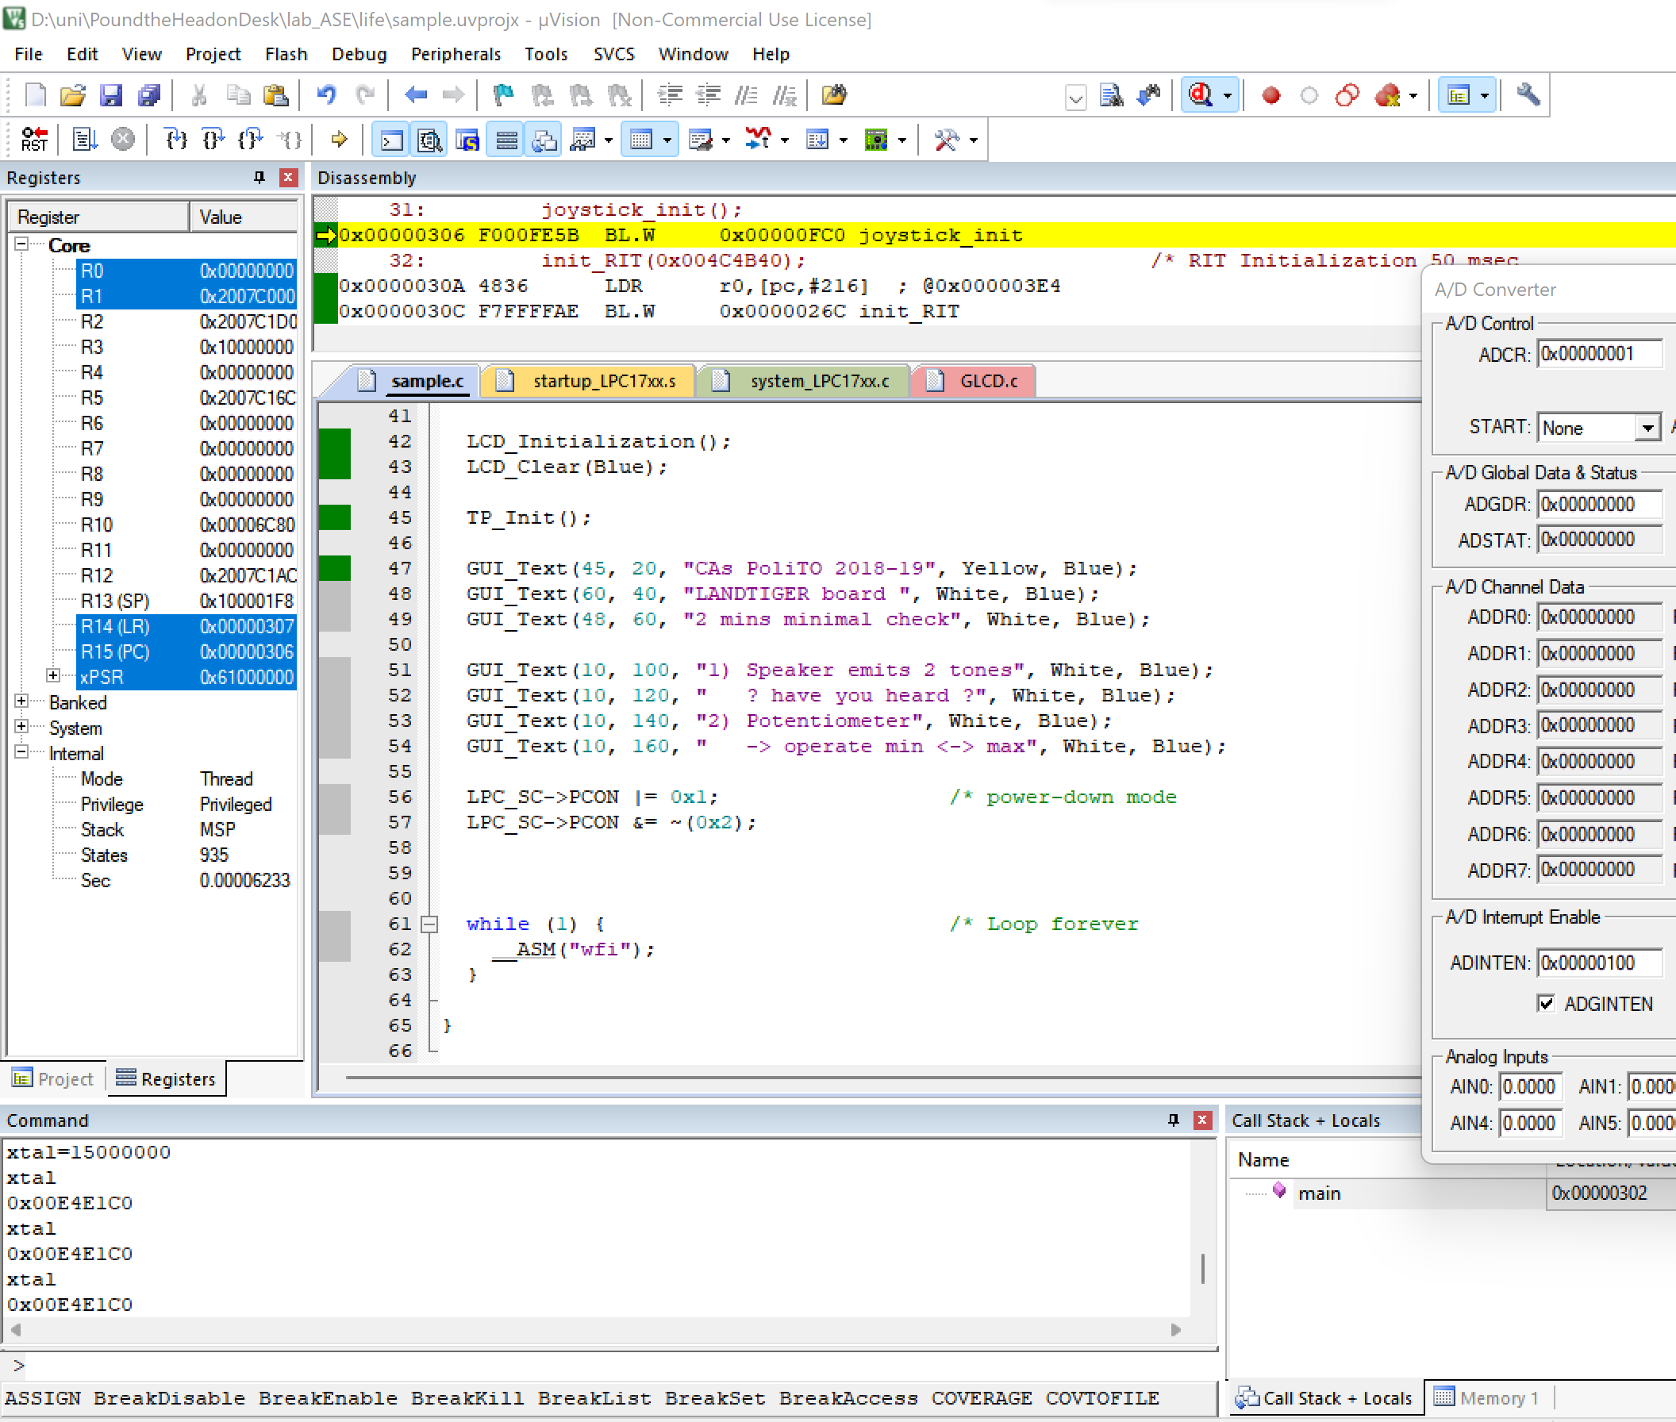
You can type xtal to check its value. To change its value, make a routine assignment, i.e., xtal=frequency, keeping in mind that frequency is in Hz must be entered. To set a frequency of 15 MHz, you must write as follows: xtal=15000000.

