Architetture dei Sistemi di Elaborazione  02GOLOV | Computer Architectures  02LSEYG
Laboratory  0x05 | Expected delivery of lab_5.zip must include:  - each configuration of the custom architecture (riscv_o3_custom.py and create_predictor.py) that you modify.  - This document with all the field compiled and in PDF form.
Delivery date:
November 13th 2025

Introduction and Background

Simulating an Out-of-Order (OoO) CPU (O3CPU)
Dispatch/Issue
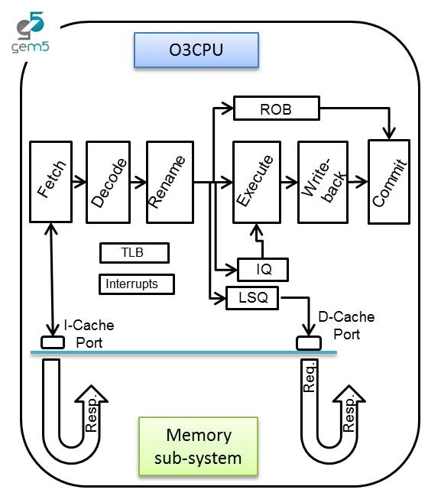

In this laboratory, you will be able to configure an OoO CPU by using a script called riscv_o3_custom.py (in the gem5 folder). In a few words, the script configures an Out-of-Order (O3) processor based on the DerivO3CPU, a superscalar processor with a reduced number of features.

Pipeline

The processor pipeline stages can be summarized as:

- Fetch stage: instructions are fetched from the instruction cache. The fetchWidth parameter sets the number of fetched instructions. This stage does branch prediction and branch target prediction.
- Decode stage: This stage decodes instructions and handles the execution of unconditional branches. The decodeWidth parameter sets the maximum number of instructions processed per clock cycle.
- Rename stage: As suggested by the name, registers are renamed, and the instruction is pushed to the IEW (Issue/Execute/Write Back) stage. It checks that the Instruction Queue (IQ)/Load and Store Queue (LSQ) can hold the new instruction. The maximum number of instructions processed per clock cycle is set by the renameWidth parameter.

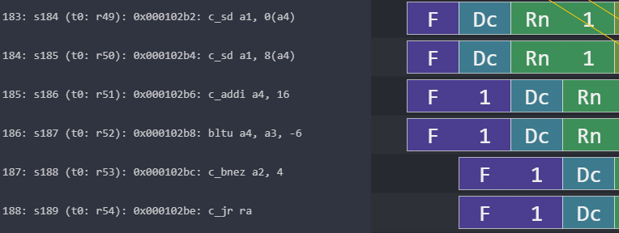
decodeWidth=2
fetchWidth=4
renameWidth=2
Stalls: the pipeline can’t move on
Figure 1: Understanding configurable OoO CPU parameters.

- Dispatch stage: instructions whose renamed operands are available are dispatched to functional units (FU). For loads and stores, they are dispatched to the Load/Store Queue (LSQ). The maximum number of instructions processed per clock cycle is set by the dispatchWidth parameter.
- Issue stage: The simulated processor has a single instruction queue from which all instructions are issued. Ordinarily, instructions are taken in-order from this queue. An instruction is issued if it does not have any dependency.
- Execute stage: the functional unit (FU) processes their instruction. Each functional unit can be configured with a different latency. Conditional branch mispredictions are identified here. The maximum number of instructions processed per clock cycle depends on the different functional units configured and their latencies.
- Writeback stage: it sends the result of the instruction to the reorder buffer (ROB). The maximum number of instructions processed per clock cycle is set by the wbWidth parameter.
- Commit stage: it processes the reorder buffer, freeing up reorder buffer entries. The maximum number of instructions processed per clock cycle is set by the commitWidth parameter. Commit is done in order.

In the event of a branch misprediction, trap, or other speculative execution event, "squashing" can occur at all stages of this pipeline. When a pending instruction is squashed, it is removed from the instruction queues, reorder buffers, requests to the instruction cache, etc.

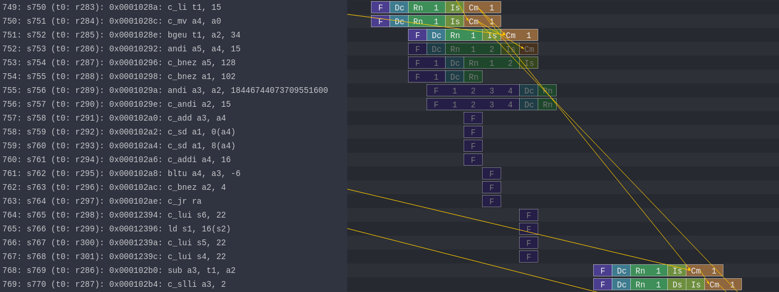
Flushed Instructions
Mispredicted branch
Figure 2: Example of a branch misprediction (transparent rows)

Pipeline Resources
Additionally, it has the following structures:
- Branch predictor (BP)
  - Allows for selection between several branch predictors, including a local predictor, a global predictor, and a tournament predictor. Also has a branch target buffer (BTB) and a return address stack (RAS).
- Reorder buffer (ROB)
  - Holds instructions that have reached the back end. Handles squashing instructions and keep instructions in program order.
- Instruction queue (IQ)
  - Handles dependencies between instructions and scheduling ready instructions. Uses the memory dependence predictor to tell when memory operations are ready.
- Load-store queue (LSQ)
  - Holds loads and stores that have reached the back end. It hooks up to the d-cache and initiates accesses to the memory system once memory operations have been issued and executed. Also handles forwarding from stores to loads, replaying memory operations if the memory system is blocked, and detecting memory ordering violations.
- Functional units (FU)
  - Provides timing for instruction execution. Used to determine the latency of an instruction executing, as well as what instructions can issue each cycle.
  - Floating point units, floating point registers, and respective instructions are supported.
Figure 3: Pipeline example of FP instructions and FP registers

All the needed resources are at a GitHub repository:
https://github.com/cad-polito-it/ase_riscv_gem5_sim

To update your simulation environment:

~/ase_riscv_gem5_sim$ git pull

ATTENTION: You may have modified files that would prevent you to directly pull the workspace. Please save them and then pull the repository.

In order to simulate an OoO CPU you MUST set the following variables in your setup_default file:

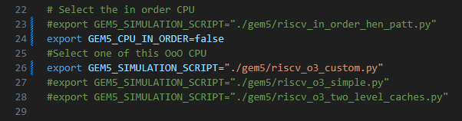

This sets the python scripts modelling the OoO CPU (line 23-24 and 25).

Moreover, you must install an additional pipeline visualizer called Konata

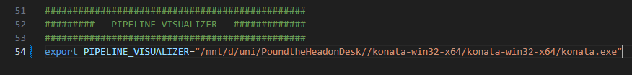

And change the path accordingly in your setup_default file (line 54).

In the repository’s README there are the instructions for installing konata (it is necessary to download a precompiled binary for your system).

Exercise 1:

Simulate the programs written in the previous lab with the OoO CPU based on the CPU architecture described in riscv_o3_custom.py ,
You can visualize the pipeline (i.e., load the trace.out file on Konata).

Collects statistics about the execution of your programs in the following table:

Laboratory | Program | Clock Per Instructions
Laboratory | Program | In Order CPU | OoO CPU
0x01 | program3.s | 1.20046 | 0,8429
0x02 | program1.s | 1,6437 | 1,1788
0x03 | program1.s | 2.24714 | 0,8785
0x03 | program1_a.s | 2.21391 | 0,8753
0x03 | program1_b.s | 1.99004 | 1,4883
0x04 | program1.s | 1.88298 | 1,4853
0x04 | program1_a.s | 1.78191 | 1,4957
0x04 | program1_b.s | 1.62209 | 4,6742

Can you identify situations (at least three) in which the OoO architecture perform better/worse than the In order architecture and viceversa?

Situation: OoO performs better than In Order
Explanation: Il fetch di due istruzioni alla volta riduce il numero dicolpi di clock necessari per eseguire ogni ciclo
In order CPU screenshot:
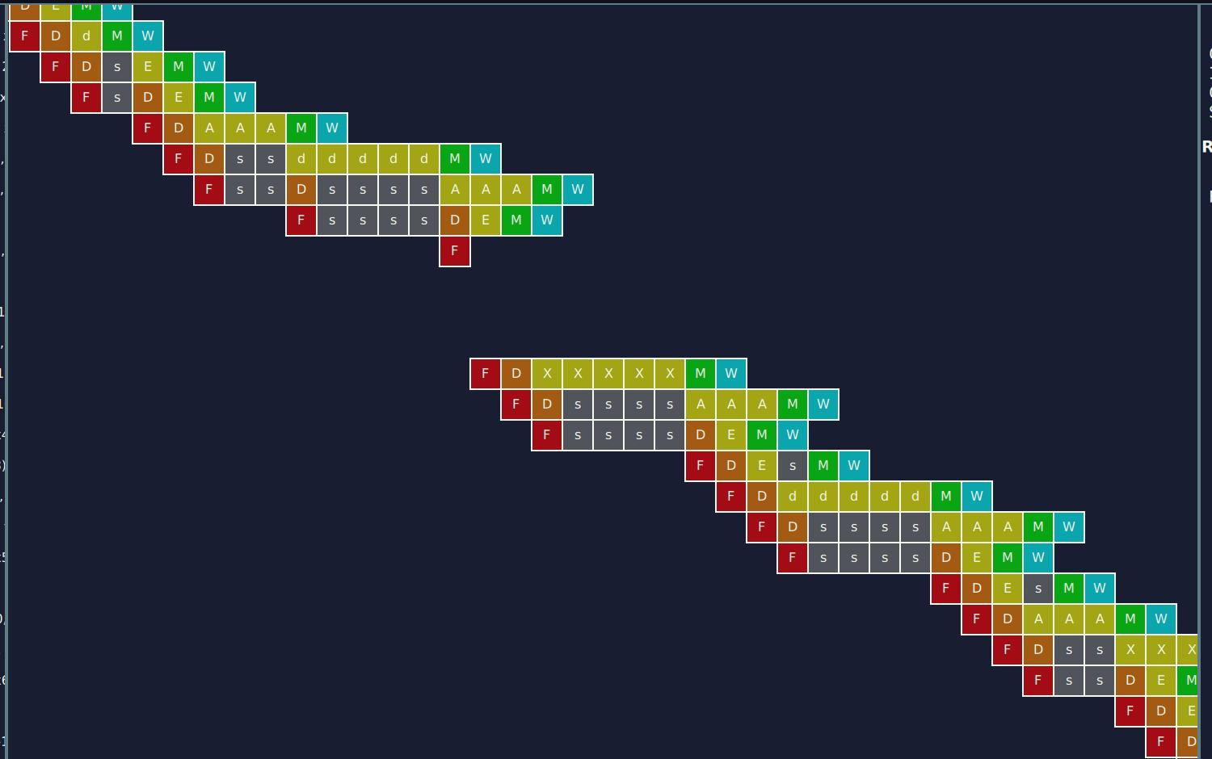
OoO CPU screenshot:


Situation: In Order performs better than OoO
Explanation: La presenza di cache misses aumenta sensibilmente il numero di colpi di clock
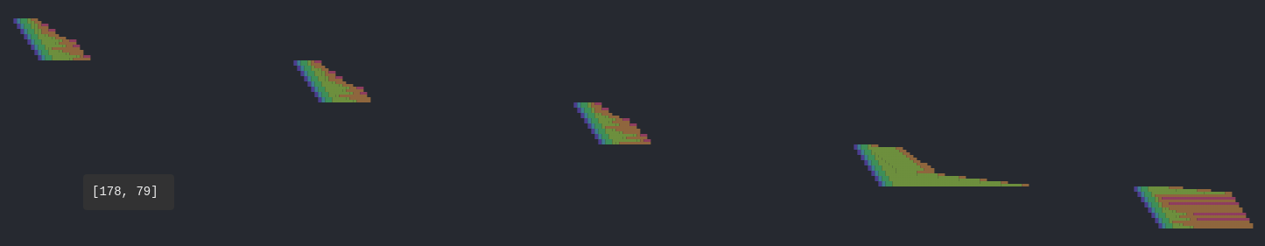
In order CPU screenshot:
OoO CPU screenshot:
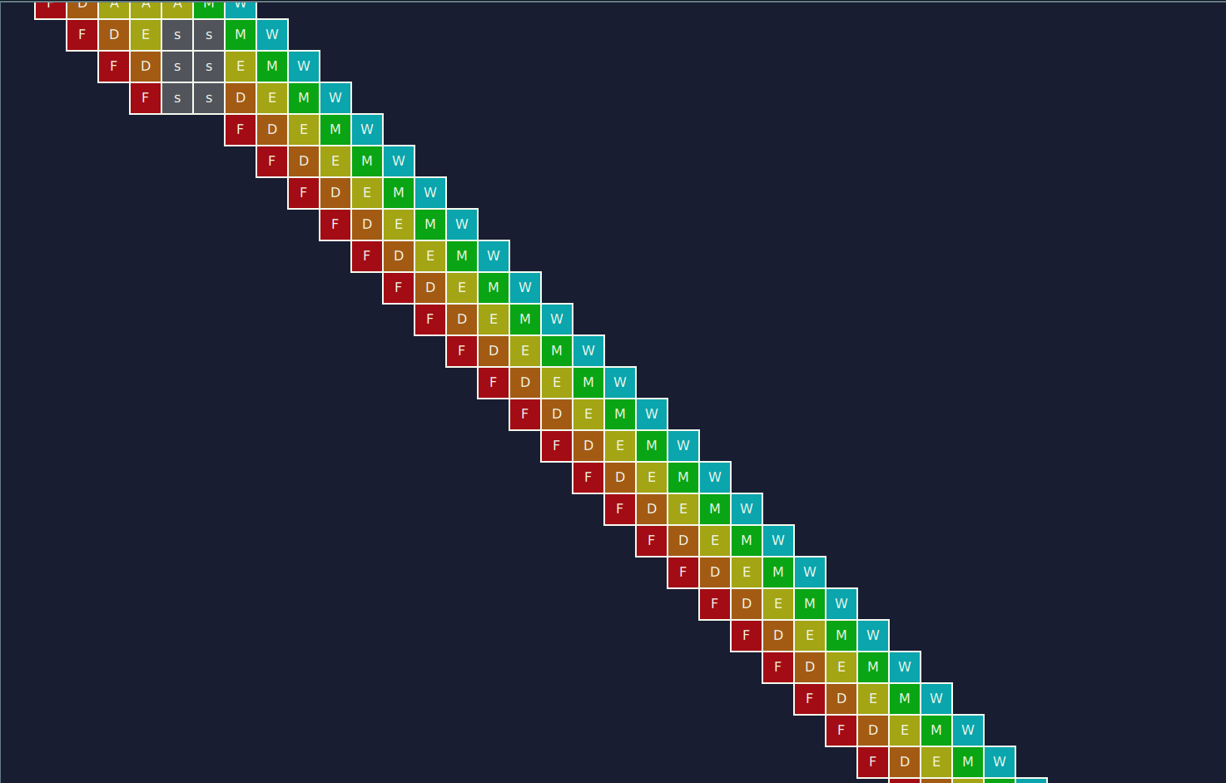

Situation: In Order performs better than OoO
Explanation: Il flush di istruzioni in caso di salto preso causa l’aumento di colpi di clock
In order CPU screenshot:

OoO CPU screenshot:


Exercise 2:

In this exercise you will experiment the usage of different Branch Prediction Unit (BPU).

You are asked to avoid as much as possible mis-predicted branches by resorting to different BPUs. Use as benchmarks the two programs developed in lab 0x03 and 0x04 (program1.s).

To modify the CPU BPU, open the configuration file of the CPU (i.e., the riscv_o3_custom.py):

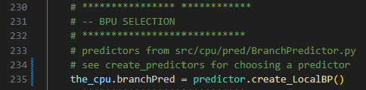

You can create/use a different branch predictors. They are defined in create_predictor.py
You are encouraged to change their internal values.

Collects statistics about the execution of your programs in the following table:

Laboratory | Program | Clock Per Instructions
Laboratory | Program | In Order CPU | OoO CPU  BPU = TournamentBP | OoO CPU  BPU = BiModeBP | OoO CPU  BPU = MultiperspectivePerceptron64KB
0x03 | program1.s | 1.7466 | 0,9438 | 1,0561 | 0,8035
0x04 | program1.s | 1.7021 | 1,4811 | 1,4853 | 1,4853

