Architetture dei Sistemi di Elaborazione  02GOLOV | Computer Architectures  02LSEYG
Laboratory  0xA | Expected delivery of lab_10.zip must include:  - Solutions of exercises 1, and 2.  - This file, filled with information and possibly compiled in a pdf format.
Delivery deadline: 20/12/2025

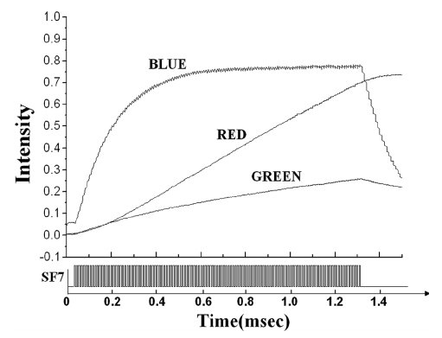
Exercise 1) Implement a system on the LANDTIGER board that can tune the brightness of an LED by making use of TIMERS.
Dimming a LED is done by appropriately turning it ON and OFF. Usually, the maximum brightness (100% brightness) is achieved when it is ON for at least a period T period. Such T time value can be often found in the LED datasheet (when available). Please see an example, where also blue and green LEDs are considered, which shows a different behaviour (non-linear).

For LANDTIGER red LEDs, the time to saturate should be in the order of few milliseconds; during this time the brightness increases almost linearly from no light to the maximum luminescence.

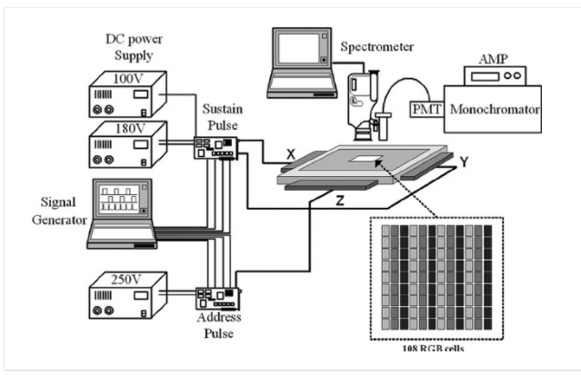
To determine the brightness of a LED is quite difficult and require expensive machineries (as shown below). We suggest you perform just a visual comparison with a setup where a LED modulated while another is always on.
In this lab, you are required to experiment with LEDs dimming using Pulse Width Modulation (PWM) via software, i.e., achieved by using GPIO outputs (on LEDS) and timers.
There exist specific peripherals for generating PWM signals (even in the LPC1768 SoC, look for them!), but they are out of the scope for the this lab.

Unfortunately, a spectrometer for measuring LEDs intensity is not available in the lab.
We are going to use a rudimental non-linear photometric sensing device, the human eyes .

The maximum frequency at which a human eye can perceive a light source (like an LED) flickering is related to the concept of the flicker fusion threshold. This is the frequency above which the human eye perceives a flickering light as a steady, continuous glow. For most people, the flicker fusion threshold is around 60 Hz to 90 Hz under typical lighting conditions. Thus, even if human eyes are the souls’ mirror, they do not work good as intensity sensing device for digital signals!

The following figure represents how a PWM signal (based on a square wave) is build and how it is perceived by human eyes.
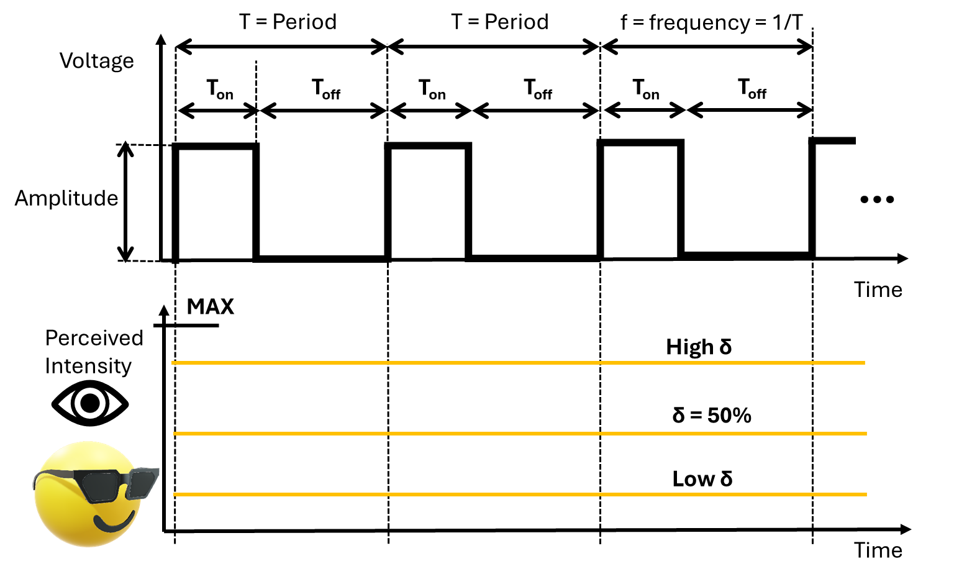
Remember that:
- Period (T) or frequency (1/T) is the amount of time for which the digital signal repeat itself.
- Time On (T_{on}) is the amount of time for which the digital signal stays at the logic value ONE (from an electrical perspective, it is the maximum voltage amplitude your GPIOs pins can reach).
- Time Off (T_{off}) is the amount of time for which the digital signal stays at the logic value ZERO.
- The duty cycle is defined as the amount of time the digital signal stays at the logic value ONE divided by the Total amount of time the digital signal repeats itself.
In other words:
$$δ= \frac{T_{on}}{T} \left[\%\right] where T= T_{on}+T_{off}$$
A higher duty cycle results into a higher perceived intensity of the LED. A lower duty cycle results into a lower perceived intensity.

Therefore, to achieve a 50% brightness (perceived intensity), for instance, the LED would have to be ON half of the time in each T period (δ = 50 %).

Note: When a LED is blinking with period T without mention the duty cycle, it implies that the duty cycle is 50 %.

To solve the exercise:
- Select one of the available LEDs, and use two Match Registers (MR0 and MR1) of TIMER 2 to synchronize the two phases. Specifically, it is necessary to set the two Match Registers so that, when TIMER 2 reaches MR0 the LED turns OFF; when the timer reaches the value held in MR1, the LED must light up.
  - Selects a frequency that avoid LED flickering.

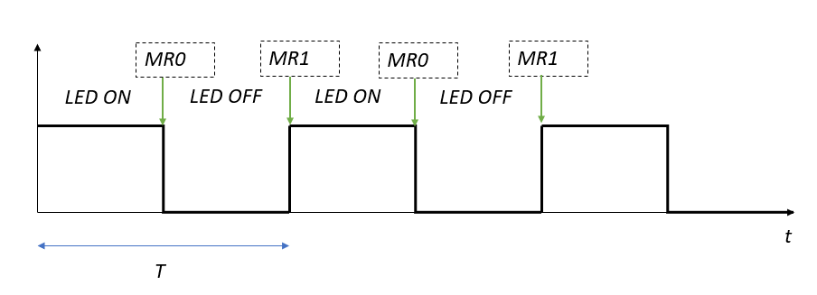
- Select another of the available LEDs, and use two Match Registers (MR0 and MR1) of TIMER 3 to synchronize the two phases (as before).
  - Selects a frequency that does not avoid LED flickering.
- Compare the TWO LEDS with the same duty cycle (50%) and different frequency.
What is happening?
Il led con frequenza superiore appare non lampeggiante ma con una luminositá inferiore, invece il led con frequenza minore appare più luminoso ma si nota che sta lampeggiando.

Fill in the table the required brightness for Timer 2.

Brightness [%] | MR0 | MR1 | Time ON | Time OFF | Period | Frequency
25 | 10000 | 7500 | 10000-7500 | 7500 | 10000 | 1/10000
50 | 10000 | 5000 | 10000-5000 | 5000 | 10000 | 1/10000
75 | 10000 | 2500 | 10000-2500 | 2500 | 10000 | 1/10000
100 | 10000 | 0 | 10000-0 | 0 | 10000 | 1/10000

Fill in the table the required brightness for Timer 3.

Brightness [%] | MR0 | MR1 | Time ON | Time OFF | Period | Frequency
25 | 200000 | 150000 | 200000-150000 | 150000 | 200000 | 1/2000000
50 | 200000 | 100000 | 200000-100000 | 100000 | 200000 | 1/2000000
75 | 200000 | 50000 | 200000-50000 | 50000 | 200000 | 1/2000000
100 | 200000 | 0 | 200000-0 | 0 | 200000 | 1/2000000

NOTE:
- To use TIMER2 and TIMER3 functionalities, you must extend the available libraries and create the appropriate functions.

Exercise 2) Starting from the project of Exercise 1, enhance the firmware with the following features:
- Upon reset, two counters (TIMER1 and TIMER2) are activated, both programmed cyclically, counting 211 milliseconds and 307 milliseconds respectively.
- The program must first count the number of times a “collision” occurs between the interrupt requests of TIMER1 and TIMER2 (in that order of arrival). The number of collisions must be saved in a variable called NUMBER, which is an 8-bit unsigned integer. When the value 255 (the maximum representable on 8 bits) is reached, the value of NUMBER must be reset to 0.
- The LEDs show the current value of NUMBER.
- Pressing KEY1 the value of NUMBER shall be decreased by 1.
The highest priority should be given to the collision between timers.
Complete the table below:
Interrupt | Priority value
Timer 1 | 0
Timer 2 | 1
KEY1 | 2

What is happening to LED counting if you repeatedly press KEY1?
Il contatore inizia a regredire come revisto

How can you solve the issue?

