# CIS5013 PORT1 Closing Kit

*Created by: Jacob Willcocks – st20235124*

*Point of contact:* [*st20235124@cardiffmet.ac.uk*](mailto:st20235124@cardiffmet.ac.uk)

*Date of publishing: 10/1/24*

## Table of Contents

CIS5013 PORT1 Closing Kit 1

Table of Contents 1

API Versions 1

Instructions 1

Repository 2

Code Demo Video 2

Credits 2

## API Versions

Visual Studio 2022 - Version 17.3.4

OpenGL – Version 3.3

Open Asset Importer Library (assimp) - Version 5.3

FreeImage – Version 3.18.0

Blender – Version 3.4.1

Photoshop – Version 25.1.0

GitHub desktop - Version 3.3.6

## Instructions

Open the project in visual studio. Open the “main.cpp” file.

In the section below, you can see the section of code where you are able to select the demo you want to run. To select a demo, comment out either the line of code on line 299 or 300 (in the example below, line 299 is commented so renderWithMultipleLights() will not run and line 300 is not commented so renderWithTransparency() will run).

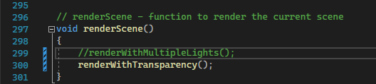

## Repository

<https://github.com/Jacopro9/CIS5013_PORT1_st20235124>

## Code Demo Video

<https://www.youtube.com/watch?v=cJcoF67kqAg>

[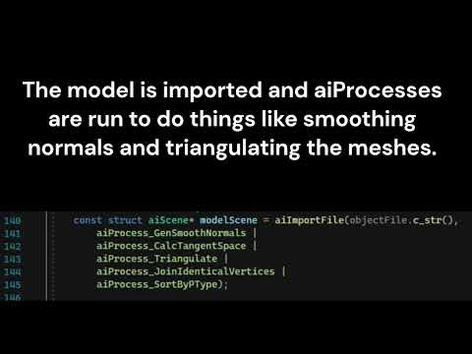](https://www.youtube.com/watch?v=cJcoF67kqAg)

## Credits

Paul Angel – created the original “multi-mesh01” repository that I worked from

Jacob Willcocks – created all models and textures used in the project. Also created all the code except for that which was from the “multi-mesh01" repository.