

**Version 1.1**

**Date: 2019/02/28**

Abstract

**Within the Imperial group there a corporate entities with a shared interest with the Engineparts catalogue system**

Catalogue Integration

*Integrate pertinent catalogue data between corporate entities with shared interests*

**Table of Contents**

Document approval and distribution list 2

1. Introduction 3

2. Audience 4

3. Objectives 5

4. Database Design Objectives 5

5. Data normalisation 8

6. Multiple suppliers for same part 9

7. Alternates, supersessions and replacement parts 9

8. Catalogue source material 10

9. Catalogue maintenance work flow 10

10. Supplier Pricing 11

11. Currency changes 11

12. Base cost calculations – optimisation 12

13. Recall of faulty / safety risk goods sold and on hand 12

14. Kitting and service sets 12

15. Supplier part profiles 13

16. Stocking Item (SKU) Maintenance 13

16.1 Group Code maintenance 13

16.2 Base Item maintenance 16

16.3 Catalogue – Bill of material node maintenance 21

16.4 Catalogue Maintenance - Stock Mark-up workbench 26

16.5 Catalogue Supplier Price Maintenance 28

17. Dependencies 28

18. Database entities and relationships 30

19. Programs 31

19.1 MS Windows Executables 31

19.2 SQL Stored Procedures 31

20. Acceptance 32

# Document approval and distribution list

|  |  |  |  |
| --- | --- | --- | --- |
| **Description** | **Name / Title** | **Signature** | **Date** |
| **Document Type / purpose** | | | |
| Prepared by |  |  |  |
| Reviewed by |  |  |  |
| Approved by |  |  |  |

# Introduction

Prior to the Imperial acquisition of Alert Engine Parts, PIA and Engineparts, each entity managed a separate – so called- catalogue of parts and applications.

Post Imperial acquisition, these entities remain largely separate but have a need to co-ordinate new data with ePart.

For this part, Engineparts receives interchange data that is ………………….

# Audience

Sales

Cataloguing

# Objectives

# Technical solution

This is still in work in progress

The current solution view is …

# Database entities and relationships

The full catalogue related database diagram provides a view of the various participating relationships. Notably is the simplicity of the database tables participating in the core structure.

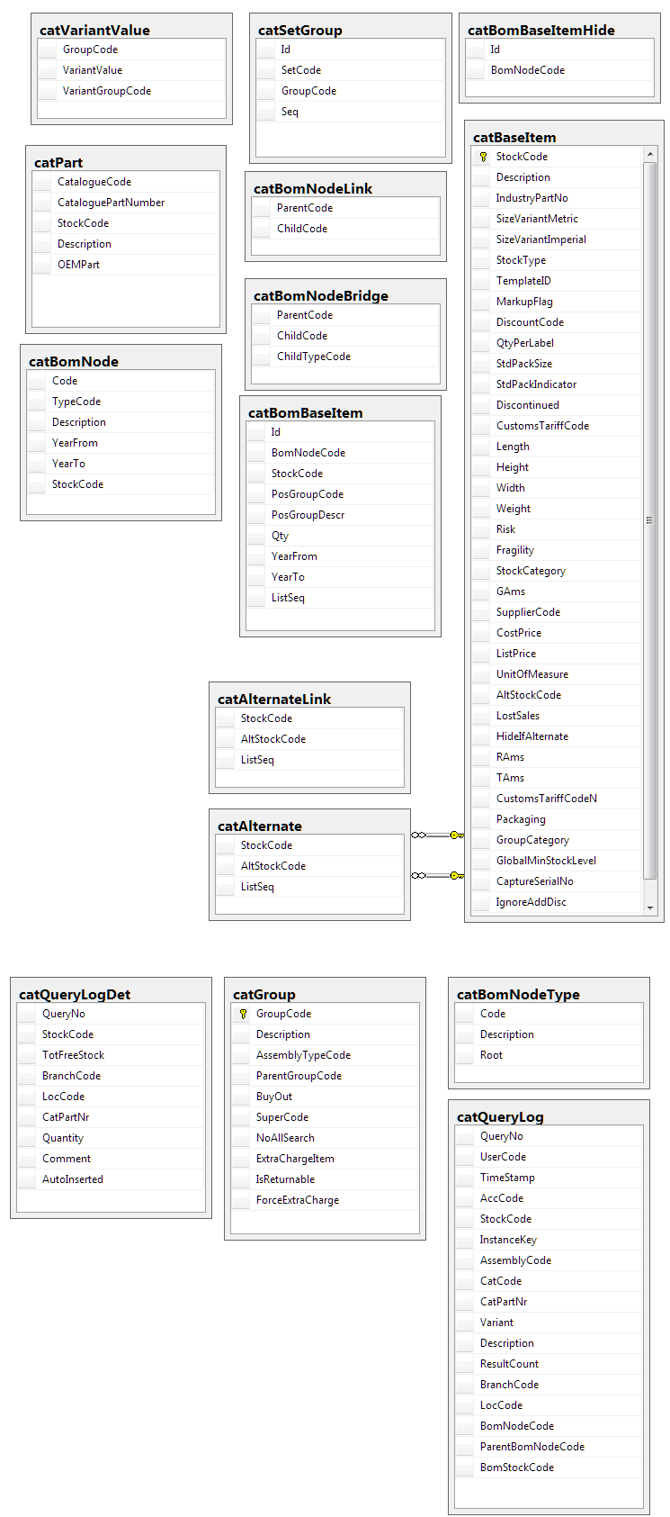Many of the additional tables are there for control and optimisation purposes.

A specific reference is made to the following tables:

* “Bridging table” – this is often used in data mining structures where the volume of data requires a specialised table of this kind
* BOM level – this table is a control table to prevent illogical parent child linking i.e. linking an engine to a water-pump rather than linking a water-pump to an engine

The catalogue support system provides for a highly efficient source of information, provided the underlying data is accurately maintained and kept up to date; failing which will result in poor customer experience.

# Programs

# MS Windows Executables

|  |  |
| --- | --- |
| **Name** | **Description** |
| catLookup2.exe | Used to look up which parts the customer wants to purchase, and add them to the sales order. |

# SQL Stored Procedures

|  |  |
| --- | --- |
| **Name** | **Description** |
| catCatQueryResultHomeFindByQueryNo2 | Searches for items matching the criteria, to populate the item grid. |
| catCatQueryBomNodeHomeFindByQueryNo | Finds the section of the BoM above and below the search results. |
| salAddToSalesOrder | Automatically adds an item to an existing or new sales order. |
| catLogLostSaleManually | Records a formal lost sale, in the form of a failed-search-type informal lost sales marked as “manual”. |

# Acceptance

I hereby confirm that I have been fully informed of the documents content and, received training to understand how the detailed instructions are to be applied.

Name ………………………………………………………………………………

Job Title ………………………………………………………………………………

Signed ………………………………………………………………………………

Date ………………………………………………………………………………