

**Version 1.1**

**Date: 2019/02/22**

Abstract

**Claims by Engineparts / customers on suppliers represent a complex set of business rules and processes. The intent of the system is to track ALL events end to end**

*Claims Sub System*

*Keep track of claims end to end*

**Table of Contents**

1. Document approval and distribution list 2

2. Introduction 3

3. Audience 3

4. Functionality Narrative 4

5. Sub system solution status 4

6. Database entities and relationships 5

7. Programs 6

7.1. MS Windows Executables 6

7.2. SQL Stored Procedures 6

7.3. Database Triggers 6

8. Risks and mitigation 6

9. Acceptance 7

# Document approval and distribution list

|  |  |  |  |
| --- | --- | --- | --- |
| **Description** | **Name / Title** | **Signature** | **Date** |
| **Document Type / purpose** | | | |
| Prepared by | Graham Smith |  | 2018/10/08 |
| Reviewed by |  |  |  |
| Approved by |  |  |  |

# Introduction

Claims for faulty parts and consequential damage and labour often occur. Additionally, goods received from suppliers may have also result in requiring claims to be issued on suppliers.

The process was manually processed but was found to be excessively labour intensive and lacked in competent management oversight.

Furthermore, the number of claims with work in progress caused administrative bottle necks and lack of operational focus.

During the requirements analysis, it was understood that the processes and related resolutions were relatively non-definitive with complex resolution permutations.

***The documentation is limited to basic narrative. Screen images etc not included due to time and financial limitations.***

# Audience

Technical department

Administration

Creditors

Software developers

# Functionality Narrative

Typically, parts would be sold to Engineparts retailer or through ***counter sales.***

Post fitting of the purchased parts, malfunction could occur resulting in something of the following profile:

* The part only failed
* The part failed and caused secondary damage of other parts
* The part failed causing catastrophic failure deemed as consequential damage with labour to repair

The variations / permutations herein:

* The part is replaced either from supplier or from Engineparts stock
* Recompense for additional costs related to the analysis and repair
* Engineparts carry the costs for parts and repairs
* Suppliers carry costs for parts and repairs
* Or a mix of the customer, Engineparts and supplier share the costs
* To track the entire claims process from end to end and to keep a log of all events
* To integrate and automate the costs and replacement parts

As can be seen from this is that there are a number if matters that need to be controlled end to end:

* Record the new claim
* Record all non-transactional events occurring during the process
* Record the costs incurred consequential or direct
* Record liability and agreement of how costs are to be shared
* Record replacement parts issued from stock. Adjust stock on hand
* Record financial settlement made by Engineparts to customer. This would be a this would be a financial entry only in lieu of goodwill
* Record what goods the supplier would replace. No GRV integration provided for
* Record what goodwill financial provision the supplier will contribute. This could be to Engineparts and can be to full or partially offset the goodwill settlement made by Engineparts to the customer.
* Record if the on-hand stock needs to be recalled. This is not integrated into the recall of safety critical stock recall.
* Track and integrate all financial entries to the related financial sub-systems

# Sub system solution status

Due to the complexity and the engaged consultant at the time, the quality of work is not good and the opinion is that a re-write should be a serious consideration.

# Database entities and relationships

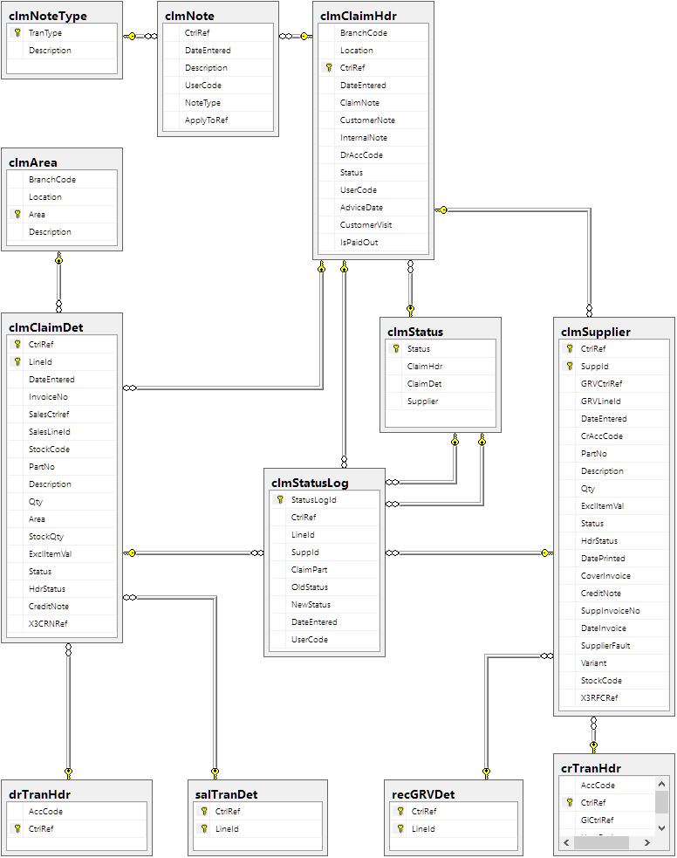

# Programs

# MS Windows Executables

|  |  |
| --- | --- |
| **Name** | **Description** |
| clmClaims.exe | Capturing of claim details and events. |
| clmMaintainArea.exe | Maintenance of claim areas. |

# SQL Stored Procedures

|  |  |
| --- | --- |
| **Name** | **Description** |
| clmSupplierList | List suppliers with pending claims. |
| clmSuppliersNotPrinted | List suppliers with open claims. |
| clmVerifyClaim | Lightly verifies the claim. |
| clmSupplierCalc | Calculates various things, presumably to auto-fill fields. |
| clmSupplierLineVerify | Logs changes to a supplier detail line. |
| clmSupplierGetBuyout | Finds the GRV given the buyout’s sales order. |
| clmCreditorCredit | Verifies details and logs the X3 reference of the supplier’s credit note. |
| clmClaimOpen | Searches for a claim. |
| clmClaimClose | Closes a debtor line, a supplier line, or a whole claim. |
| clmDebtorJournal | Verifies details and logs the X3 reference of the debtor’s credit note. |
| clmClaimNew | Opens a new claim. |
| clmClaimDelete | Deletes a debtor line, a supplier line, or an empty claim. |
| clmGetNextLineId | Gets a line id for a new debtor detail line. |
| clmClaimDetLineVerify | Verification and cascading updates on a debtor detail line. |
| clmDebtorVerify | Incompletely verifies a change to the debtor account code on the claim. |
| clmGetNextSuppId | Gets a line id for a new supplier detail line. |
| clmClaimDetCalc | Looks up the date of a sales order. |
| clmChangeStatus | Reacts to various status changes. |

# Database Triggers

|  |  |
| --- | --- |
| **Name** | **Description** |
| clmClaimHdrUpdate | Verifies that the debtor account exists. |
| clmClaimHdrStatus | Verifies and logs status change on header. |
| clmClaimDetStatus | Verifies and logs status change on debtor details line. |
| clmSupplierStatus | Verifies and logs status change on supplier details line. |

# Risks and mitigation

|  |  |  |
| --- | --- | --- |
| **#** | **Risk** | **Mitigation** |
| 1 | Safe practice is not enforced. | Careful training, and manual financial corrections. |
| 2 | Shoddy verification during capture. | Last-minute checking during posting. |

# Acceptance

I hereby confirm that I have been fully informed of the documents content and received training to understand how the detailed instructions are to be applied:

Name ……………………………………………………………………………

Job Title ……………………………………………………………………………

Signed ……………………………………………………………………………

Date ……………………………………………………………………………