

**Version 1.1**

**Date: 2019/02/27**

Abstract

**ePart was designed to permit the maintenance of system required variables such as financial periods user permissions etc**

Company Controls

Manage ePart configurable detail

**Table of Contents**

Document approval and distribution list 2

1. Introduction 3

2. Audience 3

3. Objectives 3

4. Business Flow 3

5. Detailed description of functionality 3

6. Dependencies 4

7. Application design philosophy 4

8. Database design philosophy 4

9. Catalogue lookup to sales-order 4

10. Database entities and relationships 6

11. Programs 8

11.1 MS Windows Executables 8

11.2 SQL Stored Procedures 8

12. Acceptance 10

# Document approval and distribution list

|  |  |  |  |
| --- | --- | --- | --- |
| **Description** | **Name / Title** | **Signature** | **Date** |
| **Document Type / purpose** | | | |
| Prepared by |  |  |  |
| Reviewed by |  |  |  |
| Approved by |  |  |  |

# Introduction

ePart was designed to permit the maintenance of system required variables such as financial periods user permissions etc

# Audience

* Management
* ePart Admin

# Objectives

The system configurations are varied and beyond the scope of this top-level document.

To allow for end-user system ownership, user interfaces are available, under ePart access control, through which end users can take ownership of ePart functionality.

A main example of this is the maintenance of financial periods, the opening and closing of such periods.

A view would be that it is not unusual for debtors’ sub-ledger period to have been closed whilst creditors period is still running beyond that of the formal financial period.

A key component of ePart is the user permissions to perform ePart defined tasks and is defined by creating a user defined ***menu*** of permissible tasks with associated permissions. To note is that users often can be classed into similar groupings i.e. on-line users, debtors credit controllers etc. ePart allows for a standard ***menu*** to be created for specific groups that greatly reduces menu & permissions management.

# Database entities and relationships

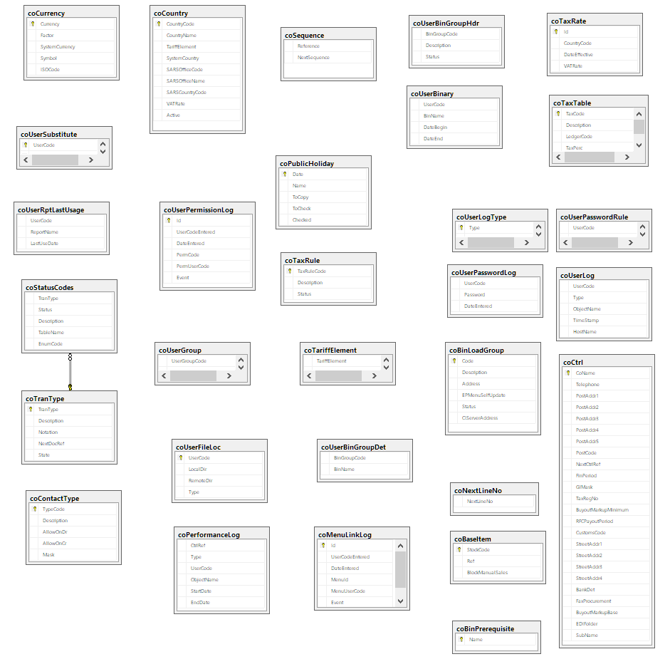

# Programs

# MS Windows Executables

|  |  |
| --- | --- |
| **Name** | **Description** |
| coMaintainBranch | ePart is multi branch capable |
| coMaintainCountry | Suppliers are associated to a country with country specific properties. Included is the trading currency that Engineparts will be required to effect payment in |
| coMaintainCurrency | All international currencies including conversion rates to ZAR |
| coMaintainGlIntegration | Profile of sub-ledgers integration to GL |
| coMaintainMailIncident | Separate mailing of logged incidents tracking system |
| coMaintainMenuOptions | Used to create / maintain user specific menu items and permissions |
| coMaintainNoteReasons | Optimised / pre-captured permissible notes in a dropdown list |
| coMaintainPermission | Once menu is constructed, specific CRUD permissions can be maintained. This is split due to separation of accountability |
| coMaintainReasons | Optimised / pre-captured permissible reason code in a dropdown list |
| coMaintainTariffElement | Import / export tariff headings required by cross border and shipping agents |
| coMaintainUser | ePart user maintenance plus allocation of menu using the group association to allocate pre-defined menu structure. |
| coMaintainUserBinGroup | The binary group for uploading new program versions |
| coMaintUserSub | Allows supervisor staff to act on behalf of a user with logging of the override event. This is applied by allocating specific users in a team to a team leader. |
| coSearchBranchLoc |  |
| coSearchUser |  |
| coSelectBranchLoc |  |

# SQL Stored Procedures

|  |  |
| --- | --- |
| **Name** | **Description** |
| coBackupToDisk | Backup script to ensure al databases are backed up to disc. This has become redundant due to server virtualisation. |
| coBinLoadGroupFieldChange |  |
| coBinLoadGroupHomeCreate |  |
| coBinLoadGroupHomeDestroy |  |
| coBinLoadGroupHomeFindAll |  |
| coBinLoadGroupHomeFindByUserCode |  |
| coBinLoadGroupRefresh |  |
| coBinPrerequisiteFieldChange |  |
| coBinPrerequisiteHomeCreate |  |
| coBinPrerequisiteHomeDestroy |  |
| coBinPrerequisiteHomeFindAll |  |
| coBinPrerequisiteRefresh |  |
| coBranchFieldChange |  |
| coBranchHomeCreate |  |
| coBranchHomeDelete |  |
| coBranchRefresh |  |
| CoChangePassword |  |
| coCheckActiveConnections |  |
| coCheckBuffer |  |
| coCheckLedgerBalance |  |
| CoConstraints |  |
| CoCopyUserMenu |  |
| coCreateUpdatePerformanceLog |  |
| CoCreateUser |  |
| coEpMailMsgAddRecipient |  |
| coEpMailMsgAddRecipientName |  |
| coEpMailMsgClearRecipients |  |
| coEpMailMsgDelete |  |
| coEpMailMsgFieldChange |  |
| coEpMailMsgGetIsPosted |  |
| coEpMailMsgHomeCreate |  |
| coEpMailMsgHomeDestroy |  |
| coEpMailMsgHomeFindDeletedItems |  |
| coEpMailMsgHomeFindInbox |  |
| coEpMailMsgHomeFindSentItems |  |
| coEpMailMsgPost |  |
| coEpMailMsgRefresh |  |
| coEpMailMsgRemoveRecipient |  |
| coEpMailMsgSetIsRead |  |
| CoFindRelatedDocuments |  |
| coFinPeriodHomeFindCurrentPeriod |  |
| coFinPeriodHomeFindNextPeriod |  |
| coFinPeriodHomeFindPeriodByDateRange |  |
| coFinPeriodHomeFindPreviousPeriod |  |
| coGetAllReasonCodes |  |
| coGetApplyPeriod |  |
| CoGetCurrentDatabase |  |
| CoGetCurrentDate |  |
| CoGetCurrentHhMm |  |
| CoGetDatePart |  |
| CoGetErrMessage |  |
| coGetFirstPeriod |  |
| CoGetLastPeriod |  |
| CoGetMenuOptsUnderConstr |  |
| CoGetName |  |
| CoGetNextCtrlRef |  |
| coGetNextDocRef |  |
| CoGetNextIncCtrlRef |  |
| CoGetNextLineNo |  |
| coGetNextPeriod |  |
| CoGetNextSequence |  |
| coGetPrevPeriod |  |
| coGetReasonCodeDescription |  |
| coGetReasonCodes |  |
| CoGetSecurityInfo |  |
| CoGetSystemUser |  |
| CoGetUserBranchLoc |  |
| CoGetUserDefaultPeriod |  |
| CoGetUserMenu |  |
| CoIsMenuOptUnderConstr |  |
| coLinkUserJrnlReasonCreate |  |
| coLinkUserJrnlReasonDelete |  |
| coLinkUserJrnlReasonSearch |  |
| coLocationFieldChange |  |
| coLocationHomeCreate |  |
| coLocationHomeDelete |  |
| coLocationHomeFindAll |  |
| coLocationRefresh |  |
| CoMailTaskProgress |  |
| CoMaintainBinaryLoad |  |
| coMenuOptionFieldChange |  |
| coMenuOptionHomeCreate |  |
| coMenuOptionHomeDestroy |  |
| coMenuOptionHomeFindByUserCode |  |
| coMenuOptionRefresh |  |
| coRecalcItemAms | AMS= average monthly sales. This Is run on a daily basis gathering transactional data to recalculate a new AMS |
| CoRefreshUsers |  |
| coRegenerateAllUsers | This is used to sync ePart user permission to the MSSQL permissions |
| coRptAllFilesLastBinaryUpdateForUser |  |
| coRptAutoMailUnusedRpts |  |
| coRptBinaryDownloads |  |
| coRptBlank | Template |
| coRptDailyTurnOver |  |
| coRptLog | Report on logged changes. The result can be filtered by sub ledger / task type |
| coRptLogPerUser | User activity relating to ePart |
| coRptPerformanceLog | Print performance stats per report |
| coRptPoorSearches | Performance stats per stored procedures |
| CoRptUserMenu | Report of user activity per assigned menu item |
| coRunawayCheck | Admin task to check for runaway SP using CPU and IO indicators |
| CoSearchMenuOptions |  |
| coSearchReason |  |
| coSearchUser |  |
| CoSendMail |  |
| CoSendMailExec |  |
| CoShowUserPassword |  |
| coStoredProcedure | Template |
| coSyncEpTestEpLoadMenus |  |
| CoSyncUserGroup |  |
| coTrigger | Template |
| coUpdatePublicHoliday | Interfaces with C++ builder UI to maintain pubic holidays in the ePart calendar or working days |
| coUpdateStats | Update MSSQL statistics for performance reasons |
| coUserBinaryReport | … |
| coUserChangePassword |  |
| coUserExecMenuOption | Checks permissions with logging |
| coUserFieldChange | Part of user maintenance |
| coUserFindGLPeriodUsers | Part of user maintenance |
| coUserGetDefaultLocation | Part of user maintenance |
| CoUserGetDepartment | Part of user maintenance |
| coUserGetLocations | Part of user maintenance |
| coUserHasNewEpMail | ePart has inbuild messaging system called epMail allowing instant messaging style of communications |
| coUserHasPermission | Part of security / permissions checking |
| coUserHomeCreate | Create new user |
| coUserHomeDelete | Delete inactive user – will only work if no dependent transactions are in the DB |
| coUserHomeFindByDepartment |  |
| coUserHomeFindByUserName |  |
| CoUserMenu | Main ePart menu |
| coUserMustChangePassword | Force a password change |
| coUserPasswordCrypted | Encrypt the password |
| coUserPasswordSync | Part of DB user permissions Sync |
| coUserRefresh |  |
| coUserSearchGeneric |  |
| coUserSetDefaultLocation |  |
| coUserValidatePassword | Password validation |
| CoValidateApplyDate | Check that period is ably to accept the transaction is applied to period |
| CoValidateUserAccess | Part of security |
|  |  |

# Acceptance

I hereby confirm that I have been fully informed of the documents content and, received training to understand how the detailed instructions are to be applied:

Name …………………………………………………………………………….

Job Title ………………………………………………………………………….

Signed ……………………………………………………………………………

Date ………………………………………………………………………………