

**Version 1.1**

**Date: 2018/12/14**

Debtors maintenance id concerned with financial control over Engineparts customers and their trading status. The ePart system has many sub-system interfaces and is described here although some controls have been relinquished to Sage X3

Debtors Maintenance

**Table of Contents**

Document approval and distribution list 2

1. Introduction 3

2. Audience 3

3. Objectives 3

4. Business Flow 3

5. Detailed description of functionality 3

6. Dependencies 4

7. Application design philosophy 4

8. Database design philosophy 4

9. Catalogue lookup to sales-order 4

10. Database entities and relationships 6

11. Programs 8

11.1 MS Windows Executables 8

11.2 SQL Stored Procedures 8

12. Acceptance 10

# Document approval and distribution list

|  |  |  |  |
| --- | --- | --- | --- |
| **Description** | **Name / Title** | **Signature** | **Date** |
| **Document Type / purpose** | | | |
| Prepared by |  |  |  |
| Reviewed by |  |  |  |
| Approved by |  |  |  |

# Introduction

The Engineparts ePart system provides for the management of is trading partners. This document is concerned with the Debtors / Accounts receivable trading partners.

Due to the logical relationship between ePart sub-systems, interaction between these are strictly controlled through the judicial use of MSSQL stored procedures providing positive re-usability of business logic.

Some development objectives are touch on here as ***critical*** functionality that needs to be considered in review of ePart functional and business requirements such as 24 by 7 availability, high performance payment allocations, sales counter POS / cashiering, balance forward vs open item, extended age analysis, credit limits, various dashboards and notations to assist credit control clerks with tools to ensure timely collections of overdue accounts.

Historically, Engineparts engaged with a NASDAC listed company (23rd or 11th of its discipline) (then known as Epicor). The venture was totally non-functional and terminated soon after implementation commenced. Unfortunately, some monies were expended that was not recoverable, but a substantial amount was recovered via reusable licensing and proportionate cash back from the German distribution company aligned with EPICOR.

At the time of implementation breakdown; management took the decision to re-write the Engineparts ERP as an in-house project for several reasons:

* In-house development model was well known to Engineparts management
* After detailed review of several standardised solution and the failure of the EPCOR offering, the GAP analysis in functionality made it almost impossible to find and affordable ***off the shelf*** solution that would meet with Engineparts specific requirements
* Fulfil the need to be able to control the Engineparts destiny
* Advanced in-house technology skills availability
* Management commitment to staff the IT section appropriately

Currently, as part of the management decisions made post liquidation, Sage X3 has become the preferred financial control system as part of the greater.

# Audience

* Management (financial)
* Credit control
* Accounts receivable

# Objectives

# Detailed description of functionality

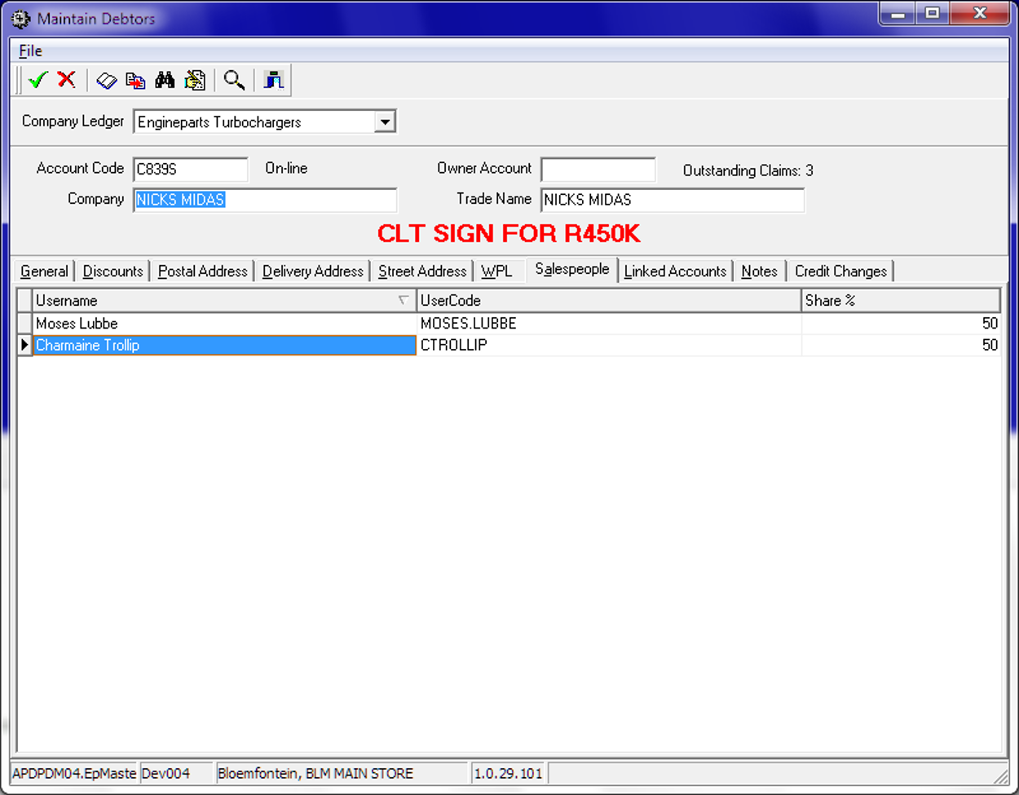The following illustration provides a view of the Debtors Maintenance

# Dependencies

* Sales staff management
* Sales order to Invoice
* RFC (return for Credit)
* Debtors account management (sales staff allocation & % allocation)
* On-line customer database.

# Application design philosophy

The same design philosophy is used as in most other ePART applications. It consists of 3 basic components:

* 1. Presentation – A C++Builder application with limited, if any, business logic.
  2. Business logic – Implemented as stored procedures on an MSSQL database server.
  3. Data persistence – The MSSQL database server is responsible for persistence.

This modular approach should increase the longevity of the product by allowing developers to replace the business logic and presentation independently of one another.

# Database design philosophy

The Debtors Maintenance application uses an object-oriented approach to the data and a three-tier approach for presentation, business logic and database persistency.

The sales staff assignment to a debtor requires that an active debtor entry be recalled. The assignment function is a tab on the ***action bar – Sales People***

**<This section will be replaced with a link to the database design philosophy document>**

# image.pngDatabase entities and relationships

# Programs

Notably, is the naming convention where the 1st 2 / 3 letters denote the sub-system i.e. ‘dr’ for debtors, ‘stk’ for stock management etc.

The stored procedures used here represent the ***business logic and data persistence*** of the solution whereas the ***presentation logic*** only performs visual functions.

The presentation logic used the Borland C++ Builder development framework; originally used for its use in tertiary education centres i.e. UOFS. However, the framework was swapped in favour of MS Visual Studio with C# and subsequently Borland as a company has ceased business, making the C++ Builder framework obsolete

***Importantly, the Borland C++ framework MUST be replaced over the long term with potentially re-developing the user interfaces in MS C# in and amongst many other UI opportunities such as web-based development.***

The effort to replace the presentation logic is near enough about 10% of the total code base; consequently represents a smaller percentage of effort.

# MS Windows Executables

|  |  |
| --- | --- |
| **Name** | **Description** |
| DrMaintainDebtors.exe | Compile name to include into EpMenu |

# SQL Stored Procedures

|  |  |
| --- | --- |
| **Name** | **Description** |
|  |  |
|  |  |
|  |  |
|  |  |
|  |  |
|  |  |
|  |  |
|  |  |
|  |  |
|  |  |
|  |  |
|  |  |
|  |  |
|  |  |
|  |  |
|  |  |
|  |  |
|  |  |
|  |  |
|  |  |
|  |  |
|  |  |

# Acceptance

I hereby confirm that I have been fully informed of the documents content and, received training to understand how the detailed instructions are to be applied:

Name …………………………………………………………………………….

Job Title ………………………………………………………………………….

Signed ……………………………………………………………………………

Date ………………………………………………………………………………