

**Version 1.1**

**Date: 2018/04/09**

Abstract

**The objective of this document is to describe the purpose of the hardware & software controls implemented for the outbound load-bay management.**

Load-bay Door Scanning

*Describe the purpose and implementation of load-bay controls*

**Table of Contents**

Document approval and distribution list 2

1. Introduction 3

2. Audience 3

3. Functionality Narrative 4

4. Bespoke hardware 4

5. Future hardware replacement strategy 8

6. Dependencies 9

7. Risks and mitigation 9

8. Requirements overview 9

9. Acceptance 11

# Document approval and distribution list

|  |  |  |  |
| --- | --- | --- | --- |
| **Description** | **Name / Title** | **Signature** | **Date** |
| **Document Type / purpose** | | | |
| Prepared by | Graham Smith |  | 2018/09/26 |
| Reviewed by |  |  |  |
| Approved by |  |  |  |

# Introduction

Part of the despatch of client goods management, is the assurance testing that orders ready for delivery are exiting the premises through the system designated load-bay door.

# Audience

Despatch

Technical (bespoke hardware purpose developed to Engineparts specification)

Software developers

# Functionality Narrative

The designation is system defined via the delivery route configuration where the route configuration, by warehouse location, defines an association between the route and the load-bay door.

When the loading manifest barcode is scanned, it identifies the exit door, route allocation and consequently the allocated / pre-configured load-bay.

The requirement is for the person performing the handover of consigned parcels to audibly understand that the goods are being passed through to the designated transporter.

The current implementation, using bespoke hardware developed specifically for Engineparts, issues a:

* Single BEEP for barcode scan matches the EXIT door
* Three BEEPS for a mismatch

The bespoke system and ePart application support operate inside the warehouse for internal governance and outside for courier governance.

The designated route(s) delivery schedule is confirmed by the scanning process where ePart staff perform the function internally and create an expectation for the courier to fulfil.

On the courier side, the scanning process is repeated by the Courier itself allocating accountability of having received the designated goods thus accountable for losses.

# Bespoke hardware

At the time when business defined the requirement, there was no favourable commercial solution at hand.

Due to the simplicity of the hardware requirement found on the internet, a prototype was manufactured within the space of 4 hours and tested with good results.

The prototype was outsourced to a hardware manufacturing company, inclusive of a sample wiring harness around 2005 / 7.

Post 2015, an availability of the bespoke hardware solution component was made, and enough units on-hand was found on site to meet with future requirements (and way beyond) during the ePart expected future life cycle.

The wiring harness was reverse engineered and documented at the time but cannot be found to date.

**Image 4.1: This is a sample of the buzzer controller box**

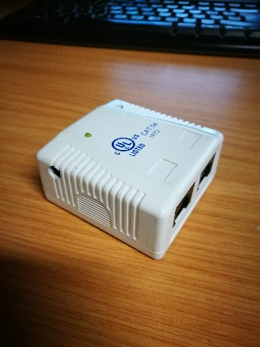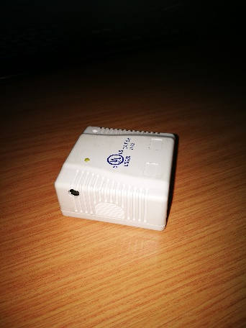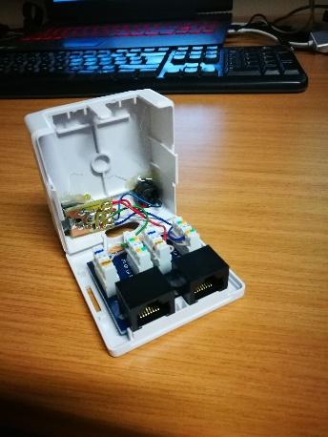

**Image 4.2: Diagram of the wiring harness**

To date no sample can be found even though a harness cable was reverse engineered and duly documented, now not to be found.

One of the operational wiring harnesses can be used to reverse engineer again

A diagram towards remanufacturing would be useful.

No diagram can be found although one was produced by reverse engineering harnesses that are currently in use.

It is recalled that it took about 4 hours to reverse engineer the previous time.

It was found that not all scanners from the same supplier for the same use format work the same around the RS232 connectivity. Although not analysed in full why, it was presumed that the scanners may have been faulty and removed for later analysis.

**Image 4.2: Sample scanner Installation – internal for Engineparts use and control**

Cable running to the PC’s RS232 port (can be USB converter too)

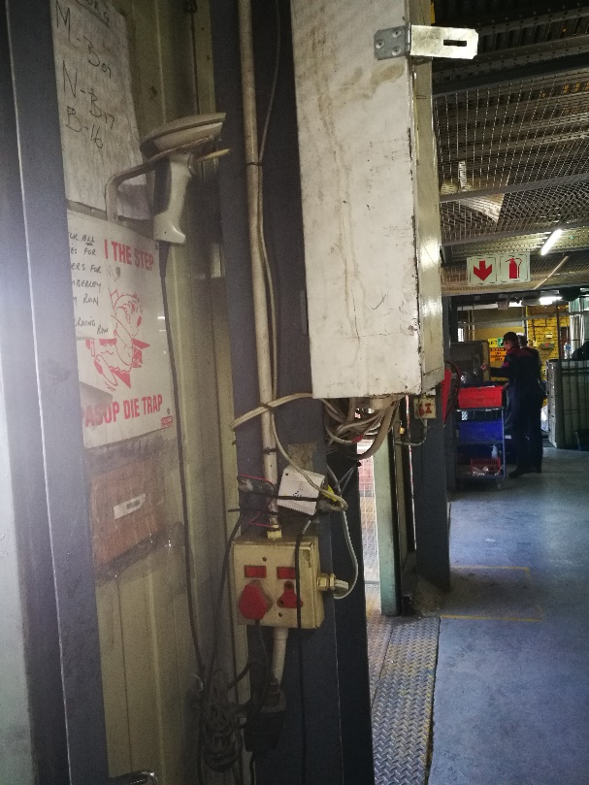

Scanner hooked onto the buzzer box with RS232

Buzzer box that is driver off a separate (to scanner) RS232 port

**Image 4.2: Sample scanner Installation – internal for Engineparts use and control**

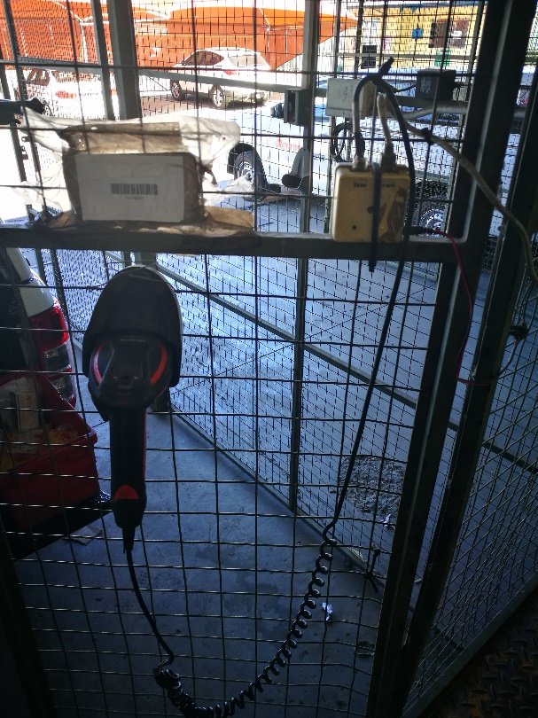External scanners are physically deployed in the same way as internal. The application is told by scanning a barcode if the scanner is internal / external deployed.

**Diagram 4.3: The following diagram represents industry standard DB9 pinouts**

The following diagram presents industry standard DB9 RS232 pinout that is generally implemented in this bespoke hardware solution.

The specific pins used 2, 3 and 5 to support scanned data communication to the PC.

Not show in this diagram (the wiring harness diagram needs to be found or reverse engineered again) is the signal pinout to the buzzer box from the PC.

Based on the C++ driver program in ePart, the buzzer is activated by raising the one of the pinouts 4 or 6 to generate power to the buzzer itself. The C++ program achieves this by opening and closing the RS232 port

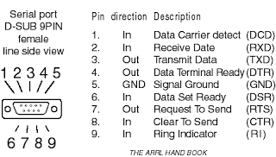

**Image 4.4: The following images provide a view of the RS232 connectivity using DB9 plugs**

In the image one can see the RS232 card with 2 ports (one used) supporting the function. The risk is that these cards are not manufactured anymore and will be challenging to obtain.

However, there is enough availability of YSB to RS232 devices still to be had but availability must be a potential future risk

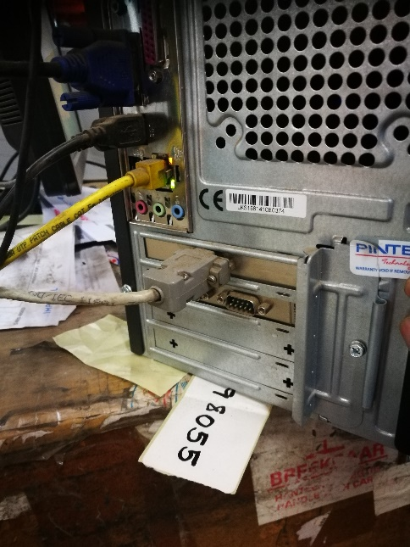

# Future hardware replacement strategy

During the tenure of Charles Swart, a strategy was worked on to replace the bespoke equipment using the following hardware scanner solution.

The scanners are blue-tooth capable with the base station being connected to a PC using USB.

The application software has been developed, tested and saved in the ePart version control system, ready for deployment.

The PC setup is challenging due to the vendor design and implementation requirements. These have been documented in the source code internals should the solution require deployment in future.

The primary reason why the deployment was not initiated:

* Cost of each scanner
* Reverse engineering the current wiring harness
* Finding a huge number of the bespoke buzzer boxes
* Stability of current implementation
* Availability of current cable scanners

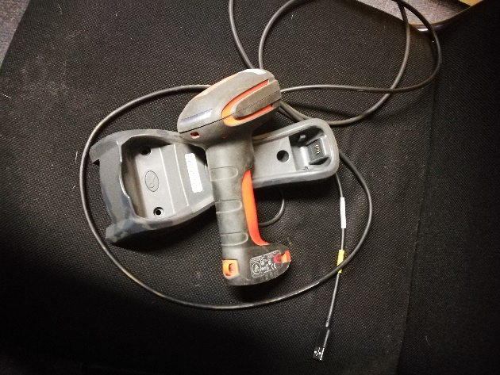

However, the planned for solution is very robust yet costly and must be reviewed against modern Android based mobile scanners which have much reduced capital investment demands yet offer highly advanced developer support through HTML5 programming support

Additionally, the mobility scanners can be deployed in many different roles within the organisation naming a few:

* Receiving
* Binning
* Picking
* Checking – inbound and outbound
* …

# Dependencies

|  |  |  |
| --- | --- | --- |
| # | Description | Action / By whom |
| 1 |  |  |
| 2 |  |  |
| 3 |  |  |
| 4 |  |  |
| 5 |  |  |
| 6 |  |  |

# Risks and mitigation

|  |  |  |
| --- | --- | --- |
| # | Risk | Mitigation |
| 1 | Bespoke hardware solution | Backup systems, simplicity, Alternate created |
| 2 |  |  |
| 3 |  |  |
| 4 |  |  |
| 5 |  |  |
| 6 |  |  |

# Requirements overview

|  |  |  |
| --- | --- | --- |
| # | Description | Action / By whom |
| 1 |  |  |
| 2 |  |  |
| 3 |  |  |
| 4 |  |  |
| 5 |  |  |
| 6 |  |  |
| 7 |  |  |
| 8 |  |  |
| 9 |  |  |
| 10 |  |  |
| 11 |  |  |
| 12 |  |  |

# Acceptance

I hereby confirm that I have been fully informed of the documents content and, received training to understand how the detailed instructions are to be applied

Name …………………………………………………………………………….

Job Title ………………………………………………………………………….

Signed ……………………………………………………………………………

Date ………………………………………………………………………………