

**Version 1.1**

**Date: 2018/11/27**

The objective is to describe the opportunity to share infrastructure between Engineparts and AAAS in support of a sane technology disaster recovery plan. Additionally, floor space to accommodate staff is reviewed at high level

Engineparts & AAAS Technology DRP

*Describe the DRP share between EP & AAAS*

**Table of Contents**

Document approval and distribution list 2

1. Introduction 3

2. Audience 3

3. Objectives 4

4. Proposed infrastructure enhancement solution 4

4.1 Overview 4

4.2 Benefits 5

4.3 Risks 6

5. Detail description of the objective 6

6. Requirements overview 6

7. Acceptance 8

# Document approval and distribution list

|  |  |  |  |
| --- | --- | --- | --- |
| **Description** | **Name / Title** | **Signature** | **Date** |
| **Document Type / purpose** | | | |
| Prepared by |  |  |  |
| Reviewed by |  |  |  |
| Approved by |  |  |  |

# Introduction

The objective of this document is to describe an opportunity to enhance the Engineparts and AAAS ***Disaster Recovery Plan*** (DRP) by sharing of infrastructure resources.

This notion is based on the following:

* Good corporate governance to ensure continued business activity
* JSE listing of the parent company and the JSE requirements to protect shareholders interest

***NOTE: this is the initial document seeking approval to implement the proposal. Post approval, the document will be extended for inclusion into a formal BCP and DRP as required by Corporate Governance***

The premise is since the 2 buildings (EP & AAAS) are adjacent to each other with a servitude boundary in between. Technology based connectivity can easily be established between the respective computer rooms using integrated well armoured overhead fibre optic cabling.

Apart from the technology DRP requirements, there is a need to cover the physical hosting of staff in the event of a partial disruption of the Engineparts operations looking at administrative staff.

Should the warehouse activities be impacted, the assumption is that the business becomes non-functional as there is no developed plan to secure the ability to trade.

However, consideration should be given to developing a ***Business Continuity Plan*** (BCP) for the Engineparts warehouse where infrastructure and trading goods are representative to the trading profile or some form of ability to recover in the shortest possible time. This could maybe be in the form of a ***GHOST*** warehouse where infrastructure is setup without any stock or a branch operation.

# Audience

Management

Technology

# Objectives

To review the opportunity herewith and to assess the risk, mitigation, legality, cost effectiveness and merit to implement and maintain over time to ensure readiness to execute on the respective BC and DR plans.

Once approved from a Corporate perspective, opportunity should be extended into an execution plan, inclusive of an approved investment budget and a critical path testing plan.

This proposal initially addresses a DRP from a technology base, touches on locating staff for business continuity but ***MUST*** be extended to proper plan for staffing and warehousing from a BCP as well.

As the proposal looks at incorporating AAAS infrastructure, there is a further opportunity for the implementation to be reciprocating to both Engineparts and AAAS, addressing the needs for both parties. This should carry several positive scoring points supporting approval.

# Proposed infrastructure enhancement solution

## Overview

A delegation from Engineparts did a site visit with AAAE management where the intent was reviewed. The concept proposed found favour subject to further investigation and necessary approval from Corporate level.

The following was established in support of the proposal:

1. Computer room review – adequate space for U3 class cabinet or 2 wall mount U2
2. Air con seems OK now, but they have had failures in extreme temperatures
3. AAAS enough floor space to relocate EP admin staff should EP building become unserviceable. Note: warehouse failure will cause no operational serviceability
4. EP to reciprocate with AAAS in establishing a suitable BC & DR plans
5. Site inspection of alley between EP & AAAS may require some trenching depending on Optic Fibre armouring used
6. About 120 meters of fibre is estimated to be the requirement
7. Will require 2 fibre switches with 2 connection modules to pair and double comms speed

The following diagram provides a high-level view of the proposed solution, highlighting some of the key elements including some of the observed risks that need ot be address in line with the King Commission related tp Good Corporate Governance and risk management

**Diagram 4.1 provides a high-level view of the proposed interconnection for a DRP**

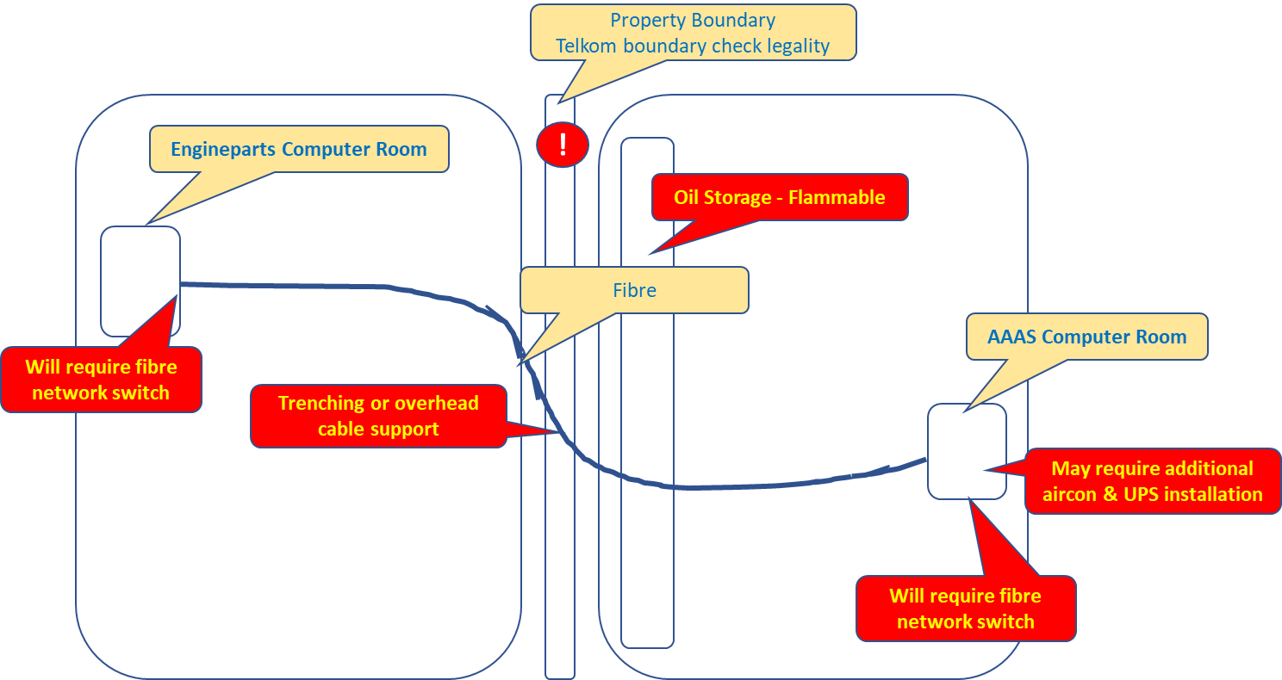

## Benefits

The main consideration for this proposal is to limit the impact on the business in the event of losing either one of the respective data processing centres.

The intent is to allow either of the businesses to operate from either data centre and in the event of one of the 2 data centres becoming unserviceable, the workload can be switched from one to the other

Additionally, testing of failure and recovery in simulation mode offers greater reliability using industry standard recovery protocols

Some additional key benefits to start with:

* Proximity of infrastructure – ease to physically manage and communications speed
* Staff movement should office and / or related equipment fail in either main centre of operation (EP / AAAS). Staff move from one building to another with minimal disruption
* Self-contained and no dependence on 3rd parties
* Accessibility to infrastructure by support staff
* Hi-speed network performance by combining several fibre strands into one data highway (multi gigabits per second)
* Both parties ***already*** have data connection with MOTUS in place. The capacity to carry both businesses data demands must be assessed.
* Should AAAS communications to MOTUS fail, the opportunity is then to route via Engineparts across the proposed fibre link

## Risks

* Failure of the single optic fibre would cause operational failure. This must be reviewed and the cost to mitigate vs benefit assessed
* It is indicated that AAAS has dual wireless connections to MOTUS without any land-based alternative. However, it is noted informally that pavement trenching is in progress near Engineparts and AAAS and the fibre installation should be imminent for consideration.
* As indicated on the diagram is the risk of oil and flammability. *This risk goes beyond technology risk and extends into physical and operational risk that needs to be addressed.*

A fire risk in the AAAS warehouse could impact the Engineparts warehouse as well should the fire spread across the servitude boundary.

The fire hazard has been addressed partially by removing automatic water-based dousing to prevent burning oil spread. (oil floats on water)

Serious consideration is required to implement foam-based fire suppression by creating a blanket over the flaming oil – removal of oxygen.

Alternatively, to house bulk oil off-site with auto replenishment on demand for immediate warehouse availability; minimising the volume of combustible oil for easier containment.

* Legal.

Telkom and related legislation prohibited interconnection crossing streets. The aspect of crossing servitude boundaries between building needs to be ascertained.

# Detail description of the objective

# Requirements overview

|  |  |  |
| --- | --- | --- |
| # | Description | Action / By whom |
| 1 | Approval to install a private optic fibre data line between Engineparts and AAAS |  |
| 2 | Hardware required to support the optic fibre links. |  |
| 3 | Hardware required to replicate the respective business operations |  |
| 4 | Review the air con requirements |  |
| 5 | Review the UPS requirements |  |
| 6 | Review the data centre fire suppression. EP is adequate, AAAS none |  |
| 7 | Engineparts external customer 3rd party support to be replicated as well |  |
| 8 | Implement replication strategy, backups, data copy, log shipping, OS snap shots, etc. onto DR site |  |
| 9 | Implement hot standby readiness |  |
| 10 | Test pattern and plan with signoff |  |
| 11 |  |  |
| 12 |  |  |

# Acceptance

I hereby confirm that I have been fully informed of the documents content and, received training to understand how the detailed instructions are to be applied

Name …………………………………………………………………………….

Job Title ………………………………………………………………………….

Signed ……………………………………………………………………………

Date ………………………………………………………………………………